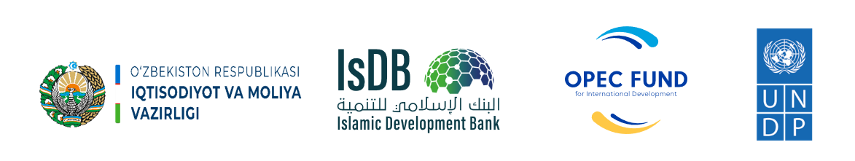
Islamic Development Bank
Ministry of Economy and Finance of the Republic of Uzbekistan
United Nations Development Programme in Uzbekistan

Project Title: | Joint project of the Ministry of Economy and Finance of the Republic of Uzbekistan and UNDP Component B "Engineering Services and Strengthening Capacity in Infrastructure Management" of the "Sustainable Rural Development" financed by Islamic Development Bank and OPEC Fund for International Development
Country: | Uzbekistan
Contract Number: | Agreement for delivery outputs
Implementation period: | 8 June 2022 – 31 December 2025 (43 months)
PROJECT NARRATIVE REPORT

Reporting period: | January 1 – December 31, 2025
Report prepared by: | UNDP CO Uzbekistan

Tashkent 2025

Table of Contents
Table of Contents 2
ABBREVIATIONS & ACRONYMS 3
TITLE LIST 4
SECTION 1. OVERALL INFORMATION 5
PROJECT SYNOPSIS 5
EXECUTIVE SUMMARY 8
SECTION 2. DESCRIPTION AND SUMMARY OF ANNUAL PROGRESS AND RESULTS PROJECT IMPLEMENTATION PROGRESS 13
PROGRESS OF ACTIVITY 1. 13
PROGRESS OF ACTIVITY 2 27
PROGRESS OF ACTIVITY 3: 31
PROGRESS OF ACTIVITY 4: 37
PROGRESS OF ACTIVITY 5: 42
Annexes: 43

ABBREVIATIONS & ACRONYMS

APA | Annual Plan of Activities
AWP | Annual Work Plan
BOA | Budget of Action
BPR | Business Process Re-engineering
CDP  CDR | Community Development Plan  Combined Delivery Report
CO | Country Office
ECA | Ecologic and Climate Action Cluster
GOU  IA  IG | Government Operations Unit  Implementing Agency  Initiative Group
IsDB  LDP  LoA | Islamic Development Bank  Local Development Plan  Letter of Agreement
M&E | Monitoring and Evaluation
NIM | National Implementation Modality
NPC | National Project Coordinator
MEF | Ministry of Economy and Finance
OPEC Fund  PIR  PIU | OPEC Fund for International Development  Project Implementation review  Project Implementation Unit
PM | Project Manager
POPP | Programme and Operations Policies and Procedures
QMS  RBM | Quality Management System  Results-Based Management
RIA | Regulatory Impact Assessment
SDG | Sustainable Development Goals
TOR  TOT  TWG | Terms of Reference  Training for Trainers  Technical Working Group
UNDP | United Nations Development Programme
USD | United States Dollar
WB | World Bank

TITLE LIST
Project number and title: | 00129160  IsDB Sustainable Rural Development Project Component B: Engineering Services and Strengthening Capacity in Infrastructure Management
Project Starting date: | 8 June 2022
Project completion date: | 31 December 2025
Implementing Partner: | Ministry of Economy and Finance of the Republic of Uzbekistan
Donor (s): | Islamic Development Bank & OPEC Fund for International Development
Contract # | Agreement to deliver output between

Total Budget for entire project period | Original Budget (USD) | Latest Signed Revision (USD)
Total Budget for entire project period | 5,000,000.00 | 5,000,000.00

Resources | Donor | Amount (USD)
Resources | Islamic Development Bank | 5,000,000.00
Resources | UNDP (in kind) | 3 050 000.00
Resources | Government  (Parallel or cost-sharing) | N/A

Period covered by this report: | 01.01.2025 – 31.12.2025
Date of annual review (Project Board meeting): | 10.12.2025

Budget for reporting period (as per the Annex III – the Budget for the Action) | Budget (USD)  (01.01.2024 – 31.12.2024) | Expenditure till  31 December 2025 (USD)
 | 1,548,786.01 | 1,255,786.01

SECTION 1. OVERALL INFORMATION

PROJECT SYNOPSIS
Project title | IsDB Sustainable Rural Development Project Component B: Engineering Services and Strengthening Capacity in Infrastructure Management
Project number | 00129160
Country | Republic of Uzbekistan
Overall objective | This UNDP Project is an integral component of the broader Uzbekistan - Sustainable Rural Development Project financed by the Islamic Development Bank (IsDB) and executed by the Ministry of Economy and Finance. The overall objective of UNDP Project is to empower and build capacities of local partners (communities, architects, engineers, local authorities) in developing and implementing local development plans and promoting locally relevant green and energy efficient as well as digital solutions. The Project aims to build capacities of targeted communities and partners in adopting and implementing environmentally friendly solutions. The Project will also confer positive impacts on human development through increased economic opportunities and wellbeing of targeted communities. Climate-related concerns will be mainstreamed into decision-making at all levels, facilitating climate-resilient and energy efficient development from the community level up to the regional level. The project takes a people-centered, gender sensitive and climate risk-informed holistic approach.
Outcome | Number of innovative and scalable solutions applied through systems integration in the Aral Sea region
Outputs | Output 1. Capacities of targeted local communities increased to identify local needs and to develop plans of actions, i.e., Community Development Plans (CDP), by identifying priority infrastructures for investments that have optimum and long-term benefits through an inclusive community engagement (including women and youth) and consultation with sub-regional and local authorities.  Output 2. Capacities of local architecture-design institutions and regional departments of architecture and construction are enhanced for development of improved engineering designs and master plans that are responsive to the sustainability aspects (economic, operational, and environment sustainability), innovative energy and water efficient, low carbon technology, climate resilient and gender responsive, and promoting local resources.  Output 3. Capacities of construction, architecture-design and public service delivery sector are increased on the local governance and community participatory mechanism in the planning and implementation of rural development programs and initiatives by using digital transformation, gender-sensitive approaches, innovative IT solutions, including development of digital infrastructure and information systems to ensure better access to social facilities and services in rural areas, including green redevelopment/regeneration and increasing resilience in post-disaster situations (such as COVID-19 and other pandemics).  Output 4. Local communities are strengthened empowering women, youth, elderly, people with disabilities, involving in decision making processes and national/sub-regional/local government capacities and institutionalization in operation and maintenance of the infrastructure to ensure sustainable functioning.  Output 5. Project Management
Activities | Output 1: (1.1) Identification/verification of target communities (170 communities) in 20 districts of Karakalpakstan, Khorezm, Bukhara and Navoi regions; (1.2) Capacity building in target districts on community mobilization for identification of community needs (up to 40 people at each community, total 6800 people); (1.3) Development and implementation of the gender-responsive CDPs at the qishloq/community level (up to 170) relying on extensive and inclusive communities mobilization in targeted communities; (1.4) Facilitate the institutionalization of the CDPs at the district administration level (inclusion of the CDP priorities and monitoring systems for CDPs into the district development plans of the government), including through engaging the locally selected deputies; (1.5) Identification/verification of target communities (around 200 communities) for the 2nd stage of the IsDB Program, from the Samarkand, Kashkadarya and Surkhandarya regions; (1.6) Organization of workshops with community participation (around 1500) and development of around 200 cluster based CDPs  Output 2: (2.1) Research on adverse impact of the ecological disaster and environment degradation on agriculture and rural population and identification of locally relevant sustainable environmentally friendly solutions.; (2.2) Building capacity of local architects/engineers by promoting innovative solutions aimed at energy and water saving, reducing CO2 emission for climate resilient planning, with focus on local agriculture and social infrastructure with particular focus on different needs of concerned groups, including women, youth, people living in poverty and people with disabilities; (2.3) Introduction of energy and water efficient, new agriculture & farming technologies, ozone-friendly and low GWP (global-warming potential) based technologies in different sectors/applications in a balanced proportion of pilot projects.  Output 3: (3.1) Digital readiness assessment, including digital gender gap, and development of local digitalization plans; (3.2) Capacity building to support regional digital transformation (25 people at each supported region, total 100 people); (3.3) Increasing digital literacy for rural population in target villages/qishloqs, with focus on students, youth communities, cooperatives, water-users associations, etc; (3.4) Based on the prioritization assessment under activity 3.1., improve access to social infrastructure through using modern technology/equipment and promoting/piloting the smart/green communities model.  Output 4: (4.1) Deployment of methods for effective and sustainable development of infrastructure in rural areas through promoting the local resource-based approaches; (4.2) Replication of Project best practices; (4.3) Development of a communication strategy in line with UNDP Principles of Gender-Sensitive Communications to make use of all possible advocacy and outreach tools and approaches to deliver messages to target audience, beneficiaries and wider public at community, district, sub-national, national and international levels; (4.4) Systems innovations advanced for integrated solutions in the Aral Sea region.
Target groups | - Population in targeted rural areas, particularly women, youth, elderly, people with disabilities  - Civil servants of government organizations and private sector who work in rural areas (doctors, architectures, farmers, teachers, designers, and others)
Project starting date | 8 June 2022
Project duration | 8 June 2022 – 31 December 2025 (43 months)

EXECUTIVE SUMMARY
Uzbekistan is a landlocked country strategically located in the heart of Central Asia, bordering Kazakhstan, Tajikistan, Kyrgyz Republic, Turkmenistan, and Afghanistan. It is a lower-middle-income country and rich with mineral resources. With 35 million (2022), Uzbekistan accounts for about 45% of the Central Asian region's total population, whereas about half of the population of Uzbekistan lives in rural area. It has a territory of 448.9 thousand km².
Uzbekistan joined the Islamic Development Bank (IsDB) in 2003 year. The IsDB Sustainable Rural Development project – “IsDB Sustainable Rural Development Project Component B: Engineering Services and Strengthening Capacity in Infrastructure Management” (IsDB project) - is a timely support to the Government’s reform agenda to introduce successful innovative and scalable solutions applied through systems integration in the Aral Sea region.
The project has four major objectives. First one is to empower and to build capacities of local partners (communities, architects, engineers, local authorities) in developing and implementing community & local development plans and promoting locally relevant green and energy efficient as well as digital solutions. The second objective is to build capacities of targeted communities and partners in adopting and implementing environmentally friendly solutions. The third objective is to confer positive impacts on human development through increased economic opportunities and wellbeing of targeted communities as well as to mainstream climate-related concerns into decision-making at all levels, to facilitate climate-resilient and energy efficient development from the community level up to the regional level. And the fourth final objective is to take a people-centered, gender sensitive and climate risk-informed holistic approach.
To achieve main outcome and major objectives, the project has been implemented by four pillars/components and one supportive component/pillar:
Component 1. Capacities of targeted local communities increased to identify local needs and to develop plans of actions, i.e., Community Development Plans (CDP), by identifying priority infrastructures for investments that have optimum and long-term benefits through an inclusive community engagement (including women and youth) and consultation with sub-regional and local authorities.
Component 2: Capacities of local architecture-design institutions and regional departments of architecture and construction are enhanced for development of improved engineering designs and master plans that are responsive to the sustainability aspects (economic, operational, and environment sustainability), innovative energy and water efficient, low carbon technology, climate resilient and gender responsive, and promoting local resources.
Component 3: Capacities of construction, architecture-design and public service delivery sector are increased on the local governance and community participatory mechanism in the planning and implementation of rural development programs and initiatives by using digital transformation, gender-sensitive approaches, innovative IT solutions, including development of digital infrastructure and information systems to ensure better access to social facilities and services in rural areas, including green redevelopment/regeneration and increasing resilience in post-disaster situations (such as COVID-19 and other pandemics).
Component 4: Local communities are strengthened empowering women, youth, elderly, people with disabilities, involving in decision making processes and national/sub-regional/local government capacities and institutionalization in operation and maintenance of the infrastructure to ensure sustainable functioning.
Component 5: Project management
The project will find solutions for the key barriers to sustainable environmentally friendly and energy efficient development and digital solutions in rural areas supporting human development in the areas affected by the Aral Sea disaster. Here are as major challenges and barriers work for:
- Insufficient knowledge base, information, and communication on the environmentally friendly, gender-sensitive, energy efficient and digital rural areas-tailored solutions in the areas of architecture, social infrastructure, and community development.
- Limited capacities and incentives for local authorities to identify, develop and implement the environmentally friendly, gender-sensitive, energy efficient and digital rural solutions in the areas of architecture, social infrastructure, and community development.
- Limited opportunities and capacities of communities to develop plans of local development.
- Lack of gender and age disaggregated data.
The project implementation started officially on June 8 with the annual approved budget of USD 587,520 for the 2022 year and continued with an annual approved budget of USD 1,834,752.43 for the 2023 year, and 1,462,743.22 was allocated for the year 2024. 2025 budget is USD 1,548,786.01, with expenditure USD 1,255,786.01 . IsDB and OPEC Fund are the main donors of the project. The project is operational in 4 pilot regions of Uzbekistan: Karakalpakstan Republic, Khorezm, Bukhara and Navoi regions.
In the reporting period, UNDP continued to work jointly with the PIU under the Ministry of Economy and Finance in the selected 170 communities located in 20 districts of Karakalpakstan, Khorezm, Bukhara and Navoi regions by implementing activities of all four components.
In 2025, the project continued to work on the development of Cluster Community Development Plans for 170 communities. Specifically, it revised and maintained the implementation of the developed gender-responsive cluster CDPs for 40 communities and reviewed CDPs for 170 communities. These communities were distributed as follows: 41 in Bukhara, 46 in Karakalpakstan, 49 in Khorezm, and 34 in Navoi. The improvement of the methodology was based on local circumstances, lessons learned, World Bank and other donors' experience in Uzbekistan, and international best practices. During the reporting period, the Initiative Groups (IG) were revised and updated, totaling 1412 community people, out of which 388 are women. Some IG members discontinued volunteering for several reasons, such as moving to another location, their work schedules, illness, or losing interest in the project.
Training modules were created to build the capacity of the IGs members, focusing on community needs assessment, project development, and monitoring and evaluation.
Key achievements include the revision and institutionalization of 40 gender-responsive Cluster Community Development Plans (CDPs), extensive community mobilization efforts involving over 1,400 Initiative Group members, and the completion of 895 technical verifications of subprojects. Construction and modernization activities advanced across 878 subprojects, with monitoring revealing issues primarily related to environmental and safety compliance, which are being addressed through strengthened oversight and capacity building. The project also supported the development of the Vabkent District Development Plan, integrating community priorities into local government planning frameworks.
Significant progress was made in capacity development for local architects, engineers, farmers, and community representatives through trainings on master planning, smart agriculture, and resource-efficient technologies. Sustainable infrastructure solutions were scaled up, including the installation of propane-based cooling systems and solar photovoltaic systems in preschools, alongside ongoing implementation of the “Green School” initiative. Digital transformation efforts expanded through cyber hygiene and e-government service trainings, provision of 3D printers and robotics kits to rural schools, and establishment of youth coworking centers that collectively reached over 3,000 users. Communication and outreach activities exceeded targets, reaching nearly 10,000 people through extensive media engagement. Challenges remained in maintaining volunteer motivation within Initiative Groups, ensuring standardized CDP formats across regions, and strengthening the effective use of deployed technologies, informing future capacity-building priorities.
Specifically, capacity building and CDP activities included the following:
- Local study exchange tour among IG members, to create and develop a sustainable communication platform
- Contest among initiative group members to encourage active participation, increase community engagement, and highlight the exceptional contributions
- On-the-job training on M&E and guided IG members while conducting monitoring visits
- Training on Effective Agriculture and Rural Economy
- Master-class training on the development and implementation of regional master plans for architects and cadastral specialists
- Smart Drip Irrigation training in Navoi region, combining theory and field-based practice
- Presentation of the Master Plan Manual conducted in 4 pilot regions for regional architecture and cadaster specialists, supporting standardized planning approaches.
- Cyber hygiene training in 8 rural schools for school teachers and students, enhancing digital safety skills
- E-government services training for local authorities and community representatives, improving access and delivery of online public services.
- Technical and educational training on 3D printers, robotics kits, and IT equipment for staff of 8 rural schools, enabling schools to independently conduct STEM and robotics lessons.
- Training on CDP development for local CSOs, NGOs, women’s organizations, and vulnerable groups, strengthening community participation in planning.
Besides the CDP process, the project initiated and conducted several field assessments in 2025. Specifically, some key assessments are as follows:
- Local Development Plan of Vabkent district (Bukhara);
- Master Plan of Buston community, in Khozarasp district, Khorezm;
- Resource mobilization strategy to support the replication of best practices beyond pilot regions;
- Digital maps of power and water supply systems.
In terms of project management, annual work plans and budgets were developed and approved. Project staff and specialists were recruited according to UNDP procedures.
Overall, the project made significant strides in community mobilization, capacity building, environmental sustainability, digital transformation, and project management, with a strong emphasis on gender responsiveness, local governance, and sustainable development practices.
The project team continued to collaborate with other UNDP initiatives to share best practices and ensure cooperation and synergy in their activities. One example is the "Empowering and nurturing leadership skills of youth through climate action education in Uzbekistan", which received support from the project team in implementing their activities in the regions.
Additionally, project activities included the installation of equipment as pilot initiatives:
- Installation of 8 propane-based air conditioning units (air conditioners, chillers, etc.) in four preschools, expanding previous pilots in rural medical facilities and improving energy efficiency and climate impact reduction.
- Installation of 10 kWp solar photovoltaic systems in 4 rural preschools, improving energy independence, reducing operational costs, and supporting sustainable infrastructure in the Aral Sea region.
- Launch of the GREEN SCHOOL pilot initiative in School No. 176 (Karakalpakstan), including sanitary upgrades, heating system modernization, and autonomous energy supply, with installation works scheduled for completion in early 2026.
- Maintanance and monitoring of 4 agrometeorological stations in 4 pilot regions, providing real-time climate and agricultural data to 231 beneficiary farmers, supporting climate-resilient agriculture.
- Delivery, installation, and commissioning of 3D printers, computer equipment, UPS systems, and robotics kits in 8 selected rural secondary schools, accompanied by training for teachers and school staff to ensure effective use.
- Establishment and equipping of 8 Youth Coworking Centers with computers, multifunction printers, upgraded internet equipment, furniture, and books, enabling access to digital tools and online services for over 3,000 users.
- Production and dissemination of videos on environmental sustainability and cyber security to support pilot initiatives and community awareness, including series used in rural schools and community centers.
The sixth Project Board Meetings were held in December, with representatives from national ministries, agencies, institutions, and regional authorities of Karakalpakstan, Khorezm, Bukhara, and Navoi regions invited, along with participants from IsDB, UNDP, international financial institutions (IFIs), and other development partners. During the meeting, the project’s progress for 2025 and plans for 2026 were presented and discussed.

SECTION 2. DESCRIPTION AND SUMMARY OF ANNUAL PROGRESS AND RESULTS PROJECT IMPLEMENTATION PROGRESS

PROGRESS OF ACTIVITY 1.
Capacities of targeted local communities increased to identify local needs and to develop plans of actions, i.e., Community Development Plans (CDP), are prepared by identifying the priority infrastructures for investments that have optimum and long-term benefits through an inclusive community engagement (including women and youth) and consultation with sub-regional and local authorities.
Activity 1.1 Identification/verification of target communities (170 communities) in 20 districts of Karakalpakstan, Khorezm, Bukhara and Navoi regions
Progress:
- The project implements its activities in 170 communities (Annex 2):
- Bukhara region - 41 communities
- Karakalpakstan - 46 communities
- Khorezm region - 49 communities
- Navoi region - 34 communities

Output: N/A
Activity 1.2 Capacity building in target districts on community mobilization for identification of community needs (up to 40 people at each community, total 6800 people)
Progress:
      - A local study tour was conducted from June 16 to June 25 for members of the Initiative Group and community chairpersons to visit exemplary communities in the pilot regions. The purpose of this activity was to create and develop a sustainable communication platform that facilitates the exchange of experiences, knowledge, and best practices among initiative groups from mahallas showcasing successful practices in the project's pilot regions. The exchanges took place between the Khorezm and Navoiy regions, as well as between Karakalpakstan and Bukhara.

Photos of Local study tour:
Participants from Khorezm region to Navoiy region

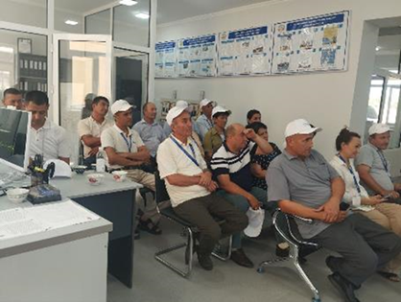 | 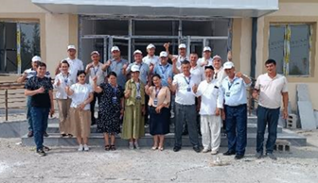
Participants from Karakalpakstan region to Bukhara region
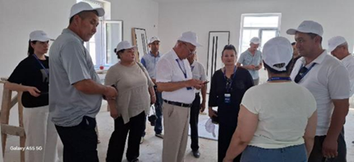 | 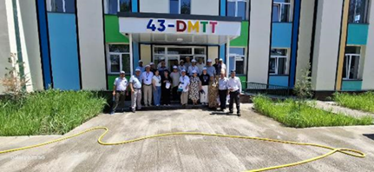
Participants from Bukhara region to Karakalpakstan region
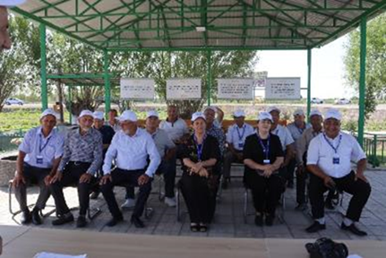 | 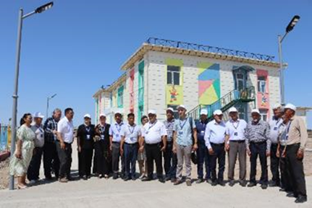
Participants from Navoiy region to the Khorezm region
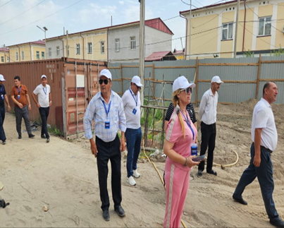 | 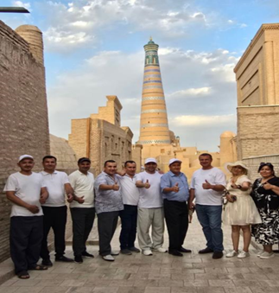

      - The contest among initiative group members was held to identify and reward the most proactive members in each project region. The competition aimed to encourage active participation, increase community engagement, and highlight the exceptional contributions made by members of the initiative group.

Photos of the result of the contest:
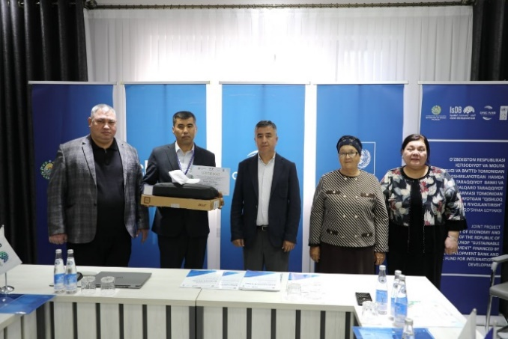  Karakalpakstan Republic | cccccccc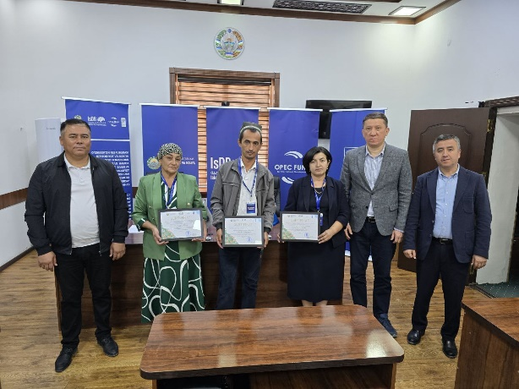  Bukhara Region
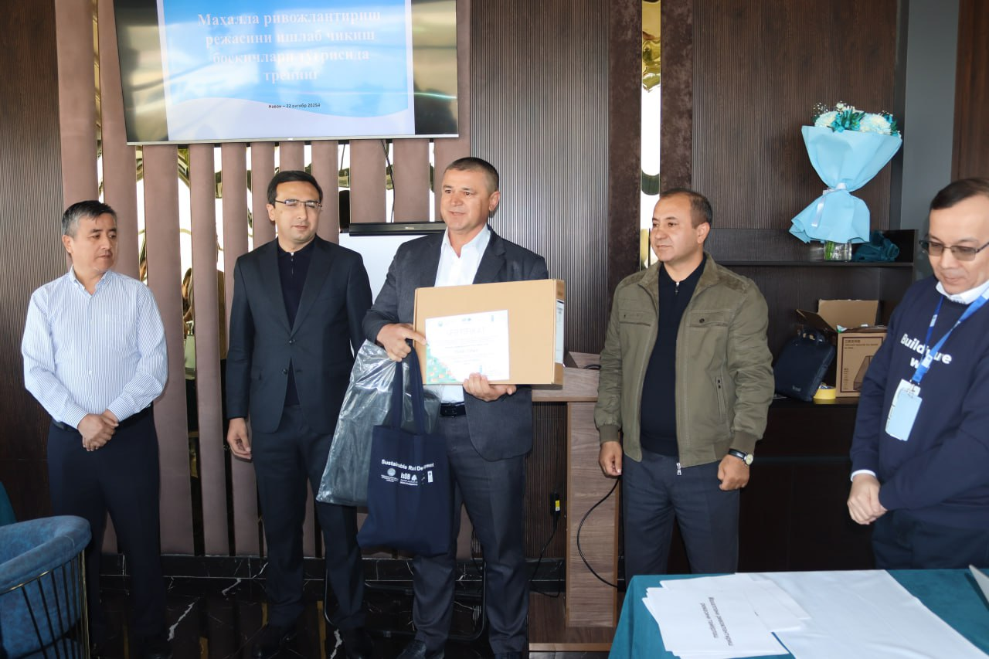  Navoiy Region | 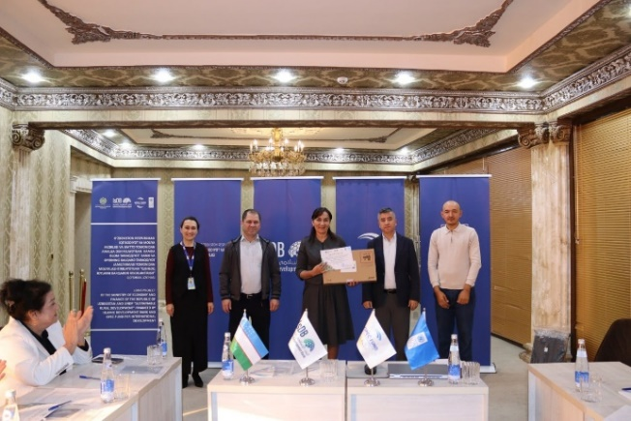  Khorezm Region

Outputs:
            - 45 representatives of IG members, mahalla committees, and project staff exchanged experiences during the local study tour (13 women and 32 men).
            - 50 members of the Initiative groups trained in the contest of “The Best IG member” with 35 men and 15 women. 12 contest winners were awarded.

Activity 1.3 Development and implementation of the gender responsive CDPs at the qishloq/community level (up to 170) relying on extensive and inclusive communities’ mobilization in targeted communities

Progress:
- CDP review process included several steps:
a) The list of Initiative Groups (IGs) members with a focus on forming gender-diverse IGs was revised and updated in a total of 170 mahallas (see Figures 1 & 2):
Figure 1 & 2. IG members updated list
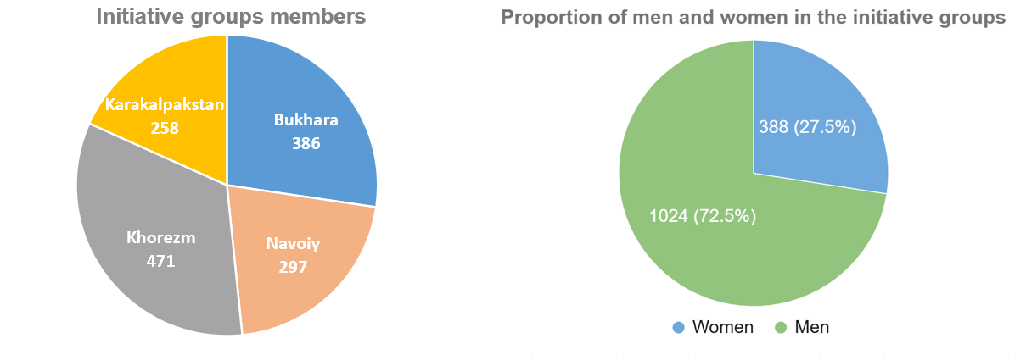

b) Technical verifications to verify the subprojects' status were conducted during May-June, 2025. As part of the Community Development Plan (CDP) review process, the project team developed detailed maps indicating the locations of subprojects across the target areas. The maps were created in KMZ format, allowing for easy visualization and analysis of subproject distribution through geographic information systems (GIS) platforms. See the following samples of the maps:

Photos of technical verification process:

Karakalpakstan region
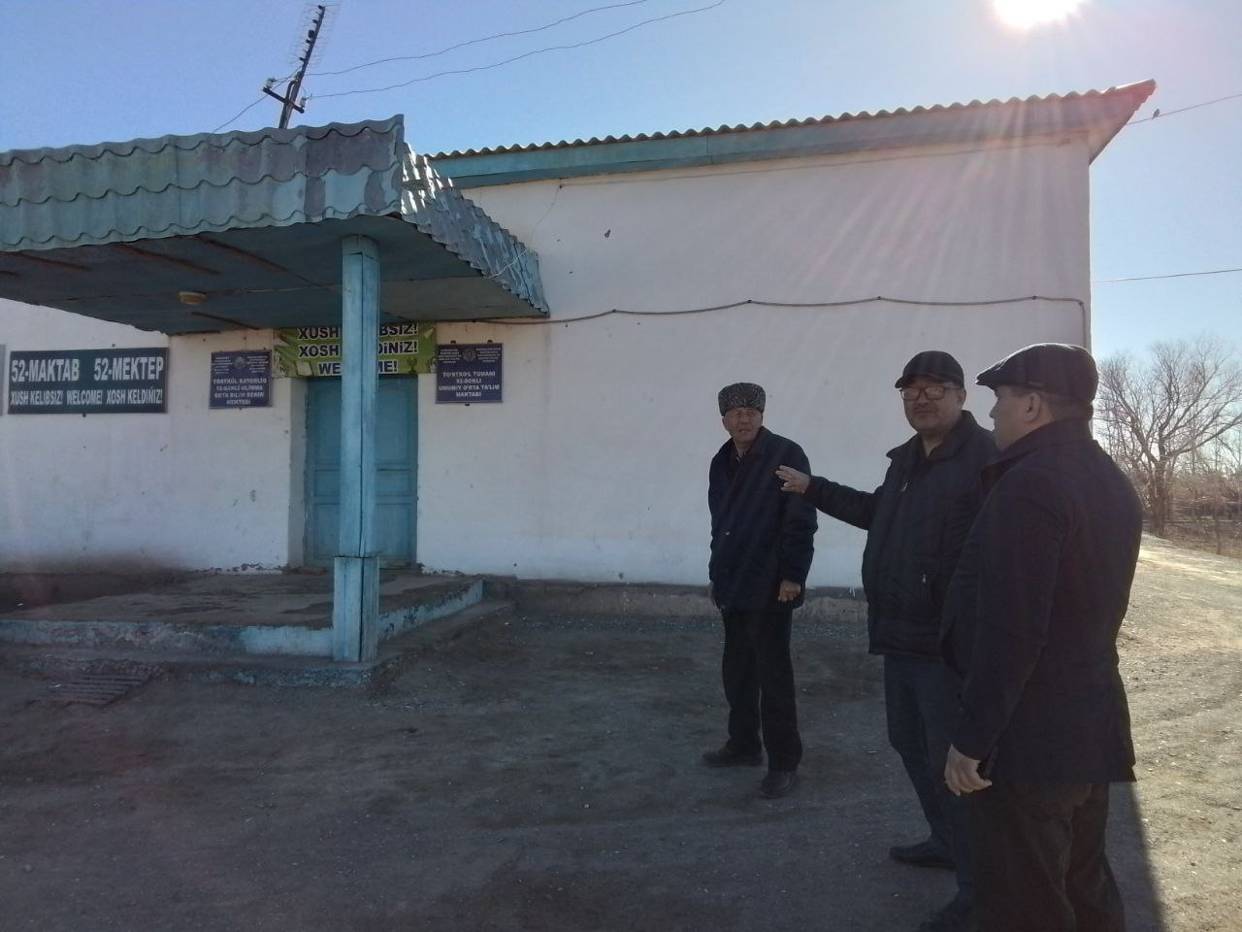Technical verification of reconstruction of the school No.52 at Otayurt community of Turtkul district, Karakalpakstan region | 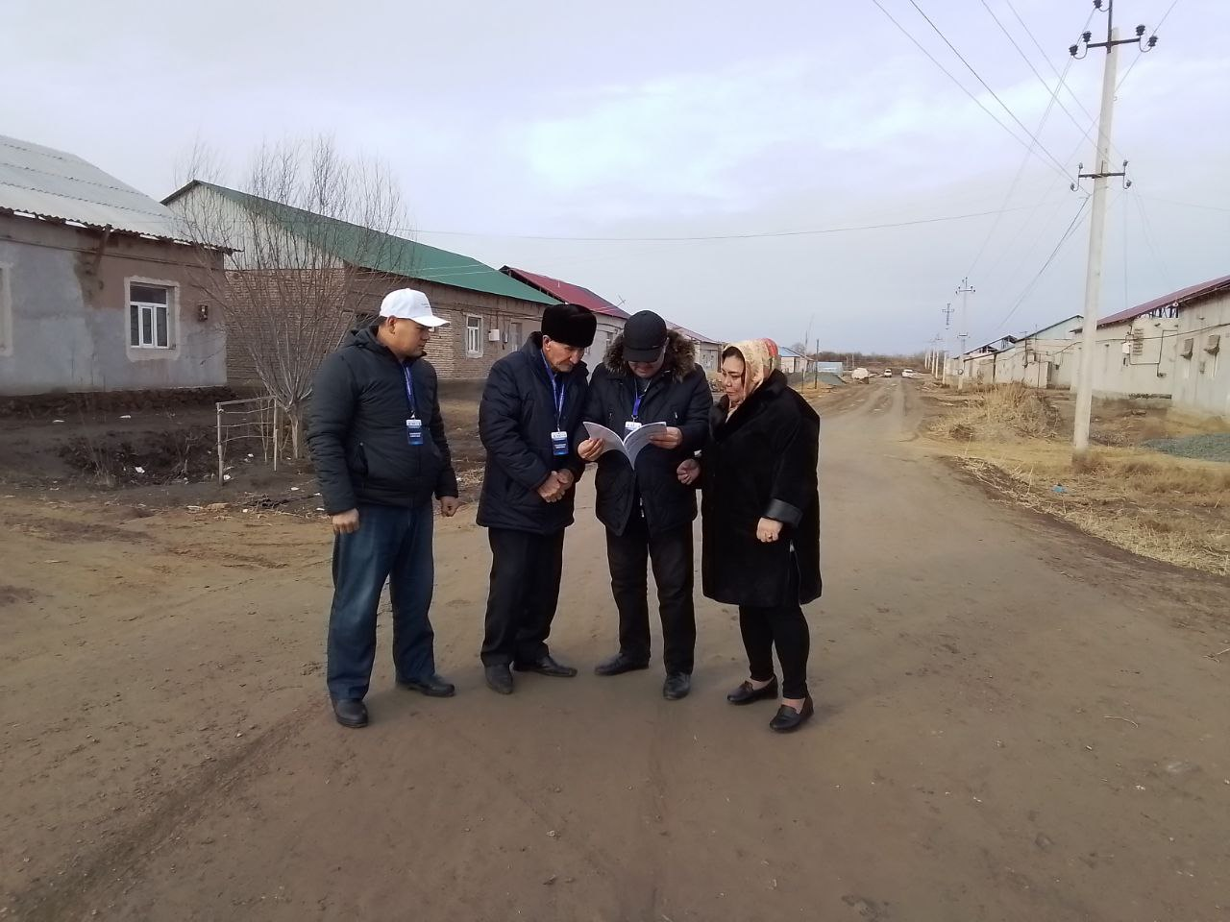Technical verification of Abad Yuli street of Kattagar community at Yuli Streetistrict, Karakalpakstan region
Khorezm region
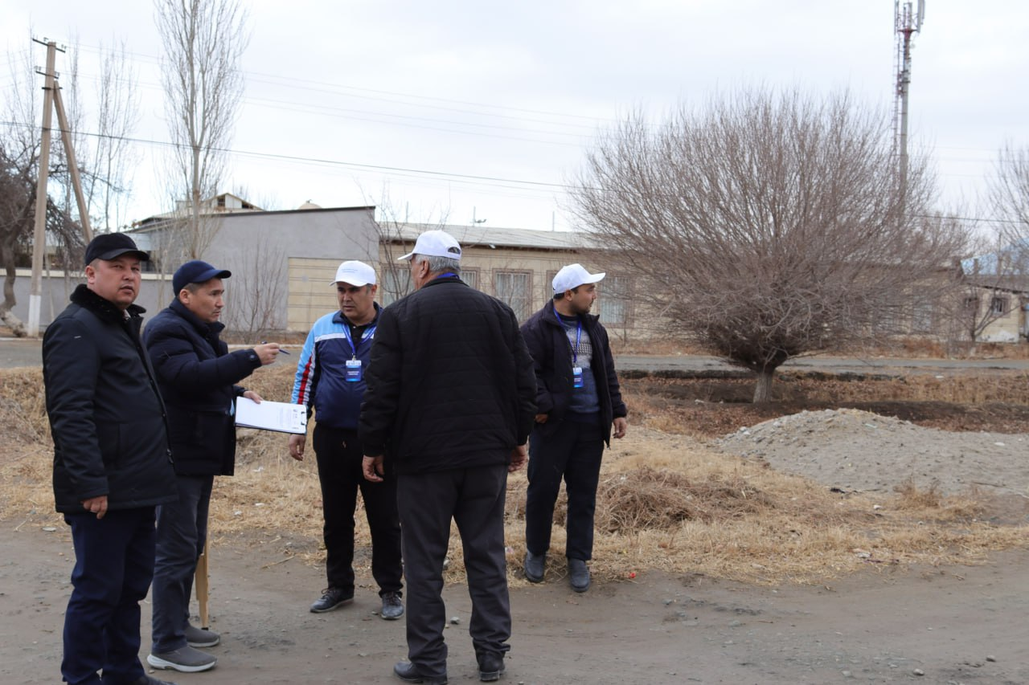Technical verification of pavement and night lighting at Avaz Utar street of Buston community at Khazorasp district, Khorezm region | 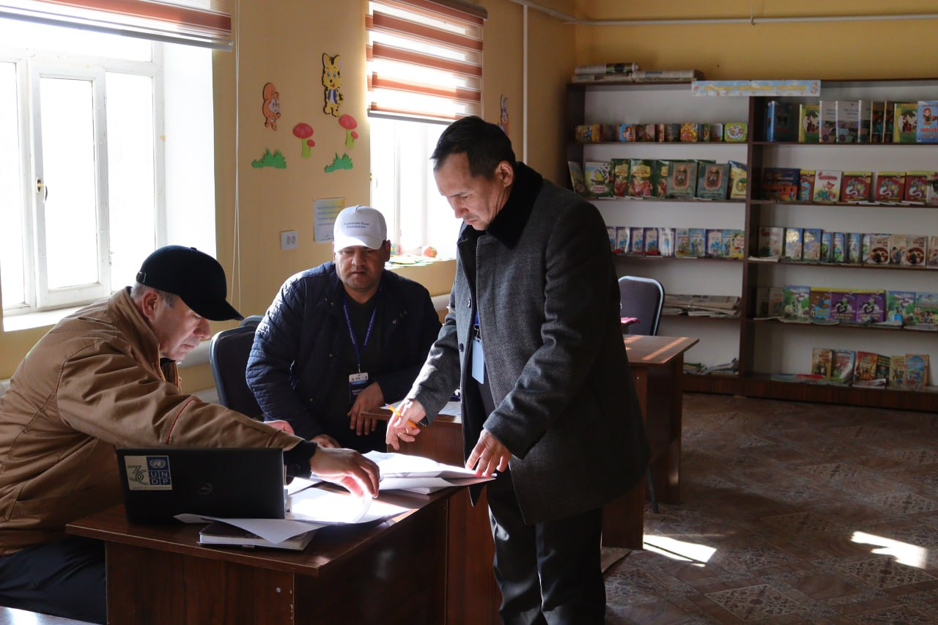Technical verification of reconstruction of the kindergarten No. 7 of Hilol community at Urganch district, Khorezm region
Bukhara region
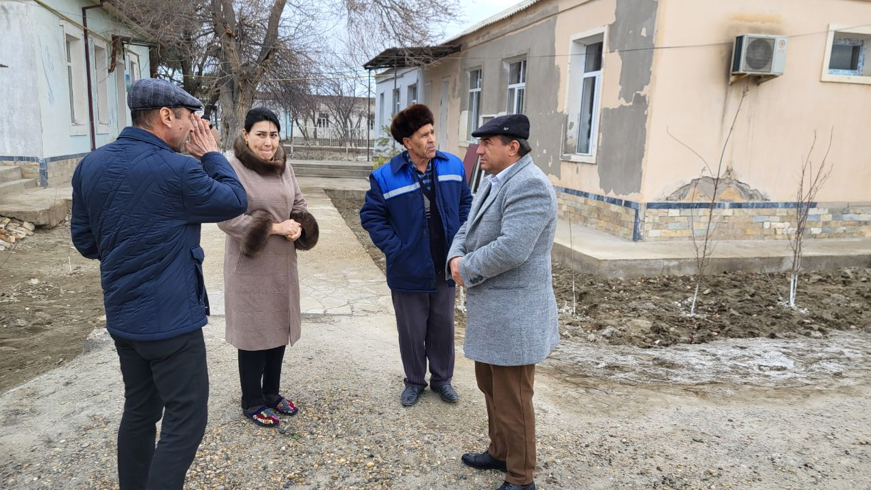Technical verification of reconstruction of kindergarten No. 20 of Rabotak community at Buhoro district, Bukhara region | 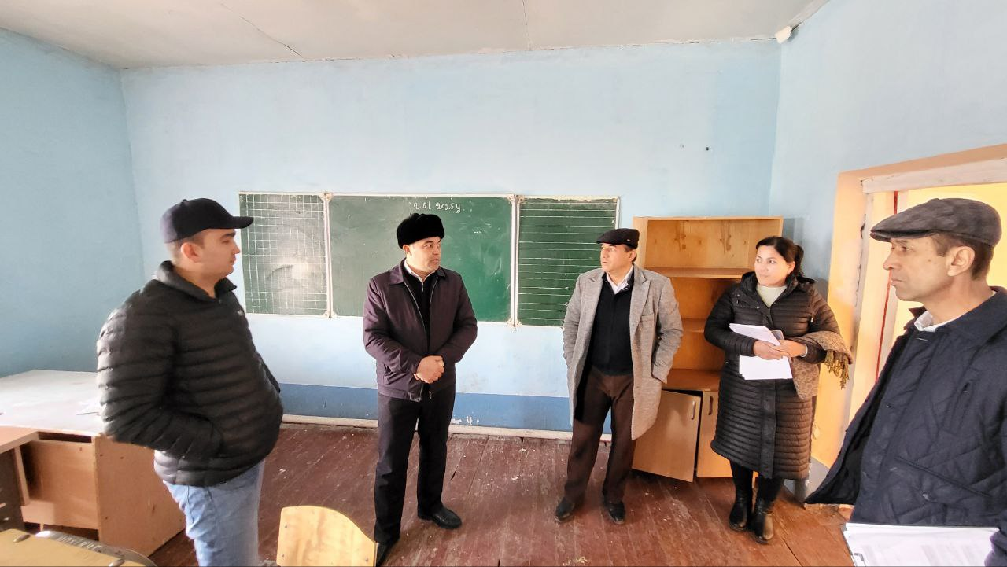Technical verification of reconstruction of school No. 43 of Novmetan community at Buhoro district, Bukhara region
Navoiy region
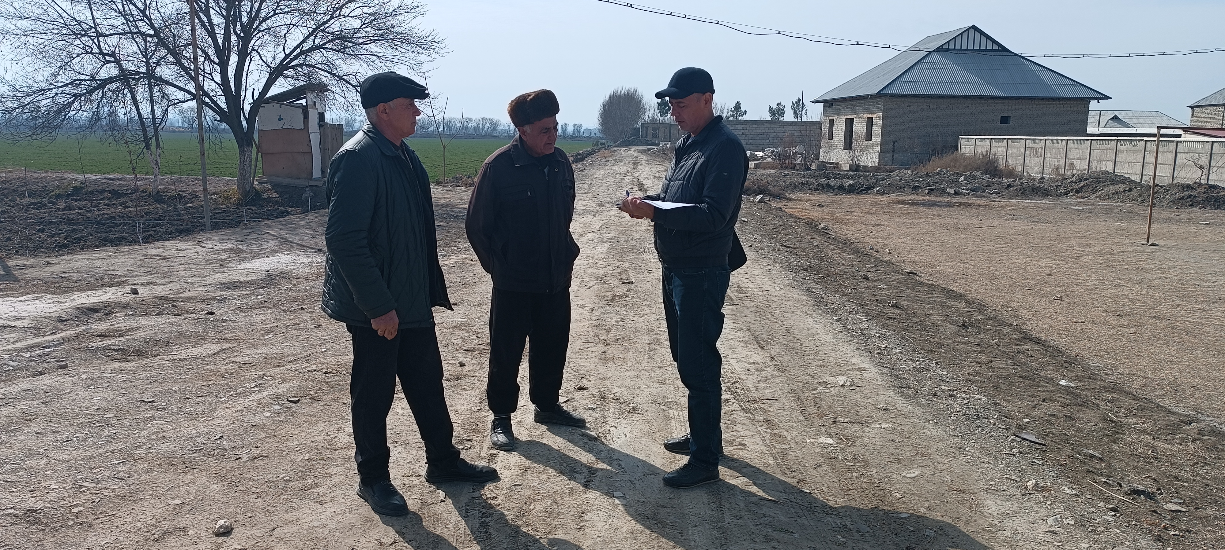  Technical verification of alphalt paving of Arabhona community at Navbahor district, Navoiy region | 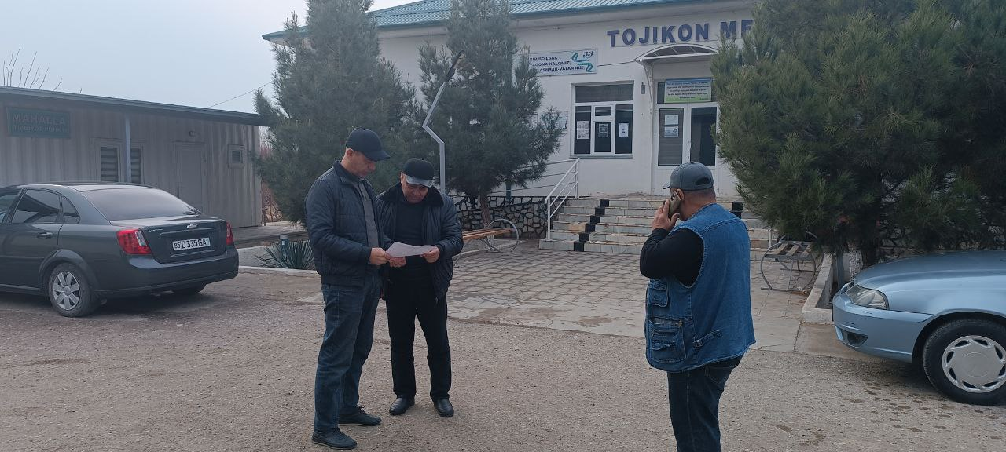Technical verification of the provision of drinking water supply system of Tojikon community at Qiziltepa district, Navoiy region

Map 1. Bukhara region  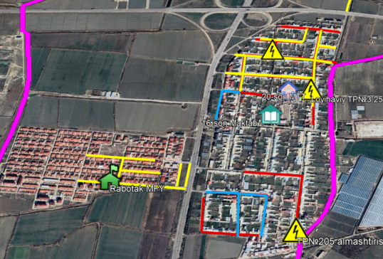 | Map 2. Karakalpakstan  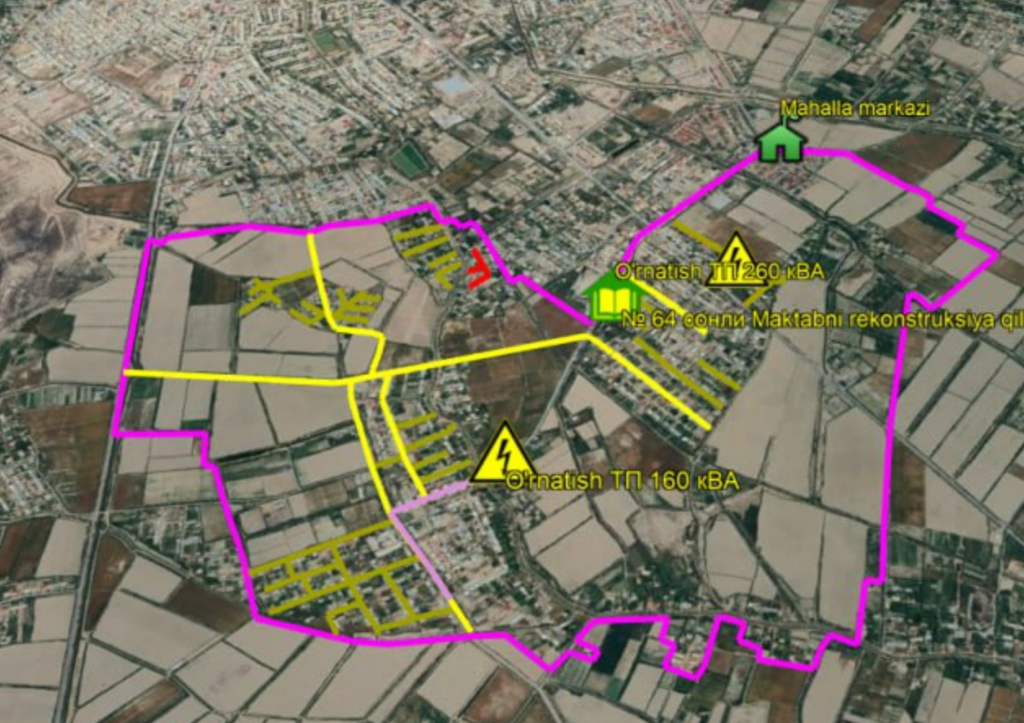
Map 3. Khorezm region  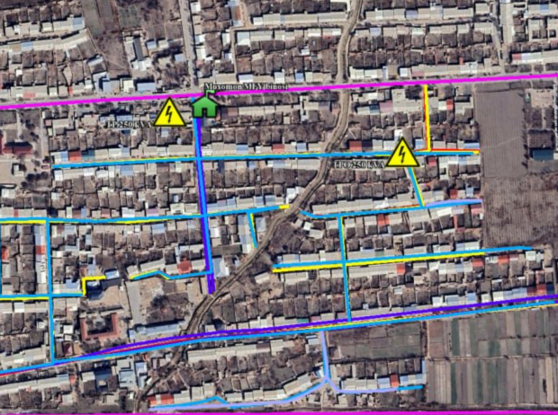 | Map 4. Navoiy region  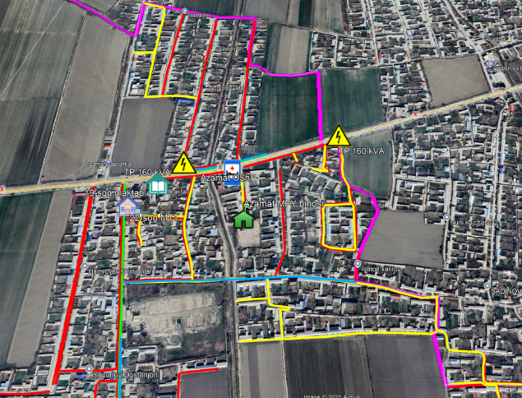

c) 40 Cluster CDP reviews were completed and prepared in Uzbek and Russian languages in 4 pilot regions:
- In Karakalpakstan: in total, 46 communities were engaged
- In Khorezm, in total, 49 communities were engaged
- In Navoiy, in total, 34 communities were engaged
- In Bukhara, in total, 41 communities were engaged

- The project team conducts monitoring visits to oversee the process of the construction work of the subprojects. Together with the IG members, they conduct monitoring of the socio-economic impact of the construction work process on the community. Refer to Tables 1 and 2 to see the status of subprojects' construction and the problems within the exact categories identified during subprojects monitoring visits.
Table 1. Subprojects construction status*
# | Region | Subprojects | Tender process did not  start | Tender  in process | Construction in process | Construction completed
1 | Karakalpakstan | 229 | 11 | 184 | 6 | 28
2 | Khorezm | 208 | 0 | 135 | 67 | 6
3 | Bukhara | 272 | 1 | 131 | 131 | 9
4 | Navoi | 169 | 0 | 95 | 64 | 10
TOTAL |  | 878* | 12 | 545 | 268 | 53
*Status update as of November 21, 2025
**Removed subprojects are provided in Table 2

Table 2. List of removed subprojects
Region | Subproject name | Comment
Karakalpakstan | Obihayot MCC, water supply system | ADB funded
Khorezm | Yuqoriovul MCC, capital repairment of the school No. 8 | PIU rejected the subproject
Khorezm | Yuqoriovul MCC, reconstruction of the bridge | PIU rejected the subproject
Khorezm | Hunarmand MCC, reconstruction of the bridge | PIU rejected the subproject
Khorezm | Yangi qadam MCC, reconstruction of the school No. 44 | PIU rejected the subproject
Khorezm | Madaniyat MCC, construction of sidewalk | IG rejected the subproject
Khorezm | Navruz MCC, reconstruction of the school No. 48 | PIU rejected the subproject
Khorezm | Pahlavovnlar MCC, construction of a pedestrian bridge | PIU rejected the subproject
Khorezm | Ziyokor MCC, reconstuction of school No. 19 | PIU rejected the subproject
Bukhara | Bobohaydar MCC, Improvement of the irrigation system | IG rejected the subproject
Bukhara | Jovgari MCC, Improvement of the irrigation system | IG rejected the subproject
Bukhara | Labirut MCC, Improvement of the irrigation system | IG rejected the subproject
Bukhara | Gajdumak MCC, Building a business center | IG rejected the subproject
Navoiy | Tojikon MCC, Building a drainage collector | IG rejected the subproject
Navoiy | Gulobod MCC, Major renovation of kindergarten 4 | IG rejected the subproject
Navoiy | Navbahor MCC, Building a business center | IG rejected the subproject.
Navoiy | Arabhona MCC, Improvement of the irrigation system | IG rejected the subproject
Navoiy | Navbahor MCC, Water supply system construction | IG rejected the subproject

- The project team conducted on-the-job training on M&E and guided IG members while conducting monitoring visits and filling in the checklists. The visit was paid to both subprojects where the construction work is undertaken and those where construction has been completed and the sites handed over for use. The monitoring covered key socio-environmental and safety aspects of the construction sites, including the presence and condition of information boards, installation of temporary barriers and traffic signs, availability of security guards, and compliance with environmental and social mitigation measures. It also assessed adherence to dust control during transportation, sanitation and hygiene practices, provision of safety information to workers and communities, air-quality and dust-control measures, waste-management compliance, and overall traffic-management arrangements. These checks ensured that construction activities did not negatively impact community safety, health, or daily livelihoods. Monitoring from February to October 2025 shows a clear decline in socio-environmental issues as construction progressed. Most recurring problems involved missing barriers and signage, a lack of security guards, and inconsistent environmental and social mitigation practices. Improvements were noted in dust control, waste management, and information display, reflecting stronger contractor compliance.

Photos of subprojects monitoring by IGs and project team:
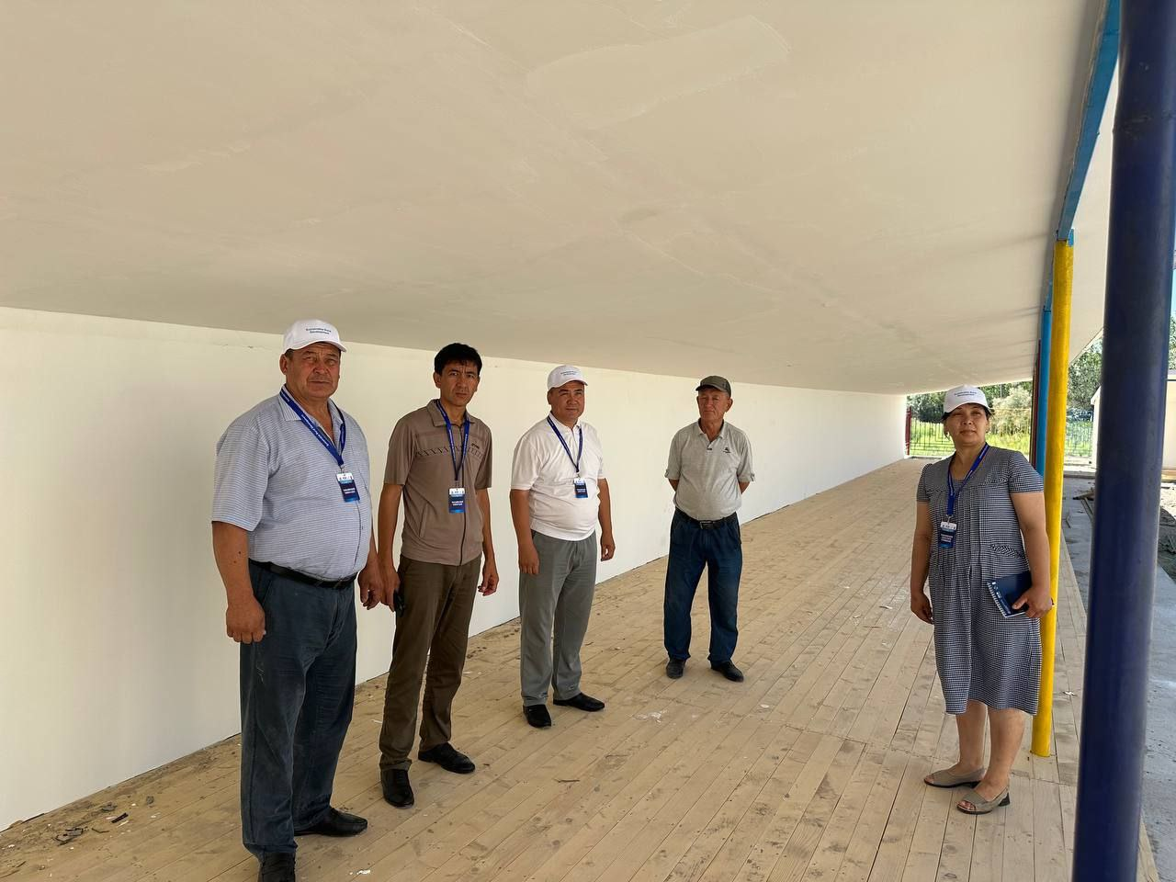  Construction of Kindergarden, Arna buyi MCC, Amudarya district, Karakalpakstan | 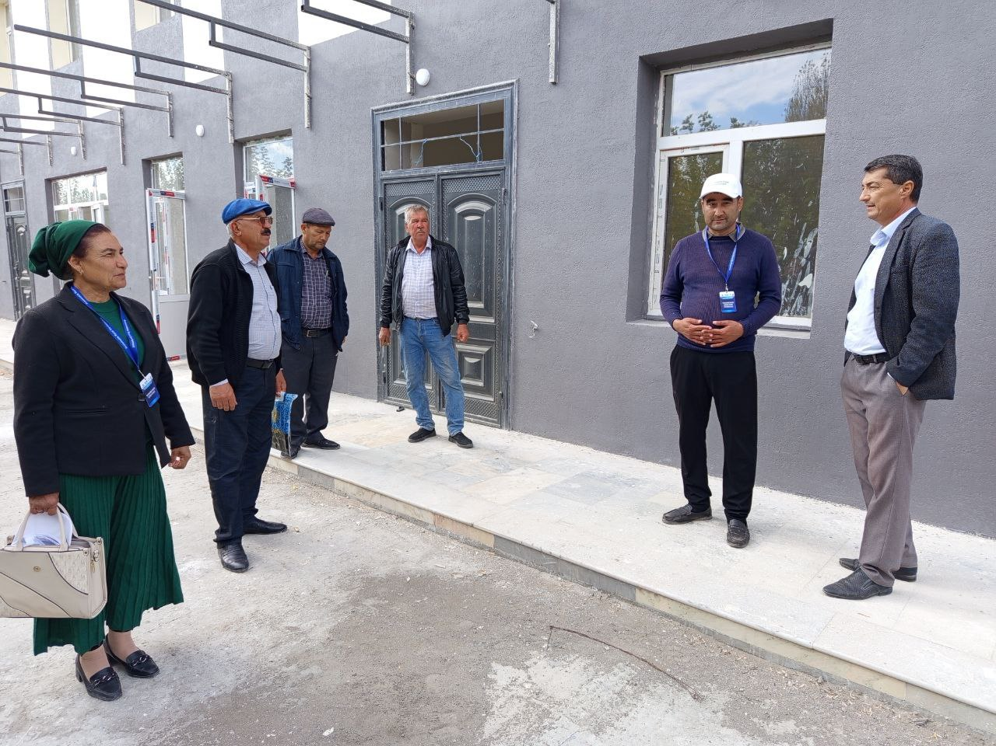  Construction of Community Center, Otayurt MCC, Turrkul district, Karakalpakstan
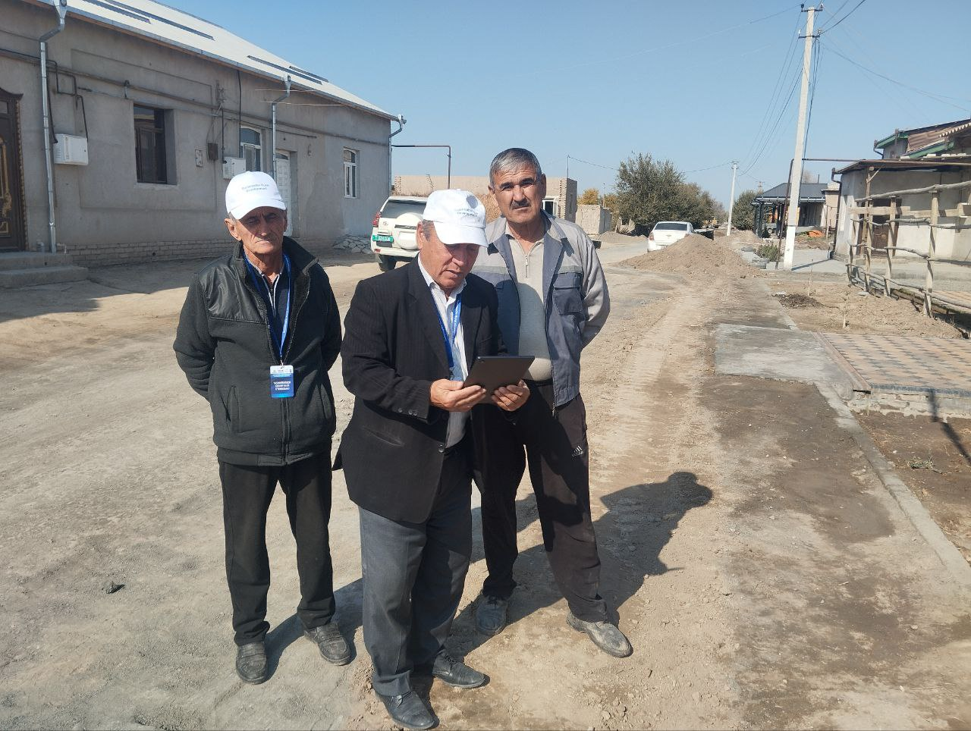  Water supply system construction, Boston MCC, Yangibozor district, Khorezm | 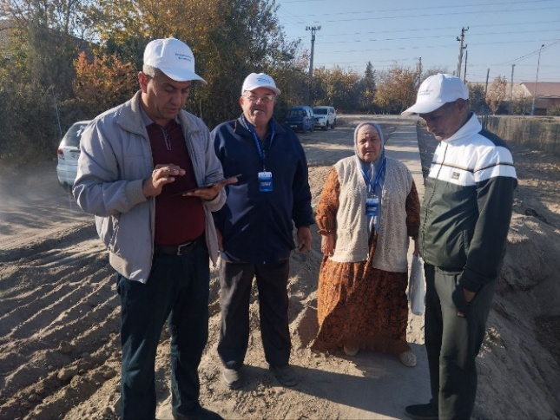Water supply system construction, Pahlavonlar MCC, Khanqa district, Khorezm
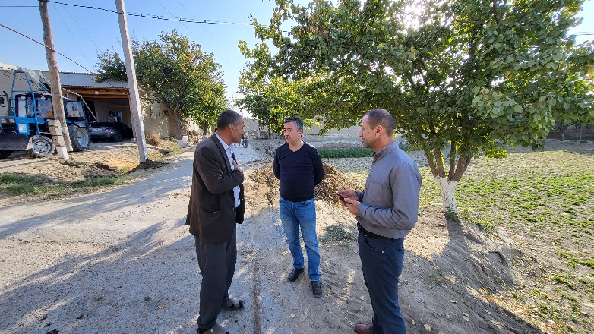  Construction of water pipeline, Tezguzar MCC, Shafirkan district, Bukhara | 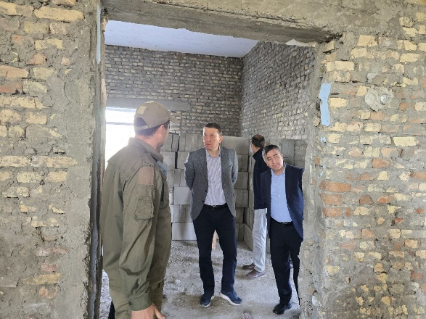  Reconstruction of school #50, Rabotak MCC, Bukhara district, Bukhara
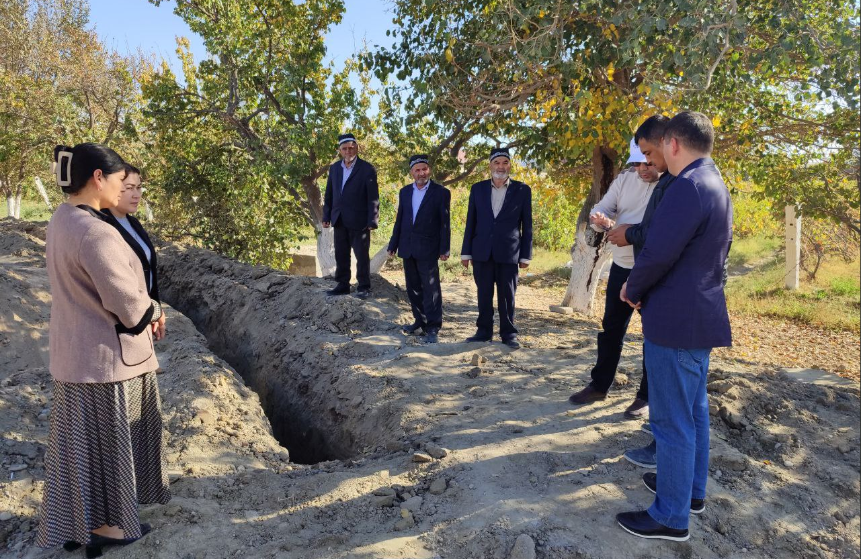  Water supply system construction, Paxtaobod MCC, Kiziltepa district, Navoiy | 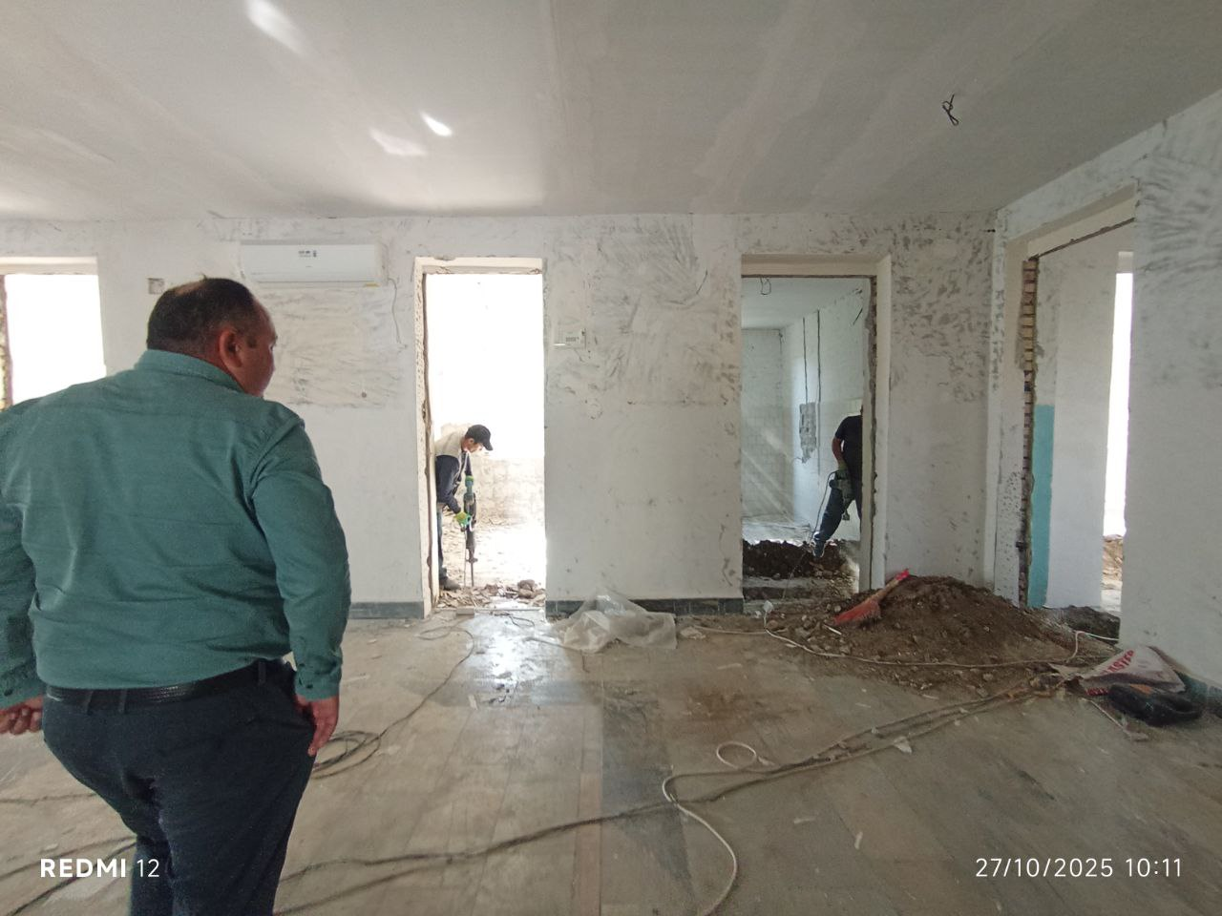  Medical point, Azamat MCC,  Karmana district, Navoiy

- Opening ceremonies were organized in pilot regions:
Photos of the ceremonies:
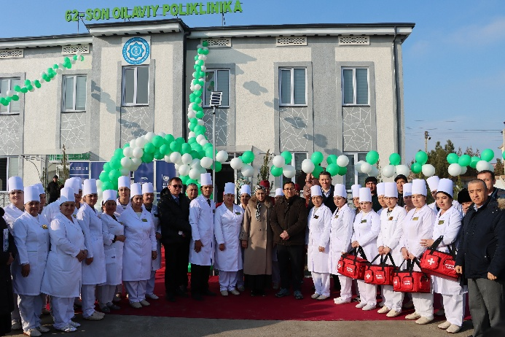  Gajdumak MCC, Bukhara |  | 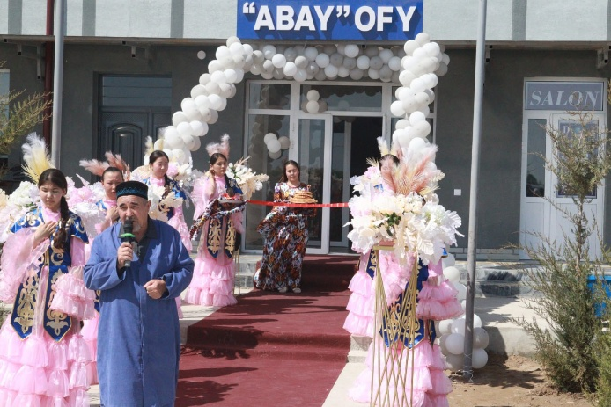  Abay MCC, Beruni district, Karakalpakstan
 | 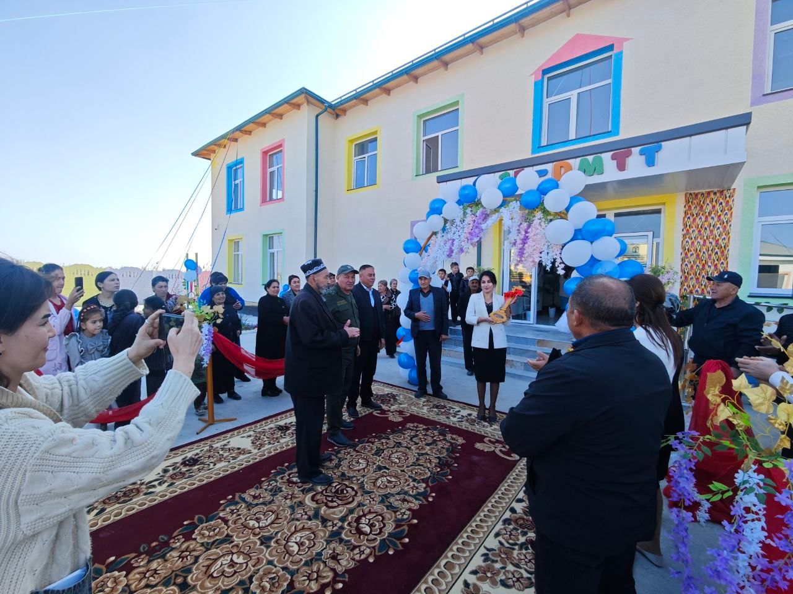Shanba MCC, Vabkent district, Bukhara | 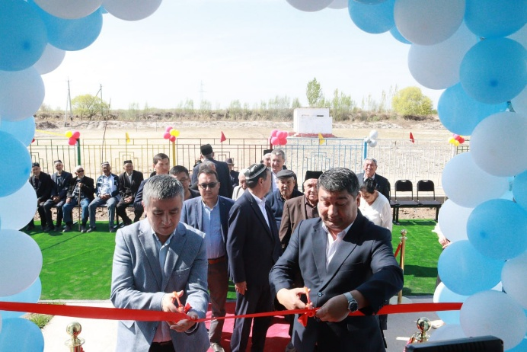Kindergarten, Shimom district, Karakalpakstan

- Training on Effective Agriculture and Rural Economy in the 4 project regions was conducted.

Table 3: Effective Agriculture and Rural Economy training participants
Region | Total participants | Men | Women
Karakalpakstan | 271 | 180 | 91
Khorezm | 204 | 141 | 63
Bukhara | 185 | 122 | 63
Navoi | 175 | 128 | 47
Total | 835 | 571 (68%) | 264 (31%)

Photos of the training:

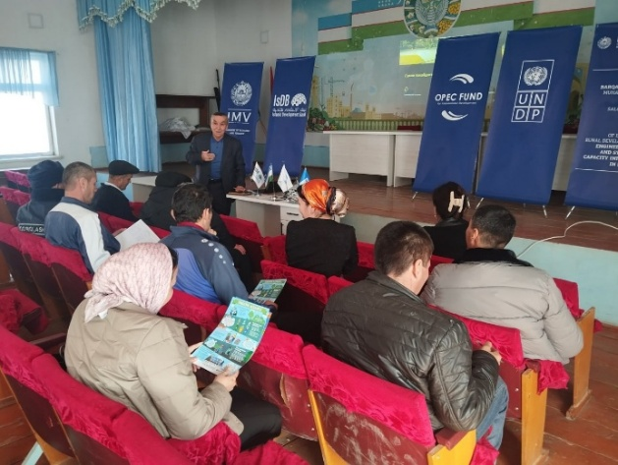 | 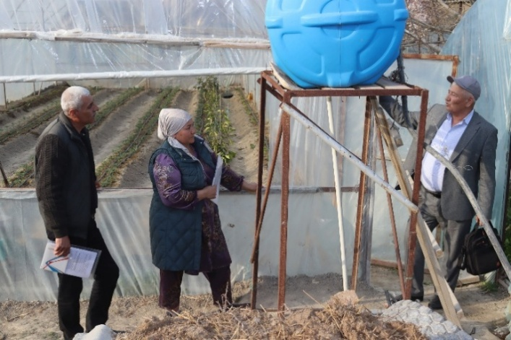
Khorezm, Bagat district, Uzumzor MCC | Bukhara, Bukhara district, Amirobod-guliston MCC
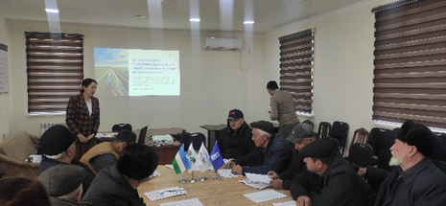 | 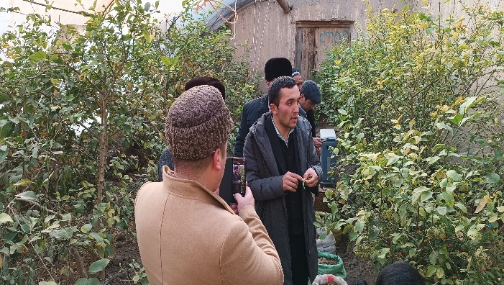
Karakalpakstan, Turtkul district, Kuna Turtkul MCC | Navoi, Karmana district, Dustlik MCC

Outputs:
      - The new updated list of IG members includes 1412 people, with 388 women and 1014 men.
      - 40 Cluster CDPs revised. 1413 participants took part in the revision of the cluster 40 cluster CDPs
      - 835 rural people trained in the training on Effective Agriculture and Rural Economy, including 571 men and 264 women

Activity 1.4 Facilitate the institutionalization of the CDPs at the district administration level (inclusion of the CDP priorities and monitoring systems for CDPs into the district development plans of the government), including through engaging the locally selected deputies:
Progress:
            - Vobkent District Development Plan (Bukhara region) has been developed and presented to local khokimiyat and line ministries on April 23, 2025. District Development Plan defined specific goals and objectives for creating new economic opportunities, reducing poverty, improving the quality of life and improving infrastructure. The plan is aimed at comprehensively improving the quality of life of the local population, ensuring sustainable socio-economic growth, modernizing infrastructure and developing key sectors of the economy. The plan identified the list of 33 priority projects of the Vabkent district with estimated cost of 417.3 billion UZS.

Photos of the Vabkent Development Plan presentation:
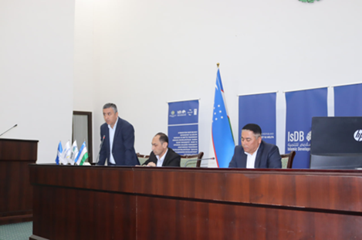 | 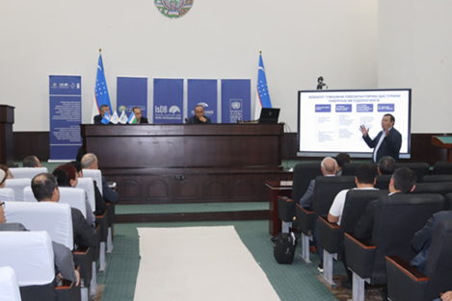
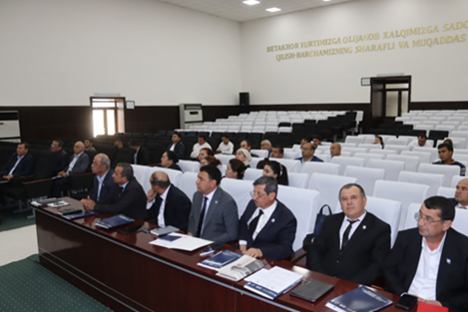 | 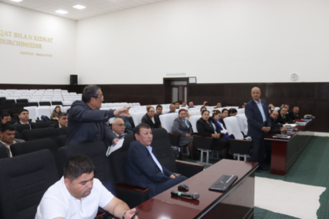

            - CDP review presentations to 20 working groups at district khokimiyats have been conducted on August 5-22 by the project team and IG members.
Photos of CDP presentations to district khokimiyats:
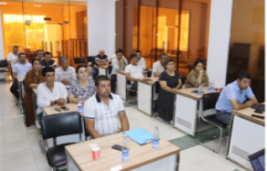  Bukhara district, Bukhara region | 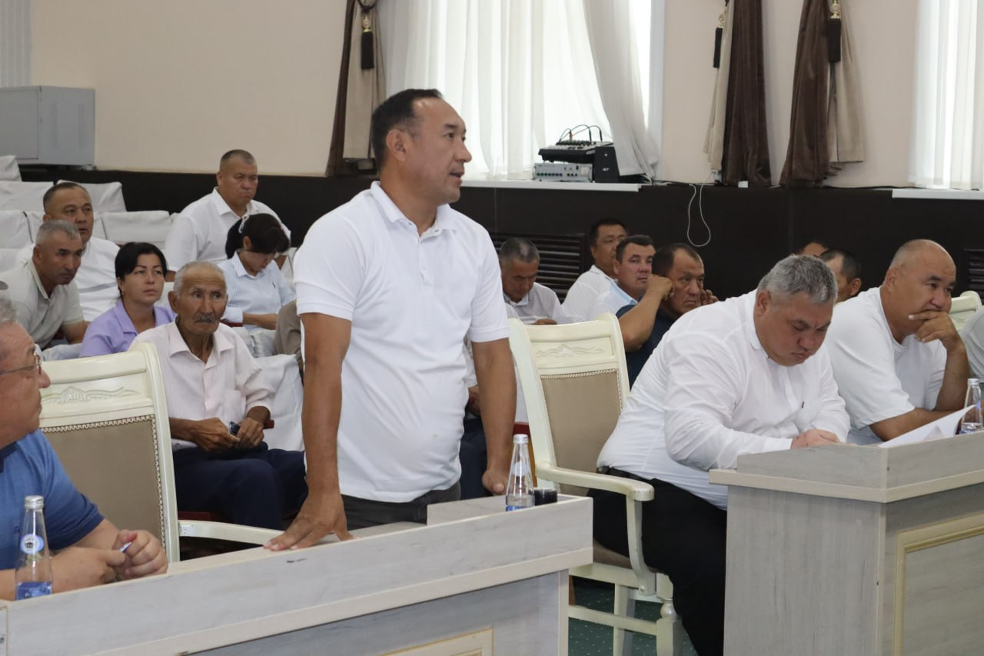  Ellikqala district, Karakalpakstan
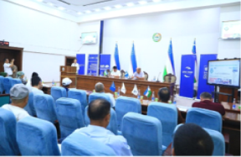  Gurlen district, Khorezm region | 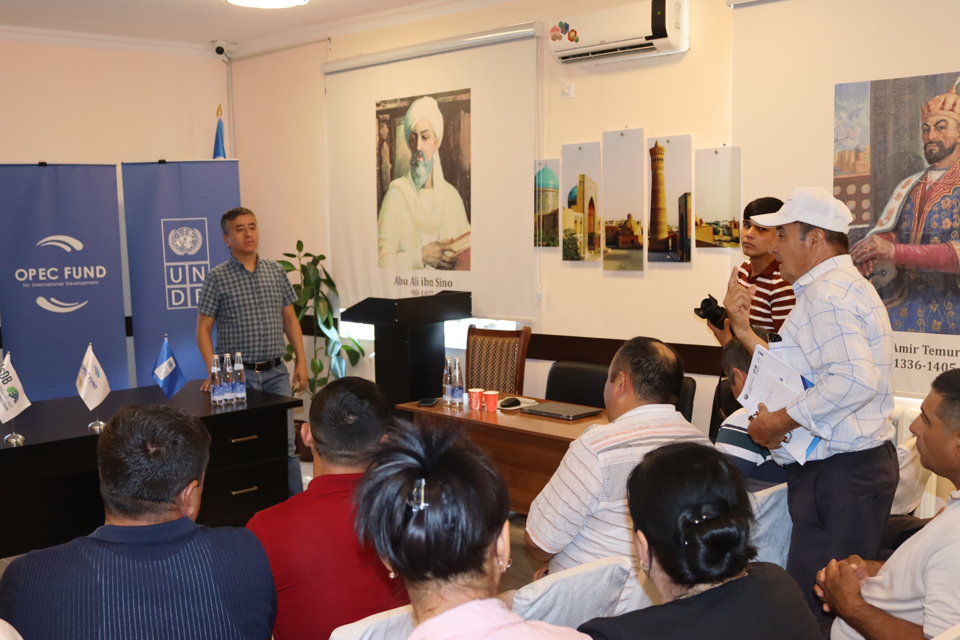  Navbakhor district, Navoiy region
            - Round table discussion conducted to present the functional analysis findings, highlighting the strengths, weaknesses and development potential of mahalla committees. Collaborative directions with key partners identified and agreed on coordination and further development the mahallas.
Photos of the round table:
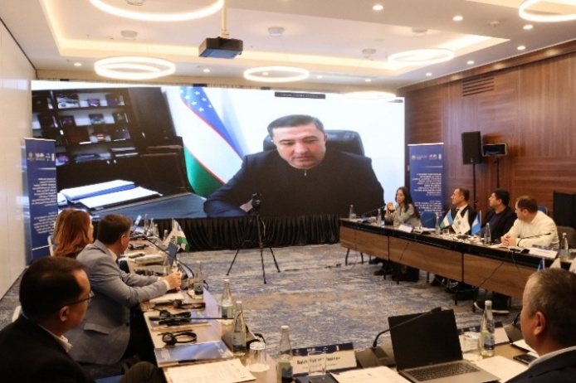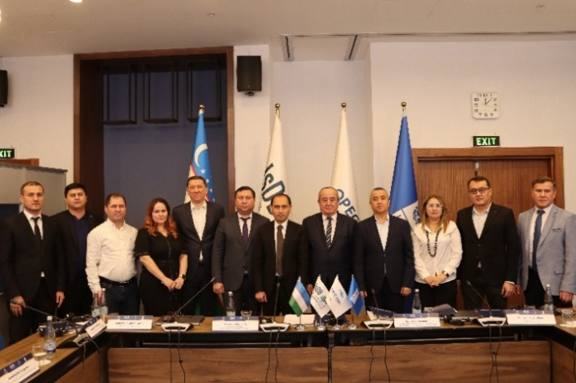
Outputs:
- Local Development Plan of Vobkent district of Bukhara region.
- 43 participants attended the Vobkent District Development Plan presentation
- CDPs presentations to 20 working groups (khokimiyats) - 684 people (85 women, 599 men)
- Karakalpakstan: 233 (32 women, 201 men)
- Khorezm: 200 (28 women, 172 men)
- Bukhara: 123 (14 women, 109 men)
- Navoiy: 128 (11 women, 117 men)
- 21 people participated in the round table in Functional analysis (3 women, 18 men).

Activity 1.5 Identification/verification of target communities (around 200 communities) for the 2nd stage of the IsDB Program, from the Samarkand, Kashkadarya and Surkhandarya regions
Activity completed
Activity 1.6 Organization of workshops with community participation (around 1500) and development of around 200 cluster based CDPs.
Activity completed

PROGRESS OF ACTIVITY 2
Capacities of local architecture-design institutions and regional departments of architecture and construction are enhanced for development of improved engineering designs and master plans that are responsive to the sustainability aspects (economic, operational, and environment sustainability), innovative energy and water efficient, low carbon technology, climate resilient and gender responsive, and promoting local resources.
Activity 2.1 Research on adverse impact of the ecological disaster and environment degradation on agriculture and rural population and identification of locally relevant sustainable environmentally friendly solutions
Activity completed

Activity 2.2 Building capacity of local architects/engineers by promoting innovative solutions aimed at energy and water saving, reducing CO2 emission for climate resilient planning, with focus on local agriculture and social infrastructure with particular focus on different needs of concerned groups, including women, youth, people living in poverty and people with disabilities.
Progress:
- Master Plan for Buston community in Khozarasp district was developed to enhance the capacity of local architects/engineers in local governments by promoting innovative solutions, climate-resilient planning, and a focus on rural basic infrastructure, as well as agricultural and social infrastructure. The Buston mahalla in the Khozaraspi district of the Khorezm region was selected for the development of a sustainable: а) Master plan for an area of 300.0 hectares (m. Buston); b) Detailed planning project for the central part of the Buston mahalla on an area of 50.0 hectares.
- Master Plan for the Buston community in Khazorasp district khokimiyat was presented on June 11th. More than 30 representatives of local government in Khorezm region and Khazorasp district khokimiyats, architects/engineers, as well as Buston community activists took part in the event.
Photos of the Master Plan presentation:
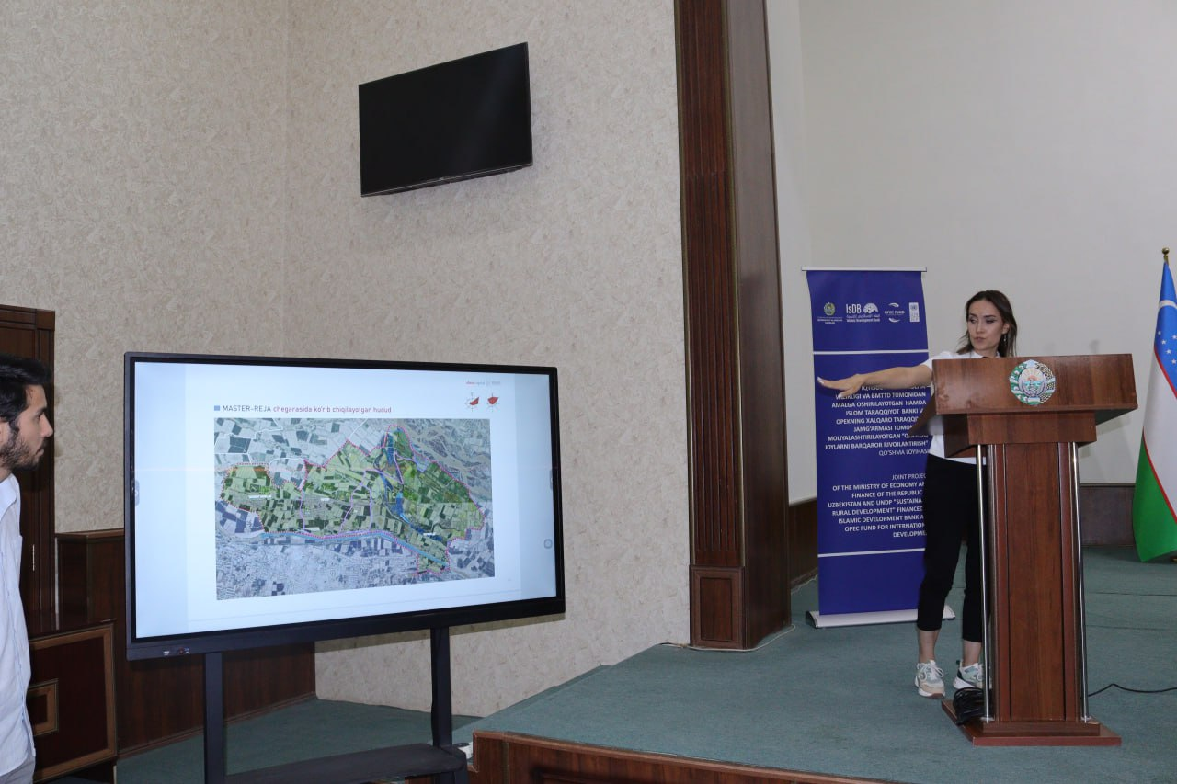 | 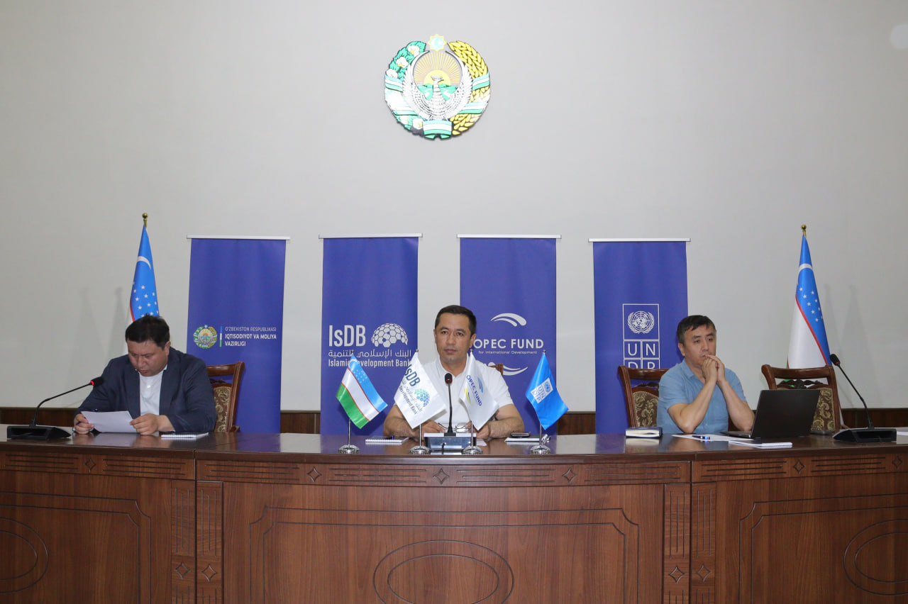 | 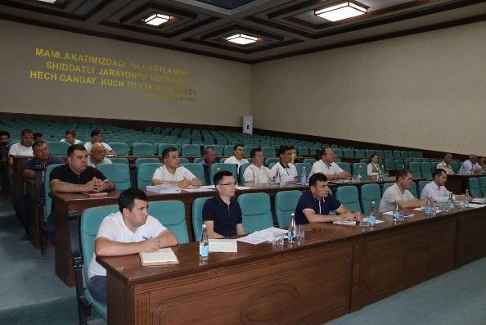

- Master-class training on the Development and implementation of a regional master plan has been conducted for Khorezm region architects and cadastral specialists on June 11, 2025
Photos of Master class:
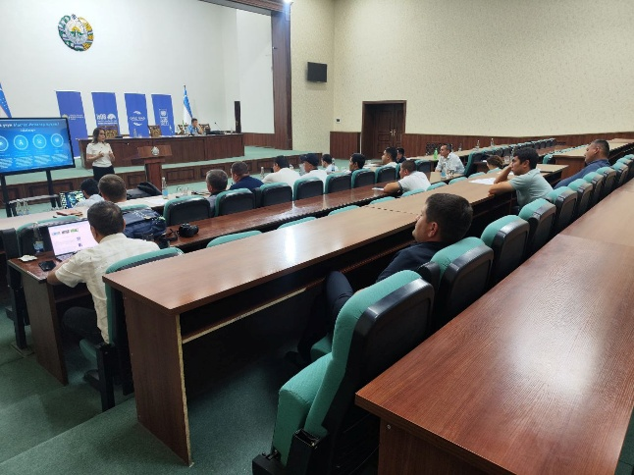 | 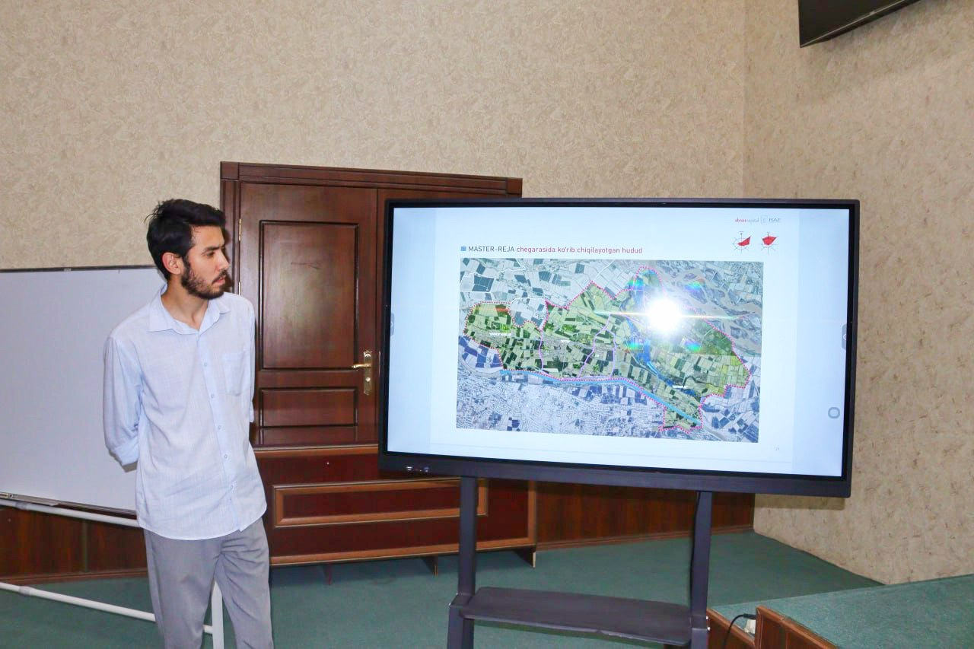

- Master Plan Manual development. To continue strengthening the capacity of cadastral and architectural specialists, the project engaged an Individual Consultant to develop a practical Manual on preparing master plans in accordance with the existing legislative framework and tailored to the needs of these specialists.
- Master Plan Development training in four pilot regions has been conducted In November 24-28, 2025. The training, incorporating international best practices, success and failure case studies from local practitioners in master plan development aims at discussing the current procedures and regulatory frameworks for master planning in Uzbekistan.
Photos of the training:
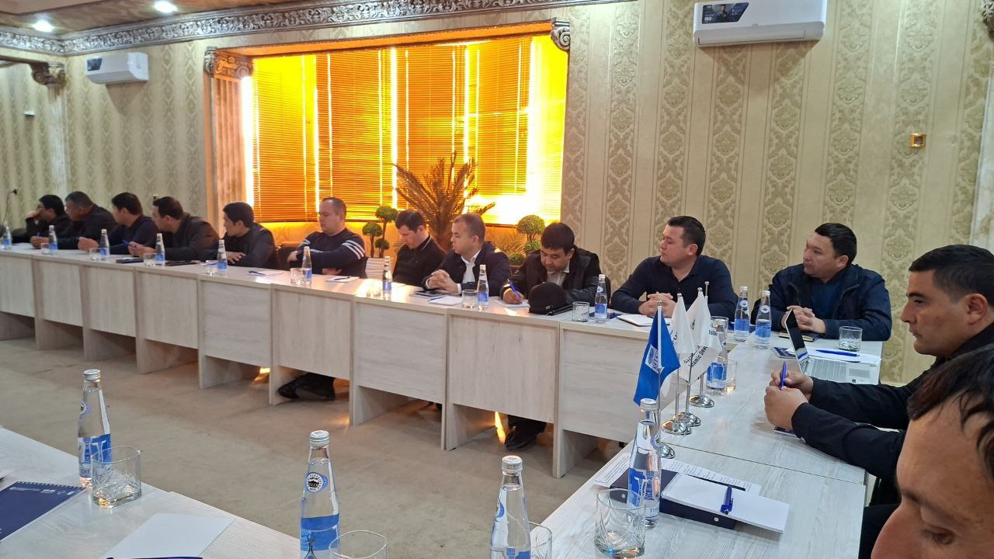  Khorezm | 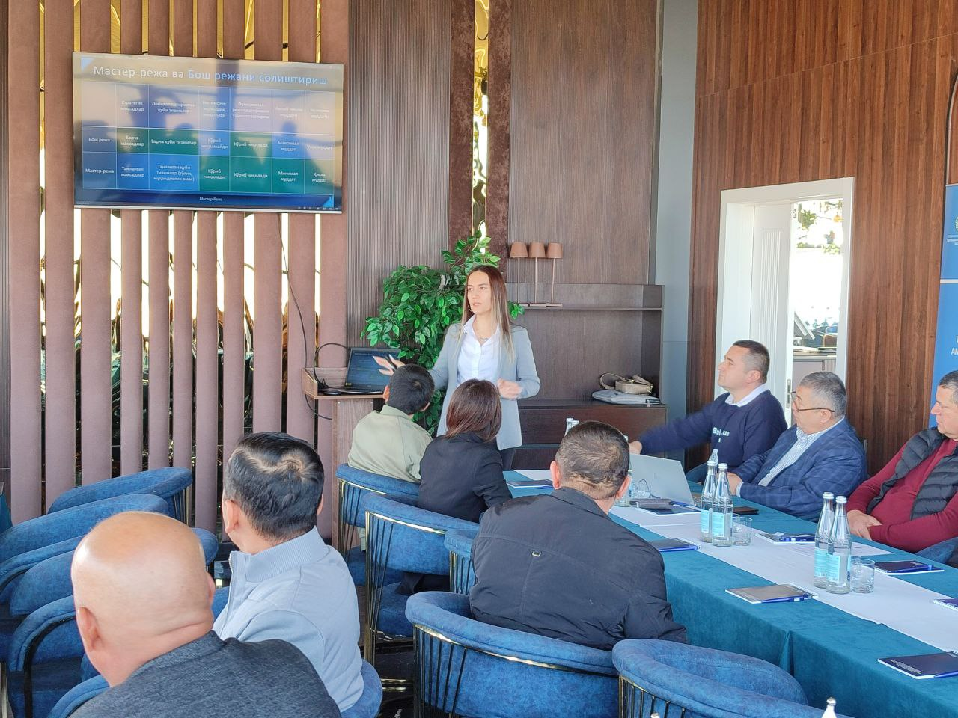  Navoiy
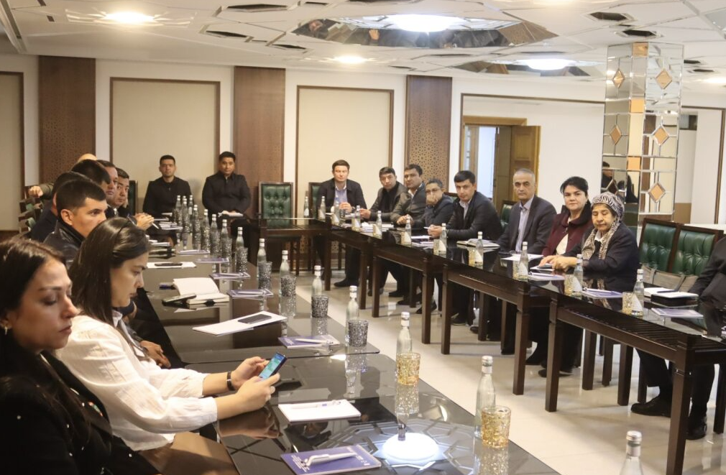  Bukhara | 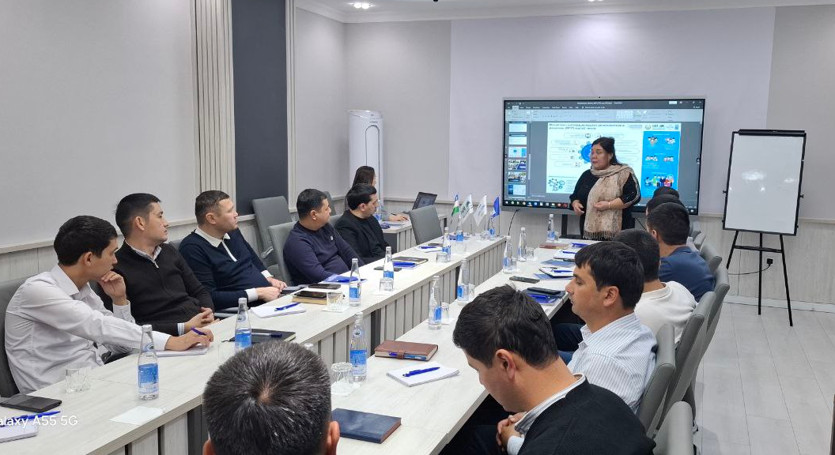Karakalpakstan

- Smart Drip Irrigation training was conducted in the Navoi region on 30–31 October to strengthen the capacity of farmers and local authorities in applying innovative, water- and energy-efficient agricultural practices. It is a two-day training, which consisted of two parts: a theoretical component, which introduced participants to the principles, tools, techniques, and benefits of smart drip irrigation for climate-resilient agriculture; and a practical component, conducted on the second day. Based on the agreement between the UNDP project and GIZ, participants carried out hands-on exercises at a field site where GIZ had installed a fully operational smart drip irrigation system. This allowed trainees to observe the system in practice and gain practical skills in its use and maintenance. Participants included farmers and representatives of the regional offices of the Ministry of Agriculture, the Ministry of Water Management, and the Association of Dekhkans and Farmers.
Photos of Smart Drip Irrigation training:
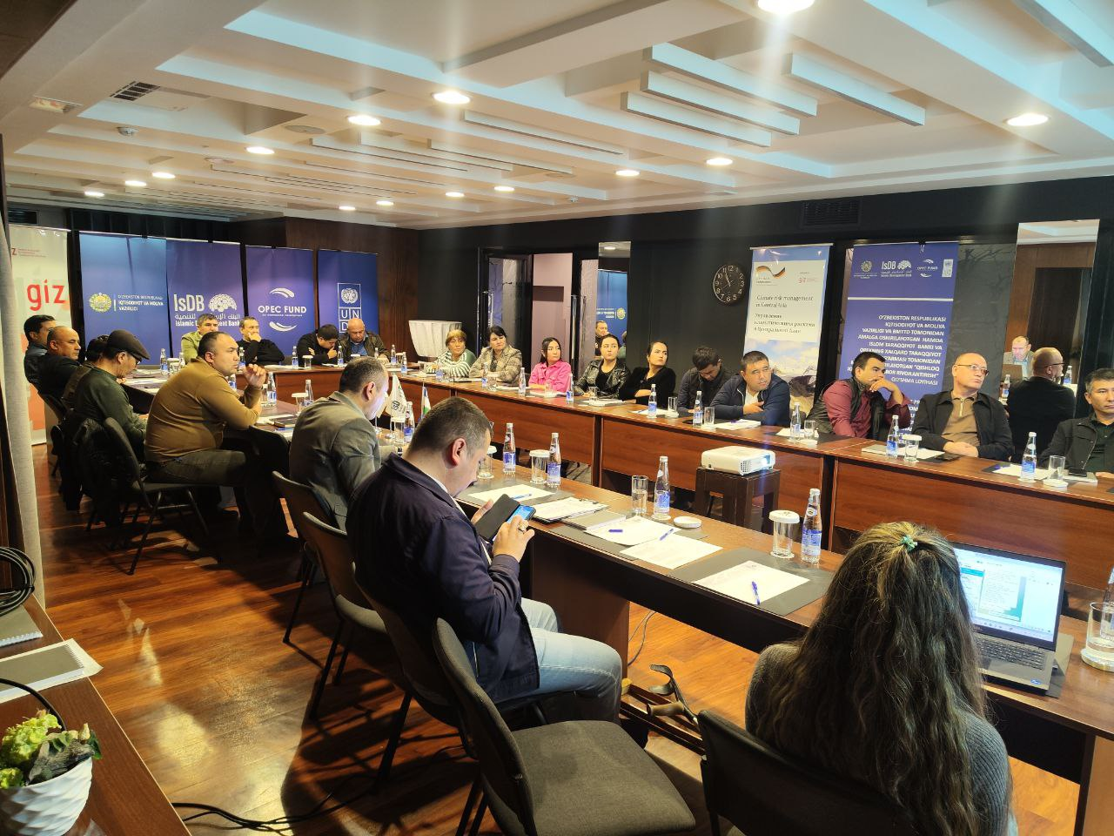 | 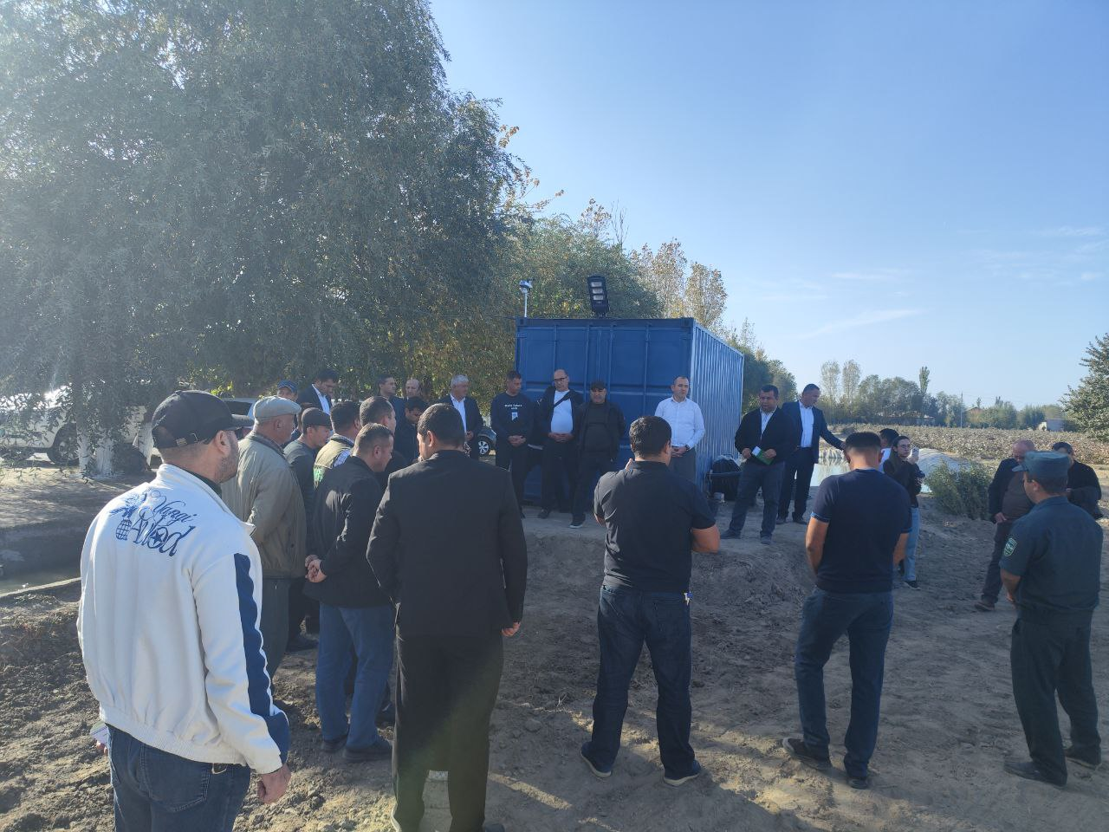 | 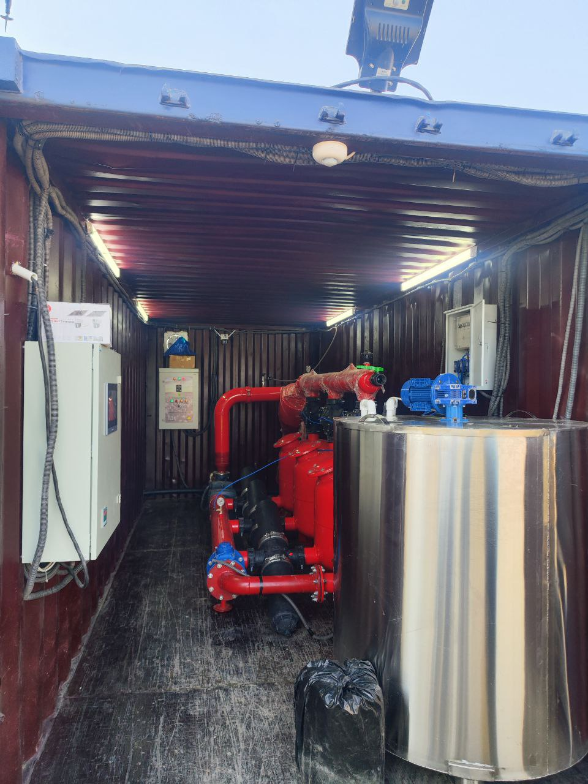

Outputs:
- Master plan of Buston community of Khopzarasp district developed.
- 30 (3 of them women) representatives of local government in Khorezm region and Khazorasp district khokimiyats, architects/engineers as well as Buston community activists took part in the Master Plan presentation.
- 30 representatives (5 women, 25 men) of regional and district architecture and cadaster specialists of Khorezm region trained in Master-class training on Development and implementation of a regional master plan
- Master Plan Mannual developed.
- 120 representatives (36 women, 84 men) of regional and architecture and cadaster specialists trained in Master Plan development tarining was conducted in 4 pilot regions. 200 Manuals printed and disseminated among all regional cadaster and construction departments.
- 30 regional representatives (6 women) of Ministry of Agriculture, Ministry of Water Management, as well as branch of Association of Dekhkans and Farmers trained in in Smart drip irrigation.

Activity 2.3 Introduction of energy and water efficient, new agriculture & farming technologies, ozone-friendly and low GWP (global-warming potential) based technologies in different sectors/applications in a balanced proportion of pilot projects.
Progress:

- 8 Low-Carbon (Propane) air conditioning units (air conditioners, chillers, etc.) were installed in 4 kindergartens in the project's target regions in 2025.
Photos:
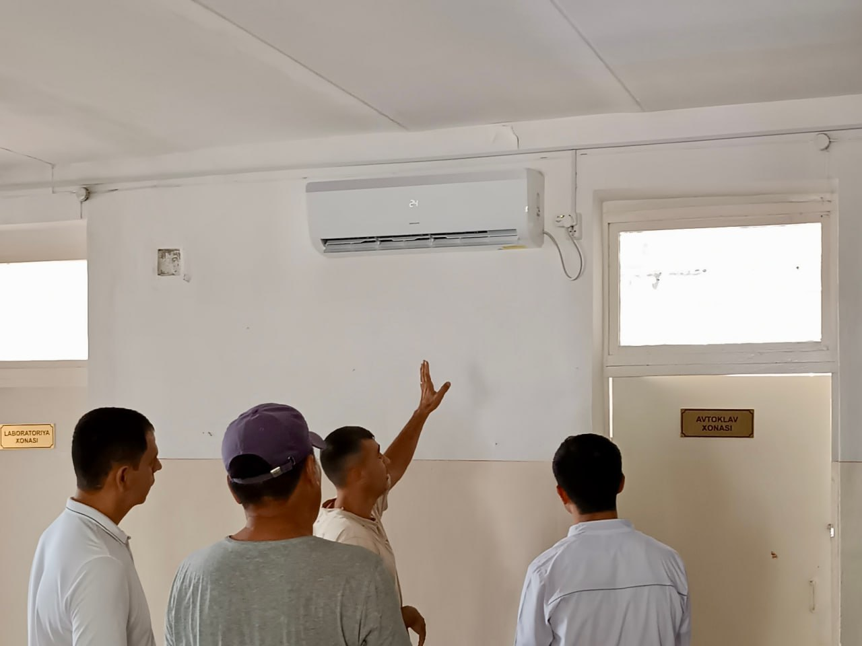 | 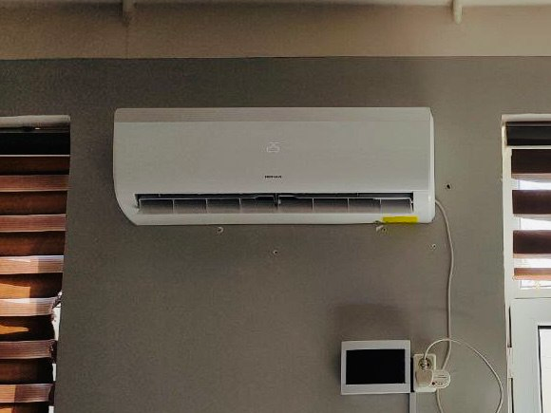

- A turnkey solar photovoltaic solution with a capacity of 10 kWp was installed in 4 preschools. The installation of solar photovoltaic power plants (PVPs) in public schools in the Aral Sea region is an initiative aimed at improving the energy independence of educational institutions, generating economic benefits, environmental sustainability, and raising the level of education. This project represents a significant step toward sustainable development and modernization of school infrastructure.
Photos:
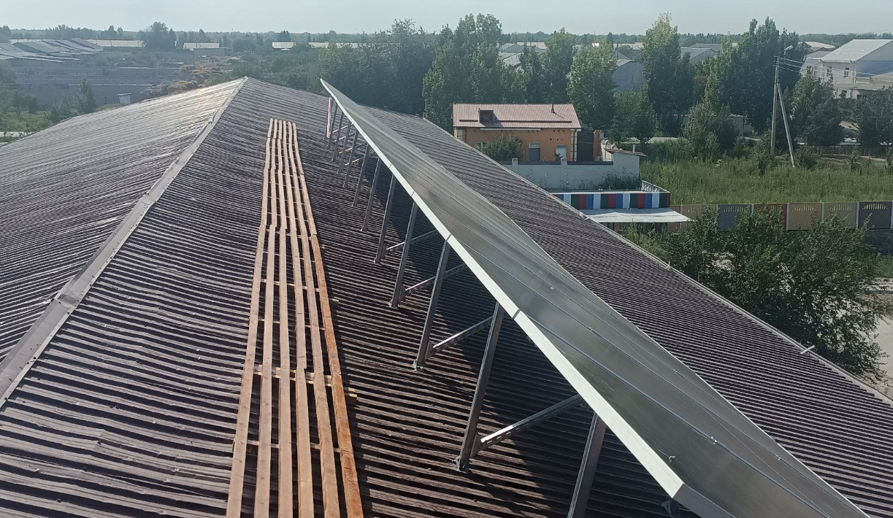 | 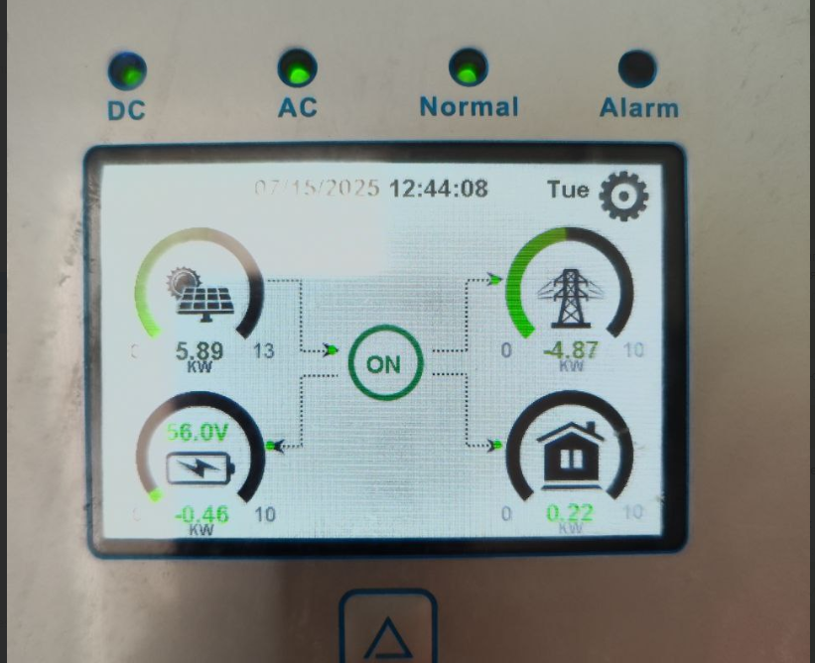

- GREEN SCHOOL project, which aims at improving sanitary and hygienic conditions, modernizing the heating system, and providing autonomous electricity supply in secondary school No. 176, Takhiatash district, Aitkushli mahalla, Republic of Karakalpakstan is being implemented. The project has currently held an open tender and selected an organization to implement this initiative. Installation work will be in 2026.
- Two videos were produced on environmental disasters and the development of sustainable master plans. To prevent negative environmental impacts, the project introduced measures promoting the rational use of water, environmentally friendly fertilizers, and the integration of environmentally advanced solutions into master plan development. The videos aim to inform rural populations about environmental challenges and innovative, practical solutions in a clear and easily understandable format.
- Monitoring of pilot initiatives, agrometeorological stations, and propane air conditioners in 4 pilot regions is in process. To support closer engagement of farmers and help to build their capacity in using the provided instruments, it is important to monitor ongoing processes and provide further adaptation to innovative solutions.

Table 4. Beneficiaries of agrometeorological stations
# | REGION | DISTRICTS | COMMUNITY | BENEFICIARY-FARMERS
1 | Karakaplakstan | Amudarya | Qipchak | 43
2 | Khorezm region | Khonqa | Gayrat | 97
3 | Bukhara region | Shofirkon | Katta Karvanboshi | 62
4 | Navoi region | Navbakhor | Arabkhona | 29
Total |  |  |  | 231

Table 5. Propane air conditioners’ monitoring at rural medical points
# | REGION | DISTRICTS | COMMUNITY | WORKING STATUS
1 | Karakaplakstan | Amudarya | Qipchak | Functioning properly
2 | Khorezm region | Gurlan | Madadkor | Functioning properly
3 | Bukhara region | Shofirkon | Qalmikon | Functioning properly
4 | Navoi region | Karmana | Azamat | Functioning properly

Table 6. Solar panels’ monitoring at rural preschools
# | REGION | DISTRICTS | COMMUNITY | WORKING STATUS
1 | Karakaplakstan | Ellikkalla | Kindergarten 6 | Functioning properly
2 | Khorezm region | Yangibazar | Kindergarten 6 | Functioning properly
3 | Bukhara region | Kogon | Kindergarten 6 | Functioning properly
4 | Navoi region | Karmana | Kindergarten 12 | Functioning properly

External power | 1710.15
Solar panels | 1786
Consumed | 1245.6
Sold | 464.55
The usage of power in kindergarten № 6, Buston mahala, Yangibozor district, Khorezm:
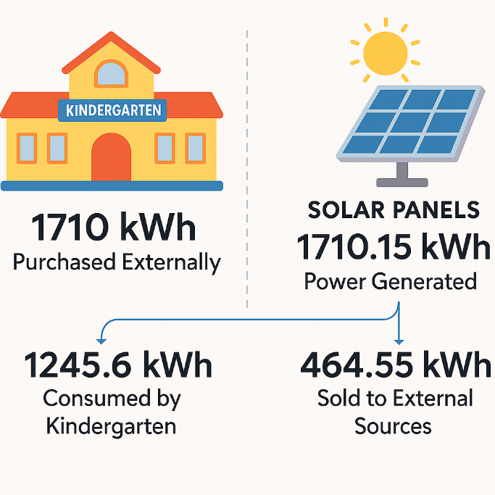

Outputs:
- 8 air conditioning units (air conditioners, chillers, etc.) were installed in four preschools.
- An installation of a turnkey solar photovoltaic solution with a capacity of 10 kWp in 4 preschools.
- Production of 2 videos on environmental disasters and development of sustainable master plans.

PROGRESS OF ACTIVITY 3:
Capacities of construction, architecture-design and public service delivery sector are increased on the local governance and community participatory mechanism in the planning and implementation of rural development programs and initiatives by using digital transformation, gender-sensitive approaches, innovative IT solutions, including development of digital infrastructure and information systems to ensure better access to social facilities and services in rural areas, including green redevelopment/regeneration and increasing resilience in post-disaster situations (such as COVID-19 and other pandemics).
Activity 3.1 Digital readiness assessment, including digital gender gap, and development of local digitalization plans:
Activity completed

Activity 3.2 Capacity building to support regional digital transformation (25 people at each supported region, total 100 people)
Progress.
      - As part of the UNDP initiative to enhance digital literacy in rural areas of Uzbekistan, cyber hygiene trainings were conducted in April–May 2025 across eight pilot schools in Bukhara, Navoi, the Republic of Karakalpakstan (Nukus), and Khorezm (Urgench). The sessions, organized under the project “Engineering Services & Strengthening Capacity in Infrastructure Management” with support from the Islamic Development Bank, provided two-hour trainings for both teachers (in a ToT format) and students in grades 5–10. A total of 414 participants—170 teachers and 244 students—received practical guidance on essential digital safety skills, including personal data protection, recognizing phishing attempts, secure password practices, safe behavior on social media and messaging platforms, and identifying suspicious online activity. Training materials were developed according to UNDP’s Terms of Reference and included case studies, visual examples, and hands-on exercises to strengthen participants’ ability to navigate digital environments safely.
Photos of the training:
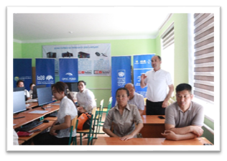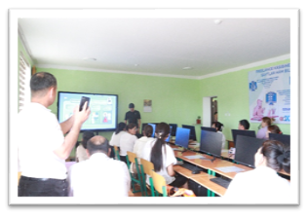

Outputs:
1. 414 teachers and students across eight rural schools trained in Cyber-hygiene training. Teachers: 170 participants: Men – 63 and Women 107. Students – 244 participants: Boys -108, Girls -136.

Activity 3.3 Increasing digital literacy for rural population in target villages/qishloqs, with focus on students, youth communities, cooperatives, water-users associations, etc.
Progress:
      - As part of UNDP Uzbekistan’s efforts to strengthen digital governance and improve access to online public services, a regional training series in E-Gov Services was conducted from April 7–17, 2025 across eight districts in Karakalpakstan, Khorezm, Bukhara, and Navoiy. The program aimed to enhance the competencies of local government officials, frontline staff, and civil society representatives by increasing awareness of key e-government platforms, improving understanding of digital identity and authentication systems, and promoting citizen-centric service delivery. Approximately 60 participants—including heads of Makhallas, social protection officers, youth leaders, women’s activists, prevention inspectors, local tax representatives, and Public Service Center staff—received hands-on instruction through live demonstrations, practical exercises, case simulations, and discussion sessions. The training covered major public service portals such as my.gov.uz, my.soliq.uz, and my.mehnat.uz, along with the newly introduced MyID facial recognition system designed to expand secure access for rural residents. Participants gained confidence in using digital platforms, identified remaining barriers such as limited infrastructure and low digital literacy in some districts, and provided valuable feedback for improving user experience. The initiative highlighted the need for continued capacity building, wider promotion of MyID, targeted outreach in rural communities, and the establishment of local digital support points to ensure sustainable improvements in public service delivery.

Photos of the training:
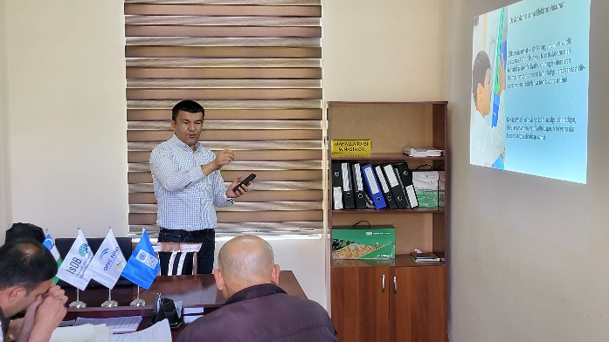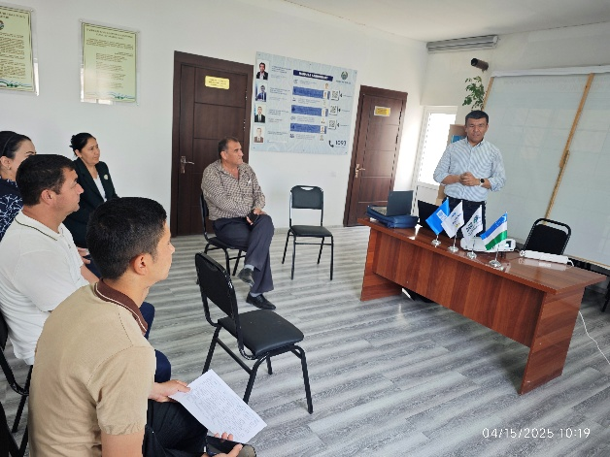

Outputs:
1.60 local government and community representatives across eight districts (32 men, 28 women) trained in a regional digital governance training series.
Activity 3.4 Based on the prioritization assessment under activity 3.1., improve access to social infrastructure through using modern technology/equipment and promoting/piloting the smart/green communities’ model.
Progress:
            - Throughout the year, the project successfully completed the procurement, delivery, installation, and commissioning of 3D printers, accompanying computer equipment, UPS systems, and robotics kits for eight shortlisted secondary schools across four regions. These schools were selected based on established criteria, including the presence of active IT classes with qualified teachers, strong university admission rates, and accessibility to serve wider student populations. Comprehensive training was provided in August to school representatives by the equipment supplier, ensuring effective operation, maintenance, and educational use of the new 3D printers. The national project consultant also delivered hands-on training on the use of robotics equipment and the development of project ideas. To further strengthen capacity, a master class for school administrators and teachers was held on September 19, 2025, focusing on using Artificial Intelligence to generate 3D printing ideas and accessing free online marketplaces offering downloadable 3D models. All schools are now actively utilizing the equipment, and transfer documentation is in progress.
Photos:
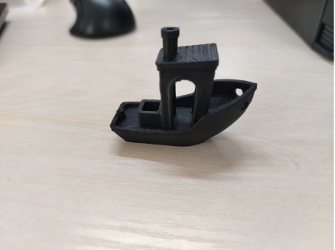 | 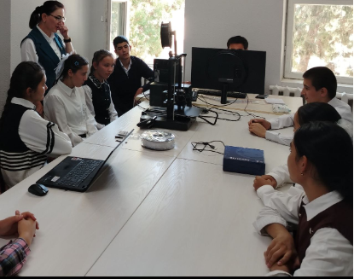

Table 7. The use of 3D printers:

# | School #, region | Boys | Girls | Total
1 | #40, Amudaryo district. Karakalpakstan | 42 | 28 | 70
2 | #7, Takhiatash district, Karakalpakstan | 51 | 56 | 107
3 | #4, Yangibozor district, Khorezm region | 15 | 20 | 35
4 | #32, Gurlan district, Khorezm region | 41 | 39 | 80
5 | #16, Bukhara district, Bukhara region | 18 | 19 | 37
6 | #7, Gijduvon district, Bukhara region | 17 | 18 | 35
7 | #19, Karman district, Navoi region | 45 | 40 | 65
8 | #5, Navbakhor district, Navoi region | 19 | 27 | 46
Total |  | 248 | 247 | 495

            - The project equipped selected rural general education schools with robotics kits and accessories and organized comprehensive training to strengthen STEM education and introduce practical learning in robotics, programming, and engineering. Schools were chosen through a structured process that included developing selection criteria, analyzing statistical data, visiting shortlisted schools, determining equipment specifications, and procuring and installing equipment through an open tender. A qualified robotics specialist, Mr. Omadjon Kimsanov conducted hands-on training sessions in each participating school, enabling teachers to develop the skills needed to independently lead robotics and STEM lessons. This initiative increased technical and digital literacy among teachers and students, fostered greater interest in technology and innovation among rural youth, and supported resource efficiency by enabling digital experimentation and reducing the need for consumable materials. In the long term, the program contributes to improved competitiveness of students in the labor market and ensures sustainability through strengthened local capacity and full integration of robotics education into the school learning process.
Photos:
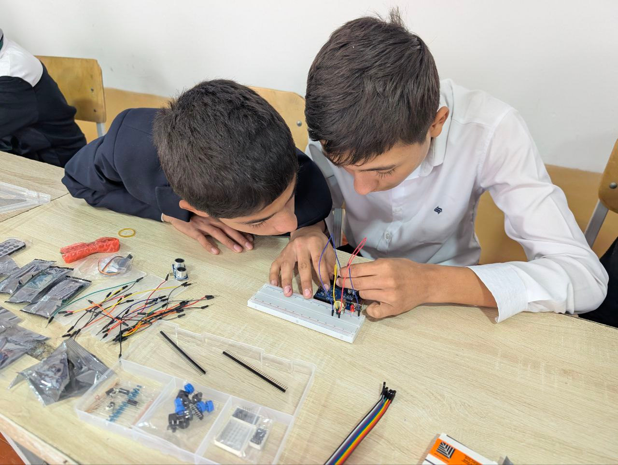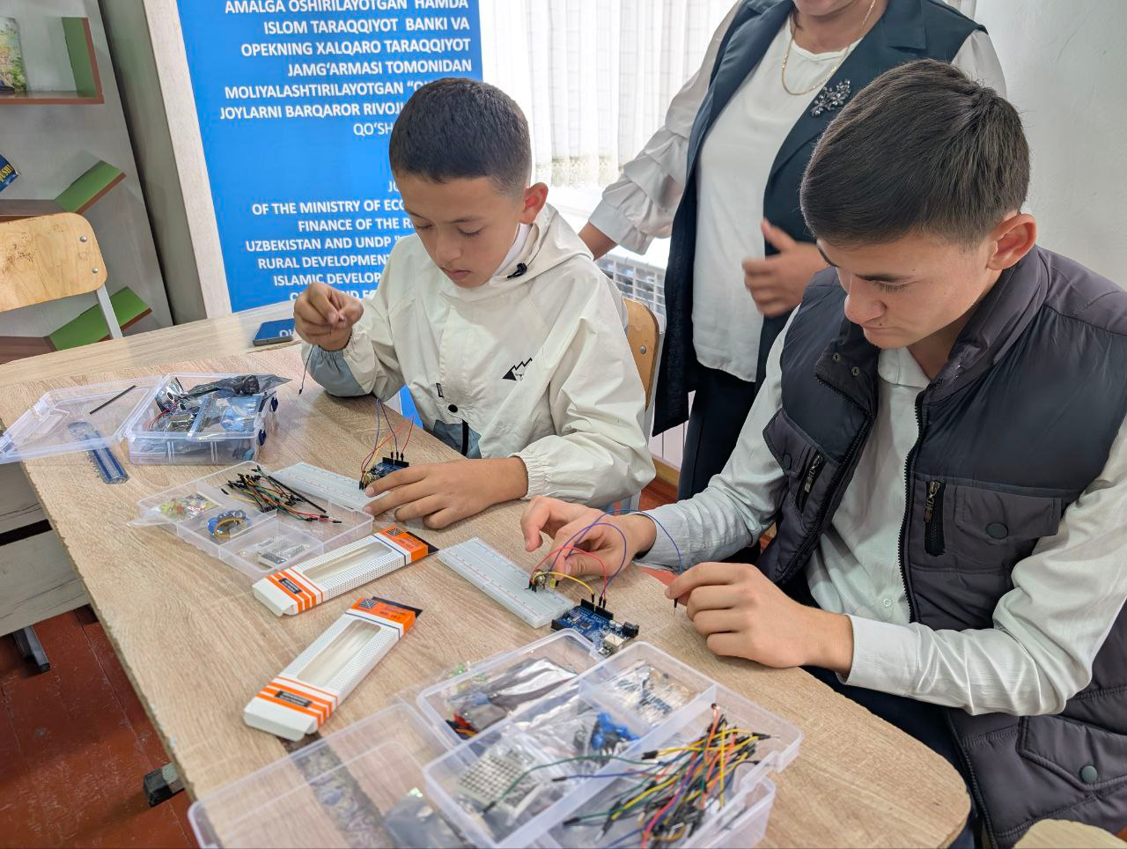

            - To enhance youth access to digital resources and create opportunities for learning, creativity, and remote work, the project supported the establishment of Youth Coworking Centers in rural community hubs. The activity included selecting eight pilot communities in four regions based on population size, distance from regional centers, availability of suitable premises, and the absence of similar donor-funded facilities. Each center was equipped with computers, multifunction printers, upgraded internet equipment, office furniture, and a set of modern books in Uzbek. Through these investments, the coworking centers now provide rural youth with safe internet access, IT tools, and a supportive environment for brainstorming, skills development, and startup ideas, significantly improving their quality of life and creating pathways to economic opportunities.
Table 8. Community resource centers’ use for online public services (as of November 30, 2025)

Community | Male | Female | Total
Ilgor MCG, Honqa district, Khorezm | 133 | 217 | 350
Kamolot MCG, Khozarasp district, Khorezm | 407 | 425 | 832
Hajuvon MCG, Vobkent district, Bukhara | 95 | 111 | 206
Jovgari MCG, Gijduvon district, Bukhara | 273 | 372 | 645
Dustlik MCG, Karmana district, Navoi | 73 | 118 | 191
Ok machit MCG, Qiziltepa district, Navoi | 92 | 122 | 214
Naymankul MCG, Takhiyatash district, Karakalpakstan | 93 | 173 | 266
Shimom MCG, Beruniy district, Karakalpakstan | 174 | 243 | 417
Grand total | 1340 | 1781 | 3121

4. The project staff continues the monitoring of the equipment use
Table 9. The use of IT technology at schools (as of November 30, 2025)

Community/school | Boys | Girls | Total
#9, Turtkul dist. Karakalpakstan | 1858 | 1875 | 3733
#17, Nukus dist, Karakalpakstan | 1015 | 1155 | 2170
#9 Urgench dist, Khorezm region | 864 | 941 | 1805
#10, Khozarasp dist, Khorezm region | 1814 | 1690 | 3504
#6, Shofirkon dist, Bukhara region | 1168 | 1124 | 2292
#28, Vobkent dist, Bukhara region | 695 | 760 | 1455
#8, Navbahor dist, Navoi region | 1781 | 1864 | 3645
#18, Qiziltepa dist, Navoi region | 1121 | 1106 | 2227
Grand total | 10316 | 10515 | 20831

Table 10. ICT in clinics (as of November 30, 2025)

Community | General service |  |  | Patronage service
Community | Men | Women | Total | Men | Women | Total
66-clinics, Qilchinoq MSG, Ellikkala region, KKP | 35199 | 58373 | 93572 | 21938 | 45156 | 67094
Uzgarish MSG, Bogot district, Khorezm region | 3402 | 5173 | 8575 | 4884 | 7668 | 12552
Galaosiyo RMP, Saxovat MSG, Bukhara district, Bukhara region | 2653 | 4295 | 6948 | 1320 | 2825 | 4145
Azamat RMP, Azamat MSG, Karmana district, Navoiy region | 4193 | 5657 | 9850 | 4601 | 7198 | 11799
Grand total | 45447 | 73498 | 118945 | 32743 | 62847 | 95590

Table 11. Information kiosks usage
Community | Men | Women | Total
Ilg'or MCG, Honqa dist, Khorezm region | 157 | 192 | 349
Kamolot MCG, Khozorasp dist, Khorezm region | 356 | 376 | 732
Hajuon MCG, Vobkent dist, Bukhara region | 122 | 84 | 206
Jovgari MCG, Gijduvon dist, Bukhara region | 342 | 371 | 713
Dustlik MCG, Karmana dist, Navoi region | 127 | 91 | 218
Oq machit MCG, Qiziltepa dist, Navoi region | 135 | 77 | 212
Naymankul MCG, Takhliyatash dist, Karakalpakstan | 121 | 133 | 254
Shimom MCG, Beruniy dist, Karakalpakstan | 199 | 220 | 419
Grand total | 1559 | 1544 | 3103

5. 5 video clip on cybersecurity were developed for demonstration in target rural areas:
  - Unknown APK files
  - Scammers
  - Antivirus
  - Likes in social media
  - PIN codes
These videos have been uploaded to the UNDP YouTube channel and disseminated among IG members. Also, the series of presentations was conducted for students of rural schools.
Output:
            - 8 rural schools across four regions were fully equipped with 3D printers, computers and UPS systems, and robotics kits, and their staff received comprehensive technical and educational training enabling effective and ongoing use of the new technologies.
            - The project selected 8 pilot communities in 4 regions and established 4 youth coworking centers equipped with 8 computers, 4 multifunction printers, 4 upgraded modems/routers, 4 full furniture sets, and 40 modern Uzbek-language books, providing rural youth with safe internet access and opportunities for learning, creativity, and remote work.
            - 20831 pupils (10316 boys, 10515 girls) used computers during the reporting period
            - 118,945 community people (73,498 women) were electronically checked up in medical points, and 95,590 people (62,847 women) inspected by patronage services in four pilot communities.
            - 3103 rural people (1559 men, 1544 women) used inforkiosks during the reporting period

PROGRESS OF ACTIVITY 4:
Local communities are strengthened empowering women, youth, elderly, people with disabilities, involving in decision making processes and national/sub-regional/local government capacities and institutionalization in operation and maintenance of the infrastructure to ensure sustainable functioning.
Activity 4.1 Deployment of methods for effective and sustainable development of infrastructure in rural areas through promoting the local resource-based approaches.
Progress.
- The Concept Note for Mahalla centers is developed and agreed upon by the PIU.
- The training on CDP development for representatives of local NGOs, women's organizations, and vulnerable groups has been delivered.

Photos of the training on CDP development:
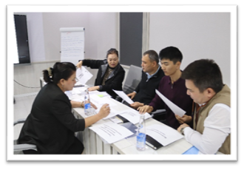 | 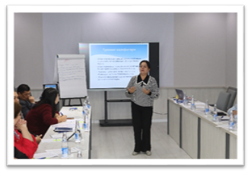
Training on CDP development for local CSOs in the Karakalpakstan region
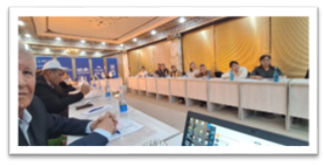 | 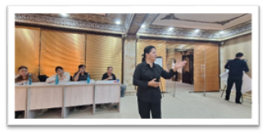
Training on CDP development for local CSOs in the Khorezm region
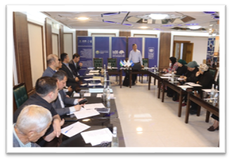 | 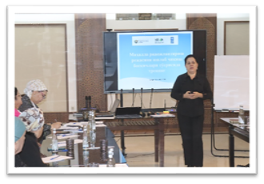
Training on CDP development for local CSOs in the Bukhara region
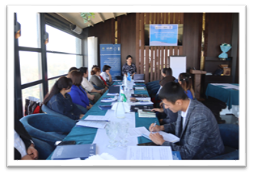 | 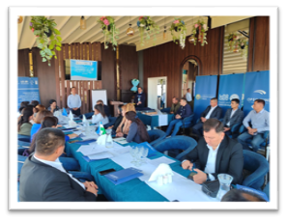
Training on CDP development for local CSOs in the Navoiy region
3. Study tour to Croatia and Bosnia & Herzegovina was conducted between November 9-22, 2025.The study tour aimed to identify lessons that can be adapted to strengthen community-based development planning and rural infrastructure initiatives in Uzbekistan. Participants familiarized with effective European practices in regional and local infrastructure development, including bottom-up planning approaches and Integrated Territorial Investment mechanisms. By observing institutions and real project sites in Croatia and Bosnia and Herzegovina, participants learned how strategic planning, financing, and implementation frameworks function in practice.
Photos:
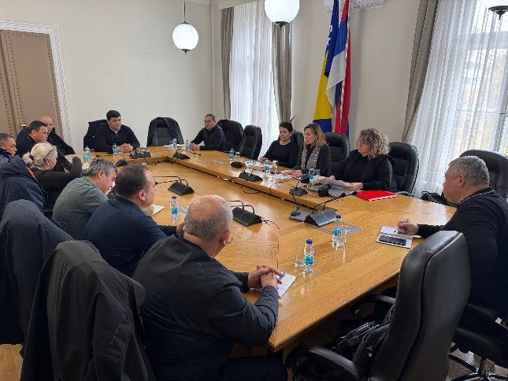 | 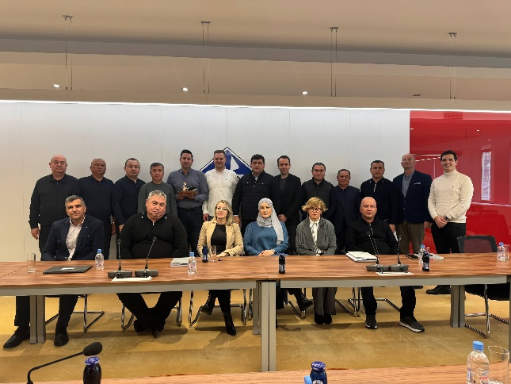
Outputs:
- A total of 82 personnel of NGOs (33 men and 49 women) trained in CDP development training.
- Concept note for mahalla centers developed
- 11 participants (1 woman) exchanged experiences during the study tour to Croatia and Bosnia & Herzegovina

Activity 4.2 Replication of Project best practices
Progress.
- Resource Mobilization Strategy was developed to support the replication of best practices beyond pilot regions, leveraging government support to mobilize additional resources from donors, the private sector, and local budgets.
- The leaflets on the following themes were developed in English, Uzbek, and Russian languages and disseminated among the local population in the target regions:
  - New Approaches to Agricultural Development in Uzbekistan
  - Innovations on the Path to Sustainable Development
  - Empowerment of Women in Communities
  - Energy Efficient Building Materials
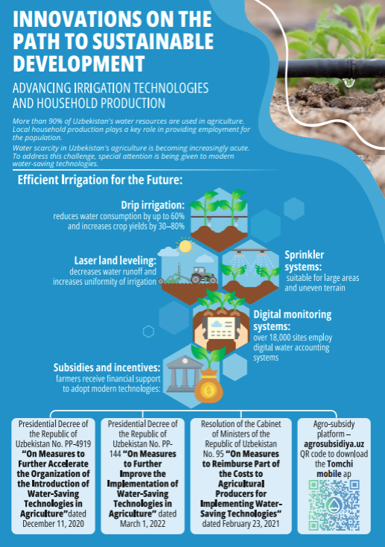
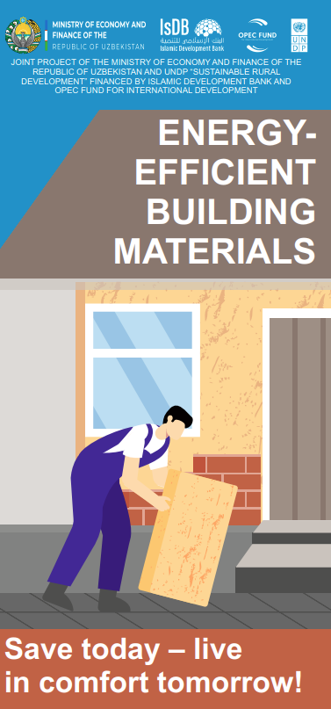
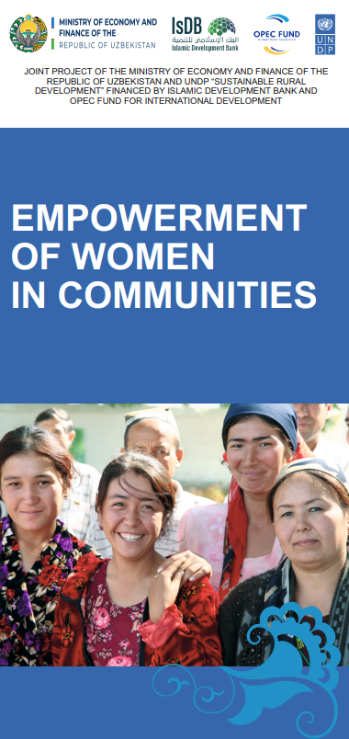
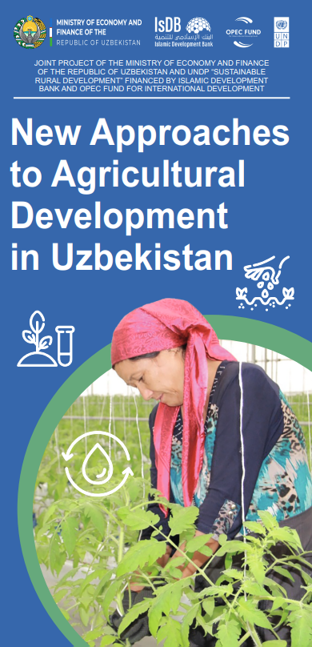

- Digital maps of power and water supply systems were developed for cluster communities to support informed planning and decision-making. Using GIS tools, the project created detailed geospatial representations of existing infrastructure, allowing stakeholders to easily visualize system layouts and identify gaps or priority areas. The maps include features such as color-coded infrastructure elements, technical annotations, and scalable layers that can be adapted for future updates or potential real-time integrations. These tools are intended to strengthen local authorities’ and communities’ capacity for effective maintenance, monitoring, and long-term infrastructure planning. Maps can be accessed on WaterMap and PowerMap
Photos of the maps:
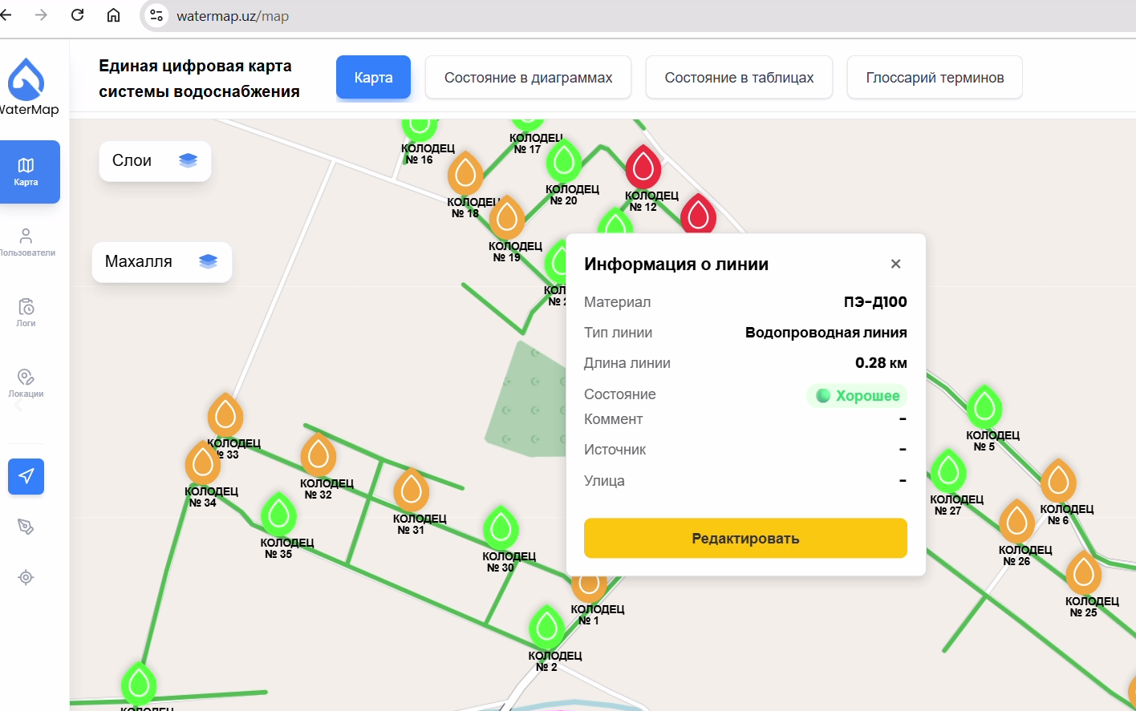 | 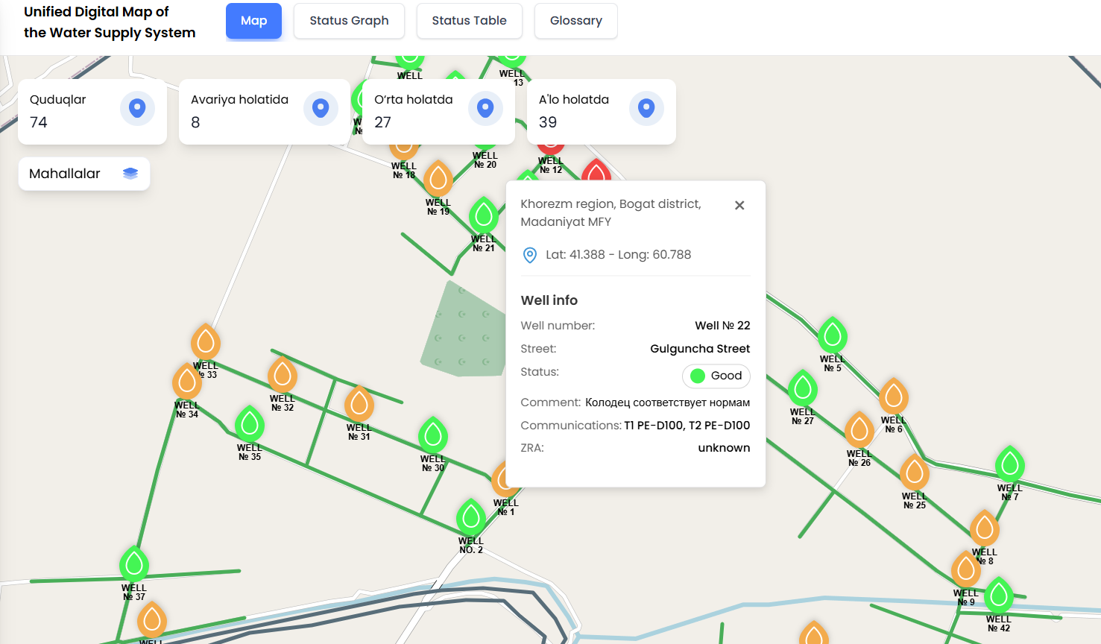

Output:
1. Project Resource Mobilization Strategy.
2. Digital map of power supply for the selected 1 cluster community in the Navoiy region.
3. Digital map of water supply for the selected 1 cluster community in the Khorezm region.
Activity 4.3 Development of a communication strategy in line with UNDP Principles of Gender-Sensitive Communications to make use of all possible advocacy and outreach tools and approaches to deliver messages to target audience, beneficiaries and wider public at community, district, sub-national, national, and international levels.
Progress.
1. Development of video clips “Before” and “After” completion of the construction of the subproject work. “Before” status has been filmed, and “After” status will be filmed in 2026.
2. The project continues its outreach and promotional campaigns through different channels, events, and with the help of producing and disseminating PR materials about the project's activities and achievements.
One-pager samples:
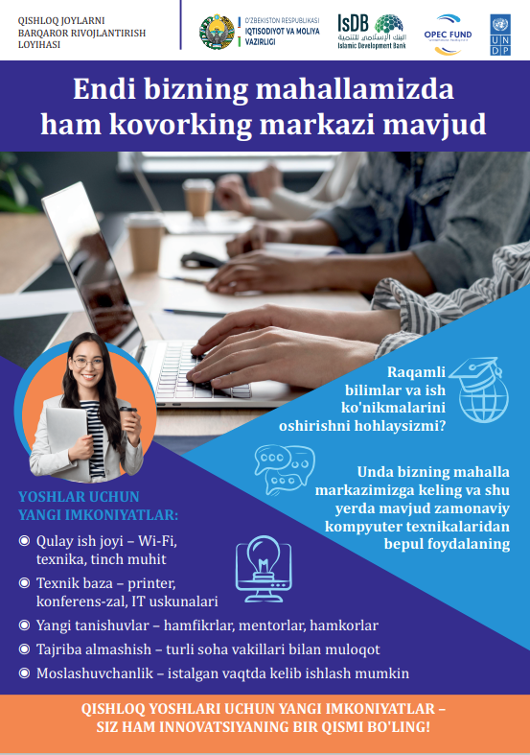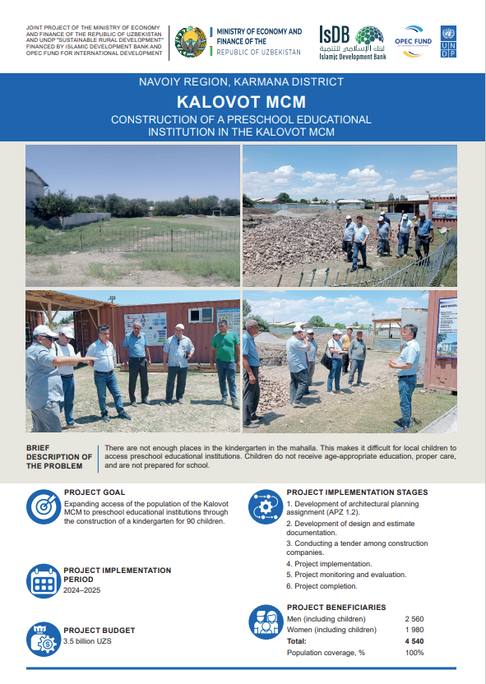
Output:
More than 200,000 people were reached through the project PR campaign (117,422 views through UNDP Telegram channels only). 100% of the target communities' people are covered by the PR and outreach campaign of the project. More than 500 PR and outreach campaigns of the project results and raising awareness were conducted.
1. Total number of publications: 518
a. Telegram - 388
b. Facebook - 62
c. Instagram - 51
d. LinkedIn - 17
2. Articles published on the websites: 260
3. TV and video reports: 26
4. Developed videos: 7
5. Number of developed pr materials: 31
a. One-pager - 21
b. Infographics and webcards - 2
c. Leaflets - 7
d. Reports - 1

PROGRESS OF ACTIVITY 5:
Project Management.
Progress:
- The team-building retreat for the joint project occurred from July 25 to 27, involving the staff from the PIU, UNDP, and a representative of the IsDB. Overall, 50 people participated with 10 women (20%) and 40 men. A total of 50 people participated, including 10 women (20%) and 40 men. The event included a learning session along with outdoor activities.

Photos of the teambuilding activity:
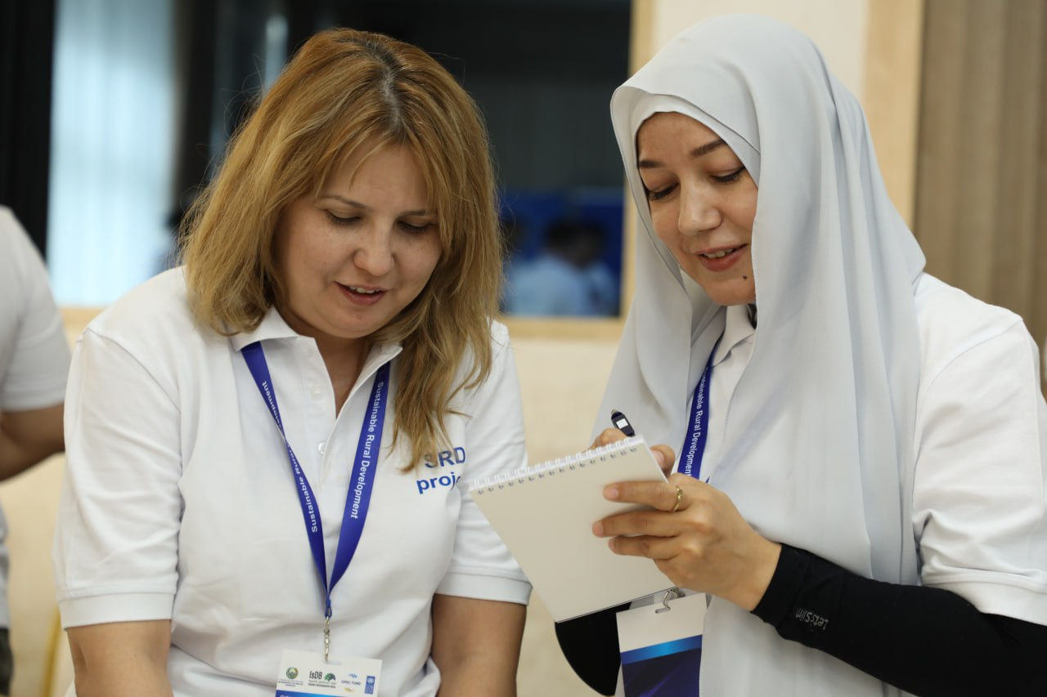 | 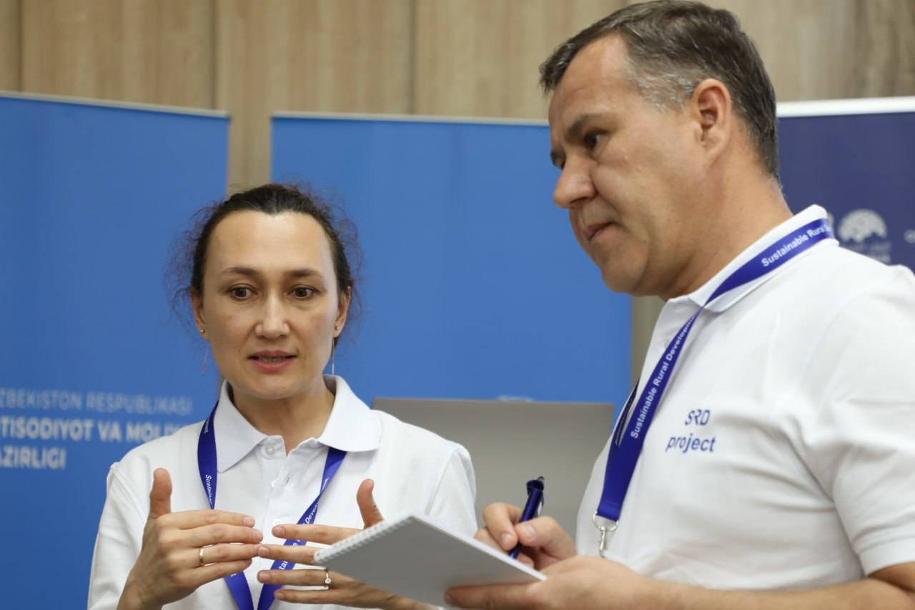
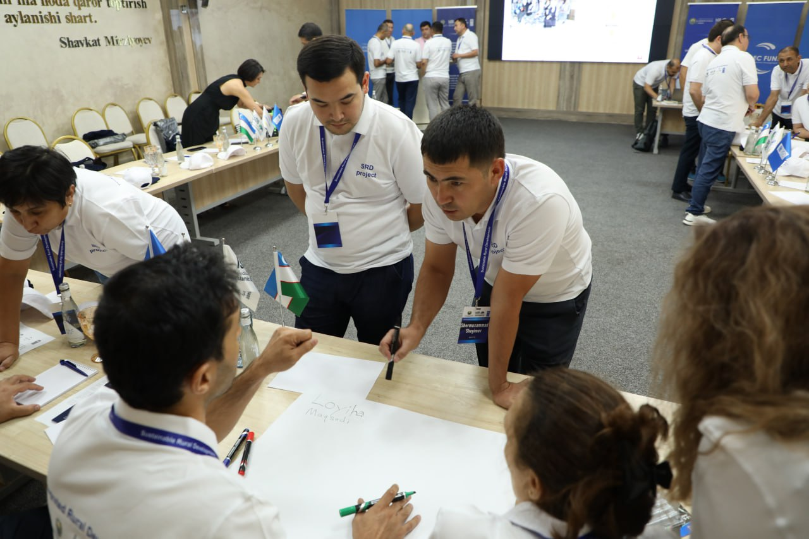 | 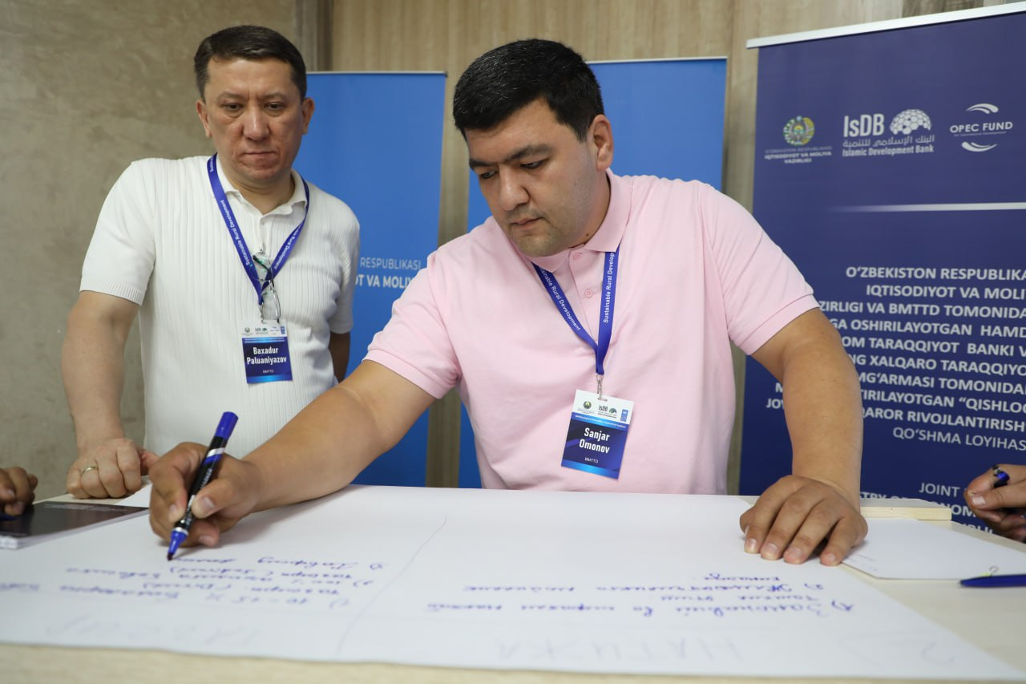
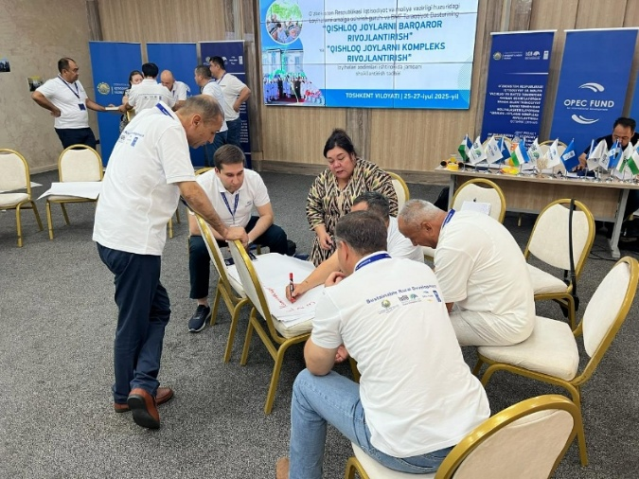 | 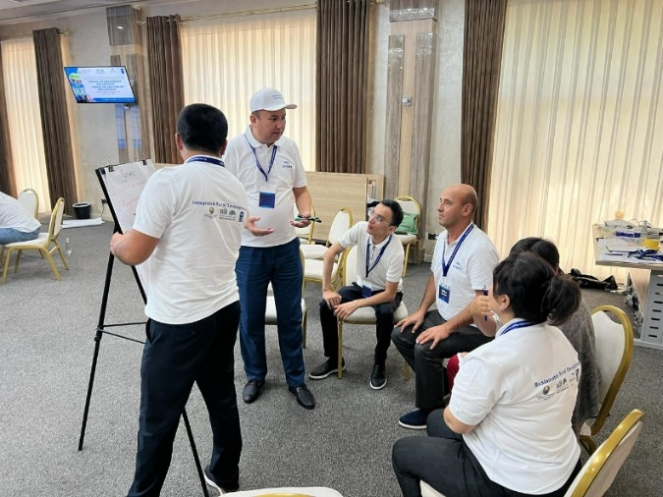

- The budget revision for 2025 is finalized and approved
- Working meetings were conducted during the reporting period with the representatives of the Ministry of Economy and Finance, UNDP, PIU, and IsDB. One of them is the Working meeting of Mr. Samandar Sadullaev - Deputy Minister of the Ministry of Economy and Finance, and Ms. Akiko Fujii - UNDP Resident Representative on July 31, 2025, to discuss the current status of project implementation, future plans, extension, and joint monitoring visits to the pilot regions.
Photos of the meeting:
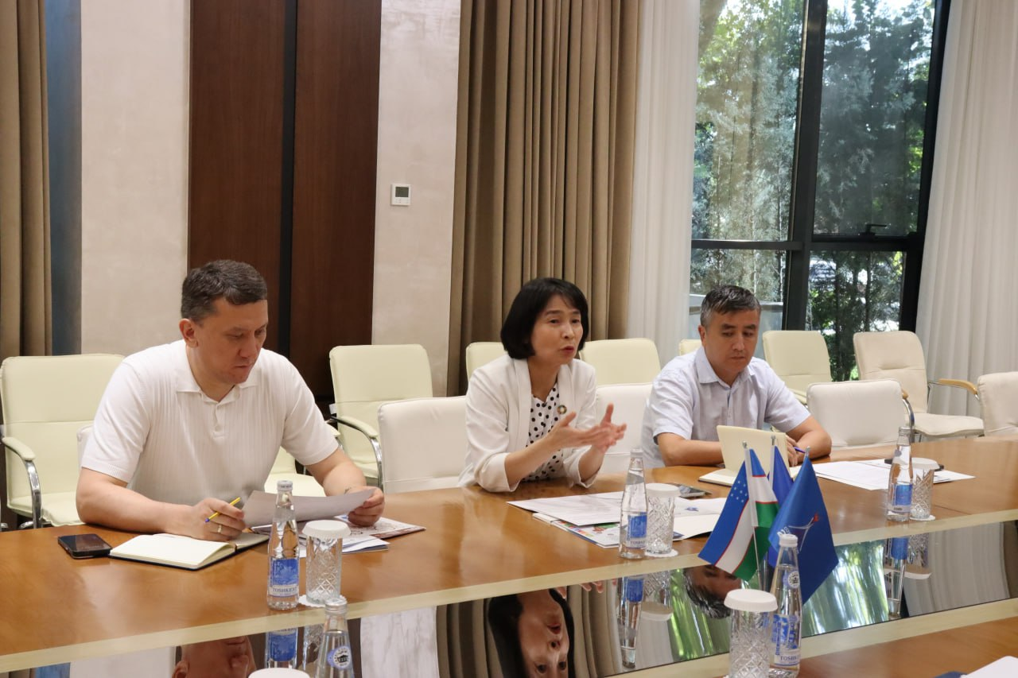 | 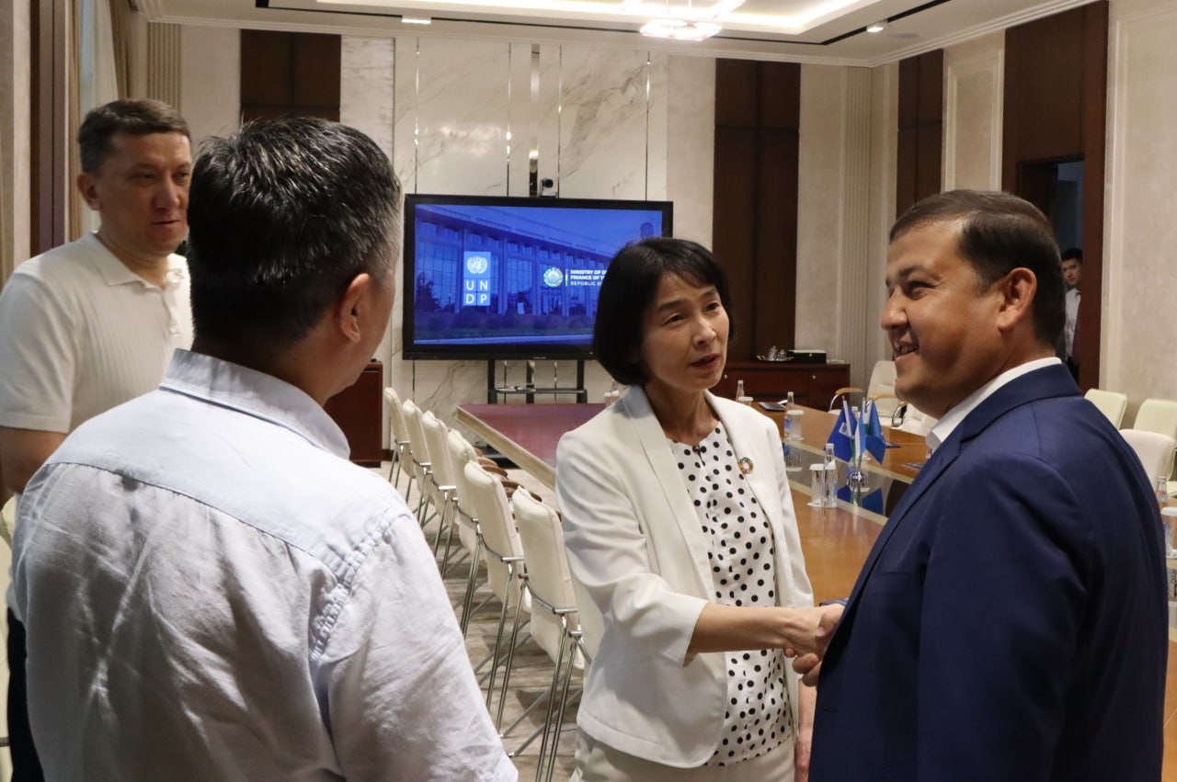

- The Annual Plan for Activities and budget for 2026 was developed and submitted for review to the PIU.
- Project 6th Board Meeting is planned for December 10, 2025.

IMPACT OF THE PROJECT'S ACTIVITIES IN 2025
The project is positioned to achieve its intended outcomes as it moves from planning to implementation. Community empowerment is visibly strengthening; local ownership of CDPs is high, and climate-smart pilots show strong potential for long-term environmental and social benefits. Surveys indicate strong motivation among women and youth to convert training into income once tools and mentorship are available. Infrastructure interventions—particularly in water, roads, early childhood facilities, and renewable energy—are expected to generate measurable improvements in service delivery and resilience. While full impact has not yet materialized, the conditions for success are firmly in place.
The IsDB project Phase I activities produced strong, measurable improvements in community empowerment, institutional capacity, and early climate-smart and livelihood outcomes across 170 mahallas in Bukhara, Navoi, Khorezm, and Karakalpakstan. Evidence from the annual monitoring and evaluation and annual report shows that the Project successfully established the foundations for inclusive, participatory, and climate-resilient rural development, enabling communities and local authorities to jointly plan and manage improvements in infrastructure, social services, and livelihoods.
Key impacts include:
- High-level community ownership and inclusive participation in local decision-making, with more than 1,614 community members engaged in CDP processes and strong representation of women, youth, vulnerable groups, and persons with disabilities. The rural population voted for priority subprojects and created 170 community initiative groups where members were elected from women, youth, the elderly, business entities, and other active community members to develop CDPs.
- Strengthening the capacity of mahallas and Initiative Groups to develop solutions for priority subprojects, verification process, prepare CDPs, present CDPs to local authorities, and oversee future infrastructure investments. As a result of the work of IG members, 40 draft Cluster CDPs for 170 communities were revised and institutionalized, and 878 subprojects have been implemented. They were completed through participatory diagnostics. During the election, 10 (4 women and 6 men) of the IG members were selected as the chairmen of mahala committees.
- Enhanced livelihood opportunities through targeted training in agriculture, entrepreneurship, sewing, digital content creation, and climate-smart farming, responding to community-identified gaps in income generation and skills.
- Improved governance and institutional readiness, where local authorities increasingly practice participatory planning, conduct joint verification, and coordinate CDP implementation with the PIU. Specifically, representatives of khokimiats (khokim, deputy khokims and specialists) attended community mobilization workshops, verification visits, and CDP presentations, as well as 4 representatives who participated in exchange study tours.
- Positive social impact and strengthened community trust, with communities reporting that they feel more included in development planning and see direct relevance of the project to education, water supply, health services, and internal roads. Evidence provided during internal and external monitoring visits.

PROJECT RISKS
- Rapid changes in the Central Government structure and ongoing restructuring of key national partners
- Changing of the CDP priorities due to the other donor interventions, national and regional investment programs, and private donations
LESSONS LEARNED AND CHALLENGES
- Engaging members of the Initiative Groups in volunteer project activities remains challenging due to a lack of motivation among some individuals. In particular, involving young people has proven difficult, as many are unavailable during events due to work commitments
- Challenges in involving IG members to volunteer in monitoring subprojects due to the lack of motivation, low level of digital literacy, and time constraints
- Ensuring the reliability of monitoring data remains a challenge, as some initiative group members may demonstrate limited digital literacy, insufficient attention during subproject visits, or a lack of seriousness in completing Google Forms.
- Achieving gender balance in project activities remains difficult due to the low representation of women in key sectors such as agriculture and government administration, which limits the project’s ability to engage the planned number of female participants.

Annexes:
Annex 1. Project target reporting table of 2025 and up-to-date figures
Annex 2. List of 170 communities
Annex 3. List of assessments, reports, and learning materials
Annex 4. List of publications
Annex 5. List of promo materials
Annex 6. List of transfer documents
Annex 7. Donor Interim Report

