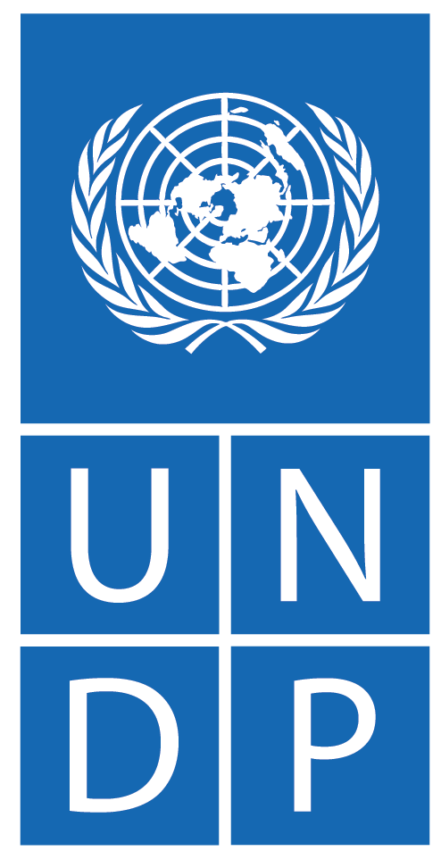

SUPPORTING THE CREATION OF AN ENABLING ENVIRONMENT FOR SOUTH SUDAN’S ELECTIONS

ANNUAL PROGRESS REPORT
1 JANUARY TO 31 DECEMBER 2024

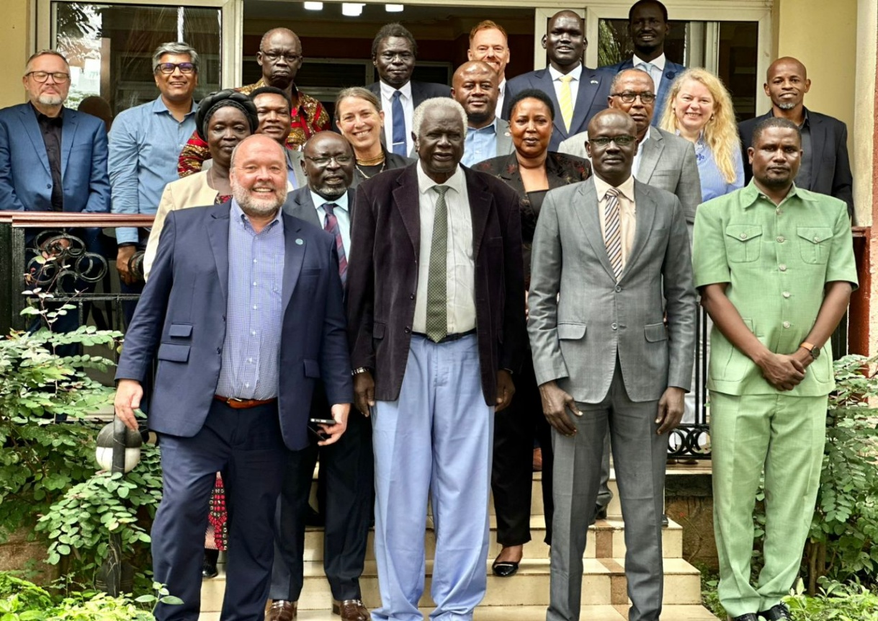
Group photo at NEC’s operational planning retreat of 3 – 5 December 2024 in Entebbe, Uganda, supported and co-facilitated by UNIEAT.
From left to right, at the front: UNMISS Chief of Electoral Affairs & Head of UN IEAT, Darren Nance; NEC Chairperson, Hon. Pr. Abednego A. Kacuol; NEC Deputy Chairperson, Hon. Gabriel Gabriel Deng; NEC Commissioner and Spokesperson, Hon. George Lemi Stans Yata). At the middle: NEC Commissioner Hon. Thabo Abosuh Ajang Alijok; NEC Assistant Director John Bullen; Commissioner Hon. Amos Ochieng Juma Ochieng OdekNEC; CTA SSES Project & UN IEAT Deputy Head, Costanza Lucangeli; Idrissa Kamara (UN IEAT); NEC Commissioner Hon. Sarah Daniel Gatluak Lul; Joram Rukambe (UN IEAT); Evelina Krinickaite (UN IEAT); Ben Ngumi (UN IEAT). At the back: Stefan Scheer (UN IEAT); Irfan Mahmood (UN IEAT); NEC Commissioner and Chief Electoral Officer, Hon. Mac Maika Deng; NEC Commissioner Hon. William Kolnyin Deng Deng; Ian Smith (UN IEAT); NEC Commissioner Hon. Manuel Makum Matuop Thian; NEC Director of Budget Ahon Malou .

CONTENTS

CONTENTS 0
PROJECT BRIEF 1
ACRONYMS 2
EXECUTIVE SUMMARY 4
PROJECT RESULTS AND ACHIEVEMENTS 6
PARTNERSHIP 21
PROJECT MONITORING AND EVALUATION 22
CHALLENGES and LESSONS LEARNED 22
RISK MONITORING 23
PROPOSED WAY FORWARD AND NEXT STEPS 24
ANNEX A: FAST FACTS 26
ANNEX B: RISK LOG 31
ANNEX C: FINANCIAL SUMMARY 35

PROJECT BRIEF

Project title: | South Sudan Electoral Support Project
Project number: | 01000165
Project duration: | July 2023 - December 2025
Implementing Partner: | UNDP (Direct Implementation Modality)
Project partner(s): | National Elections Commission (NEC), Political Parties Council (PPC), United Nations Mission in South Sudan (UNMISS), UNESCO and UN Women
Total budget: | USD 14,515,200
Development Partner | Contribution | Disbursed
 | In USD
EU | 3,281,400 | 3,281,400
Canada | 948,642 | 948,642
Switzerland | 776,855 | 776,855
UNDP | 1,000,000 | 1,000,000
UN Women | 80,000 | 80,000
Sub-Total | 6,086,897 | 6,086,897
UN PBF | 515,193 | 515,193
Japan | 172,859 | 172,859
Africa Elections Fund (Germany) | 167,772 | 167,772
Sub-Total | 855,825 | 855,825
Total | 6,942,722 | 6,942,722
UNSDCF (2023-2025) Outcome 1: | “Women and men in South Sudan, particularly youth and vulnerable groups, benefit from and participate in more transparent, accountable, and inclusive governance that protects and promotes human rights, enables the consolidation of peace, establishes the rule of law, and ensures access to justice for all.”
Related Strategic Plan outcome 3: | Resilience built to respond to systematic uncertainty and risk.
Country Programme Document’s (2023-2025) related programme priority: Pillar 1 (b). | “Enhance the integrity and credibility of elections by strengthening the capacity of the Elections Commission, the Political Party Council, and CSOs, as well as the police and judiciary for elections security and dispute resolution in compliance with human rights standards”.
Gender Marker | GEN 2
Contact : | Aouale Mohamed Abchir, UNDP Resident Representative  Email: mohamed.abchir@undp.org  Costanza Lucangeli, Chief Technical Advisor, UNDP SSES Project.  Email: costanza.lucangeli@undp.org

ACRONYMS
AU African Union
BRIDGE Building Resources in Democracy Governance and Elections
CO Country Office (UNDP)
CoC Code of Conduct
CSO Civil Society Organization
CTA Chief Technical Advisor
CVE Civic and Voter Education
DRI Democracy Reporting International gGmbH
DRR Deputy Resident Representative (UNDP)
EAD Electoral Affairs Division (UNMISS)
ESC Elections Security Committee
ESWG Elections Security Working Group
GoSS Government of South Sudan
IDP Internally Displaced Person
IEA International Electoral Assistance
IGAD Intergovernmental Authority on Development
IOM International Organization for Migration
JICA Japanese International Cooperation Agency
JMAC Joint Mission Assessment Centre
MoJCA Ministry of Justice and Constitutional Affairs
NCRC National Constitutional Review Commission
NEA National Elections Act
NEC National Elections Commission
NPS National Police Service
PMU Project Management Unit
PPC Political Parties Council
QIP Quick Impact Project
R-ARCSS Revitalized Agreement on the Resolution of the Conflict in the Republic of South Sudan
R-JMEC Reconstituted Joint Monitoring and Evaluation Commission
RoLSIS Rule of Law and Security Institutions Section (a Section within UNMISS)
RR Resident Representative (RR)
TNLA Transitional National Legislative Assembly
RTGoNU Revitalized Transitional Government of National Unity
SHEC State High Elections Committee
SSES South Sudan Electoral Support
UN United Nations
UNCT United Nations Country Team
UN IEAT UN Integrated Electoral Assistance Team
UN Women United Nations Entity for Gender Equality and the Empowerment of Women
UNDP United Nations Development Programme
UNESCO United Nations Educational, Scientific and Cultural Organization
UNMISS United Nations Mission in South Sudan
UNPOL United Nation Police
VAWiE Violence Against Women in Elections
WPPWG Women’s Political Participation Working Group

EXECUTIVE SUMMARY
Established in July 2023, the United Nations Development Programme (UNDP) South Sudan Electoral Support (SSES) Project forms a key component of the United Nations Integrated Electoral Assistance Team (UN IEAT). The Project is designed to contribute meaningfully to the strengthening of national institutions, platforms, and electoral processes, with the overarching aim of fostering inclusive, credible, and peaceful elections. At its core, the initiative reflects a shared commitment to supporting South Sudan’s democratic aspirations through collaborative and locally grounded engagement.
On 8 January 2024, members of the Board of Commissioners of the reconstituted NEC were sworn in. In late January 2024, the NCRC, the NEC and the PPC submitted their budgets, but only received seed funding in the months that followed. The budgets were resubmitted by all three institutions for the financial year 2024-2025, but as of 31 December 2024, no additional funds were received, which hampered the ability of the institutions to build their structures and conduct activities.
On 17 June 2024, the NEC appointed five (5) members in each of the ten (10) State High Elections Committees (SHECs) and on 11 July, fifty (50) SHEC members took the oath of office and were instructed to start civic education activities, alongside identification of locations for voting centres. Due to delays in finalizing the proposal for the NEC’s new structure and staffing, Presidential approval of the institutional and staffing changes is still awaited.
The NEC, NCRC and PPC, despite their significantly different mandates, identified similar priorities, including building of structures, infrastructure and staffing, enhancing the capacity of their staff, and establishing the legal framework to allow internal functioning and the implementation of their respective mandates.
On 18 September, at the request of the Revitalised Transitional Government of National Unity (RTGoNU), the Reconstituted Joint Monitoring and Evaluation Commission (R-JMEC) met in an extraordinary session to consider the decision of the Parties to the Revitalised Agreement on the Resolution of the Conflict in the Republic of South Sudan (R-ARCSS) to extend the transitional period for twenty-four additional months, from 22 February 2025 to 22 February 2027, and reschedule the general elections from December 2024 to December 2026. On 21 September, following R-JMEC’s endorsement of the extension of the transitional period, the Transitional Constitution was amended to accommodate the extension. On 31 December, during his end-of-year address to the nation, President Kiir explained that the postponement of the election and consequent extension of the transitional period for another 24 months was chiefly due to economic hardship and the ensuing inability to fund the implementation of key provisions of the agreement.
Throughout 2024, the UN IEAT focus remained in line with the mandate to support an enabling environment for elections, focusing on capacity and institution building of electoral stakeholders (primarily the NEC, the PPC, the National Police Service (NPS), civil society, the media and the Ministry of Justice and Constitutional Affairs (MoJCA), enhancing the legal framework for elections, building the foundations for the conduct of voter and civic education and supporting election security preparedness.
Despite being underfunded throughout the year, and the challenges faced by national counterparts, the UN IEAT provided substantial support to national counterparts.
This Annual Progress Report presents provides an overview of the output-level results achieved between 1 January and 31 December 2024, in alignment with the Project Results Framework of the SSES project. These results reflect the concerted efforts undertaken through the integrated implementation approach the UN IEAT through a collaborative and cohesive approach. Beyond a summary of tangible outcomes, the report also offers a broader reflection on the progress made throughout the year underscoring the spirit of partnership and shared commitment that has guided this work.
Project Output I: Establishment of an enabling legal framework for free, fair, and inclusive elections is supported: Results in this area relate to fostering the development of an effective and inclusive legal framework for elections. As a nascent electoral management body with limited financial resources and staff, the NEC faced challenges in developing a comprehensive legal framework required to manage elections and its own structure. At the end of the year 2024, some progress was recorded in the development and adoption of regulations and codes of conduct for elections by the NEC and the PPC.
Project Output II: Strengthened institutional capacities for professional, transparent, and accountable election management: Results in this area relate to supporting the institutional capacity of relevant electoral stakeholders to efficiently plan and manage electoral processes. After years of inactivity and following its reconstitution, the NEC as well as the newly established PPC identified as one of their key priorities the establishment of their offices and building the capacity of their staff. Thus, during the year 2024, the UN IEAT supported the NEC and the PPC in strengthening their organisational, technical, and operational capacity towards performing their mandated roles. In the same vein, the UN IEAT also supported the enhancement of the capacity to effectively implement their mandate and contribute to credible and peaceful elections of the NPS, MoJCA, the media and civil society, including women’s groups, youth and persons with disability (PWDs) organizations.
Project Output III: Inclusive participation fostered through enhanced rights and access to information: Results in this area relate to the enhancement of inclusivity in the electoral process through fostering an open and pluralistic civic space, conducive to the freedom of information. During the year 2024, the UN IEAT, supported the NEC in establishing its civic and voter education strategy, including the conduct of a baseline survey for the assessment of access to information and electoral awareness, through UN Women, supported targeted activities to enhance women’s participation in political life in view of the upcoming electoral process, and through UNESCO, supported the strengthening of the capacity of media institutions and journalists, including on reporting professionally on elections.
Project Output IV: Enhanced environment for maintaining security and mitigating violence during elections: Results in this area relate to strengthening the capacity of security actors, the MoJCA and the NEC, to manage election security and electoral offenses and contribute to establishing mechanisms for the prevention of electoral violence, including the prevention of violence against women in elections (VAWiE). During the year 2024, delays in the implementation of the roadmap for elections as well as the lack of funding hampered the efforts of security actors to advance detailed planning for elections security. The UN IEAT, in coordination with UNPOL, engaged with the NPS and the NEC in strengthening institutional readiness, through building the capacity on elections security, strengthening infrastructure as well as coordination mechanisms.
Project Output V: Strengthened effectiveness in planning and implementing electoral operations for all citizens: Activities under this output pertain to Phase 2 of the UN electoral assistance: “support to the electoral event” which are not part of the current mandate. Hence no activities have been budgeted nor been implemented during the reporting period.
Project Output VI: Project effectively managed: The results in this area reflect the dedicated efforts and strategic contributions of the Project Management Support Unit (PMSU) in advancing the effective and timely implementation of the South Sudan Electoral Support Project (SSES) throughout 2024. Serving as the operational and technical backbone of the project, the PMSU played a pivotal role in ensuring coherence, efficiency, and accountability across all components of electoral assistance. Working in close coordination with the UN IEAT, the Unit provided critical support in the areas of human resources, budget management, procurement, logistics, finance, and administration. These interventions enabled the seamless delivery of capacity-building and technical assistance to key national counterparts including the NEC, the PPC, the NPS, and civil society organisations. Through its comprehensive and responsive approach, the PMSU laid a firm foundation for inclusive, well-coordinated, and accountable electoral preparations in an evolving and complex operating context.

PROJECT RESULTS AND ACHIEVEMENTS
The following provides a summary of the key results attained in 2024, aligned with the output-level indicators outlined in the South Sudan Electoral Support (SSES) Project Document (2023–2025) and the 2024 Annual Work Plan. These achievements reflect the collective efforts of partners and stakeholders working together to advance the project’s objectives in a complex and evolving context.
The ability to deliver electoral technical assistance during the year was largely conditioned by the slow implementation of the R-ARCSS milestones which had an adverse impact on election related planning and implementation. Nevertheless, the positive progress following the reconstitution of NEC and establishment of the PPC between November 2023 and January 2024 provided the UN IEAT with an opportunity to advance its mandate for phase 1, support to the enabling environment for elections.
In partnership with NEC, PPC and NPS, the UN IEAT was able to implement an extensive capacity building programme including for civil society and other relevant national stakeholders. Capacity building also involved the media, through UNESCO and specifically for women organizations and platforms through UN Women. The UN IEAT was able to establish a productive partnership with the MoJCA on matters related to electoral offences and dispute resolution mechanisms, laying the foundations for more robust engagement in 2025.
Lack of clarity on the legal framework for elections and absence of political decisions on legal reform, also limited the ability to support substantial advancement of drafting and adoption of secondary legislation for elections. Nevertheless, with support from the UN IEAT both the NEC and PPC adopted regulations, other regulatory instruments and NEC’s members and staff Code of Conduct.
There were, however, some significant milestones reached by the NEC in 2024 and achieved with the support of UN IEAT, namely the drafting of the gender and inclusion and the civic and voter education strategies. The strategies, when adopted, will enable the NEC to implement gender and inclusion policies and launch civic and voter education campaigns in 2025.
Strengthening of the partnership with NPS marked a significant progress in support of elections security. The Elections Security Committee (ESC), established by the NPS in late 2022, expanded its membership to the NEC and UN IEAT during the late summer of 2024; its meetings were regularized, providing the necessary coordination mechanism to discuss elections security capacity building, institutional strengthening and overall an holistic approach to planning for elections security.
The progressive establishment of the Project Management Unit (PMU) starting in February 2024 enabled the SSES project, and the UN IEAT at large, to effectively deliver operational support to electoral stakeholders, manage effectively the project and relations with international partners transparently and

2024 SNAPHOT
Training and capacity building:
- 19 training and capacity building workshops; a dozen thematic areas; 1250 direct beneficiaries (837 men, 413 women).
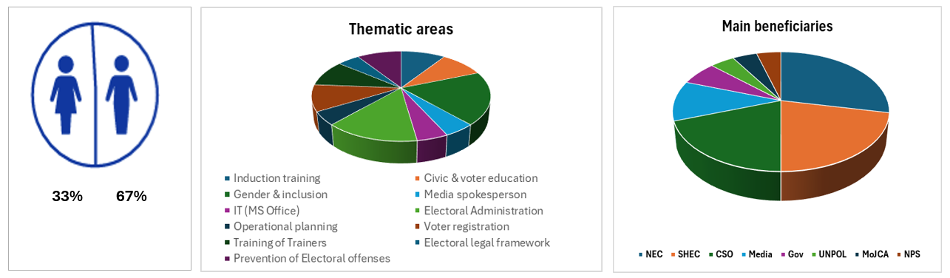

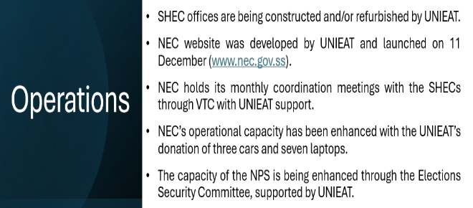
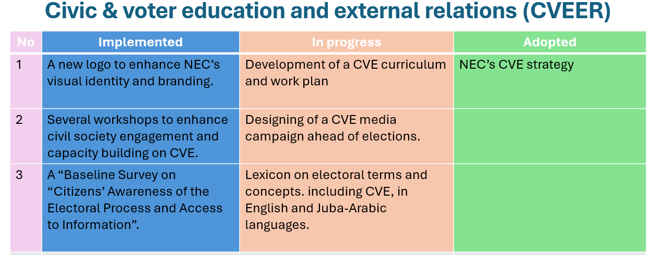

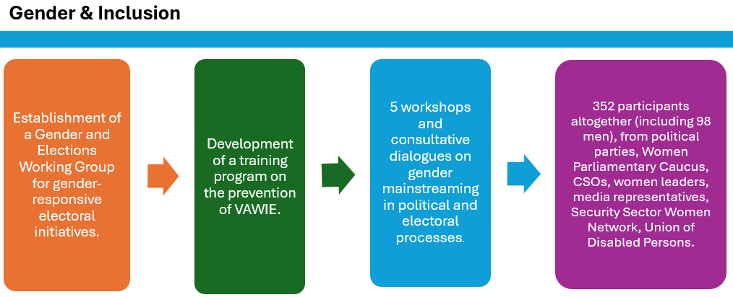
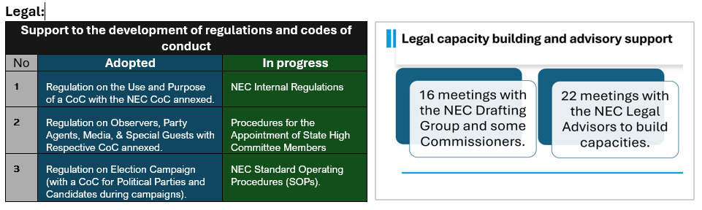

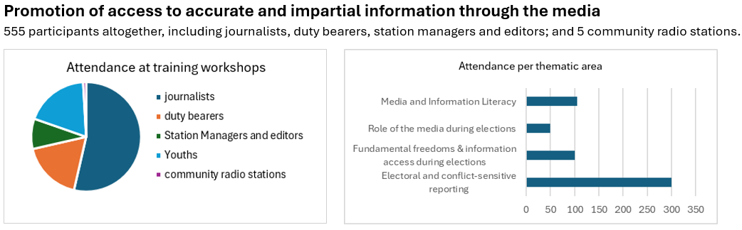

Output 1: Establishment of an enabling legal framework for free, fair, and inclusive elections is supported.
Results in this output relate to the support to the reform of legal framework for elections, drafting of regulations, other regulatory instruments and code of conduct. The year 2024 recorded some progress with respect to this output.
The UN IEAT, through a dedicated advisor co-located at the PPC provided regular support to the institution throughout 2024; the UN IEAT advised on the set up of the PPC structure and supported the drafting of: (i) the regulation on the registration of political parties, which contains provisions that UN IEAT advised against, as for instance the very high fees including for registration, and the code of conduct (CoC) for registered political parties, and (ii) the regulation on political party funding which were adopted by the PPC during the reporting period, and (iii) Guidelines on the Hearing and Determination of Disputes by the Political Parties.
UN IEAT also provided technical assistance for the development procedures for verification of application files for political party registration, including parameters for the verification and dispute resolutions. Further support is ongoing for the development of Dispute Resolution Regulations, and Guidelines on Hearing and Determination of Disputes by the PPC. Moreover, as part of its technical support, the UN IEAT also assisted the PPC in the development of a framework for monitoring and regulating political party activities. The UN IEAT supported the PPC in developing a Manual on the Processes Governing Mergers and Coalitions, Checklist, a user-friendly version of the legislative framework for political parties and a Monitoring, Evaluation and Reporting Tool and Checklist to be administered by the PPC in monitoring of political parties’ activities. The UNIEAT also provided support to the PPC’s participation in the Political Parties Forum where the development of the voluntary CoC for political parties was discussed and adopted.
Regarding support to the development of regulations and codes of conduct of the NEC, UN IEAT legal advisors contributed to the establishment in February 2024 and is part of the NEC legal drafting working group, which is led by the NEC Deputy Chairperson and includes two NEC legal officers. The working group takes the lead on drafting secondary legislation as well as review of the existing legal framework for elections (Electoral Act). The UN IEAT legal team participated in 16 meetings with the NEC legal drafting team and/or some Commissioners to discuss the legal framework and 22 meetings with the Legal Advisors of the NEC to build capacities, to raise awareness and promote knowledge about the multi-layer electoral legal framework and its challenges in South Sudan.
With support by the UN IEAT, the NEC drafted the Procedures for the Appointment of State High Committee Members , drafted and adopted three regulations and one code of conduct: (i) the Regulation on the NEC Code of Conduct and code of conduct; (ii) the Regulation on Observers, Party Agents, Media, and Special Guests, and (iii) the Regulation on Election Campaign (with a Code of Conduct for Political Parties and Candidates during Election Campaign);
The UN IEAT also supported the initial draft of the regulation for Campaign Finance and participated in ongoing review of NEC’s Internal regulations. Input and detailed commentary were provided to the draft Voluntary Registration and Code of Conduct for CSOs for engagement in voter and civic education activities.
The UN IEAT legal team also led the revision of the analysis of the National Elections Act and worked closely with the NEC legal department in finalizing the document, including a summary to contribute to an informed and comprehensive engagement with the parties to the agreement on the required legal reform. The analysis is also meant to be socialized with the broad range of electoral stakeholders to enhance a general understanding of the challenges and opportunities of the required legal reform.
UN IEAT extended support to the Ministry of Justice and Constitutional Affairs (MoJCA) in organizing two workshops for prosecutors and NPS investigators aimed at strengthening the capacity of the MoJCA and NPS to effectively respond to electoral offences. The two workshops held in Juba and Wau in October and November 2024 titled “Electoral Legal Framework: The Role of Prosecutors and Police Investigators in Preventing and Addressing Electoral Offenses” with 118 prosecutors and investigators in attendance from across South Sudan. The activity provided an opportunity for the two institutions to establish a collaborative partnership, which is likely to be further developed with the rollout of a broader training programme for prosecutors and investigators., The rollout is expected to begin once the legal framework on electoral disputes resolutions is established.
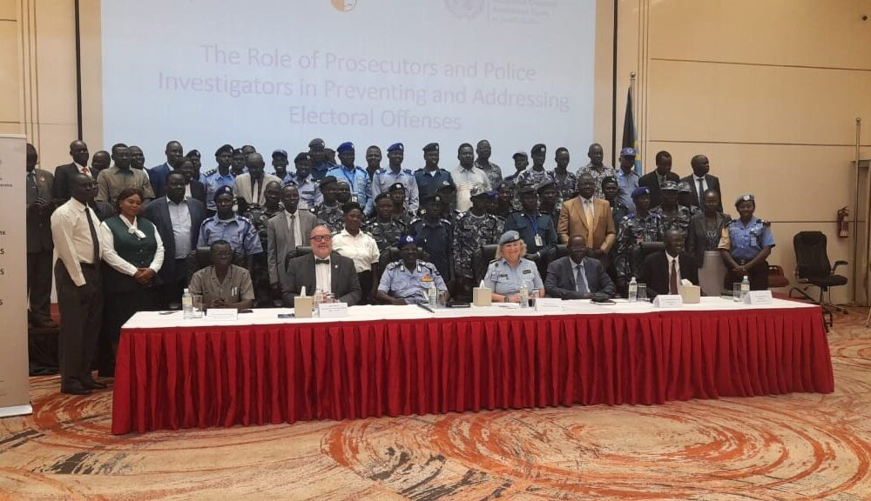
Group Photo, workshops on "The Electoral Legal Framework: The Role of Prosecutors and Police Investigators in Preventing and Addressing Electoral Offenses” that held in Juba from 16 - 17 October 2024.
The UN IEAT also coordinated with the UNMISS Rule of Law and Security Institutions Section (RoLSIS) to enhance the legislative drafting capabilities of the legislative committee of the Transitional National Legislative Assembly (TNLA). As part of its mandate on capacity building, the UN IEAT supported a training organised by RoLSIS to support the TNLA legislative committee on legislative drafting also aiming at re-launching discussions on requirements for the review of the legal framework for elections. It is hoped that the two-year extension of the transitional period and the postponement of elections to December 2026 would allow significant progress in the implementation of the R-ARCSS.
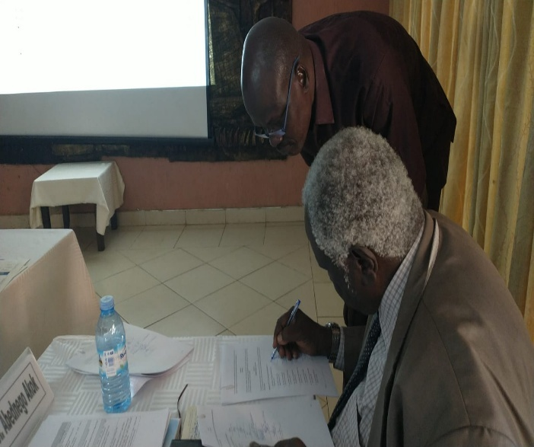
In terms of technical assistance, the UN IEAT supported the capacity building of the NEC and the PPC through regular meetings, coordination, technical advice, and contributions to draft legal documents. Throughout the reporting period the UN IEAT also provided several presentations and briefings on the legal framework for elections to national and internal interlocutors, and engaged on a regular basis with the NEC in drafting concept notes and other documents to support the development of the required secondary legal framework as well as planning capacity building activities.
NEC Chairperson, Hon. Prof. Abednego Akok Kacuol and Deputy Chairperson Gabriel Gabriel Deng, signing the NEC Code of Conduct during NEC’s operational planning retreat - December 2024 in Entebbe.

Output 2: Strengthened institutional capacities for professional, transparent, and accountable election management.
Following the appointment of the Board of Commissioners in early January 2024, the NEC identified institutional strengthening as its first priority. This encompassed three main areas: (i) capacity of Members and staff and institution building to (ii) support the institution’s planning for elections then scheduled for December 2024 and (iii) civic and voter education.
In line with its mandate to support the enabling environment for the establishment of the minimum conditions for credible, inclusive and peaceful elections, and in line with the priorities set by the NEC, throughout the year the UN IEAT supported the development and implementation of a broad capacity building programme. This included initial workshops for the Commissioners and core staff of the NEC on general principles of electoral administration starting in January 2024, as well as specific technical workshops on elections planning and operations, foundational principles of civic and voter education, voter registration modalities and ICT among others.
Similarly, the initial phase of capacity building for the PPC, as agreed with the PPC leadership, focused on effective management of the political party registration process. The UN IEAT also provided technical and operational assistance to the PPC to build its structure. This included technical assistance in the design of the PPC’s organizational structure, budget preparation and the development of operational plans. UN IEAT extended operational support to the PPC through the procurement of Internet services and ICT equipment to support the operational capacity of the institution. During the second part of 2024, the UN IEAT assisted the PPC in the development of its revised workplan for the 2025 financial year.
As a second phase of the capacity building efforts, a comprehensive training programme was design to extend support to other electoral stakeholders, including civil society, NPS and representatives of relevant ministers. Phase 2 was based on the Building Resources in Democracy Governance and Elections (BRIDGE) methodology and curriculum, the latter customized to address the specificities of South Sudan’s context. 20 workshops were conducted across 10 states and one administrative area between mid-May and end of June 2024. Over 400 participants were identified according to their role in the electoral process and attended one of five different modules: Introduction to electoral administration, building institutional excellency in elections, civic and voter education, operational planning, disability rights in elections. The aim of the extensive BRIDGE programme was to strengthen the understanding of electoral stakeholder on planning, organization and basic standards for the conduct of credible elections. As part of the programme, one Training the Facilitators (TtF) workshop was organized in June. The first 19 South Sudanese from the NEC, CSOs and UN IEAT, including one woman, were accredited and can continue building their experience and become fully accredited BRIDGE facilitators.
As the NEC appointed members of the SHECs in early July, the UNIEAT supported the drafting of the content for the initial briefing for the newly appointed members that followed the oath-taking ceremony on 11 July. This included: (i) the legal framework for elections; (ii) the structure of the NEC and roles of commissioners; and (iii) the vision, mission, values, and Code of conduct for the NEC. Fifty (50) copies of the National Elections Act were printed with support by the UN IEAT.
UN IEAT assisted with the conceptualization and implementation of a dedicated training programme for the 50 newly appointed members. The training programme included a 5-day induction in Juba in October and a series of specialized BRIDGE workshops that took place between October and November. Additional BRIDGE training were held during the same period specifically for CSOs representatives with some overall 150 individuals trained between October and November.
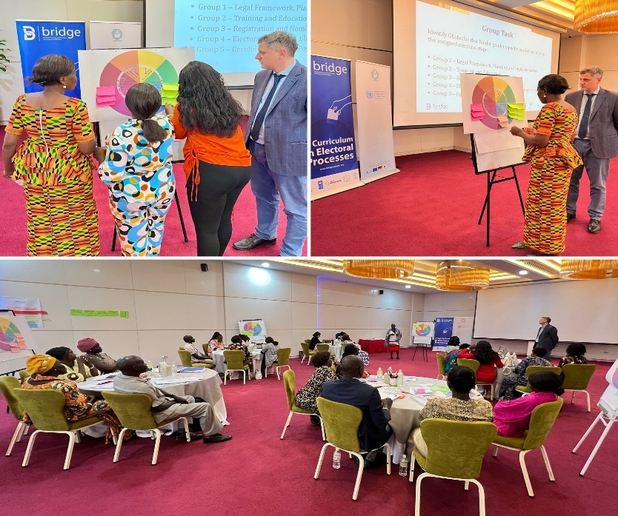
Beside these formal training and workshops, the UN IEAT worked daily with the NEC, providing on-the-job capacity building. Within this framework, the UN IEAT supported the drafting of the NEC organizational chart, the terms of references (ToRs) and functions for the directorates and departments, staffing requirements and a strategy to frame the priorities and way forward for the NEC. In close collaboration with various departments of the NEC, the UN IEAT assisted in drafting policies for web and email management and supported the NEC Secretariat in reviewing the elections’ budgets.
UN IEAT also supported the development of the NEC website which was launched on 11 December, accessible on www.nec.gov.ss , and supported the updating of the visual identity of the Commission, by providing technical support for the review of the NEC logo, adopted in November and developed the branding manual and user guide for the logo as part of the new corporate branding strategy.
Bridge training workshops for NEC, SHEC, and CSOs on electoral Administration

The UNIEAT also advised on the functioning of PPC’s Advanced Electronic Registration System, a demonstration of which took place on 17 July 2024.
The UN IEAT support also pertained to guidance and development of advisory papers vis-a-vis complaints filed before the PPC by parties with leadership wrangles, and the development of a Monitoring and Evaluation Tool on the activities of political parties. The purpose of the tool is to monitor political parties in the conduct of their activities to pre-empt deviations from the legislated prescriptions, and to ensure corrective actions are taken. Shared with PPC members on 3 September 2024, the Tool is internet based (“Google Tool) with back-end user analysis and report generation. However, given the limited IT capacity of PPC staff, the tool was developed for an interim period, through the generation of a verification checklist and reporting instrument.
Starting January, the UN IEAT supported the establishment of regular coordination between the NEC HQs and field structure. The first virtual meeting was facilitated through VTC equipment at UNMISS Tomping premises in Juba and in UNMISS field offices. The VTC meeting weres regularized following the nomination of SHECs members in early July and occur monthly since September.
Following the two-year extension of the transitional period in September, UN IEAT support the NEC in conducting a thorough review on the impact of the extension on electoral preparation. To this end the team assisted with the analysis of the timeline of the extension, the review of the legal framework as well as considerations on budget and operational plans. As part of the review process, with the aim at consolidating the analysis conducted since late September, the UN IEAT also supported the NEC’s three-day operational planning retreat of 3-5 December 2024 in Entebbe, Uganda. The retreat concluded with the signature of three regulations, the code of conduct for Members and staff of the NEC, an action plan and the issuing of a communiqué. The communiqué stated the need of political decision on the review of the timeline, considered by the NEC not feasible, the need for legal review and immediate release of funding to enable the NEC to plan and implement elections in December 2026.
During the Entebbe retreat, the NEC also identified as a priority the engagement with political parties and civil society as a means to strengthen understanding of stakeholders of the electoral process, enhance transparency and foster progress in political decision-making. The first of the consultations for political parties was hold by the NEC, with support by IEAT, on 17 December. The main objective of the consultation was to socialize the content of the communiqué, with emphasis on the challenges posed by a not feasible extension timeline.
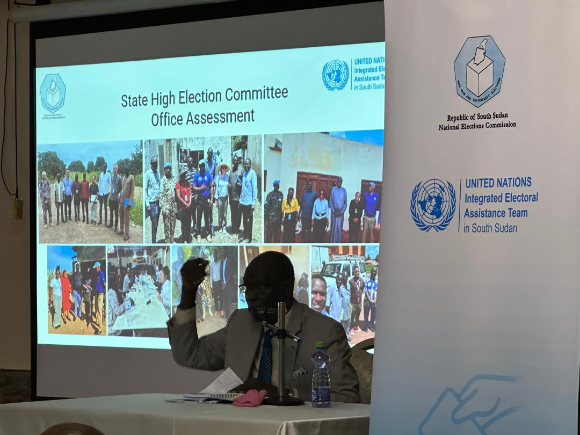
As part of its mandate to support institution building of the NEC, the UN IEAT provided operational support for enhancing operational capacity of the NEC in HQ through the procurement of essential equipment and services. In coordination with JICA and liaison with IGAD, who also provided operational support, to avoid duplications, UN IEAT procured ICT equipment, internet services and Microsoft Office licenses for the NEC and supported the re-establishment of back up electricity supply at the Juba HQs (rented premises). During 2024, UN IEAT also supported the NEC in the assessment of the state offices infrastructures and equipment. To this end, UN IEAT provided operational assistance for the first round of visits of newly elected Commissioners to the 10 states. This first round of assessment was followed by a review following the appointment of SHECs members. As a result, through the UNMISS component of the UN IEAT, 10 Quik Impact Projects (QIPs) were submitted for the refurbishing and or reconstruction of SHECs offices. The scope of the QIPs was agreed with the NEC and tailored to the needs of each state and are expected to be completed by June 2025. These included, among others, the procurement of furniture, solar panels, and a variety of construction works. By the end of the year, UN IEAT, through the UNDP lead basket fund, also launched the procurement of around 250,000 USD for ICT equipment mainly for SHECs offices. Equipment to be delivered in 2025.
NEC discussing SHECs assessments during the induction workshop for SHECs members from 5 to 8 October 2024 in Juba. Curtesy of UN IEAT.

Output 3: Inclusive participation fostered through enhanced rights and access to information.
Results in this output relate to promoting and protecting human rights in elections, promoting access to accurate and impartial information through media, supporting broad and inclusive CVE, strengthening civic engagement in promoting electoral standards and good practices, fostering inclusive political participation in elections for women and other vulnerable groups and the provision of technical advisory support. There was some progress with respect to this output during the year 2024.
To support the efforts of the NEC in implementing its mandate on civic and voter education (CVE), UN IEAT, in close coordination with the Japanese International Cooperation Agency (JICA) and The EU funded Democracy Reporting International gGmbH (DRI), supported the establishment of coordination mechanisms to ensure a coherent, comprehensive and effective action of the NEC as well as the cohesive support by the international community. To this end UN IEAT advised on the establishment of two CVE Working Groups early in the year. The CVE working group of the NEC was established as part of the NEC internal coordination mechanisms and includes representatives of JICA and UN IEAT. The NEC CVE Working Group has been meeting regularly on a weekly basis during the year and has enabled the institution to plan, implement and monitor the progress of its working plan. The participation of JICA and UN IEAT at the working group has also ensure effective coordination of international technical support. The establishment of a second working group, comprising of the international partners of the NEC, JICA, DRI, FES and UN IEAT (UNDP/UNMISS/UNESCO/UN Women), aims at strengthening coordination and cohesive support to the NEC and other stakeholders. The working group has been meeting regularly on a fortnightly basis since February and had a positive impact on the ability of international partners to effectively support the NEC and other national stakeholders, most importantly including civil society, avoid duplication of efforts and importantly create opportunities for joint activities.
UN IEAT, in partnership with JICA and DRI, supported the newly established NEC CVE working group to identify priorities and the working plan for the year. The first priority identified was the development of a CVE strategy to inform the development of inclusive and effective CVE campaigns.
As part of the development of the strategy, together with JICA, DRI and UN Women, UN IEAT supported the conceptualization and implementation of a base-line survey on elections awareness and sources of information to identify gaps and inform the CVE strategy. As part of the support, JICA and UN IEAT engaged a company to implement the base-line survey. The base-line survey was rolled out in November and the draft report was issued in December following an initial validation workshop. The NEC decided to establish a Steering Committee to oversee the implementation of the base-line survey and adoption of the final report, planned for the first quarter of 2025. The Steering Committee included representatives of the NEC, JICA, DRI, UN IEAT, CSOs and relevant Ministries.
The strategy was drafted and consulted internally within the NEC awaiting finalization through the inclusion of recommendation from the base-line survey. While awaiting the finalization of the strategy, based on the draft survey report, the NEC started developing the operational plan for the first civic education campaign to be implemented during the first half of 2025.
In parallel and complementary to the drafting of the CVE strategy, UN IEAT supported the design and implementation of workshops to build the capacity of the NEC and other electoral stakeholders to equip stakeholders with the knowledge and instrument required to take full ownership of the strategy, or contributions to it. The capacity building programme had also a strong focus on inclusivity, to strengthen the participation of women, youth, persons with disabilities and other marginalized groups to the electoral process. The capacity building programme included initial internal workshops for NEC staff, followed by workshops for multiple stakeholders including NEC, civil society the media and relevant ministries. Additionally, as inclusivity was recognized as one of the main principles guiding the NEC efforts on CVE, the initial draft of the strategy was presented to civil society groups early in its development to include the perspective and suggestions by women’s groups, youth and persons with disabilities organizations.
UN IEAT also supported the development of a CVE curriculum to guide civil society and state actors in implementing CVE activities, specifically to foster consistent and coordinated messaging. A national consultant was recruited to ensure that the curriculum responds to the cultural and societal realities of the country.
During the last quarter of 2024, UN IEAT launched two different initiatives to support the implementation of NEC’s CVE campaigns. A 240,000 USD procurement process for services and goods was initiated through UNMISS funding to contribute to the NEC campaign to be implemented by June 2025. In parallel, the UNDP component of UN IEAT initiated the engagement with three CSOs to conduct campaigns to strengthen the participation of Internally Displaced Persons (IDPs) in the electoral process in Upper Nile, Western Bahr-el-Ghazal and Northern Bahr-el-Ghazal. The CSOs were identified and work started on the development of the campaigns for completion by March 2025. The campaigns aim at reaching out directly at a minimum of 50,000 individuals in each of the three states.
By December, the UNIEAT also finalized the first edition of the lexicon on election terms and concepts in English and Arabic languages for a wider public use, including CVE terminology. The lexicon, based on similar documents produced by the UN in other countries, aims not only at standardizing the use of electoral terminology but also raising awareness of electoral related principles. The lexicon is expected to be published during the first quarter of 2025.
During the year UN IEAT also coordinated and supported, both through technical and operational assistance, several activities led by national CSOs, international partners and other UNMISS components with the objective of fostering dialogue among electoral stakeholders, enhancing the political and civil space, strengthening inclusivity and over all contributing to building an enabling environment for inclusive, credible and peaceful elections.
To this end UN IEAT partnered with the Community Empowerment and Progress Organisation (CEPO) and supported the conduct of several workshops throughout the year for civil society organization and other stakeholders. Thematic areas varied from political transition processes and election observation and civic and voter education.
In the same vein, in December, the UN IEAT supported a workshop on women and elections organised by DRI and Mamara Sakit, a civil society organization, which focused inter alia on the South Sudan electoral legal framework and the electoral system. Participants comprised women from CSOs and political parties. The workshop highlighted the impact of the legal framework on gender equality and women’s participation in the electoral process and enlightened them on the opportunities and challenges in the legal framework and how they can take advantage of them to advance women's political participation.
UN IEAT takes part in the dialogue platform with CSOs established by UNMISS under auspices of the SRSG. The meetings with CSOs take place on a quarterly basis.
UN IEAT also collaborated with UNMISS Political and Civil Affairs sections on electoral components workshops and fora organized for political parties and other state and non-state actors. To this end, UN IEAT contributes to preparation of material related to elections but also facilitates the participation of the NEC through operational support to the PAD-led Monthly Political Parties Forum. The engagement of UN IEAT was provided both at national and state level. For instance, in November, the UNIEAT also supported a BRIDGE training workshop on CVE for CSOs. The UNIEAT also provided guidance for civic education activities for the UNMISS Field Offices in Central Equatoria, and Western Equatoria States and participated in the launch of a Quick Impact Project (QIP) to support Civic and Voter Education (CVE) in Central Equatoria State (CES), under the auspices of the CSO Network. The UNIEAT provided technical support in the review of sensitization campaign messages intended to reach over 35,000 people in three months.
UN IEAT support to strengthening a gender and inclusion focus during the year focused on different fronts: strengthening the capacity of the NEC to mainstream gender and inclusion in building the institution and its actions as well as promoting gender and inclusion as a key element of electoral preparations with the broader spectrum of electoral stakeholders.
To this end, UN IEAT assisted the NEC with the conduct of and internal Gender Audit, involving an assessment of its status regarding gender equality and social inclusion. Subsequently, meetings were held with the NEC Commissioner overseeing gender and inclusion efforts, to discuss existing gaps and priorities within NEC. A desktop review of relevant laws, including election-related legislation laid the groundwork for shaping NEC’s Gender and Social Inclusion Policy which aims at addressing gaps and promoting gender equality and inclusivity in its operations. The Gender and Social Inclusion Policy was drafted and awaiting adoption by the Board of Commissioners. Similarly, the UN IEAT supported the PPC in finalizing a gender assessment questionnaire for political parties.
Support specifically aiming at fostering inclusive political participation in elections for women and other vulnerable groups, included the establishment of a coordination mechanism on gender and elections. The Women’s Political Participation Working Group was established in September including the UNIEAT, UNPOL, UNMISS’ Gender Affairs Unit, other gender components and UN Women. The group meets regularly to harmonise actions towards and rationalized support national counterparts on gender and inclusion activities.
During the reporting period, UN Women, in collaboration with other UN entities, and partner organisations, enhanced the capacities of electoral stakeholders, including the PPC through consultative dialogues related to the political parties’ assessment. A total of 100 participants (49 women, 51 men) including 29 in the positions of Secretary General and the seniormost women in 29 registered political parties, participated in the consultations. Others were members of the Women Parliamentary Caucus and the PPC. The dialogues led to an ongoing survey of 29 registered political parties aims to ensure gender responsiveness to develop inclusive policies for various marginalized groups. The initiative is expected to enhance gender-sensitive practices and more inclusive policies.
Still as part of its support to the PPC, the UN-IEAT organized, in collaboration with DRI, a 3-day workshop in Juba from 19 to 21 June to sensitize women from political parties on the upcoming elections. The event aimed at enhancing women’s representation in political parties. it brought together 67 women who engaged in discussions and dialogue on the role of women in political parties and measures towards promoting participation of women in the electoral process. Moreover, still as part of its capacity building efforts, the WPPWG designed a training programme on the prevention of VAWiE to build the capacities of NEC and UNPOL trainers to subsequently train members of the NPS in each state and to promote the inclusive political participation of women and vulnerable groups in elections.
Similarly, from 13-15 November in Juba, UN Women held a three-day intergenerational dialogue on women's leadership and political participation. It was attended by 127 participants (107 women and 20 men), including representatives from the Women Parliamentary Caucus, the East African Legislative Assembly (South Sudan, Rwanda, and Kenya), the South Sudan Women Coalition, the South Sudan Security Sector Women Network, and the Union of Disabled Persons. The dialogue placed a strong emphasis on the upcoming elections, with speakers underscoring the need for increased female representation and active involvement in the electoral process. Key points included the importance of creating enabling environments for women's participation, fostering intergenerational mentorship, and ensuring that elections are inclusive and gender responsive. Participants also called for strengthened collaboration at regional and national levels to promote sustainable solutions for advancing women's roles in political and electoral processes.
Furthermore, UN Women, in collaboration with UN IEAT and DRI, held strategic consultative dialogues with political parties, underrepresented groups, women’s CSOs, women leaders, faith-based and media organizations to strengthen evidence-based gender inclusion in political parties. The consultations aimed at gathering insights into the policies, practices and challenges related to gender equality and promoting inclusive leadership in political parties. 58 participants (31 women, 27 men) attended the sessions.
As to the promotion of access to accurate and impartial information through the media, UN IEAT operated through UNESCO to strengthen the capacity of journalists and editors, particularly women journalists, to deliver professional, accurate, impartial, conflict-sensitive and gender-sensitive reporting on elections. UNESCO also built the capacities of community radio stations in election broadcasting and promoted understanding of the positive role of the media in electoral processes and principles of freedom of and access to information through awareness raising targeting different stakeholders, including security personnel, the Media Authority, the South Sudan Broadcasting Corporation, specialised Parliamentary Committee for Information and media associations. Focus was placed on constructively engaging youth in local media activities around elections, and strategies for responding to mis/disinformation and hate speech, particularly against women. Thematic areas including media professionalism, electoral coverage, legal frameworks, countering hate speech, misinformation and disinformation, gender responsive reporting, conflict sensitive reporting, media and information literacy were covered, including the strengthening of grassroot communities to participate in elections. In addition, key documents such as the “Mass Media Election Coverage Guide” were drafted to strengthen self-regulatory mechanisms among media professionals. Some of the achievements through the year include:
- Training of over three hundred (300) journalists across the ten states in partnership with the Union of Journalists of South Sudan (UJOSS). The journalists were equipped with skills on electoral reporting; the legal framework on elections; fundamental rights and freedoms; improved understanding on conflict sensitive and gender responsive reporting; fact checking; physical safety during elections; media and information literacy; countering hate speech; and ethical and accurate reporting.
- At least one hundred (100), duty bearers (State Ministers of Information, Director Generals, parliamentarians, security representatives and journalists) drawn from the Greater Bahr El-Ghazal region, Greater Upper Nile region, and Equatoria region were trained and equipped with knowledge on legal frameworks, including their role in promoting the safety of journalists, fundamental freedoms and access to information during elections. The beneficiaries committed to support freedom of expression, the safety of journalists and access to information during elections.
- Over fifty (50) Station Managers and editors from Greater Bahr-El Ghazal Region, Equatoria region and Greater Upper Nile Regions were trained and equipped with skills and knowledge on electoral reporting; awareness-raising on the role of the media during elections; conflict-sensitive reporting; gender-responsive reporting; fact-checking; countering hate speech; ethical and accurate reporting. The training aimed at strengthening and increasing the role of the media in educating and promoting access to information during elections for the public, as well as the use of the media to promote peaceful elections.
- The development of the draft “Mass Media Election Coverage Guide”, in partnership with the Association for Media Development in South Sudan. The guide is a set of Self-regulatory principles that involves both the initiation and maintenance of behavioural change for journalists during elections in South Sudan, while inhibiting undesired behaviours and responding to situational demands before, during and after elections.
- In partnership with Youth Media Initiative South Sudan (YMISS) and Centre for Media and Information Literacy, Kenya, 105 youths in Bor, Rumbek and Wau were trained and equipped with skills and knowledge on Media and Information Literacy with the aim of empowering young people with skills, including critical thinking and creative problem solving to allow them to become informed consumers as well as information producers. Also, the youth were trained on combating hate speech, misinformation, and disinformation and integration of values of peace, tolerance, and cultural understanding.
- Five community radio stations in Amadi, Magwi, Yirol, Pibor, Ruweng and, Morobo were supported towards diversifying their content, information/data, and the ability to promote balanced reporting on electoral issues. In addition, over 100 members of the youth and women listeners’ clubs in the five locations were trained and are now able to listen and contribute to programmes on elections. Also, a new women’s listener club was established in Pibor.
- Furthermore, to promote access to information and educate communities on elections and democratic processes, UNESCO partnered with Radio Community to produce and broadcast programs to inform and educate communities on the election process through radio talk shows. The stations included Singaita 88.3 FM in Kapoeta, Eastern Equatoria state, Akol Yam 90.1 FM in Aweil, Northern Barh el Ghazal state, Mingkaman 100 FM in Awerial, Lake’s state, Leer 88.0 FM in Unity State, and Mayardit 90.7 FM, and Turalei, Warrap State. Each station broadcast reached an estimated 500,000 people, except Leer which is estimated at 150,000 people (2008 Sudan population and housing census estimates). The Broadcast Radius was 100 KM, and programs were broadcasted in the Dinka, Nuer and Toposa local languages, and they addressed the importance of elections in South Sudan, the role of citizens in an election and the civic duties of an electorate, the role of the NEC, the economic situation and how it will impact the election process come December 2026 among others.
Output 4: Enhanced environment for maintaining security and mitigating violence during elections.
Results in this output pertain to the strengthening of the police and other security actors in maintaining security for elections; promoting civic and community engagement in preventing electoral violence; and technical advisory support to other election security related matters. There was some progress during the year 2024 with respect to this output.
The main achievement under this output during the year was the establishment of a constructive partnership with the National Police Service (NPS) on elections security, which laid the foundations for the coordination with the NEC and further collaboration for 2025.
During the first half of the year, together with UNPOL, UN IEAT engaged with the Minister of Interior, the Inspector General of Police (IGP) and the Elections Security Committee (ESC), to assist with the review of the elections’ security plan and elections security manual drafted by the NPS and develop a sound capacity building programme on elections security for NPS.
The NPS was very keen on a partnership with UN IEAT on a capacity building programme for the institution, nevertheless, there were initial divergencies of views on what the programme would look like. A breakthrough came about when a step-by-step approach was agreed. NPS requested support for the conduct of a workshop for its leadership in HQs and state level. The Leadership workshop on the role of police in electoral process, that took place over 3 days in Juba at the beginning of July, opened the door to a more practical engagement with NPS. With a strengthen understanding of the role of the police and other stakeholder in elections, the need for close collaboration with the NEC as well as other stakeholders, NPS requested the NEC and UN IEAT to be part of the ESC coordination structure (established by NPS since the end of 2022) and regularized the meeting schedule of the committee. The ESC has been meeting on a weekly basis since August. The coordination mechanism, proved to be essential for a coordinated effort and planning. Since August, important decisions were taken such as the review of the training manual through a joint committee including NPS, NEC and UN IEAT, the development a revised security plan to build in the requirements of NEC following its operational plan and the development of training plans to cascade the workshop on elections security to the middle management of NPS at state level and a broad training on the prevention of electoral violence against women in elections (VAWiE) for a broad range of state and county NPS officials. To this end, UN IEAT developed curricula for both training programmes and a manual for the prevention of VAWiE. The development of the manual, finalized and adopted in early November also prompted the development of three brochures on the role of prevention of VAWiE, respectively on the role of NPS, CSOs and NEC.
The training will be implemented through a cascade methodology with UNPOL taking the lead on Training of Trainers for NPS. The training will be rolled out in January, with a training of UNPOL trainers in Juba and consequent training of NPS trainers at state level and further training directly implemented by NPS.
Since September, NPS officials have been included in a broad range of capacity building activities organized by or coordinated with UN IEAT. This includes BRIDGE workshops on VAWiE and the workshops on electoral disputes co-organized under the leadership of MoJCA, for prosecutors and NPS investigators that took place in Juba and Wau, respectively in October and November.
Furthermore, the ESC platform was the opportunity to discuss in depth the issue of prevention and mitigation of electoral violence. While an official decision on the role the police will hold in elections security, the is an expectation that the NPS will take the lead. Operating under this assumption, the NPS had established as one of its priorities that of building its institutional readiness, beyond capacity building of its forces. To this end, based on the request of NPS, UN IEAT supported the strengthening if its infrastructure in Juba by building and equipping a meeting/office space at the NPS Buluk facilities in Juba for the ESC as well as enhancing infrastructure at the premises where the Joint Electoral Operation Center (JEOC) operated for the 2010 Sudan elections and the 2011 referendum. Works at both locations are expected to be completed by the end of January 2025 and to be handed over to NPS.
In line with the above, UN IEAT has agreed to support field visits to each of the 10 states and two administrative areas to assess the status of NPS infrastructure in light of the establishment of JEOCs. An assessment form has been developed to standardize fundings and enable a comprehensive assessment to inform requirements and possible operational support by the UN IEAT. The visits scheduled to start in February 2025 will include members of NPS, NEC and UN IEAT.
Output 5: Strengthened effectiveness in planning and implementing electoral operations for all citizens.
NOT ACTIVE.
Output 6: Project effectively managed.
In 2024, the Project Management Support Unit (PMSU) made significant strides in delivering effective oversight, coordination, and operational support under Output VI of the South Sudan Electoral Support Project. The Unit served as the backbone of project implementation, ensuring timely and responsive support in a dynamic electoral environment.
One of the key accomplishments was the development and successful submission of two critical planning instruments: the 2024 Annual Work Plan (AWP), with an approved budget of USD 7.3 million, and the 2025 AWP, with an indicative budget of USD 5.6 million. Both were formulated in full alignment with UNDP operational standards and the specific stipulations of donor contribution agreements. These plans not only structured the project’s technical and financial trajectory but also reaffirmed the Project’s commitment to transparency, results-based management, and value for money. Resource mobilisation efforts were markedly enhanced through PMSU’s technical input in the drafting of funding proposals to key development partners, including the Netherlands (USD 1 million), Japan (USD 750,000), and the UN Peacebuilding Fund (USD 500,000). These efforts contributed to securing a total of USD 1.5 million in new funding from the UN PBF, Switzerland, Japan, and UN Women. Furthermore, PMSU coordinated amendments to existing donor agreements with the European Union, Canada, Switzerland, UN Women, and UNESCO, safeguarding continuity and reinforcing donor confidence in the project’s governance mechanisms. Strategic partnerships were nurtured and operationalised, particularly with UN Women and UNESCO, yielding outputs such as initiatives to reduce violence against women in elections and professional development for media actors in electoral reporting.
PMSU’s role in maintaining effective oversight was equally critical. The Unit ensured the regular and accurate updating of project data in UNDP’s Quantum system, enabling transparent financial tracking and reporting. High-quality, results-focused reports were submitted to donors, national counterparts, and the UNDP Country Office, reinforcing accountability and promoting shared ownership. This was complemented by the successful coordination of four Project Board meetings (held in March, May, September, and December), during which key strategic and financial decisions were endorsed, including the approval of the 2025 AWP.
Central to the Unit’s responsibilities was the strategic recruitment and onboarding of qualified national and international personnel. Over the course of the year, the PMSU led competitive recruitment processes for a range of highly specialised positions, including but not limited to: Procurement Specialist, Logistics Specialist, Electoral Reporting and Coordination Specialist, Electoral Dispute Resolution Consultant, Electoral Planning Consultant, Early Warning System Analyst, Gender and Inclusion Consultant, and BRIDGE-accredited trainers. These appointments significantly strengthened the project’s technical and operational foundation and enhanced its ability to respond to evolving electoral priorities.
Collaboration with national and international partners was further deepened through PMSU’s proactive engagement with the National Elections Commission (NEC), Political Parties Council (PPC), and other electoral stakeholders. PMSU provided technical advisory services that supported institutional strengthening, organisational development, and staff deployment within the NEC, thereby contributing to the enhancement of its internal operations and readiness to fulfil its constitutional mandate. In its broader capacity-building role, the PMSU facilitated the implementation of BRIDGE training workshops across a series of thematic modules from April to December 2024, tailored to the needs of electoral institutions and stakeholders. Additionally, the Unit developed and launched a Request for Proposal (RFP) for a baseline survey on public awareness and access to electoral information, setting the stage for more targeted voter education interventions. Through its support to the issuance of grant agreements for three civil society organisations (CSOs), PMSU also advanced grassroots civic engagement and outreach. To strengthen institutional capacity, PMSU drafted an RFP for a comprehensive Capacity Building Programme for NEC, encompassing human resources, finance, procurement, and project management. In support of electoral security, PMSU facilitated coordination between the NEC and the National Police Service (NPS), and oversaw infrastructure enhancements, including the construction of the Electoral Security Committee Office at NPS headquarters in Juba. Regular technical advisory support was also extended to the NEC on budget formulation, operational planning, and preparedness strategies, ensuring that the institution was adequately equipped to discharge its mandate.
From a financial and operational standpoint, PMSU effectively managed a multi-donor basket fund valued at USD 7.5 million, supported by contributions from Canada, the EU, Germany (Africa Elections Fund), Switzerland, Japan, the UN Peacebuilding Fund, UN Women, and UNDP core resources. The Unit oversee the procurement activities totalling approximately USD 1.5 million, encompassing the drafting of Terms of Reference, technical specifications, and bid evaluations all in full compliance with UNDP procurement policies. Notably, PMSU also facilitated the drafting and finalisation of a Memorandum of Understanding between UNDP and UNMISS, enabling the relocation of UNDP electoral personnel to UNMISS premises. This strategic co-location has significantly improved coordination within the UN Integrated Electoral Assistance Team (UN IEAT) and strengthened joint programming and operational coherence between UNDP and UNMISS.
Throughout the year, the work of the PMSU demonstrated not only operational efficiency and rigour but also a deep commitment to fostering inclusive, resilient, and accountable electoral processes. Its achievements in 2024 reflect a responsive, values-driven approach to project management anchored in the principles of partnership, equity, and good governance that has laid the groundwork for the next phase of support to South Sudan’s electoral process.

PARTNERSHIP
In alignment with the United Nations’ integrated approach to electoral assistance in mission settings, the South Sudan Electoral Support (SSES) Project, led by UNDP, forms a critical component of the United Nations Integrated Electoral Assistance Team (UN IEAT), under the political and operational leadership of the United Nations Mission in South Sudan (UNMISS).
The Project’s partnership strategy is designed to maximise synergies, reduce duplication of efforts, and ensure a coherent and consistent delivery of support to national institutions and platforms. This collaborative approach reflects not only a practical commitment to development effectiveness, but also a shared sense of responsibility among stakeholders towards South Sudan’s democratic transition. The contributions and roles of partners are reflected across all project outputs, reinforcing a whole-of-project ethos grounded in consensus and mutual accountability.
At the heart of the SSES Project’s engagement are South Sudan’s national institutions and entities, whose ownership and leadership are critical to the long-term sustainability of electoral processes. The project supports national counterparts in strengthening institutional capacities, deepening civic engagement, and extending the reach and inclusivity of electoral support to subnational and grassroots levels. The primary institutional partner remains the National Elections Commission (NEC), with which the Project collaborates closely in both the planning and implementation of electoral activities. Additional national partners include the Political Parties Council (PPC), National Police Service (NPS), and a broad spectrum of civil society organisations (CSOs), all of whom play important roles in fostering an inclusive, peaceful, and participatory electoral environment.
The Project also leverages synergies within the broader UNDP portfolio, aligning with complementary initiatives in access to justice, human rights, rule of law, peacebuilding, governance, gender equality, and youth empowerment. This internal collaboration ensures that electoral assistance is embedded within a wider development framework and avoids the establishment of parallel structures.
At the UN system level, the SSES Project works in close coordination with UNMISS and relevant UN agencies, drawing on their respective mandates and comparative advantages. Notably, collaboration with UN Women has supported efforts to advance women’s participation and rights within the electoral process, while engagement with UNESCO has focused on strengthening media development, access to information, and civic education.
Beyond the UN system, the Project actively coordinates with international and regional actors to enhance complementarity, avoid overlap, and optimise the collective use of resources. Strategic cooperation with the African Union leverages the organisation’s regional legitimacy and electoral expertise, particularly in observation and technical advisory roles. The Project also works closely with bilateral and technical partners such as the Japan International Cooperation Agency (JICA), whose capacity-building programme for the NEC reinforces institutional preparedness, and the Max Planck Foundation, which provides legal and constitutional advisory support.
International Donor Partners
The SSES Project benefits from the generous diplomatic and financial contributions of several international partners, whose sustained support reflects a broader commitment to democratic governance and peace in South Sudan. Core donors include Canada, the European Union, Germany (through the Africa Elections Fund), Japan, and Switzerland. Their support not only facilitates the delivery of electoral assistance, but also underscores the shared international interest in fostering credible, peaceful, and inclusive electoral processes in the country.

PROJECT MONITORING AND EVALUATION
In 2024, four Project Board meetings were convened in March, May, September, and December, under the auspices of the UNDP South Sudan Electoral Support Project (SESS). These meetings brought together the National Elections Commission (NEC) and international partners, serving as a critical platform for strategic dialogue and decision-making. Beyond the formalities, the gatherings fostered a spirit of collaboration and shared responsibility, enabling stakeholders to review and approve annual work plans and budgets aligned with the project’s results and resources framework. Importantly, the meetings played a central role in providing oversight, tracking progress against planned activities, and ensuring the project remained responsive to evolving priorities on the ground.
By the end of the year 2024, the Project, overall, had made some progress in the outputs, despite a very challenging year with a sociopolitical and economic context marked by economic crisis, lack of national funding for relevant national institutions, a deadlock in the implementation of the transition and electoral operations, and consequent extension of the transitional period to February 2027 and postponement of elections from December 2024 to December 2026. These factors inevitably slowed down the initial momentum to implement the electoral process by the NEC and the other relevant electoral stakeholders, thereby preventing the UN IEAT from achieving most of its planned outputs.
However, this political deadlock also created an opportunity for the NEC and the other relevant national electoral stakeholders to reprioritise and focus on enhancing the creation of an enabling environment for inclusive and credible elections in 2026.

CHALLENGES and LESSONS LEARNED
Challenges and lessons learned for the year include the following:
Capacity gains are fragile in the absence of fully recruited staff within permanent NEC structure : The UN IEAT and other international assistance providers take a capacity-building approach to their work. The reduced number of permanent NEC staff during this period, together with the limited experience in managing electoral operations within both the Board of Commissioners and the Secretariat, puts at risk the ability of the institution to retain knowledge and lessons from the pre-elections period. A related challenge concerns NEC’s staff and leadership being overwhelmed by the sheer volume of international assistance providers relative to their own skeleton staff. Lessons from initial stages of implementation, point to the need for permanent staff to be recruited at an early stage in the process.
Lack of infrastructure and funding hamper the ability of electoral institution to perform: The infrastructure of the main state counterparts, NEC, PPC and NPS was almost inexistent or inadequate at the beginning of the year. The limited funding received during the reporting period, only in the case of the PPC resulted in a substantial improvement with new functional premises established in Juba. The absence of adequate infrastructure had a significant impact, especially on the NEC’s ability to deliver on its mandate. The UN IEAT stepped up to support the establishment of minimum operational requirements both in HQ and state level. While the support from international partners in developing the infrastructure is still in progress at the end of 2024, looking forward to 2025, the dependence from the international community is a concern in terms of sustainability. Learning from previous experience, UN IEAT focused on supporting the establishment of permanent structures and essential communications needs through the procurement of ICT equipment and services as well as limited support to transport.
Maintaining adaptability and flexibility to cope with unexpected changes to the operating context: The year 2024 was characterized by uncertainties around the ability of South Sudan to conduct elections scheduled in December. There was limited progress in the implementation of the key milestones of the roadmap, notably the reconstitution of the electoral institutions, but none on CMP and census. In view of these significant delays, a decision by the signatory to the R-ARCSS was made in September 2024 to extend the transition for two years. Lessons learned address the challenges associated with adapting to a fluid environment:
- Persistent lack of political decisions carried knock-on effects for the eventual electoral process, requiring extension of the transitional period and rescheduling of elections.
- A fluid operational environment necessitated ongoing efforts to ensure flexibility.
- Resource availability is less predictable and less stable, negatively impacting flexibility.
- The persistent lack of legal clarity hampers the ability of the NEC to thoroughly plan for different phases of elections.
- Political and security challenges increased the complexity associated with planning.
Establishment of coordination mechanisms strengthen the effectiveness of national management of processes as well as international support: The establishment of coordination mechanism within the NEC and NPS to manage planning for elections as well as the establishment of coordination mechanisms among international providers of electoral technical assistance, proved to be effective in streamlining efforts and minimizing duplications. The establishment of these coordination mechanisms are expected to enable a cohesive and coherent modus operandi for more labour-intensive periods ahead.

RISK MONITORING
During the reporting period, the situation for each of the below risks, pre-identified in the Project document, was as follows:
- Risks associated with the national context.
Risk #1: Increased instability and insecurity. The reporting period witnessed an increase in the probability of the occurrence of this risk, but no impact on the electoral process at its current stage.
Risk #2: Changes in the political and electoral context resulting in new priorities. The reporting period witnessed a high probability with respect to this risk which eventually materialized with the postponement of elections to December 2026.
Risk #3: Reduction in political and civic space. The reporting period saw the political and civic space still challenged, however with little impact on the electoral process as the latter remained at its inception phase and eventually elections were postponed.
Risk #4: Delays in the implementation of the R-ARCSS and legal and institutional frameworks to hold elections. There was a high probability with respect to the occurrence of this risk, which materialized during the reporting period with the extension of the transitional period, therefore a high impact on the timely implementation of the electoral process.
Risk #5: Natural or manmade hazards. No change with respect to this risk over the reporting period as it remained high with floods limiting access to some areas. However, there was little impact on the electoral process due to the absence of electoral operations.
Risk #6: Lack of experience and capacity of national stakeholders. The reporting period witnessed no change in the probability of this risk. The capacities of relevant national electoral stakeholders remained constringed by their inability to proceed with substantial recruitments, causing a delay in the implementation of their respective mandates. This has mostly impacted on the NEC.
Risk #7: Unaligned needs and lack of national ownership. No change to this risk over the reporting period, hence no impact on the electoral process. While on national ownership the risk is no longer relevant, thanks to the re-establishment and establishment of the NEC, PPC and NCRC
- Organisational Risks for the Project.
Risk #8: inadequate harmonization and rationalization of international efforts. No change to this risk over the reporting period, hence no impact on the electoral process.
Risk #9: lack of demand for, or consent to, international electoral assistance. While this risk remains low in the longer term, during the reporting the national counterparts established a very constructive relationship with UN IEAT and other international providers of electoral assistance hence the risk did not materialize.
Risk #10: Inadequate national funding of the electoral process. This risk materialized during the reporting period with high impact on the establishment of the NEC, the NPS and partly the PPC. This risk remains high for the year 2025. The Project itself remained underfunded throughout the year, nevertheless adequate programming of limited resources along with the slow implementation of electoral activities minimized the impact on the support provided to national counterparts.

PROPOSED WAY FORWARD AND NEXT STEPS
With the extension of the transitional period and the postponement of elections, the UN IEAT will uphold its coordination with, and support to, NEC, the SHECs, and other relevant national electoral stakeholders, including the NPS, PPC, the MoJCA, TNLA and CSOs.
Coordination and assistance continue focusing on the strengthening of the enabling environment for elections. Support will continue to be provided for capacity and institution building, enhancing the capacity of the NEC and CSOs to conduct civic and voter education, strengthening of an inclusive electoral process with focus on women, youth and other marginalized groups, supporting the legal reform and legal drafting, technical, logistical, and operational support, all with the overarching objective to enhance the capacities of the beneficiaries towards planning, organising and implementing the December 2026 General elections.
Specifically, during the year 2025:
- Under Output 1, the UN IEAT will continue supporting the NEC and the PPC in the development of regulations and codes of conduct for elections and other counterpart with the necessary reform of the legal framework for elections, including for effective electoral dispute resolution.
- Under Output 2, the UN IEAT will continue strengthening the institutional capacities of NEC, CSOs and other national stakeholders for accountable, transparent, and professional election management.
- Under Output 3, the UN IEAT will be fostering inclusivity through supporting civic and voter education planning and implementation, including for women and vulnerable groups, and enhancing access to information through support to media organisations in the provision of accurate and impartial information.
- Under Output 4, the UNIEAT will also be strengthening the institutional capacity and capacity building of the NPS as national, state and county level to professionally manage elections security and mitigate the occurrence of electoral related violence, with a specific focus on the prevention of violence against women in elections (VAWiE).
- Under Output 6, the UN IEAT will uphold its project management support towards achieving the above outputs but also maintaining a transparent and accountable relation with international partners.

ANNEX A: FAST FACTS
OPERATIONS (Coordination, ICT, electoral Logistics, elections Security, etc.)
No | Area | Achievements | Observations, challenges, and lessons learned.
1 | Coordination | Liaison with NEC and SHEC towards assessment of SHEC infrastructure and equipment.
2 | Logistics | Refurbishment of SHEC offices, construction of new offices, donation of four (4) cars and seven (7) laptops to NEC to enhance its operational capacity.
3 | ICT | - Development and launching of NEC’s website.  - Training on MS Office, emails, and website navigation.
4 | Elections security | Coordination in the framework of the Electoral Security Committee.  Capacity building on the prevention of VAWiE and electoral offenses.
LEGAL (including support to EDR and constitutional review)
No | Area | Achievements | Observations, challenges, and lessons learned.
1 | NEC Secondary Legislation - Regulation No. 1/2024 on the Use and Purpose of a Code of Conduct, with the NEC Code of Conduct; | Regulation adopted by Commission and Code of Conduct signed by the Commissioners in Dec 2024 | It remains unclear why this regulation and the code for conduct was not signed earlier – however, it happened during the NEC retreat in Entebbe.
2 | NEC Secondary Legislation - Regulation No. 2/2024 on Observers, Media Representatives, Agents and Special Guests (with four Codes of Conducts for observers, media representatives, agents and special guests); | Regulation adopted by Commission in Dec 2024
3 | NEC Secondary Legislation - | Regulation No. 3/2024 on Election Campaign (with a Code of Conduct for Political Parties and Candidates during Election Campaign) adopted by Commission in Dec 2024
4 | NEC Secondary Legislation | Internal NEC Regulation and Campaign Finance Regulation Regulations developed, awaiting discussion and adoption.
5 | Support to NEC in relation to electoral legal reform | Draft NEC analysis of the NEA and legal reform strategy paper developed, awaiting actions from NEC.
6 | Establishment of regular weekly meetings between UNIEAT and NEC legal advisors and NEC drafting group members. | Approx. 38 mentoring and advisory meetings were held between UNIEAT legal and NEC since the formal reconstitution of the NEC in 2024. | NEC was reconstituted in the beginning of 2024 but suffers from a lack of qualified staff. NEC drafting group did not meet regularly due to the absence of some key NEC group members.
7 | Capacity building Workshop | Two (2) regional Workshops on the "Electoral Legal Framework: The Role of Prosecutors and Police Investigators in Preventing and Addressing Electoral Offenses" in Juba and Wau. 116 participants, including 15 women, from all 10 states and 2 administrative areas (excluding Abyei). Additionally, two legal officers from the NEC and six journalists attended the workshops. The broad geographical representation of participants promoted inclusive dialogue and facilitated the exchange of diverse perspectives from across the country. | Despite efforts of the UNIEAT to encourage diverse nominations, women's participation remained notably low. The need to translate relevant materials to and from Arabic for participants from various regions was confirmed.
8 | Capacity building Workshop | From 2 - 4 December, the UNIEAT supported a training to the TNLA legislative committee on legislative drafting by delivering a presentation focusing on general drafting defects of the NEA and by organising and leading a working group session. The purpose of this session was to enhance the legislature's knowledge of the NEA and TNLA understanding of the numerous deficiencies of the NEA to initiate discussions for its amendment. Both the presentation and the working group session succeeded in their aim of making the legislators understand the necessity of reviewing the NEA and the complexities that this process entails. | Examples of coordination among different UNMISS sections (RoLSIS and UNIEAT) and with different service providers, such as DRI, as well as targeting different audiences (TNLA (MPs) and CSOs).
9 | Capacity building Workshop | On 2 and 3 December, the UNIEAT supported a workshop on women and elections organised by Democracy Reporting International (DRI) and Mamara Sakit, a civil society organization. The UNIEAT delivered presentations on the South Sudan electoral legal framework and the electoral system. The participants comprised of women from civil society and political parties. The workshop aimed to highlight the impact of the legal framework on gender equality and women’s participation in the electoral process and enlighten them on the opportunities and challenges in the current legal framework and how they can take advantage of such opportunities to advance women's political participation.
TRAINING & CAPACITY BUILDING
No | Area | Achievements | Observations, challenges, and lessons learned.
1 | General Induction for NEC Board of Commissioners and Secretariat | Twenty-three newly appointed members of the National Election Commission (NEC), comprising nine NEC Commissioners and Secretariat staff, were provided with the knowledge and skills required to effectively oversee and administer the upcoming elections. | Inexperience and lack of exposure to elections made the induction training challenging and was a good opportunity to set expectations.
2 | BRIDGE training programs included key modules, such as Introduction to Election Administration, Civic and Voter Education, Operational Planning, Train the Facilitators (TTF), and Access to Electoral Processes. These modules were specifically tailored to address the unique context and needs of South Sudan. | Over 750 personnel from the National Electoral Commission (NEC), State High Electoral Committees (SHEC), Civil Society Organizations (CSOs), and media received specialized training on election-related topics specifically tailored to the South Sudanese context. These training sessions were conducted in Juba and extended across all 10 states. As a result of the extensive training, four NEC staff members achieved accreditation as BRIDGE facilitators. This accreditation equips them to independently facilitate BRIDGE training sessions in South Sudan in the future, further enhancing local capacity for electoral processes. | Difficulties in selecting suitable venues. Many available locations did not meet the specific requirements for these types of training, which necessitate room layouts and sufficient space to facilitate group activities effectively.  Additionally, the transportation of SHEC members to Juba posed significant logistical difficulties. Ensuring the timely arrival of all participants for the planned programs was complicated by the limited availability of transportation options within the country.
3 | General Election Induction for State High Election Committee (SHEC) Members | Fifty newly appointed members of the State High Election Committee (SHEC) were equipped with the knowledge and skills were enhanced to effectively oversee and administer the upcoming elections. The training covered key areas, including legal frameworks, administration, electoral systems, gender inclusion, communication, and field coordination. | The transportation of SHEC members to Juba posed significant logistical difficulties. Ensuring the timely arrival of all participants for the planned programs was complicated by the limited availability of transportation options within the country.
4 | Introduction to MS Office | The knowledge of 29 members of the National Election Commission (NEC) was enhanced in the use of MS Office tools, enabling them to perform their duties more efficiently, streamline administrative tasks, and support the effective execution of electoral processes. | In-house training for Commissioners was not possible due to a lack of time and availability of training space.
5 | Voter Registration Planning | Basics of voter registration planning for the voter registration (VR) process. | VR modalities were too unclear for the training to be concrete, but the basic challenges and options were well understood.
6 | Voter registration Operations | Basics of operational planning for the VR process.
7 | Election Legal Framework Presentation | The review of elections act and legal timeline. | Brief overview provided to SHEC members during their induction.
GENDER & INCLUSION
No | Area | Achievements | Observations, challenges, and lessons learned.
1 | Intergenerational Dialogues to foster women’s political participation. | UN Women, in partnership with the East African Legislative Assembly and the Women Parliamentary Caucus, convened an Intergenerational Dialogue on Women Leadership and Political Participation, engaging 287 participants (15 men, 272 women) with 50% under 35, including seven representatives from organizations for people with disabilities. As a result, over 35 institutions agreed to collaborate on the implementation of the Dialogue’s outcomes, including a nationwide campaign that profiles women leaders and challenges harmful social norms affecting political participation. There is ongoing content processing of 40 interviews of diverse electoral stakeholders which will further empower women to lobby for the minimum 35% affirmative action quota and gender inclusivity. | Outcome document will be edited and finalized in January 2025. A communique document may be published by the women of South Sudan.  It is important to ensure that the outcomes are not treated in a siloed manner and all efforts be made to integrate them into the broader work being done on women political participation and women peace and security.
2 | Strategic Consultations with women and underrepresented groups | UN Women held a strategic dialogue with 58 participants, including 31 women and 27 men, to improve the perspectives of electoral stakeholders in South Sudan. The event produced a stakeholder mapping matrix and an analysis of challenges to women's political participation, along with identified opportunities to enhance their involvement. | A follow-up meeting involving 25 strategic women leaders who participated in the IGD and related consultations is scheduled for the first quarter of 2025. The purpose of this meeting will be to finalize a comprehensive roadmap for the year.
 | Strategic Consultations (Registered Political Parties senior leadership). | UN Women engaged 58 senior leaders (Secretary Generals and senior women representatives) from 29 registered political parties, in strategic consultations. The discussions yielded actionable insights aimed at enhancing the parties’ capacity to promote women's political participation. | UN Women, in partnership with women-led CSOs and underrepresented groups, will develop a fact sheet on Temporary Special Measures and the minimum 35% affirmative action quota in the first quarter of 2025.
 | Political Parties Assessment | The assessment of the 29 registered political parties is ongoing. The focus is on reviewing mechanisms and policies related to gender inclusivity within political parties. | Ongoing
PROMOTING A WIDER CIVIC SPACE & ACCESS TO INFORMATION THROUGH MEDIA
No | Area | Achievements | Observations, challenges, and lessons learned.
1 | Support to freedom of expression | At least one hundred (100), duty bearers (State Ministers of Information, Director Generals, parliamentarians, security representatives and journalists) drawn from the Greater Bah El Ghazal region, Greater Upper Nile region and Equatorial region were trained and equipped with knowledge on legal frameworks, including their role in promoting safety of journalists, fundamental freedoms and access to information during elections. | Women participation remained a challenge, mainly due to cultural barriers. To address this challenge, the capacity building trainings conducted so-far for the journalists have been tailored to include trainings on gender balance and inclusion, and activities targeted for women groups to encourage women participation in and through the media have kicked-off.  Slow government response on adoption of guides: to address this challenge we and the national partners have continued with lobbying and engaging the line Authority on a way forward to fast track and validate the Mass Media Reporting Electoral Guide.
2 | Promoting access to accurate and impartial information through media | Over 300 journalists countrywide were trained, in partnership with the UJOSS, on electoral reporting, understanding of the electoral legal framework, freedom of expression, improved understanding in conflict sensitive, gender responsive reporting, fact-checking, physical safety during elections, media and information literacy, countering hate speech, and ethical and accurate reporting.
2 |  | Five community radio stations in Amadi, Magwi, Yirol, Pibor, Ruweng and, Morobo were supported towards the diversification of their content and balanced reporting on electoral issues. Additionally, over 100 members of the youth and women listener’s clubs in the five locations were trained to listen and contribute to programs on elections. A new women’s listener club was established in Pibor to help increase women’s use and participation.
3 | Promoting access to information during elections and using the media to promote peaceful elections. | Fifty (50) Station Managers and editors from Greater Bahr-El Ghazal Region, Equatoria region and Greater Upper Nile Regions were equipped on electoral reporting, awareness-raising on the role of media during elections, conflict sensitive reporting, gender responsive reporting, fact checking, countering hate speech, ethical and accurate reporting.
3 |  | UNESCO, in partnership with the Association for Media Development in South Sudan, developed a draft “Mass Media Election Coverage Guide” containing a set of Self-regulatory principles that involves both the initiation and maintenance of behavioral change for journalists during elections, while inhibiting undesired behaviors and responding to situational demands before, during and thereafter the election periods.
3 |  | In partnership with Youth Media Initiative South Sudan (YMISS) and Centre for Media and Information Literacy-Kenya, UNESCO trained 105 youth in Bor, Rumbek and Wau on Media and Information Literacy to empower them with critical thinking skills and creative problem solving to allow them to become informed consumers as well as information producers. Also, the youth were trained on combating hate speech, misinformation, and disinformation, and integrating values of peace, tolerance, and cultural understanding.
3 |  | UNESCO partnered with Radio Community to produce and broadcast programs to inform and educate communities on the election process through radio talk shows to promote access to information and educate communities on elections and democratic processes.

ANNEX B: RISK LOG
# | DESCRIPTION | DATE IDENTIFIED | TYPE | PROBABILITY & IMPACT = Risk level | COUNTERMEASURES/ MNGT RESPONSE | OWNER | SUBMITTED, UPDATED BY | LAST UPDATE | STATUS
1 | Increased instability and insecurity. | 04/07/2023 | Political  Economic  Social,  Safety and security. | Despite an increase in the likelihood of a rise in instability due to the economic crisis resulting from the suspension of oil production and sales and the ensuing non-payment of the salaries of civil servants, the people of South Sudan have shown resilience so far with no widespread instability, hence no significant impact on the electoral process during the reporting period.  P = 4; I = 1; Risk = moderate | Continuous monitoring of the political and security environment; adjustments to the workplan if necessary; and consultations with the relevant stakeholders to “do no harm” through project actions and targeted interventions when and wherever possible. | SRSG; UNDSS; RC; RR; DRRs; CTA; TLs | UNIEAT | 30/09/2024 | Latent
2 | Changes in the political and electoral context resulting in new priorities. | 04/07/2023 | Political  Operational  Strategic | Political and electoral process experienced a deadlock with no tangible progress on key benchmarks and key prerequisites to hold elections. This subsequently resulted in the extension of the transitional period and the postponement of elections till December 2026.  P = 4; I = 5; Risk = very high | Coordination with the relevant national stakeholders; contextual analysis; and adaptive programming. | RR ; DRRs; PMSU, CTA; TLs. | UNIEAT | 30/09/2024 | Active
3 | Reduction in political and civic space. | 04/07/2023 | Political. | Following the TNLA’s decision on 3 July to pass a legislation that would authorize the National Security Service to conduct arrests and detentions without warrants, the probability for civic and political space to shrink rose, however with little impact on electoral activities during the reporting period.  P= 4; I = 2; Risk = moderate. | Support to the establishment of conditions conducive to dialogue amongst the relevant stakeholders of the electoral process; support to approaches which promote and protect human rights, and freedom of expression during the electoral process. | SRSG; RC; RR; DRRs; CTA | UNIEAT | 30/09/2024 | Active
4 | Delays in the implementation of the R-ARCSS and legal and institutional frameworks to hold elections. | 04/07/2023 | Political,  Operational  Financial  Strategic | With delays in the achievement of key benchmarks of the R-ARCSS and for elections, the probability of further delays during the reporting period was very high. This eventually led to the extension of the transitional period till February 2027.  P = 5; I = 5; Risk = very high | Review with relevant stakeholders of key project priorities and timelines, and prioritisation of actions for greater efficiency. | SRSG; RC; RR; DRR; CTA; Project Manager | UNIEAT | 30/09/2024 | Active
5 | Natural or manmade hazards. | 04/07/2023 | Natural,  Operational. | During the reporting period, access to some areas of the country remained a challenge due to floods and insecurity from intercommunal tensions. The likelihood of a further increase compared to its current state remained low with no significant impact on the electoral process due to the absence of electoral operations during that period.  P = 2; I = 2; Risk = low | Due consideration to historic data, and UN contingency planning and responses. | RC; RR; DRRs; CTA; Project Manager | UNIEAT | 30/09/2024 | Active
6 | Lack of experience and capacity of national stakeholders | 04/07/2023 | Political,  Operational  Financial  Strategic | During the reporting period, the capacities of relevant national electoral stakeholders remained weak, causing a delay in the implementation of their respective mandates for the initial December 2024 elections.  P = 4; I = 5; Risk = very high | In coordination with the other members of the International Electoral Assistance (IEA), the Project will consult with key national IPs on the scope and type of assistance, including in the development and execution of their workplans. | SRSG; RC; RR; DRR; CTA; Project Manager | UNIEAT | 30/09/2024 | Active
7 | Unaligned needs and lack of national ownership. | 04/07/2023 | Political,  Operational  Financial  Strategic | During the reporting period, key implementing partners remained committed to implementing the electoral process despite political and economic challenges.  P = 2; I = 2; Risk = low | Collaboration with key national stakeholders on agreed interventions related to identified needs and priorities including the mutual design, monitoring, and evaluation of activities. | RC; RR; DRRs; CTA; Project Manager | UNIEAT | 30/09/2024 | latent
8 | Inadequate harmonization and rationalization of international efforts. | 04/07/2023 | Political,  Operational  Financial  Strategic | During the Reporting period, coordination continued with members of the IEA, including relevant sections of UNMISS, UNDP, and UNWOMEN, UNESCO, and JICA on common deliverables.  P = 1; I = 1; Risk = low | Uphold coordination and communication with the members of the IEA to build consensus around priorities and to share responsibilities. Regular Monitoring and evaluation will contribute to maintain focus on achieving objectives. | RC; RR; DRRs; CTA; Project Manager | UNIEAT | 30/09/2024 | latent
9 | Lack of demand for, or consent to, international electoral assistance. | 04/07/2023 | Political,  Operational  Financial  Strategic | The relevant national electoral stakeholders remained receptive to support from the IEA during the reporting period.  P = 1; I = 1; Risk = low | Regular coordination, communication, and transparency with the national partners to prevent reputational risks and biased perceptions, including through the emphasizing of national sovereignty over political and electoral processes. | SRSG; RC; RR; DRR; CTA; Project Manager | UNIEAT | 30/09/2024 | latent
10 | Inadequate national funding of the electoral process. | 04/07/2023 | Political,  Operational  Financial  Strategic | Due to economic crisis and priorities of the GoSS, funding for the electoral process remained very low causing much pressure on the Project and donors’ resources to cover shortfalls.  P = 4; I = 5; Risk = very high | Coordination with NEC and Ministry of Finance and Planning to establish appropriate budget estimates and timelines required for elections. SRSG’s good offices for the effective and timely release of funds to ensure quality and integrity of the elections. | SRSG; RC; RR; DRR; CTA; Project Manager | UNIEAT | 30/09/2024 | Active

ANNEX C: FINANCIAL SUMMARY
A financial overview of the South Sudan Electoral Support (SSES) Project as of 31 December 2024 is presented below. This summary reflects the project's resource utilisation over the year and offers insight into the financial stewardship underpinning the delivery of planned results.
- Expenditure by Project Output
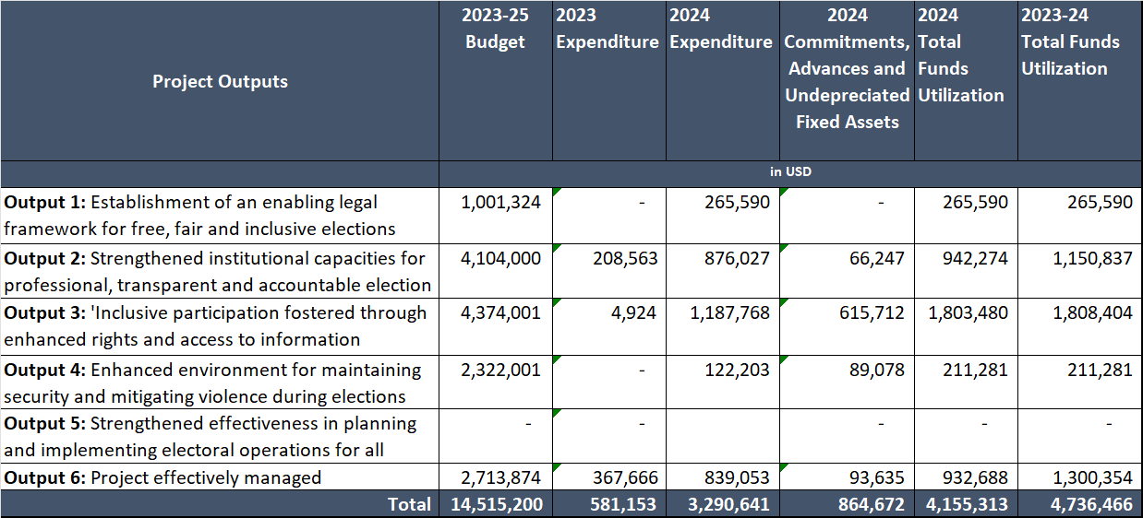

- Donor contribution and funds utilization.
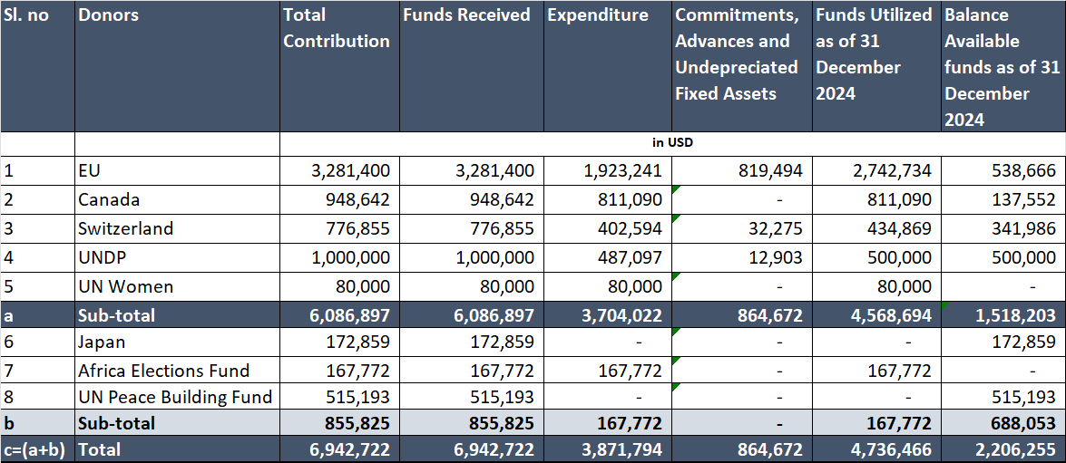
*Financial information provided above is provisional pending certified financial reporting expected no later than 30 June 2025.

The Reconstituted Joint Monitoring and Evaluation Commission is constituted under Chapter VII of the R-ARCSS and is responsible for monitoring and overseeing the implementation of the Revitalised Peace Agreement and the mandate and tasks of the RTGoNU, including the adherence of the Parties to the agreed timelines and implementation schedule. RJMEC reports to the Heads of States and Governments of IGAD.
For the assessment of achievements with respect to the outputs, performances include: no progress; little progress; some progress; and substantial progress.
Including the Union of Journalists of South Sudan (UJOSS), Association for Media Development in South Sudan (AMDISS), Community Media Network South Sudan (CoMNTESS), National Editors Forum (NEF), National Press Club South Sudan (NPC_SS).
Social and environmental; financial; operational; organizational; political; regulatory; strategic; safety and security.
Likelihood (Probability): scale of 1 (not likely) to 5 (expected). Impact: scale of 1 (low) to 5 (critical).
Risk levels: 2 – 4 (low); 5 – 6 (moderate); 7 – 8 (high); 9 – 10 (very high).

