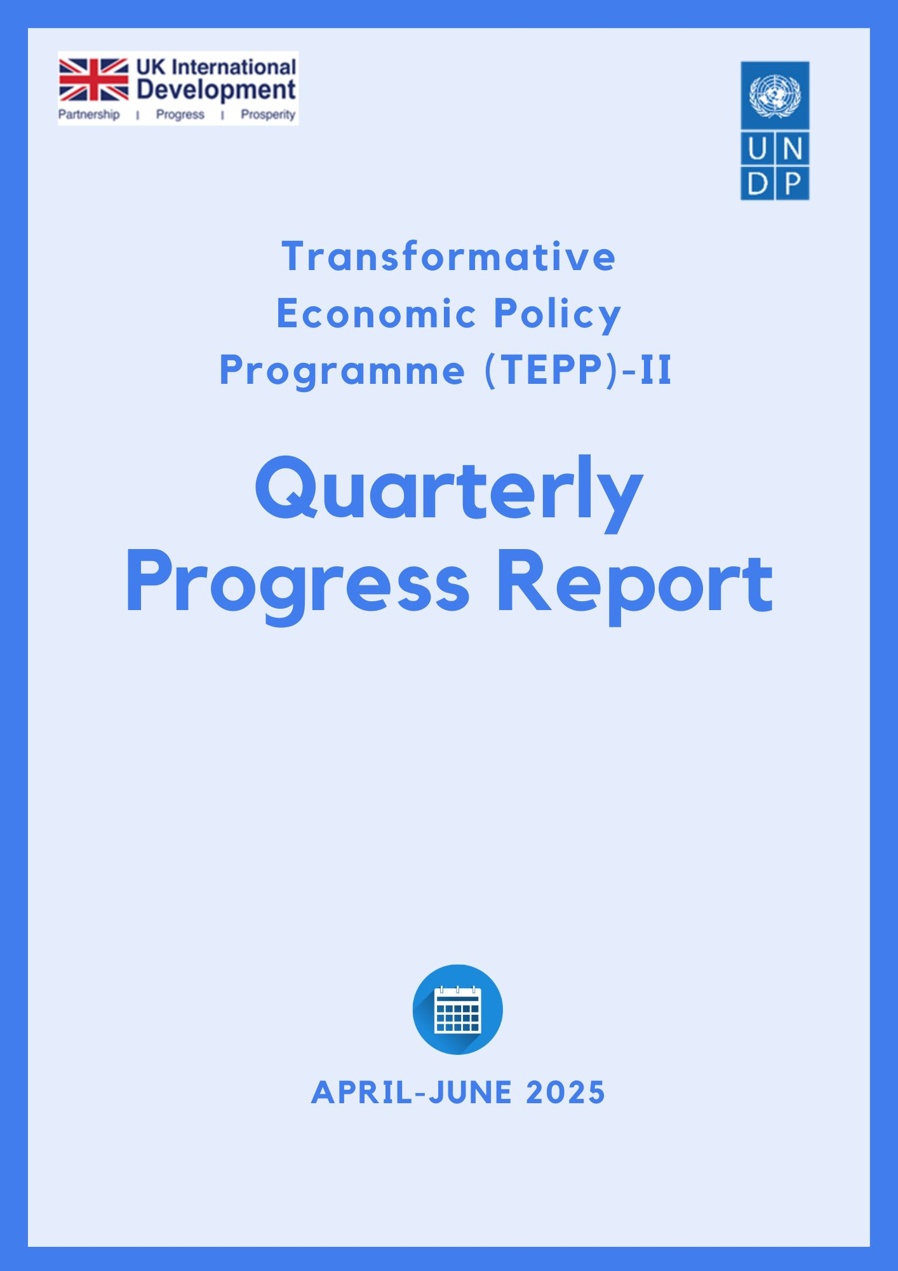
unctad

Table of Contents

A. Project Brief 1
B. Executive Summary 2
C. Project Progress and Result 5
1.0 Output 1: Trade Policy and Negotiation Capacity Strengthened 5
1.1 Progress on establishing the Trade Negotiator’s Pool 5
2.0 Output 2: Government institutional structures on trade policy assessed to improve effectiveness and coordination 5
2.1 Institutional Diagnostic of the Bangladesh Competition Commission (BCC) 5
2.2 Partnership with UNCTAD to Support BIDA 6
3.0 Output 3: Engagement with the private sector improved through regular consultation on business and trade policies and investment climate 7
3.1 Bangladesh Investment Summit 2025 7
3.2 Engaging Youth Entrepreneurs 7
3.3 Letter of Intent (LoI) signed to build partnership 8
4.0 Output 4: New research and evidence generated to support effective economic policy-making and institutional reforms 9
4.1 Strategic Interventions and Support to BIDA 9
4.2 Assessing context for policy reform 10
4.3 Planned assessment 10
4.4 Strategic Communications, Knowledge Products, and Institutional Support to BIDA 10
D. Project Management 12
F. Lessons Learned 14
G. Visibility and Communication 16
H. Value for Money (VfM) 19
I. Way forward and Next Quarter Plan (July–September 2025) 21
Annex-1 22
Annex-2 24
Annex-3 25

Project Brief
Implementing Agency | United Nations Development Programme (UNDP)
Country | Bangladesh
Project title | Transformative Economic Policy Programme (TEPP-II)
Project duration | July 2024 – March 2028
Reporting Period | April 2025- June 2025
Project budget for this financial year (April 2025-March 2026) | USD 1,666,917 (GBP 1,233,518 )
Total project budget | GBP 4,000,000
Lead department for the project | Democratic Governance Cluster
Date this report is submitted: | 30 June 2025

Executive Summary
The momentum that was created in the first quarter of 2025 was further picked up in the second quarter of this year. The implementation of the Transformative Economic Policy Programme (TEPP-II) gathered further speed and there was visible progress in the delivery of key outputs, while ensuring flexibility and responsiveness to priorities and needs of national counterparts. . The partnership with key government counterparts was further strengthened to ensure ownership and buy-in at the highest level.
Under Output 1, significant progress has been made in establishing the Trade Negotiators Pool (TNP). Following the submission of 93 nominations, the shortlisting process for 50 participants commenced. Planning for the inaugural residential training titled “Orientation program for Trade Negotiators Pool’” are well underway, with the schedule confirmed for July 12-14, 2025. A draft capacity development plan for TNP has also been put together which will be implemented through the second half of 2025. A key priority for the project was to avoid ad hoc interventions to build national capacities in trade negotiations. Instead, the emphasis was to ensure that these capacities are institutionalized before significant investments are made in capacity development.
Under Output 2, the institutional diagnostic of the Bangladesh Competition Commission (BCC) was completed and presented at a high-level national seminar, resulting in strong endorsement from senior government and development partners. The Research and Analytics Unit (RAU) embedded within BIDA continued to drive key reform initiatives. Among others, the work has focused on improvements in work permit processing, business licensing, capital repatriation, and establishing a semiconductor taskforce. Additionally, preparations have been made with UNCTAD to rollout the Investment Policy Review (IPR) for Bangladesh.
For Output 3, TEPP-II played a central role in the successful hosting of the Bangladesh Investment Summit 2025, which attracted over 3,000 participants and led to new public-private partnerships. The project contributed to curating the technical content, coordinated expert panels, and supported investor dialogues. TEPP-II also conducted a youth entrepreneurship survey during the Youth Expo, with follow-up activity including developing policy brief and roundtable discussion scheduled with a youth entrepreneurs for next quarter. A Letter of Intent (LoI) was signed between UNDP, ILO, MoC, and BIDA to promote sustainable trade and investment practices grounded in ESG principles and International Labour Standards.
Under Output 4, several high-value research outputs were finalized or advanced, including studies on inflation, leather industry investment, and agricultural machinery whereas some new research was initiated on SME technology adoption, tariff rationalization, and the impact of U.S. tariffs on Bangladesh’s top export sectors.
Looking ahead, TEPP-II will focus on capacity development in trade negotiation, addressing regulatory barriers to investments while continuing work on investment promotion. Furthermore, the project will strengthen the interface with the private sector. Together, these initiatives will help to support the implementation of priorities articulated in the Smooth Transition Strategy (STS). Besides partnerships in Bangladesh, the project will tap into global and regional expertise of the UN system to deliver customized solutions in trade and investment.

Table 1: Action Matrix
Sl | Ourput | Comments by FCDO | Actions Taken/Planned
 | Output 01 | we encourage the development of the full plan for the pool. | For now, we have a capacity development plan through the end of the year. Before the end of the year, we will stocktake and develop a plan for 2026. For more, see Annex-2. Besides technical assistance for the pool, we are already thinking of institutionalizing a mechanism in MoC that ensures a support system and smooth functioning of the pool.
 | Output 02 | Encouraging UNDP to explore feasible regulatory reform options that can be implemented in the coming months. These should align with the interim government’s priorities and take advantage of the current reform window. | The work on investment climate and regulatory reform is increasingly becoming more balanced, focusing on upstream policy and technical fixes. The former has focused on sector priorities, investment promotion, and policy review. Technical support in a number of areas is already being provided (e.g work permits, licenses etc) which will be the focus going forward. For ore, see Annex-3
 | Output 03 | Emphasizing more regular consultations on trade and business policies, including regulatory barriers and labour standards, among others. | We have already started doing it, either through TEPP or through other projects and for a (e.g. UN-Private sector dialogue). Also, a Letter of Intent was signed with BIDA together with ILO to promote environmental and labour standards for compliance and addressing red tape. This work will be further scaled up soon.
 | Output 04 | Commissioning no research to external suppliers. | While we agree that we can limit research to external suppliers, there will be occasions when we need draw from expertise and that will entail some outsourcing. As our team has grown, we plan to strengthen our evidence-based and advocacy efforts utilizing our internal capabilities and bringing external expertise when and where needed.

Project Progress and Result

1.0 Output 1: Trade Policy and Negotiation Capacity Strengthened

1.1 Progress on establishing the Trade Negotiator’s Pool
The 2nd Working Committee Meeting on ‘Creating Trade Negotiators Pool for Strengthening Bangladesh’s Trade Policy and Negotiation Capacity’, was held on 22 May 2025, with full participation from its six members representing the Ministry of Commerce, FCDO, and UNDP. The committee reviewed progress on the nomination process and focused on three core priorities: finalizing the nomination list, incorporating academic and research institutions, and structuring the introductory training module. In the aftermath of the meeting, the Ministry of Commerce (MoC) submitted a comprehensive nomination list of 94 individuals representing government bodies, think tanks, academia, and the private sector. A structured selection process is now underway to shortlist 50 candidates based on key criteria such as years of experience, past involvement in trade negotiations, affiliations with international trade organizations, diplomatic experience, training participation, research credentials, and specific subject-matter expertise. The pool is thoughtfully designed to include junior, mid-level, and senior officials to ensure both immediate functionality and long-term institutional resilience.
Building on this progress, the 3rd Working Committee Meeting was held on 24 June 2025, following the 2nd meeting, to finalize the detailed activity plan for the inaugural training session, titled ‘Orientation program for Trade Negotiators Pool’, which is tentatively scheduled for 12–14 July 2025. The committee reiterated its commitment to fast-track the implementation phase, recognizing the initiative's strategic value in preparing Bangladesh for more effective participation in global trade dialogues, particularly in the post-LDC graduation context.
To guide the skills development of the selected participants, an indicative capacity development plan has been designed by the TEPP team, encompassing a blend of in-person training, expert-led workshops, thematic seminars, and international exposure or study visits. These interventions are tailored to enhance technical knowledge, negotiation proficiency, and familiarity with international trade protocols and institutions.
Simultaneously, recruitment of technical resource persons is in progress. UNDP has also initiated all required logistical, procurement, and operational arrangements to ensure the smooth delivery of the inaugural training session, which will lay the groundwork for subsequent thematic trainings planned throughout 2025. The Proposed Roadmap of Trade Negotiator’s Pool (till December 2025) is attached in Annex-2.

2.0 Output 2: Government institutional structures on trade policy assessed to improve effectiveness and coordination

2.1 Institutional Diagnostic of the Bangladesh Competition Commission (BCC)
As part of its ongoing institutional strengthening initiatives, the TEPP-II project conducted a comprehensive diagnostic study of the Bangladesh Competition Commission (BCC). The assessment identified critical structural and functional gaps, and proposed 62 actionable recommendations, 41 of which were identified as high priority. These recommendations included short and medium-term reforms aimed at improving regulatory independence, clarifying legal mandates, and increasing operational efficiency.
Based on these findings, a reform roadmap was developed to support BCC’s transformation into a more effective, transparent, and proactive regulatory authority.
The diagnostic results were formally presented during a high-level dissemination event held on 20 May 2025, which received a strong endorsement from the Commerce Advisor. In parallel, a working lunch was convened with senior leadership including the Commerce Advisor, Commerce Secretary, UNDP Deputy Resident Representative, and TEPP management provided an opportunity to reflect on broader reform strategies and highlight TEPP-II ’s major contributions.
Discussions emphasized the need for structured enforcement, especially in light of emerging challenges in digital markets and the dominance of large firms. Panel discussions raised issues such as audit market concentration, unfair bidding practices, distortions in public procurement, and issues within input markets and the need for regulation in the digital economy, particularly concerning big tech. Participants stressed the importance of public-private partnerships, targeted reforms, and a cautious enforcement approach in the early stages of BCC’s institutional evolution. Development partners expressed strong commitment to supporting BCC’s transformation into a credible, independent authority, aligned with Bangladesh’s LDC graduation priorities and broader economic reform goals. Participants reached a consensus on the urgency of strengthening the institutional framework for competition in Bangladesh, recognizing BCC’s central role in promoting fair business practices, protecting consumers, and fostering innovation.
Building on the success of the BCC diagnostic, preliminary discussions have been initiated to replicate this methodology across selected wings of the Ministry of Commerce. This approach is expected to lay the groundwork for structured institutional reform, enabling the design of targeted technical assistance packages and improving the Ministry’s responsiveness to evolving trade and regulatory challenges.

2.2 Partnership with UNCTAD to Support BIDA
To strengthen the strategic capabilities of the Bangladesh Investment Development Authority (BIDA), a partnership agreement was formalized between UNDP and UNCTAD on 25 May 2025. The collaboration aims to support the preparation of a new Investment Policy Review (IPR) for Bangladesh - an update long overdue since the country’s last IPR conducted in 2013. This renewed initiative responds to Bangladesh’s rapidly evolving investment environment and its ambitions to attract more sustainable and diversified foreign direct investment (FDI).
The forthcoming IPR will serve as both a diagnostic tool and a forward-looking policy blueprint. It will analyze contemporary FDI trends, assess the effectiveness of recent policy reforms, and identify institutional and regulatory gaps. The goal is to produce a roadmap of actionable reforms that can enhance Bangladesh’s investment climate, improve investor confidence, and promote inclusive, high-impact growth aligned with the country's development priorities.
Complementing the review, UNCTAD will also support BIDA in developing a “Live Implementation Matrix” which is an interactive tracking tool that will enable real-time monitoring of reform progress. This mechanism is expected to strengthen government accountability and provide evidence-based assessments of the implementation and impact of investment-related policies and reforms.
RAU’s workplan in collaboration with the Bangladesh Investment Development Authority (BIDA) for January–December 2025 is provided in Annex 3.

3.0 Output 3: Engagement with the private sector improved through regular consultation on business and trade policies and investment climate

3.1 Bangladesh Investment Summit 2025
During this reporting period, TEPP-II provided strategic support to the Bangladesh Investment Development Authority (BIDA) in organizing and delivering the Bangladesh Investment Summit 2025, held from 7–10 April in Dhaka. This high-level event marked a milestone in Bangladesh’s efforts to position itself as a globally competitive and reform-oriented investment destination.
The Bangladesh Investment Summit 2025 attracted over 3,000 participants, including 710 attendees at the inauguration (58% of whom were foreign delegates) and NRBs. The event facilitated more than 150 B2G meetings and featured 130 expert panellists across five priority sectors: Renewable Energy, Digital Economy, Textile and Apparel, Agro-processing, and Healthcare and Pharmaceuticals. These sectors were chosen for their high-growth potential and strategic importance in promoting economic diversification and sustainable development.
Strategically co-hosted by BIDA and BEZA with support from UNDP, World Bank, and FICCI, the summit convened a broad coalition of investors, policymakers, development partners, and private sector actors. Plenary sessions and technical forums addressed sector-specific investment opportunities, regulatory reform, and infrastructure readiness. Notable initiatives included the launch of the Bangladesh Investment Opportunities Portfolio 2025, commitment to scale up the One-Stop Service (OSS) platform, and announcement of the Bangladesh Innovation Fund to support early-stage startups. RAU has prepared a report on the Summit which has been published from UNDP website and disseminated with BIDA officials.
The summit generated multiple investment announcements and signed memoranda of understanding (MoUs) across energy, logistics, digital services, and manufacturing. High-level discussions and presentations underscored Bangladesh’s commitment to inclusive, green, and innovation-led growth. A cultural showcase on 9 April also promoted Bangladesh’s creative economy to the international audience.
TEPP-II ’s contributions included technical coordination, communications support, sectoral research, and facilitation of dialogue platforms that led to meaningful policy and investment outcomes. The summit reinforced Bangladesh’s readiness to engage with global capital markets and fostered new partnerships that align with national development goals and SDG 8,9 and 17.
Looking forward, follow-up meetings with investors, government agencies, and development partners are scheduled to translate summit dialogues into tangible investments. Recommendations were made to further strengthen future summits through sector-specific roundtables, enhanced SME participation, and advanced investor matchmaking tools.

3.2 Engaging Youth Entrepreneurs
Following the Bangladesh Investment Summit, the TEPP-II team conducted a survey including 25 youth entrepreneurs who attended a Youth Expo organized by UNDP’s Futurenation initiative. Based on the insights gathered, RAU is planning to organize an event with youth entrepreneurs from various sectors. The aim is to identify two to three specific bottlenecks that TEPP-II can directly address through targeted interventions. As part of this process, a policy brief will also be developed to document the key challenges and propose actionable recommendations to support youth entrepreneurship in Bangladesh.

3.3 Letter of Intent (LoI) signed to build partnership
Consultations with UN agencies and development partners took place ahead of the Bangladesh Investment Summit 2025, exploring collaboration in developing a sustainable and inclusive trade and investment ecosystem. These discussions culminated in the signing of a Letter of Intent (LoI) between UNDP, ILO, BIDA, and MoC at the Summit. Under this agreement, BIDA and MoC aim to organize an annual forum and provide services to businesses. Additionally, UNDP and ILO will support the development of an online portal hosted by BIDA that will serve as a knowledge and service hub. The portal will promote good practices and programs related to decent work, responsible business conduct, human development-based approaches to investment, adherence to International Labour Standards, and integration of Environmental, Social, and Governance (ESG) principles into business operations.

4.0 Output 4: New research and evidence generated to support effective economic policy-making and institutional reforms

4.1 Strategic Interventions and Support to BIDA
During the reporting period, TEPP-II continued its strategic collaboration with the Bangladesh Investment Development Authority (BIDA) to advance investment climate reforms. An annual workplan meeting was organized to refine BIDA’s strategic priorities and align project interventions with ongoing national economic reforms. As part of this engagement, the Research and Analytics Unit (RAU) embedded within BIDA provided technical support across several key areas, including the revision of the Investment Handbook and the redesign of investor-facing materials such as brochures and sector-specific booklets. These efforts aimed to improve BIDA’s service delivery and promote Bangladesh as a competitive investment destination.
To further strengthen BIDA’s reform agenda, the Senior Investment Policy Advisor, supported by TEPP-II led several high-impact interventions in close coordination with government counterparts and private stakeholders.
In the semiconductor sector, a multi-stakeholder workshop was convened on 10 May 2025 under the Semiconductor Taskforce’s Skills Sub-Committee. The session engaged national and international experts including diaspora professionals and academia to refine a roadmap for sector development. The outcome of this workshop included an initial strategy document, which has been aligned with broader national digital and industrial policy priorities through coordination with relevant high-level advisors.
On work permit and security clearance reform, six separate engagements including a technical workshop, and a high-level dissemination session were held with key security and immigration agencies. These consultations led to the mapping of current procedures and the identification of critical bottlenecks. Draft recommendations were formally presented, and endorsement was secured from relevant authorities to advance the proposed simplifications, signaling a breakthrough in addressing long-standing bureaucratic hurdles faced by foreign investors.
The capital repatriation framework emerged as another priority area. Till now, a total of 13 consultations were conducted with leading financial institutions and multinational corporations to assess challenges in capital movement and profit repatriation. These discussions were complemented by a series of in-depth dialogues with the Foreign Exchange Investment Department of Bangladesh Bank, which helped shape a set of practical and context-specific recommendations aimed at enhancing regulatory clarity and streamlining repatriation procedures. Following the completion of the assessment phase, a reform proposal was developed and is currently under internal review, with formal submission to BIDA leadership underway. Agreement has already been secured from the BIDA Chairman on the need to move forward with these improvements. The next steps involve finalizing a valuation methodology and strengthening BIDA’s internal procedures to facilitate timely and transparent repatriation of capital. The reforms are intended to align Bangladesh’s practices with international standards and support the country’s broader strategy to attract sustainable and responsible foreign direct investment.

In the area of business licensing reform, initial consultations with regulatory stakeholders identified inefficiencies in obtaining and renewing critical business licenses, including trade licenses, fire clearances, import registrations, labour approvals, and environmental permits. These findings are guiding the development of an integrated reform proposal to simplify licensing procedures, reduce investor burden, and enhance regulatory transparency.
Collectively, these interventions reflect TEPP-II ’s ongoing commitment to institutional strengthening, evidence-based reform, and private sector facilitation. They also demonstrate growing ownership and alignment between BIDA and TEPP-II in driving reforms that support Bangladesh’s ambition to attract sustainable, responsible, and diversified investment.

4.2 Assessing context for policy reform
4.2.1 Study on SME Technology Adoption to Drive Industry 4.0 Competitiveness
TEPP-II initiated a study on SME technology adoption to enhance Bangladesh’s competitiveness post-LDC graduation. Focusing on sectors like Agroprocessing, IT, Jute and light engineering, the study compares Bangladesh’s progress with peers such as Vietnam and India in adopting Industry 4.0 technologies. It aims to develop a cost-effective roadmap for integrating automation, AI, and IoT into production systems. The report is under finalization, with a validation workshop and dissemination event scheduled for the next quarter.

4.3 Planned assessment
4.3.1 Study on the Implications of Tariffs Rationalization and Revenue Generation
A Terms of Reference (ToR) has been issued to recruit an individual consultant to assess the implications of tariff rationalization in the context of Bangladesh’s upcoming LDC graduation. The study will explore the impact of tariff reforms on revenue generation, business competitiveness, and economic growth. key issues as future trade agreements shift from preferential to reciprocal terms. The consultant will engage a wide range of stakeholders, including policymakers, trade experts, and private sector actors, to analyze the policy, fiscal, and political economy dimensions of tariff restructuring and its role in shaping future trade and industrial strategies.
4.3.2 Study on the Impact of US tariff on Bangladesh’s Trade in Five top Exporting Sectors
A Terms of Reference (ToR) has been published to engage an individual consultant to assess the impact of the 37% U.S. tariff on Bangladesh’s top five export sectors: Ready-Made Garments (RMG), headgear (HS Code 65), footwear and leather products, specialty items (HS Code 67), and pharmaceuticals. The consultant will conduct a desk review, consult with private sector and policy stakeholders, and produce a concise 10-page policy brief. The study will evaluate the overall economic implications of the U.S. tariff, analyze sector-specific effects, and compare Bangladesh’s position with competitor countries such as Vietnam, Cambodia, India, Sri Lanka, Pakistan, and China under the U.S. “reciprocal tariff” framework.

4.4 Strategic Communications, Knowledge Products, and Institutional Support to BIDA
Over the reporting period, TEPP-II continued to provide strategic and operational support to the Bangladesh Investment Development Authority (BIDA) to improve its institutional visibility, enhance investor outreach, and strengthen internal communications infrastructure. This support was delivered through the preparation of key knowledge products, facilitation of communications deliverables, and targeted research inputs aligned with BIDA’s reform agenda.
4.4.1 Development of BIDA Brochure
Between May and June 2025, TEPP-II finalized the development of BIDA’s official investment brochure. The process involved drafting comprehensive content that highlights investment opportunities, institutional services, and key reforms. Following coordination with the selected vendor, feedback was systematically provided to ensure design quality and alignment with BIDA’s branding. The finalized brochure now serves as a key tool for investor engagement and promotional activities, particularly ahead of the upcoming Bangladesh Investment Summit.
4.4.2 Investment Handbook Drafting
During the same period, TEPP-II collaborated closely with BIDA’s Communications unit to prepare a preliminary draft of the Investment Handbook. This publication aims to offer clear, consolidated guidance for prospective investors on regulatory procedures, priority sectors, and entry facilitation. A draft version was shared with BIDA’s senior leadership for further review, and finalization will continue into the next quarter based on feedback received.
4.4.3 Ad-hoc Technical and Communications Support
TEPP-II remained responsive to emerging institutional needs at BIDA through ad-hoc research and editorial contributions. These included developing content for BIDA’s quarterly newsletter among other tasks. All deliverables were submitted in a timely manner and have contributed to evidence-informed communications and sector outreach.
4.4.4 Publication and Distribution of Analytical Studies
To support policy advocacy and stakeholder engagement, TEPP-II facilitated the printing of two flagship RAU research outputs: the Investment Diversification Report (1,000 copies) and the Agricultural Machinery Sector Report (500 copies). A total of 1,500 hard copies were produced and delivered to BIDA for dissemination among government, development partners, and private sector actors.
4.4.5 Development of Economic Dashboard
In coordination with BIDA’s Communications Unit and the Head of Business Development, TEPP-II is working on developing an Economic Dashboard intended to provide real-time, user-friendly access to trade and investment indicators. The existing TOTTHO dashboard, which aggregates key metrics and trends to support data-driven policy and investor decision-making will be integrated in BIDA website.
4.4.6 Capacity development of RAU staff
During this quarter, RAU staff actively participated in learning and collaboration initiatives with BIDA to support BIDA in preparing a sectoral newsletter. They provided substantial support to BIDA’s research on the pharmaceutical sector, beginning with contributions at the inception meeting and continuing through joint site visits to Square and Incepta Pharmaceuticals. Their engagement ensured meaningful technical input throughout the research process. It is part of BIDA’s initiative to prepare a sectoral newsletter, with the upcoming issue focusing on the pharma industry. RAU supports BIDA in developing newsletter content, including economic analysis.
The interaction helps ensure accurate, evidence-based representation of sectoral challenges and opportunities

Project Management
The TEPP-II project has continued to strengthen its management and staffing structure to support effective implementation. Dr. Mehruna Islam Chowdhury has been serving as the acting Project Manager while the formal recruitment process for the position is underway. Key personnel have already joined the team, including a Policy Analyst, Communications Analyst, two Research Analysts, and a Monitoring, Evaluation, and Learning (MEL) Analyst.
Recruitment for several remaining positions is at an advanced stage, with most roles expected to be filled in the next quarter. To ensure continuity and technical quality during this transitional period, UNDP’s Country Economist and Senior Governance Specialist have been providing ongoing strategic oversight and policy guidance. The UNDP Governance Cluster continues to offer essential backstopping support, ensuring that the project remains on track with its objectives and deliverables.

- Challenges faced & Mitigation strategy
There were delays in getting the endorsement from the Ministry of Commerce to operationalize the Trade Negotiators Pool. It was important that the government took the lead, and nominations were sought through the government system. While the necessary documentation was provided to MoC, it took the government time to get and finalize the nominations. With the formal arrangements being made, rolling out technical assistance should not face any major challenges. The turnaround time for processing procurement has improved considerably, and with additional staff, responsibilities have been delegated gradually. However, the project is trying is balance quick response and ensuring accountability and value for money. .

Right through the reporting period, TEPP intensified communication efforts with MoC and other stakeholders through consistent follow-ups, emails, and calls to minimize delays. Project implementation remains guided by an Annual Work Plan (AWP) aligned with national priorities. There are regular review meetings between UNDP senior management and project team and focal points have been conducted to monitor delivery and address bottlenecks.
- UNDP's Internal Control Framework ensured accountability, risk mitigation, and financial compliance through clear role separation and multilevel approval systems.
- The project adopted the Harmonized Approach to Cash Transfers (HACT) to manage partner capacities and uphold transparency standards.

Lessons Learned
- Regular assessment of government partners' needs and capacity is essential for achieving broader project goals
The project's implementation was significantly affected by political instability shortly after inception, resulting in a change of government and the appointment of an interim administration in August 2024. This transition led to major personnel shifts within government agencies, including the two principal counterparts of the project. In response, the TEPP-II team invested time in building relationships and understanding the evolving priorities of national stakeholders. These sustained efforts began to yield results during the first quarter of 2025, as engagement with both BIDA and the Ministry of Commerce improved notably. The institutions began to actively seek TEPP-II 's strategic input and technical assistance. This growing alignment and trust led to renewed momentum and progress in areas that had previously faced delays. The experience highlights the importance of maintaining continuous coordination and adapting to institutional changes through regular dialogue. When government counterparts recognize the alignment of project activities with their own priorities, their engagement strengthens and supports more effective implementation.

- Expanding collaboration across government and private sector stakeholders is critical for long term impact.
Relying on a single government partner limits the scope of policy influence and impact. While TEPP-II has engaged closely with the Ministry of Commerce and BIDA, the nature of trade and investment issues demands broader inter-agency cooperation. Engagement with institutions such as the National Board of Revenue and the Ministry of Industries can enhance the policy ecosystem and foster more integrated solutions. In parallel, private sector involvement is vital. The project must go beyond ad hoc consultations and establish more regular and structured dialogues with private sector actors. As Bangladesh prepares for its transition from least developed country status, private sector input is essential to assess readiness, improve competitiveness, and promote sustainable practices. The integration of international labour standards, responsible business conduct, and environmental and social governance principles must become part of the private sector development agenda. Strengthening partnerships in both the public and private spheres will increase the relevance and sustainability of project outcomes.

- Engaging international experts to adapt best practices to the local context enhances partner adaptability and promotes greater ownership
Based on stakeholder consultations, it was realized that international experts can play a vital role in contextualizing global best practices to fit Bangladesh’s trade and investment ecosystem. Integrating these practices with local realities not only improves the adaptability of policy interventions but also fosters stronger buy-in from government counterparts and promotes national ownership of reform initiatives. In addition, TEPP-II’s engagement with national experts and diaspora professionals, such as, in the semiconductor roadmap and capital repatriation reforms already helping to translate global benchmarks into feasible local solutions.
- Collaboration with other UN agencies and development partners strengthens the investment ecosystem
TEPP-II’s coordination with UNCTAD, ILO, UNESCAP, and other development partners has demonstrated the value of leveraging complementary expertise and mandates. Joint initiatives such as the Investment Policy Review, TINA, promotion of ESG-aligned investment practices, and development of investor service platforms have not only expanded the program’s reach but also enriched its technical depth. Such partnerships create synergy, reduce duplication, and amplify policy influence, ultimately contributing to a more resilient, inclusive, and sustainable investment climate in Bangladesh.

Visibility and Communication
Bangladesh Competition Commission Diagnostic Study report and dissemination event

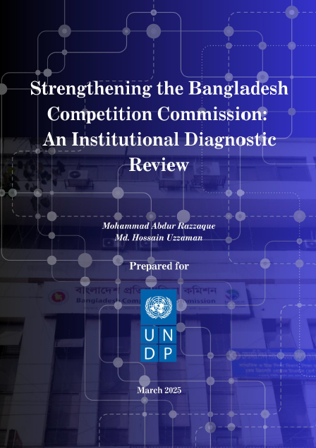 | 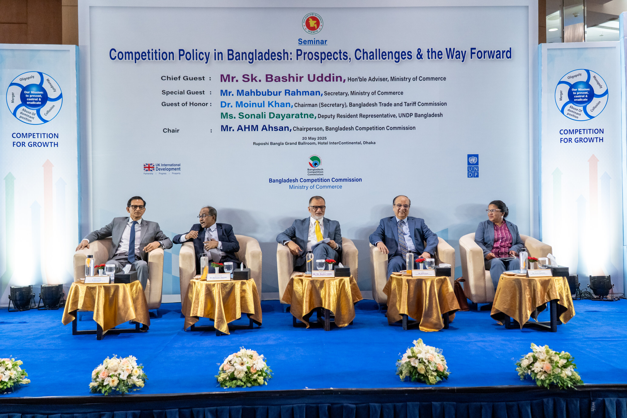

Bangladesh Investment Summit
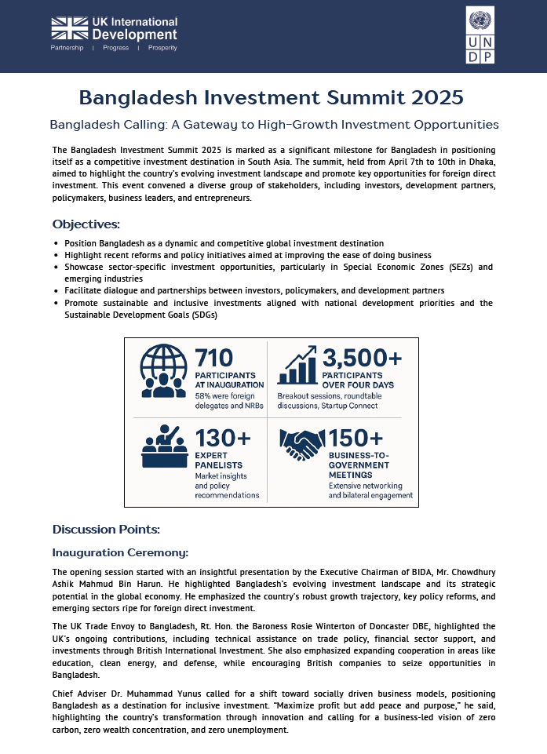 | 

Letter of Intent signing with ILO, MoC and BIDA
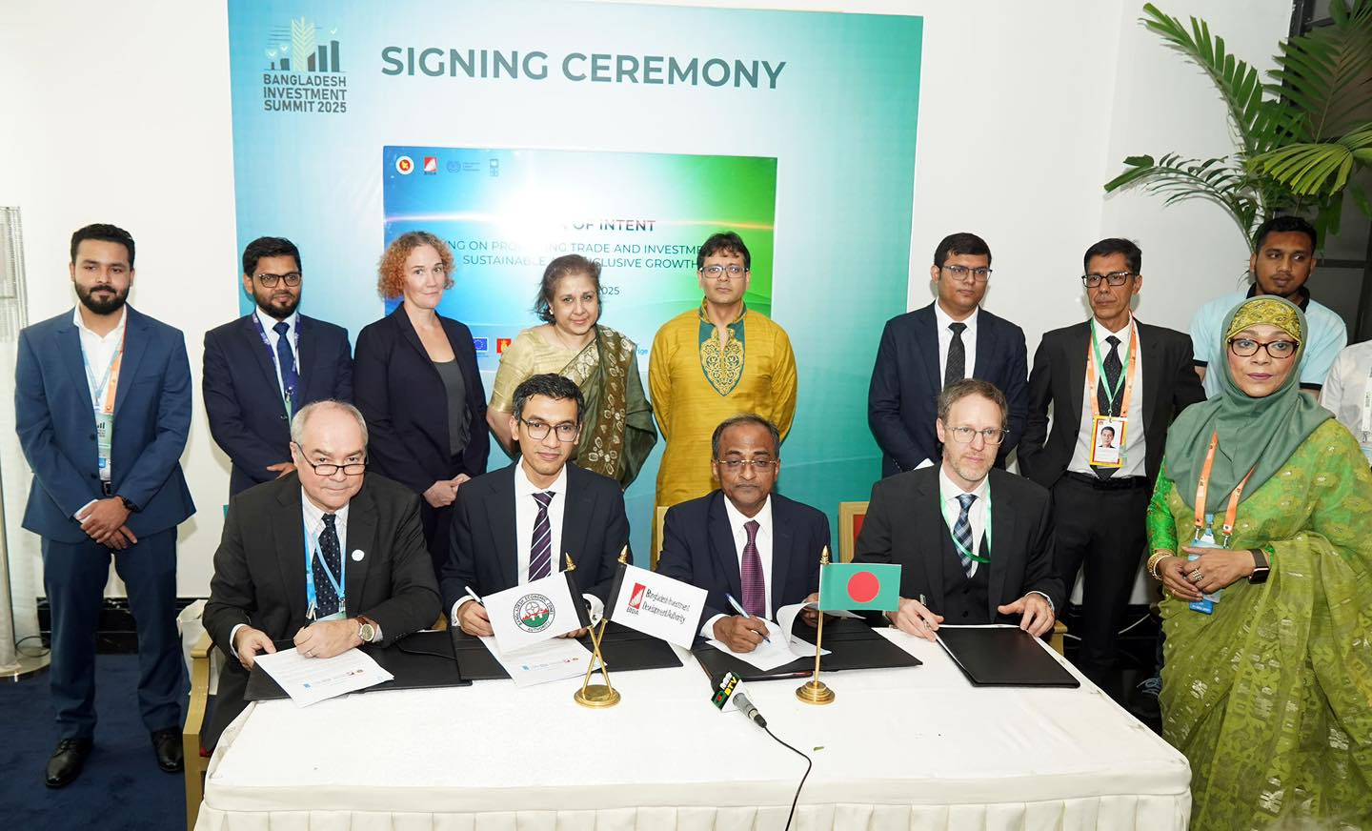
Brochure for BIDA
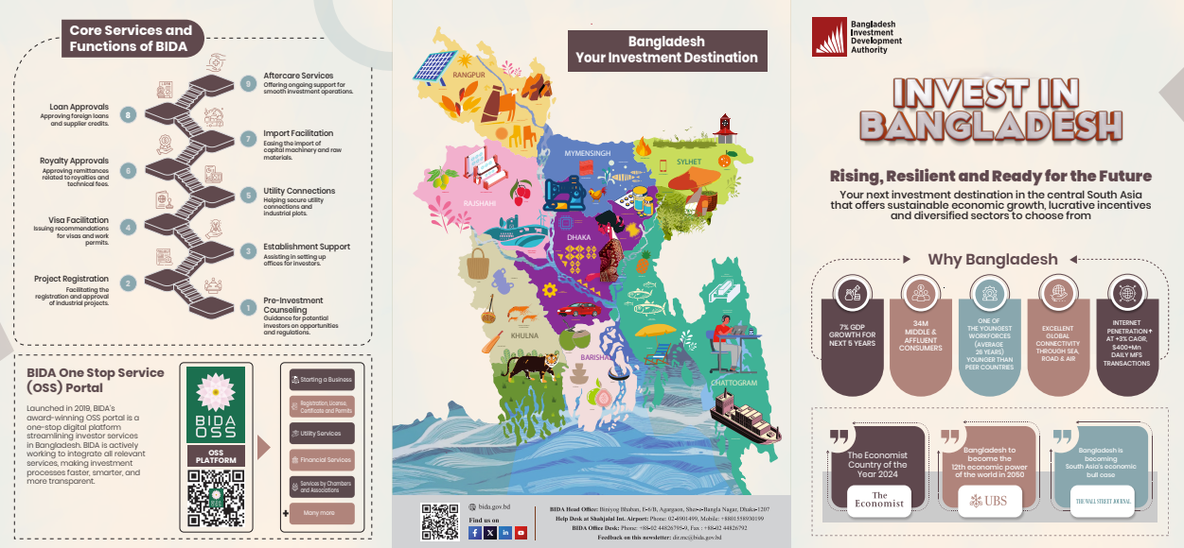

BIDA Quarterly Newsletter
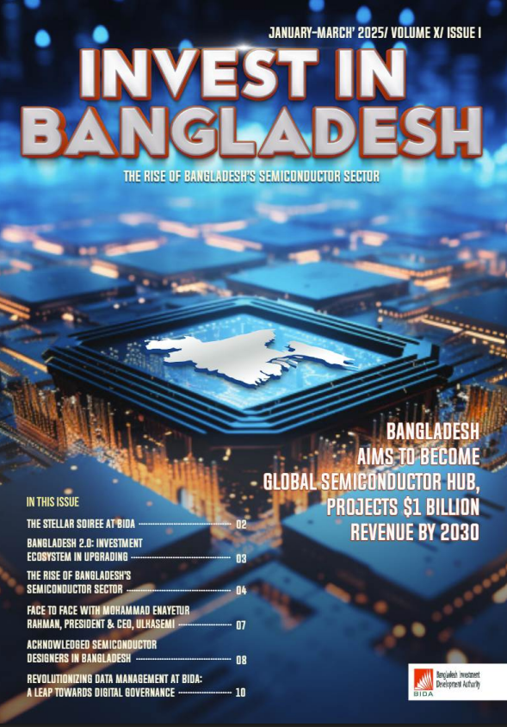

Value for Money (VfM)
During the reporting period, the Transformative Economic Policy Programme-II (TEPP-II) maintained a deliberate and strategic focus on delivering value for money across all project components. Grounded in the principles of economy, efficiency, effectiveness, and equity, the project ensured that financial and human resources were optimally utilized to deliver policy-relevant outcomes, enhance institutional capacity, and promote inclusive engagement.
Economy
The project leveraged existing institutional mechanisms and national expertise to deliver activities in a cost-conscious manner. For example, technical experts and project associates were deployed under short-term contracts in the absence of full-time staff positions, enabling flexibility in resource utilization without compromising on quality. Joint programming with UNDP Country Office staff also minimized the cost of extended recruitment delays, while securing high-quality technical inputs. TEPP-II adopted a cost-conscious approach by maintaining tight procurement planning, conducting transparent bidding processes, and sharing operational infrastructure. Procurement activities were guided by quarterly procurement plans, developed in close coordination with the UNDP Country Office to avoid unnecessary delays and cost overruns. Contracts were awarded based on competitive evaluation processes that emphasized both cost and quality. Bidders’ prior technical experience and sectoral engagement were critically assessed through designated evaluation panels. Instead of renting separate office space, the project co-located with another UNDP initiative, significantly reducing overhead costs related to facility renovation, equipment, and utilities.
Efficiency
A structured work plan guided implementation, allowing the project to align activities with evolving partner needs while maintaining timely delivery. TEPP-II strategically utilized in-house expertise, particularly through the Research and Analytics Unit (RAU), for generating evidence-based outputs and policy briefs. These reduced costs associated with external consultancy while enhancing institutional memory and internal learning. Additionally, the recruitment of five interns to support technical and operational functions reduced personnel expenditures and shortened onboarding time. These cost-effective approaches ensured that key outputs, including analytical studies and technical support to partners like BIDA and MoC, were delivered on time and with impact.
Effectiveness
TEPP-II demonstrated strong alignment between resource use and outcome achievement. Research activities informed national debates and led to concrete follow-up by government partners. For example, the BCC Diagnostic study generated policy interest and administrative actions, while the outcome of the summit is now receiving focused analytical attention. Discussions with BIDA on aligning project research outputs with policymaking needs have ensured that resources are directed towards interventions with strategic value. This adaptive and evidence-led approach contributed to meaningful policy influence and improved institutional responsiveness.
Equity
The project maintained an inclusive and equity-driven approach, engaging a wide spectrum of stakeholders including government institutions, private sector actors, think tanks, youth, and vulnerable economic groups. In all events and consultations arranged during the quarter, diverse representation was ensured and the study on SME sector is aimed at addressing the challenges faced by small entrepreneurs. This ensured that equity considerations were embedded in both the design and intended impact of interventions.
In summary, TEPP-II ensured value for money by balancing cost containment with strategic investment in activities that yield long-term policy and institutional gains. By leveraging internal capacities, strengthening national systems, and promoting inclusive engagement, the project has created a strong foundation for sustainable development impact while maintaining high financial accountability.

Way forward and Next Quarter Plan (July–September 2025)
- Operationalize Trade Negotiators Pool
  - Conduct the inaugural residential training on “Introduction to Trade Negotiations” on 12 July 2025.
  - Begin planning for advanced thematic modules and finalize participant selection documentation.
- Disseminate and Advance Research Outputs
  - Organize the Dissemination Seminar on “Technology Adoption of SMEs for Export Competitiveness” on 30 July 2025.
  - Publish and distribute finalized research outputs on SME tech adoption, inflation, and agricultural machinery.
  - Initiate new studies on Tariff Rationalization, U.S. Tariff Impact, and Gender-Responsive Trade Policy.
  - Schedule the event on inflation (date to be confirmed).
- Policy Dialogue and Stakeholder Engagement
  - Host a Gender Stakeholder Consultation in the first week of July 2025.
  - Organize an event on the leather sector in the second week of August 2025 to drive sector-specific investment dialogue.
- Launch and Support Investment Policy Review (IPR)
  - Facilitate UNCTAD’s field mission, initiate the IPR, and launch the Live Implementation Matrix development.
  - Support BIDA’s reform agenda through ongoing research, dashboard deployment, and licensing framework improvements.
- Institutional Strengthening
  - Begin institutional diagnostic reviews for selected divisions of MoC.
  - Continue capacity building for BCC and BIDA and expand collaboration across agencies.
- Private Sector Engagement and Partnerships
  - Follow up on Investment Summit commitments.
  - Begin development of the ESG and Responsible Business Conduct portal with BIDA, MoC, ILO, and UNDP.
- Project Operations and Oversight
  - Complete recruitment for all remaining project positions.
  - Conduct quarterly project review and adjust the Annual work plan as necessary to reflect evolving priorities.

Annex-1

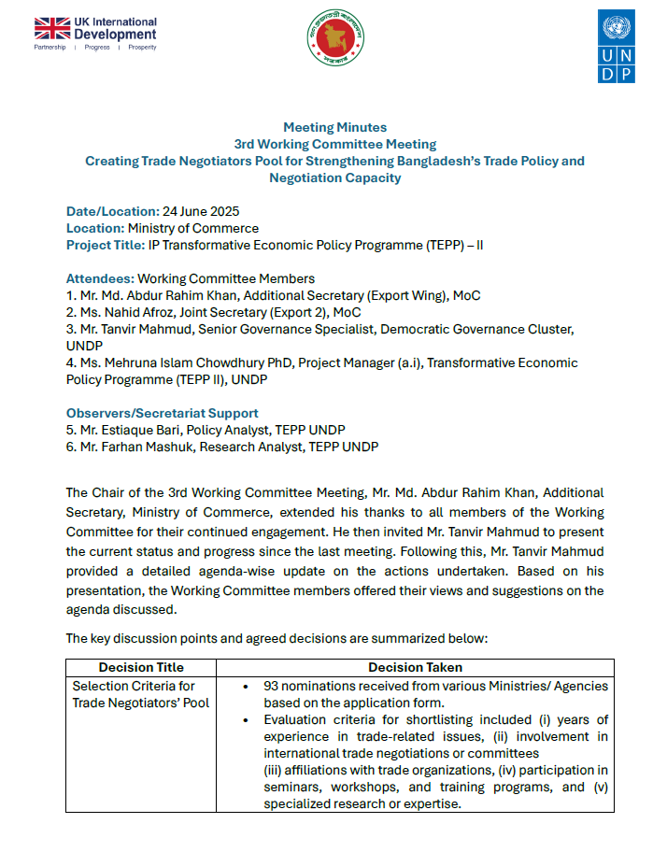

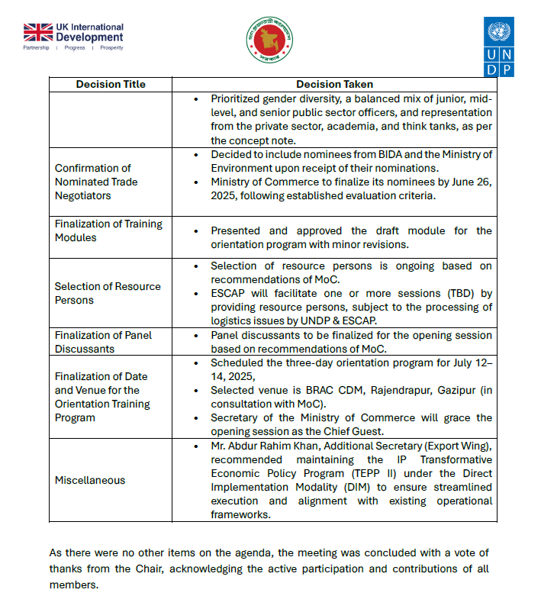

Annex-2
Proposed Roadmap of Trade Negotiator’s Pool (till December 2025)
Sl | Timeline/ Date  (tentative) | Topic | Modality | Days | Resource Person
 | 17 August  2025 | Closing Session of TNP Orientation | In-person | 1 | - N/A
 | 19 August 2025 | Expert Group Meeting | In-person | 1 | All resource persons
 | 20 August 2025 | Knowledge Sharing Workshop Session | In-person | 1 | Dr. Henry Gao,  Trade Expert, Singapore Management University
 | 28 August 2025 | Knowledge Sharing Workshop Session | In-person | 1 | Dr. Deborah Elms,  Head of Trade Policy, Hinrich Foundation in Singapore
 | 08-09 September 2025 | Training on TINA | In-person, Residential | 2 | Yan Duval,  Chief of Trade Policy and Facilitation, UNESCAP  Alexy Kravchenko  Economic Affairs Officer, UNESCAP
 | 18 September 2025 | Investment Aspect of Trade Negotiation | Seminar/ Workshop | 1 | UNCTAD
 | October 2025 | Overseas Training | In person | 5 | TBD
 | Last week of October 2025 | 5 Day long Thematic Training | In-person, Residential | 5 | UNCTAD
 | November 2025 | Online Training | Online | 6 Weeks | UNCTAD

Annex-3

RAU’s workplan with BIDA: January – December, 2025
Completed Activities under the workplan
- Dissemination of Investment Diversification Research for Three Priority Sectors in the Context of LDC Graduation
On 18 November 2024, a high-level research dissemination event titled “Workshop on Investment Diversification for Priority Sectors Post-LDC Graduation” was held at the Radisson Blu Water Garden Hotel, Dhaka. The event was graced by BIDA Executive Chairman Mr. Chowdhury Ashik Mahmud Bin Harun as Chief Guest, with Mr. Owais Parry, Senior Economic Advisor at UNDP Bangladesh, as Special Guest. The keynote presentation was delivered by Dr. Selim Raihan, Lead Consultant of the UNDP TEPP II Project, and the takeaway remarks were presented by Dr. M Masrur Reaz, CEO and Chairman of Policy Exchange Bangladesh. The session was chaired by Dr. Khandoker Azizul Islam, Executive Member (Local Investment Promotion Wing), and moderated by Mr. Shah Mohammad Mahboob, Executive Member (Marketing and Communication Wing) of BIDA. The study focused on investment diversification in the Agriculture, Jute and IT & ITEs sectors, highlighting sector-specific opportunities and constraints in the context of LDC graduation. Several proposed measures, particularly in Agriculture and IT & ITEs, align with national priorities and are being incorporated into ongoing reform efforts. Key recommendations will be featured in BIDA’s upcoming newsletter (where relevant) and in sector-specific factsheets prepared by the RAU. In addition, a total of 900 copies of the report were shared with BIDA for wider dissemination among relevant ministries, agencies, and private sector stakeholders.
- Five Sector Profiles Developed and Published
As part of its effort to promote strategic investment diversification, BIDA has prepared five comprehensive sector profiles for (i) Pharmaceuticals, (ii) Automobile, (iii) Light Engineering, (iv) Healthcare, and (v) Shipbuilding. These profiles offer in-depth insights into market potential, regulatory frameworks, and Bangladesh’s competitive advantages to attract quality domestic and foreign direct investment. They highlight sector-specific value propositions, trends, and policy incentives, serving as practical tools for investors and policymakers. The initiative supports evidence-based investment promotion and aligns national priorities in the post-LDC context. All five profiles are currently available on BIDA’s new website and are being used for investor facilitation and advocacy.

- Policy Paper on Diversifying Investments in Bangladesh on Agricultural Machinery Industry Completed and Published
This published study evaluates the growth potential of Bangladesh’s agricultural machinery manufacturing sector, estimates the investment required to sustain projected growth, and analyzes domestic market dynamics. It identifies key competitors in prospective export markets and explores avenues for mobilizing foreign direct investment. The research also reviews the current investment policy regime to identify barriers to both domestic and international investment, offering sustainable policy recommendations based on global best practices. A total of 400 printed copies have been shared with BIDA for wider circulation among relevant ministries, government agencies, and private sector stakeholders. The study is intended to inform evidence-based policymaking and support strategic investment promotion in this priority sector.
- Conduct Research on Two priority sectors in consultation with BIDA: One on Leather Sector is completed while second study will be soon initiated
Leather Sector Study
The study on the leather sector, finalized in April 2025, aims to assess investment and export potential with a strong focus on overcoming key constraints. LWG (Leather Working Group) compliance has been identified as a critical barrier, hindering the sector’s ability to attract investment and penetrate global markets. The research highlights the need for improved environmental and regulatory practices to ensure competitiveness. A stakeholder consultation will be held on the 2nd week of August 2025 to discuss findings and gather feedback. This will be followed by a leather exhibition in the last week of August to showcase investment opportunities and sectoral advancements.
In addition, RAU is reviewing a request to support a feasibility study for developing international-standard tourism facilities on land owned by the Bangladesh Parjatan Corporation. The scope and modality of RAU’s technical assistance in this assignment are yet to be finalized.
- Data archiving for BIDA-registered companies
RAU supported BIDA in implementing the BIDA Archiving Project from 1 July to 31 December 2024, aimed at digitizing legacy company registration records. The initiative covered 39,512 physical files of companies registered between 1988 and 2019, prior to the introduction of the One Stop Service (OSS) platform. These hardcopy records were previously difficult to manage and retrieve, posing challenges to efficient service delivery and institutional memory. Under the project, all files have been scanned, indexed, and digitalized, with integration into BIDA’s Investor Relationship Management System (IRMS) currently underway. This digital archive will serve as a vital resource for evidence-based policymaking, investment tracking, and more efficient, transparent service delivery.
- Co-partnership with BIDA in Investment Summit-2025
As part of its co-partnership with BIDA in the Investment Summit 2025, RAU provided both financial and strategic support to ensure the event’s successful execution. This included active participation in preparatory meetings, logistical coordination, and technical support across various summit sessions. RAU also played a key role in drafting the official summit outcome report, which consolidates major insights and policy recommendations emerging from the event. Additionally, RAU conducted a short survey with 25 young startups to capture their investment challenges, expectations, and potential growth enablers. The findings are currently being finalized and will be presented at the upcoming Youth Enterprise Programme, scheduled for the second or third week of July 2025.
- Co-led the National Semiconductor Taskforce
In March 2025, as Co-Lead of the National Semiconductor Taskforce, Shahnila Tazreen Azher, Senior Investment Policy Adviser of UNDP (through RAU), worked with Taskforce members to consolidate diverse inputs into a comprehensive sector roadmap, which was presented at the Taskforce meeting and received endorsement for the formation of three thematic sub-groups. To support coordination across related initiatives, she engaged with the Adviser to the ICT Division to align separate workstreams on semiconductor development. During Dr. Hussain’s visit in April, she facilitated working meetings between the Taskforce sub-groups and the ICT Division to promote consensus on a coherent implementation plan. She also co-drafted the final set of Taskforce recommendations, which were submitted to the Chief Adviser’s Office for policy follow-up.
- Develop Content for BIDA Brochure
A tri-fold brochure has been developed to highlight Bangladesh’s economic outlook and key investment opportunities across priority sectors. Designed as a concise and visually engaging tool, it aims to attract both domestic and foreign investors by showcasing the country’s growth potential and sectoral advantages. The UNDP TEPP II project provided financial support, along with technical assistance in content development and design feedback. The brochure aligns with BIDA’s investment promotion strategy and will be used in national and international outreach efforts. The final version is now ready for print and will be disseminated through BIDA’s upcoming investor engagement activities.
Initiated/Work in Progress
- Report on Investment Policy Review of Bangladesh with UNCTAD
The signing with UNCTAD has been successfully completed under the UNDP TEPP II project, and work on updating Bangladesh’s Investment Policy Review (IPR) is expected to commence shortly. This initiative builds on UNCTAD’s original IPR of Bangladesh published in 2013, which provided a comprehensive assessment of the country’s investment climate. The 2013 review identified key opportunities and challenges—particularly around regulatory constraints and infrastructure gaps—and proposed actions under two main pillars: (i) improving the regulatory framework for investment, and (ii) enhancing infrastructure to facilitate sustainable development through FDI. The upcoming update will revisit these areas in light of recent reforms and new priorities, offering revised recommendations to align with Bangladesh’s evolving development and investment agenda.
- RAU will contribute to quarterly newsletter of BIDA on Investment Ecosystem Status
RAU will regularly contribute to BIDA’s quarterly newsletter by providing updates and analytical content on the status of Bangladesh’s investment ecosystem. The upcoming edition will feature a special focus on the pharmaceutical industry, for which RAU is currently preparing a comprehensive sector factsheet. Alongside, a one-page update on the overall investment ecosystem status will be shared in the first week of July 2025, marking the beginning of this recurring contribution. This initiative aims to strengthen evidence-based investor communication and reinforce transparency in investment climate reporting.
- Review the 'B-Ready' Index Methodology and Identify How Bangladesh Can Progress in Ranking
At the request of the Office of the Executive Chairman of BIDA, RAU has conducted a detailed analysis of Bangladesh’s standing in the B-READY Index, which evaluates investment readiness across three pillars, ten topics, 1,200 indicators, and over 2,000 data points per economy. The assessment includes a thorough review of the index methodology, identification of low-performing areas, and actionable recommendations to enhance Bangladesh’s performance. Special attention has been given to cross-cutting themes of gender inclusion, sustainability, and digital adaptation, in line with global benchmarks. The resulting recommendations will serve as a basis for targeted interventions to improve Bangladesh’s ranking and overall investment readiness.

- Workshop on Investment Opportunities for Youth Entrepreneurs of Bangladesh
Preparations are ongoing for the workshop titled “Harnessing Youth Entrepreneurship Potential in Bangladesh: From Ideas to Policy to Pilots”, planned for the 2nd or 3rd week of July 2025. A concept note and draft agenda have been developed, focusing on key barriers, policy gaps, and pilot solutions to support youth-led startups, particularly beyond Dhaka. The RAU team is finalizing speakers, breakout themes, and coordination with key stakeholders including BIDA, Startup Bangladesh, and the ICT Division. The workshop will bring together founders, regulators, investors, and ecosystem actors. Expected output includes a draft entrepreneurship roadmap, sector-specific policy recommendations, and proposed public-private pilot initiatives.

- Developing Factsheet on FDI
The initiative to develop sector-specific factsheets was launched by RAU under the UNDP TEPP II project on 20 June 2025. Within the first two weeks of commencement, draft factsheets for the leather and leather goods sector and the pharmaceutical industry will be prepared. These drafts will be shared with the BIDA Research Unit for review and feedback. Once finalized, the structure and format will be standardized and applied to all 10 priority sectors identified by BIDA in alignment with the FDI Heat Map. This effort aims to create a unified and data-driven knowledge base to support targeted investment promotion and sectoral policy formulation.
- Leading the Work Permit Simplification Process
Phase 1 of the Work Permit Simplification Process focused on diagnostics and recommendations has been completed, while Phase 2 on implementation is currently ongoing. As part of the initial phase, meetings were held with representatives from BIDA, the Ministry of Home Affairs/Security Services Division, NSI, Special Branch of Police, and the software vendor to map the full work permit and security clearance process for foreign nationals in Bangladesh. A technical workshop was co-organized at BIDA on 18 May, bringing together operational teams from the aforementioned agencies, including the Department of Immigration & Passports, to discuss key bottlenecks and propose improvements. On 22 May, the core recommendations were presented at a high-level meeting with the Home Secretary, DG of NSI, and DIG of Special Branch Police, during which various implementation options were discussed, and consensus was reached on the proposed way forward.

- Streamline the Capital Repatriation Process
Phase 1 of the Capital Repatriation Process Reform focused on diagnostics and recommendations has been completed, with Phase 2 on implementation currently underway. As part of the diagnostic phase, extensive consultations were held with multinational companies (MNCs), banks, and financial sector experts to identify key challenges in repatriating capital from Bangladesh. Based on these insights, a set of targeted recommendations was developed and formally endorsed by the Chairman of BIDA. The next phase involves work on refining the valuation methodology and implementing process improvements within BIDA to facilitate faster, more transparent repatriation procedures.
- Licensing Simplification Work
Phase 1 of diagnosis and recommendations is ongoing, focusing on challenges in obtaining and renewing key business licenses. Desk research has been completed on process timelines, documentation, and legal frameworks for Trade License, Fire License, IRC, ERC, DIFE Plan Approval, Environmental Clearance, and Bonded Warehouse License. Initial findings indicate procedural inefficiencies and regulatory burdens. Further stakeholder consultations are underway to validate insights and formulate practical, actionable recommendations for streamlining the licensing regime.
- RAU will support to develop Investment Handbook
A draft outline of the Investment Handbook has been presented to Mr. Shah Mohammad Mahboob, Executive Member (Marketing and Communication Wing) of BIDA. To inform the structure and content, the RAU team reviewed investment handbooks from 15 different countries, drawing on global best practices. The drafting process is scheduled to begin in the third week of July 2025, in close consultation with BIDA officials, particularly from the Bangladesh Investment Authority (BIA). The handbook aims to serve as a comprehensive, investor-friendly guide to doing business in Bangladesh.
- Technology Adoption for Enhanced Competitiveness of Export-oriented SMEs of Priority Sectors in Bangladesh
The study on technology adoption by SMEs seeks to address challenges in technological integration and backward supply chain development. A draft position paper on SME technological adoption is currently under review by the TEPP II internal team. The study highlights the need for targeted interventions to enhance SME productivity and competitiveness through modern technologies. To validate the findings and identify additional issues, a stakeholder consultation and Expert Group Meeting (EGM) are scheduled for September 2025. These engagements will inform the final recommendations and guide evidence-based policy reforms for the SME sector.
Proposed/ To be Finalized
- Sensitisation Workshop on Work Permit Issues at the Divisional Level
A sensitization workshop on work permit issues at the divisional level is under discussion between UNDP and BIDA. The scope of RAU’s facilitation and support in organizing the event is yet to be finalized.
- Support on Investment Calculation Methodology
At the request of the Executive Chairman of BIDA, RAU is exploring a review of the investment calculation methodology, including best practices from comparator countries. While BIDA collects proposed investment data, there is no existing system to track actual investment realization. The design and scope of RAU’s potential involvement in this area are still under consideration.

