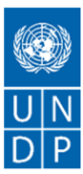

ANNUAL PROGRESS REPORT
2025

Livelihoods Improvement and Disaster Resilience Enhancement in the Areas Affected by the Jajarkot Earthquake

PROJECT PROFILE

About the Programme | Geographic coverage
Title: Livelihoods Improvement and Disaster Resilience Enhancement in the areas affected by the Jajarkot Earthquake (LIDRE)  Project Atlas ID: 01004107  Web links:  https://www.undp.org/nepal/projects/livelihoods-improvement-and-disaster-resilience-enhancement-areas-affected-jajarkot-earthquake | National level coverage (Yes/No): No  Number of Provinces covered: 1  Number of municipalities covered: 5
Strategic Results
UNDP Strategic Plan 2022- 2025 Six Signature Solutions: Resilience
Support communities in building resilience to diverse shocks and crises, including conflict, climate change, disasters, and epidemics.
UNSDCF Nepal Priority Area 3: Environmental Sustainability, Climate and Disaster Resilience
Outcome 3: By 2027, more people, especially women, youth, and the most marginalized and poor, increasingly benefit from and contribute to building an inclusive, sustainable, climate-resilient, and green society and reduced impacts of disasters at federal, provincial, and local levels.
Country programme document (CPD) for Nepal (2023–2027): Outcome 3: Environmental sustainability, climate and disaster resilience
CPD Output 3.1: Innovative resilience-building solutions introduced at all levels to reduce risk from disasters and climate change.
CPD Output 3.2: Risk informed and gender-responsive recovery solutions, including stabilization efforts and mine action, implemented at regional, national and sub-national levels
Duration (day/month/year) | Implementing Partner(s) | Implementation Modality
Start Date: 01/03/2025  End Date: 31/07/2026 | Partners:  - National Disaster Risk Reduction and Management Authority (NDRRMA)  - Ministry of Federal Affairs and General Administration (MoFAGA)  - Jajarkot District:  Nalgad Municipality, Bheri Municipality, Barekot Rural Municipality  - Rukum West District: Aathbiskot Municipality, Sanibheri Rural Municipality  Local Implementing Partners:  - SETM  - TPO Nepal  - Middleway Films  - Mahavir Shree International Pvt. Ltd.  - Strength Engineering JV  - The Designers Nepal  - SOSEC Nepal | Direct Implementation Modality (DIM)
Project Budget (US$)
UNDP Contribution:
TRAC I (UNDP Cost Sharing): 87,400.00

Government Contribution: N/A
Other Contributions: N/A

Donor Contributions (GOJ): 1,639,212.00

Total Program Budget (2025 –2026): | US$ 1,726,812.00
Total Expenditure till 31 Dec 2025: | US$ 449,070.00
Budget for 2025: | US$ 1,629,798.00
Expenditure (including commitments) for 2025 | US $ 1,182,167.29
Budget Utilization % (2025) | 68%

Signature: _________________  Pragyajan Yalamber Rai  Portfolio Analyst, UNDP  Date: | Signature: _________________  Julien Chevillard  Deputy Resident Representative, UNDP  Date:

TABLE OF CONTENT

1. Executive Summary 1
2. Background and Rationale 2
3. Project Summary and Objectives 3
4. Programmatic Adjustment 5
5. Key Achivements and Project Progress 6
5.1. Narrative on Key Results Achieved in 2025 6
5.2. Progress towards the UNSDCF/CPD Outcomes 9
5.3. Progress on Project Outputs 11
6. Budget and Expenditure 14
7. Cross Cutting Issues 16
7.1. Targeting and voice/Participation of Target groups 16
7.2. Gender Equality, Women’s Empowerment, and Social Inclusion 16
7.3. National Capacity Development 17
7.4. Sustainability 17
7.5. South-South and Triangular Cooperation 17
7.6. Partnerships 17
7.7. Promotion of Civic Engagement 18
7.8. Expanding Opportunities for Youth 18
7.9. Innovation 18
7.10. Knowledge Management and Products 19
8. Lessons Learned 20
9. Implementation Issues and Challenges 20
10. Priorities for 2026 20
11. Case Stories 21
12. Risk and Issue Logs 24
13. Annex: Photo Gallery 31

LIST OF TABLES

Table 1:Output and Activity 9
Table 2: Progress in Country Programme Indicators 9
Table 3: Progress in Output Indicators 11
Table 4: Beneficiaries' Disaggregated Data 14
Table 5: Annual Budget and Corresponding Expenditure 14
Table 6: M&E Expenditure in 2025 15
Table 7: Risk and Issues Log Matrix 24

LIST OF FIGURES

Figure 1: Prefabricated Buildings under Construction for Local Government 31
Figure 2: 3-Day Search and Rescue Training 31
Figure 3: Improved Foot Trails 32
Figure 4: School-Based Psychosocial Group Intervention 32

Executive Summary
The Livelihoods Improvement and Disaster Resilience Enhancement in the Areas Affected by the Jajarkot Earthquake (LIDRE) project, implemented by UNDP in collaboration with the Government of Nepal with support from the Government of Japan, demonstrated steady progress in 2025 toward supporting earthquake recovery and strengthening long-term resilience in Karnali Province. Despite some implementation delays, the project advanced key interventions across governance, service delivery, and community resilience. Financial delivery reached 67% (USD 1,109,567) of the total allocated budget of USD 1,655,604, reflecting continued implementation momentum.
Significant achievements were made in strengthening mental health and psychosocial support (MHPSS) and disaster preparedness capacities. A total of 53 community members (including 48 women) were trained as Community Psychosocial Workers, while 29 health workers and 106 government officials were oriented on mental health. Five counselling centers were established and are now operational. In addition, group healing sessions reached 411 students and 233 adults. On disaster preparedness, Standard Operating Procedures (SOPs) for five municipalities were drafted, while 202 community members were oriented on disaster risk reduction, complemented by search and rescue training and simulation exercises, strengthening local emergency response capacity.
The project also made substantial progress in community infrastructure planning and livelihood recovery, completing feasibility studies and detailed designs for 10 prefabricated government buildings, 25 community infrastructures, 10 market and common facility centers, and 2 cold storage facilities, positioning these investments for implementation in 2026. The project reached 1,451 beneficiaries in 2025, with strong participation of women and vulnerable groups, reflecting its commitment to inclusive recovery. While external disruptions required a timeline extension to July 2026, the project remains well-positioned to deliver tangible results in restoring services, rebuilding livelihoods, and strengthening resilience in earthquake-affected communities.

FIVE KEY RESULTS ACHIEVED IN 2025
- 53 community members trained as Community Psychosocial Workers (CPSWs) including 48 women. 29 health workers including 12 women and 106 government officials oriented on mental health contributing to strengthened MHPSS capacity at community and institutional levels.
- Five counselling centres established in five project municipalities. School- and community-based group healing sessions conducted reaching 411 students and 233 adults.
- Standard Operating Procedures (SOPs) for five project municipalities drafted and a province-level sharing workshop successfully completed
- 202 community members oriented on disaster risk reduction and management including 114 women. 22 participants including 5 women benefitted from a three-day search and rescue orientation and 27 participants including 4 women took part in simulation exercises.
- Detailed feasibility studies completed for 10 prefabricated government office buildings, 25 community infrastructures, 10 market centres and common facility centres, and 2 cold storage facilities.

Background and Rationale
Nepal is highly vulnerable to both seismic and climate-induced hazards, including earthquakes, floods, landslides, droughts, and heat and cold waves. Karnali Province, located in western Nepal, is among the most hazard-prone regions of the country, with these recurrent shocks significantly undermining development gains. Limited access to basic services, challenging geographical terrain, widespread poverty, and persistent inclusion gaps are key factors contributing to the high level of vulnerability in the province.

On 3 November 2023, a 6.4 magnitude earthquake struck Karnali Province, with its epicenter near Ramidanda in Jajarkot District. The earthquake triggered more than 466 aftershocks and caused widespread destruction across affected areas. It resulted in 154 deaths and 366 injuries, directly affecting approximately 250,000 people. Jajarkot and Rukum West districts were the most severely impacted, with extensive damage reported to housing, government offices, schools, health facilities, and community infrastructure. The disaster significantly disrupted essential public services and livelihoods.

Following the initial response and relief phase, the Government of Nepal, with support from UNDP and other development partners, has prioritized early recovery and reconstruction efforts. These efforts are focused on restoring essential services, supporting the recovery of livelihoods, and strengthening disaster preparedness and resilience at the local levels.

Project Summary and Objectives
UNDP, with support from the Government of Japan is collaborating with the Government of Nepal to implement ‘Livelihoods Improvement and Disaster Resilience Enhancement in the Areas Affected by the Jajarkot Earthquake’. The overarching goal of the project is to support effective earthquake recovery and long-term resilience by enhancing government capacity for service delivery, supporting reconstruction, and promoting revitalized livelihoods.

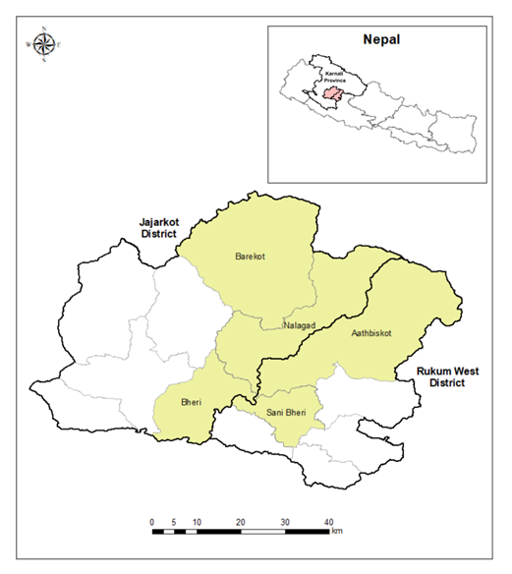

Figure: Map showing project districts and municipalities
The project has two outputs:
- Output 1: Local and district level governance in earthquake-affected areas strengthened to ensure continuity of basic service delivery, support long-term reconstruction, and enhance disaster preparedness
- Output 2: Earthquake-affected community resilience enhanced

The project is currently being implemented in five local governments —Nalgad Municipality, Bheri Municipality and Barekot Rural Municipality in Jajarkot District, and Aathbiskot Municipality and Sanibheri Rural Municipality in Rukum West District. The key government stakeholders include National Disaster Risk Reduction and Management Authority (NDRRMA), Ministry of Federal Affairs and General Administration (MoFAGA), Karnali Province Ministry of Land Management, Agriculture and Cooperatives (MoLMAC), Office of Chief Minister and Council of Ministers (OCMCM), District Administration Offices (DAOs) of Jajarkot and Rukum West districts, and local governments.

THEORY OF CHANGE
Following Theory of Change (ToC) is envisioned to achieve the project overarching goal of “effective earthquake recovery and long-term resilience, by enhancing government capacity for service delivery, support reconstruction, and promote revitalized livelihoods”

“If the damaged government buildings are immediately replaced by prefab structures and equipment; and risk governance of the municipalities strengthened, then the disrupted public services will be restored and transition towards long long-term recovery, reconstruction and rehabilitation will be smooth”.
“If the critical community infrastructure damaged by the earthquake are immediately rebuilt, then the livelihood services of the poor, women and vulnerable community lost by the earthquake will be restored, and new livelihood opportunities will be created”.
“If the capacities of the local governments and community to respond to disasters are increased through improved disaster preparedness and emergency response, the community will be able to reduce the loss from future disasters and enhance long-term resilience to risks”.

To realize this a range of synchronized interventions are proposed under the Project which includes : i) restoration of public services disrupted by the earthquake through construction of pre-fab structures at local and district levels and upgrading/replacement of damaged office equipment contributing to Specific Objective 1: To enhance capacities of earthquake-affected local governments for effective basic service delivery, reconstruction, and long-term resilience; ii) building critical community infrastructures needing repair and reconstruction such as watermills, irrigation canals, common facility centres for tailoring and iron smiths, solar-powered cold storage, beehive and tailoring equipment, and training to community members contributing to Specific Objective 2: To strengthen sustainable and resilient livelihoods of earthquake affected people and communities; and iii) strengthening emergency preparedness and response capacities and mechanisms through simulations, search and rescue equipment, coordination, information management and SOPs; and updating risk management plans and awareness generation contributing to Specific Objective 3: To enhance capacity of local governments on emergency preparedness and response through improved plans/procedures, response equipment and response facilities.

Given a short duration of 12 months implementation and it builds on immediate recovery needs of the community and the local governments, high ownership of the project results by the community and local governments is expected. As the project approaches will be guided by lessons learnt and experiences gained from other similar projects and initiatives, project implementation is expected to be very smooth and on-time without any disruptions, except the unpredicted impacts from new earthquake and climatic disasters.

Programmatic Adjustment
Due to the political disturbance in September and its implication on the disruption of activities and coordination with the governments, progress on activities under Output 2 were delayed. Final consultations planned for September 2025 to ensure social and environmental considerations and stakeholder consensus on community infrastructures were disrupted. The site selection and social and environmental evaluations of two cold stores were also disrupted causing delay in the planned project timeline.

The project thus requested to the Embassy of Japan for the approval of the extension of the project ‘Enhancing Livelihoods Improvement and Disaster Resilience Enhancement in the Areas Affected by the Jajarkot Earthquake’ (Jajarkot Earthquake Recovery Project) Project for a period of five months, until 31 July 2026. The revised timeline includes completion of construction of community infrastructures by June and construction of two cold stores by July 2026.

Key Achivements and Project Progress

Narrative on Key Results Achieved in 2025
Capacity building on mental health
The project provided 7-day training programmes to around 10 locals in each project municipality to capacitate them as community psychosocial workers (CPSWs). A total of 53 community members including 48 women were capacitated with skills to provide a broad range of psychosocial services to individuals, families and communities. Out of these 53 CPSWs, 15 were engaged during project intervention period.

Similarly, schools- and community- based group healing sessions were conducted for 411 students (178 boys and 233 girls) in schools and 233 adults using innovative methods and recreational activities in the communities. One self-help group and peer support group each with total members of 116 including over 70% women was formed in each project municipality that can provide peer support in the community and schools. The project also conducted 1-day district-level orientation workshop on mental health to 29 health staffs including 12 female health staffs from district hospital, and health centers and health posts of project municipalities. Further, a total of 106 municipal staffs and elected representatives of all five project municipalities were oriented on mental health to build their capacities in implementing psychosocial interventions.

Establishment of counselling centers
Five counselling centers were established in five project municipalities with engagement of one psychosocial counsellor (PSC) in each counselling center to provide individual counselling to the referred individuals.

Local- and Districts-level Emergency Operation Centers (LEOCs) strengthened
The project provided seven laptops and seven printers for five Local Emergency Operation Centers (LEOCs) and two District Emergency Operation Centers (DEOCs) to support their effective functioning. Further, Standard Operating Procedures (SOPs) of 5 project municipalities have been drafted incorporating inputs received from local-level consultations, and province-level sharing workshop of draft SOPs has been completed with engagement of participants (total: 29, men: 24, women: 5) from UNDP and federal and local agencies.

Capacity building on DRRM
The project conducted awareness raising programmes on disasters and climate change impacts, community-based preparedness and response and mitigation measures, among others, for 202 school children and community members including 114 women in Aathbiskot Municipality and Sanibheri Rural Municipality. A 3-days search and rescue orientation programme was conducted for 22 Community Emergency Rescue Team (CERT) volunteers (5 women) from the most vulnerable wards in Sanibheri Rural Municipality. The search and rescue orientation components included basic modules on rope rescue, river rescue, preparing improvised stretchers, and household fire prevention. 27 participants including 4 women took part in simulation exercise to test disaster preparedness including coordination, clarity on roles and responsibilities of stakeholders, and resource inventory at municipal level in Sanibheri Rural Municipality.

Detailed Feasibility Study of infrastructures
The feasibility study of the identified sites for construction of 10 prefabricated buildings has been completed to assess their viability and requirements, which include technical feasibility (land availability and ownership, access, toilet facility), financial and economic feasibility (costs, economic benefits) and operational feasibility (operation and maintenance). Detailed Project Reports (DPRs) for 10 prefab structures were prepared which include architectural, structural, sanitary, and electrical drawings of the 10 prefab structures, Bill of Quantity (BOQ) and cost estimation and 3D visualizations of the prefab structures for better visualization and stakeholder approval. A comprehensive social and environmental screening has also been completed for each site to assess potential environmental and social safeguard risks that may arise during construction such as accessibility, slope, water resources, potential hazards, environmentally sensitive areas, areas of religious and cultural importance etc. Following this, specific management plans such as Waste Management Plan, Grievance Redress Mechanism, Occupational Safety and Health Plan, Gender Action Plan and Child Labour Mitigation Plan were prepared to ensure compliance measures during construction phase.

A baseline survey as pre-feasibility assessment and field validation of the identified 10 CFCs and Market Centers and assessing existing condition of identified/long-listed 25 community infrastructure, including damage caused by earthquakes and the restoration needs were also completed. Feasibility study of these 35 infrastructures was also completed following a community-led process for field verification and validation of selected community infrastructure. This included detailed designs, Bill of Quantity (BOQ) and environment and social safeguard system assessment. To mitigate identified risks, specific management plans such as Waste Management Plan, Grievance Redress Mechanism, Occupational Safety and Health Plan, Gender Action Plan and Child Labour Mitigation Plan were prepared to ensure compliance measures during construction phase.

A feasibility study for potential development of cold storage facility in Rukum West and Jajarkot districts has been completed. This included stocktaking of agricultural produces and existing cold stores in the project districts/municipalities and recommendation of feasible technical, financial and operational mechanism for efficient operation of existing cold stores and/or new construction in specific locations of project municipalities. This study has recommended construction of two cold storage facilities equipped with thermal energy storage and solar power system in Aathbiskot Municipality and Sanibheri Rural Municipality. This technology incorporates solar energy and grid electricity to run the condensing unit and store thermal energy in the Phase Change Materials (PCM). A comprehensive social and environmental screening has also been completed for each site to assess potential environmental and social safeguard risks that may arise during construction such as accessibility, slope, water resources, potential hazards, environmentally sensitive areas, areas of religious and cultural importance etc. Following this, specific management plans such as Waste Management Plan, Grievance Redress Mechanism, Occupational Safety and Health Plan and Gender Action Plan were prepared to ensure compliance measures during construction phase.

Gender Equality, Disability and Social Inclusion (GEDSI)
The psychosocial support activities have been able to engage over 50% of women and vulnerable groups including children and youth. The peer-support groups formed in each project municipality engage school children of age 13-15, while self-help groups engage adults, mainly women. The capacity building on DRRM activities have also engaged over 45% of women. Similarly, GEDSI is a key criterion of beneficiaries mapping, based on which beekeeping farmers were identified. For selection of community infrastructures, community consultations with engagement of women and vulnerable groups were conducted, and schemes that benefit vulnerable groups were prioritized. Further, Users’ Committees have been formed with participation of women members for construction of community infrastructures. GEDSI has also been integrated into SOPs of LEOCs.

Knowledge Management and Visibility:
The project established a dedicated webpage withing the UNDP Nepal website to host key resources and updates. This platform now features the project brief along with a knowledge product detailing lessons learned from the project’s psychosocial interventions—a document produced in close collaboration with the Country Office’s Communications Unit. In addition to being available for public viewing online, 500 physical copies of the learning document were printed and distributed to government counterparts, civil society partners, and beneficiaries. Furthermore, the webpage now features a story on the project’s small-scale infrastructure interventions.

From the start of the project in February 2025 to March 2026, the project was featured in at least 24 posts from UNDP, UN-Habitat, government, and other partners on Facebook, X, Instagram, and LinkedIn. These posts reached over 36,000 individuals on Facebook, nearly 7,000 on X, over 15,000 on Instagram, and over 6,000 on LinkedIn. Likewise, the project maintained strong public visibility through local and national newspapers. As of March 2026, eight local/national newspapers had covered news about the project.

- Project webpage: https://www.undp.org/nepal/projects/livelihoods-improvement-and-disaster-resilience-enhancement-areas-affected-jajarkot-earthquake
- Story (Improving Lives and Livelihoods in the Areas Affected by the Jajarkot Earthquake): https://www.undp.org/nepal/stories/improving-lives-and-livelihoods-areas-affected-jajarkot-earthquake
- Media hits: Media Hits Tracker.xlsx

The following table shows the linkage of the outputs and activities of projects:
Table 1:Output and Activity
Output | Activity
Output 1: Local and district level governance in earthquake-affected areas strengthened to ensure continuity of basic service delivery, support long-term reconstruction, and enhance disaster preparedness | Activity 1.1: Strengthen earthquake affected municipalities and districts to deliver basic public services
 | Activity 1.2: Strengthen disaster response capacity of municipality and create awareness at community level
Output 2: Earthquake-affected community resilience enhanced | Activity 2.1: Provide support to households for improved livelihood interventions
Output 2: Earthquake-affected community resilience enhanced | Activity 2.2: Construction support for facilities i.e. Community Facility Center and small-scale infrastructure for improved economic opportunities
Output 2: Earthquake-affected community resilience enhanced | Activity 2.3: Psychosocial support to earthquake affected community

Progress towards the UNSDCF/CPD Outcomes
UNSDCF/CPD Outcome 3:
By 2027, more people, especially women, youth, and the most marginalized and poor, increasingly benefit from and contribute to building an inclusive, sustainable, climate-resilient and green society and reduced impacts of disasters at federal, provincial and local levels.

CPD Outputs
CPD 3.1: Innovative resilience-building solutions introduced at all levels to reduce risks from disasters and climate change
CPD 3.2: Risk informed and gender-responsive recovery solutions, including stabilization efforts and mine action, implemented at regional, national and sub-national levels

Country Programme Indicators
3.1.2. Number of local governments implementing electronic building permit systems, climate friendly, resilient (infrastructure) guidelines and (health) waste management initiatives (IRRF-3.1.1) Baseline (2021): 17 | Targets (2027): 34
3.2.3. Number of federal, provincial and local governments integrating climate-change adaptation responding to gender equality and social inclusion in plans based on NPC mainstreaming guideline (2019) (IRRF-4.2.1) Baseline (2022): 280 | Target (2027): 424

Applicable Output(s) from the UNDP Strategic Plan:
CP Output 3.1: Institutional systems to manage multi-dimensional risks and shocks strengthened at regional, national and sub-national levels
CP Output 3.3: Risk informed and gender-responsive recovery solutions, including stabilization efforts and mine action, implemented at regional, national and sub-national levels

Table 2: Progress in Country Programme Indicators
Outcome statement | indicator | Baseline | Cumulative Target for 2025 - 2026 | Milestone for 2025 | Achievement 2025 | Source of data
 | CPD Output 3.1: Innovative resilience-building solutions introduced at all levels to reduce risks from disasters and climate change
By 2027, more people, especially women, youth, and the most marginalized and poor, increasingly benefit from and contribute to building an inclusive, sustainable, climate-resilient, and green society and reduced impacts of disasters at federal, provincial, and local levels | 3.1.2. Number of local governments implementing electronic building permit systems, climate friendly, resilient (infrastructure) guidelines and (health) waste management initiatives (IRRF-3.1.1) Baseline (2021): 17 | Targets (2027): 34 |  | 5 | 3 | Ongoing
 | CPD Output 3.2: Risk informed and gender-responsive recovery solutions, including stabilization efforts and mine action, implemented at regional, national and sub-national levels
 | 3.2.3. Number of federal, provincial and local governments integrating climate-change adaptation responding to gender equality and social inclusion in plans based on NPC mainstreaming guideline (2019) (IRRF-4.2.1) Baseline (2022): 280 | Target (2027): 424 |  | 5 (SOPs of 5 LEOCs for disaster preparedness and management) | 3 | 5

Progress on Project Outputs
Table 3: Progress in Output Indicators
Output | Indicator | Baseline | Cumulative Target for 2025- 2026 | 2025 | 2025 Progress | Means of verification
 |  |  |  | Milestone | 2025 Progress | Means of verification
Output 1: Local and district level governance in earthquake-affected areas strengthened to ensure continuity of basic service delivery, support long-term reconstruction, and enhance disaster preparedness  Gender Marker: 2 | 1.1 Number of prefabs constructed for improved basis service delivery | 7 | 10 | 0 | 0 | - Visit reports by UNDP  - Reports by LGs, Districts  - Photos  - Meeting minutes  - Handover documents
 | 1.2. Number of Local Governments with enhanced disaster risk preparedness | 2 EPRs | Emergency Preparedness and Response (EPR) Plan for 5 LGs | Emergency Preparedness and Response (EPR) Plan (Update of Standard Operating Procedures (SOPs) of LEOCs) for 5 LGs | SOPs of 5 LGs updated | - Emergency Preparedness and Response (EPR) Plan for LGs  - Meeting minutes and handover documents  - Visit reports by UNDP and photographic evidence
 | 1.3. Number of persons trained on disaster response at the local government and community | 0 | 1000 person trained on disaster response including 30% beneficiaries including women and youths & 50% of all govt. staffs | 1000 person trained on disaster response including 30% beneficiaries including women and youths & 50% of all govt. staffs | 251 (men: 128, women: 123) | - Training Modules  - Meeting minutes  - Training Reports/Proceedings
Output 2: Earthquake-affected community resilience enhanced  Gender Marker: 2 | 2.1 Number of household provided support for improved livelihood from bee keeping support | 0 | 400 households benefitted from livelihood support including 30% women led HHs | 0 | 0 | - Visit reports by UNDP  - Reports by LGs, Districts  - Photos  - Meeting minutes  - Handover documents
 | 2.2 Number of facilities constructed i.e. Community Facility Center and small-scale infrastructure for improved economic opportunities | 0 | 35 facilities constructed for improved economic opportunities | 0 | 0 | - Visit reports by UNDP  - Reports by LGs, Districts  - Photos  - Meeting minutes  - Handover documents
 | 2.3 Number of people directly benefit from psychosocial counselling support | 0 | 400 community members provided support from psychosocial counselling including 30% women, youth and marginalized groups | 300 community members provided support from psychosocial counselling including 30% women, youth and marginalized groups | 1172 (men: 391, women: 781) | - Visit reports by UNDP  - Reports by LGs, Districts  - Photos  - Meeting minutes  - Handover documents

Output 1: Local and district level governance in earthquake-affected areas strengthened to ensure continuity of basic service delivery, support long-term reconstruction, and enhance disaster preparedness
Activity Result 1.1: Capacities of earthquake affected local governments and districts strengthened to deliver basic public services
Progress has been made in strengthening local service delivery capacity through ongoing construction of 10 prefabricated government buildings. These facilities are being developed to ensure continuity of basic services, support long-term reconstruction, and enhance disaster preparedness. Preparatory activities have been completed, including site analysis, social and environmental screening, and design of all 10 buildings. Furnishing is expected to commence in April 2026, supporting the operationalization of these facilities and improving service delivery at the local level.

In parallel, operational capacity of emergency response systems has been strengthened through the provision of seven laptops and seven printers to five Local Emergency Operation Centers (LEOCs) and two District Emergency Operation Centers (DEOCs), contributing to improved coordination and emergency management capacity.

Activity Result 1.2: Resilience to earthquake and climate risks enhanced in earthquake affected local governments
Progress has also been made in strengthening disaster preparedness and risk management systems. Draft Standard Operating Procedures (SOPs) for Local Emergency Operation Centers have been developed and shared through municipal-level meetings and a provincial-level joint workshop, supporting improved coordination and standardization of emergency response processes. In addition, municipal-level consultations to develop and update Disaster Risk Management (DRM) Fund Mobilization Guidelines are scheduled for February 2026, contributing to improved financial preparedness for disaster response.

Further progress is underway in strengthening response capacities, with the provision of search and rescue equipment to five LEOCs and two DEOCs scheduled for completion by March 2026. Capacity-building activities are also ongoing, including basic search and rescue orientations, simulation exercises, and school- and community-based awareness programmes. These interventions are contributing to enhanced preparedness and response capacity at both institutional and community levels across earthquake-affected areas.

Output 2: Earthquake-affected community resilience enhanced
Activity Result 2.1: Livelihoods opportunities created, and market revitalized through, community infrastructure and other livelihoods interventions
Progress has been made in advancing the development of community-based infrastructure and livelihood support initiatives. A baseline study, including social and environmental assessments and detailed design work for 35 community-based infrastructures (comprising 15 small-scale infrastructures, five market centers, and five Community Facility Centers), is currently underway. Construction of these infrastructures is scheduled for completion by June 2026.

In parallel, preparatory work has progressed on livelihood support activities. Beneficiary selection criteria have been developed to guide the provision of beekeeping tools and associated training programmes targeting 400 households. The distribution of beekeeping tools and implementation of related training are planned for March 2026.

Further progress has been made in promoting agricultural value chain development through cold storage facilities. Coordination with the Ministry of Land Management, Agriculture and Cooperatives (MoLMAC), Karnali Province, has been undertaken to assess feasibility. The feasibility assessment has been completed, and Aathbiskot Municipality and Sanibheri Rural Municipality have been identified as implementation sites, with both municipalities confirming land allocation and financial contributions. Procurement for the construction of two cold storage facilities is currently ongoing, with construction expected to commence in April 2026.

Progress has also been achieved in strengthening psychosocial support systems. Psychosocial centers have been established and are operational in project municipalities. A total of 53 community members have been trained as community psychosocial workers, while school- and community-based group healing sessions have reached 411 students and 233 adults. In addition, mental health orientation programmes have been conducted for 29 district-level health staff and 106 municipal staff and elected representatives, contributing to strengthened awareness and response capacity at both institutional and community levels.

Project Beneficiary in 2025
Under the LIDRE project in 2025, approximately 1,451 people, including 115 female and 21 people with disabilities, benefitted from the project activities. The beneficiary details are given in the table below.
Table 4: Beneficiaries' Disaggregated Data
Total | Male | Female | Others | Disable | 0-17 | 18-35 | 36-59 | 60+
1451 | 536 | 115 | 0 | 21 | 678 | 538 | 214 | 21

Budget and Expenditure
The following table shows the output-wise indicative budget and expenditure for 2025, and the sources of funds budgeted and utilization.
Table 5: Annual Budget and Corresponding Expenditure
Expenditure (in USD)
Activities | Budget | Total expenditure  - (including commitments) | Balance | - Expenditure in %
Output 1 | 738,673.00 | 540,815.68 | - 197,857.32 | 73%
Output 2 | 615,198.00 | 482,176.12 | - 133,021.88 | 78%
Project Management Cost | 285,341.00 | 70,183.49 | - 215,157.51 | 25%
UN Coordination Levy (1%) | 16,392.00 | 16,392.00 | - - | 100%
TOTAL | - 1,655,604.00 | 1,109,567.29 | - 546,036.71 | 67%
Date: 31 December 2025

Table 6: M&E Expenditure in 2025
Total Expenditure on Monitoring  Costs associated with UNDP/project staff, consultants, project partners, supporting national statistical systems in designing project specific data collection methodologies (qualitative and quantitative), monitoring methods including stakeholder surveys and other qualitative methods, collection of data, analysis and dissemination of the findings to inform a project, either with project partners or to fulfill specific UNDP/project requirements (preferably the former). | $21,809
Total Expenditure on Decentralized Evaluations
Costs associated in designing, implementing, and disseminating evaluations for specific projects.
Combined Total Expenditure on M&E | $21,809

Narrative on Progress related to Budget and Expenditure
In 2025, the project allocated US$ 1,629,798.00 to implement the initiatives outlined in the approved annual work plan for that year. Of the total, US$ 1,557,198.00 was funded by GOJ and the remaining US$ 72,600.00 was provided by TRAC. A total of US$ 1,109,567.29 was spent, including commitments, accounting for 67% of total budget.

Cross Cutting Issues

Targeting and voice/Participation of Target groups
LIDRE project has prioritized reaching its target groups while implementing project activities. The implementing partner UN-Habitat and local partners are working as per their respective defined scopes and are ensuring that the needs of the targeted populations are addressed through the project interventions. The Project has coordinated with the Government of Nepal, including NDRRMA, MoFAGA, the Karnali provincial MoLMAC, DAOs and affected local governments to align implementation with local priorities and needs.
The project conducted kick-off meetings with the local and district level agencies to discuss on the project intervention areas and identify prioritized activities of project municipalities. The kick-off meetings were conducted in the respective municipalities and District Administration Offices (DAOs). The participants included Mayors/Chairs, Chief Administrative Officers, municipality staffs and ward chairs in urban and rural municipalities, and Chief District Officers and focal persons in DAOs. During these meetings, the project brief, outputs, major activities and implementation modality were shared and needs of project municipalities and identification of specific activities under each project output were assessed. As a follow-up to these meetings, a provincial-level technical meeting was also held to share project brief and receive inputs on implementation. The participants included key stakeholders from federal, provincial and local governments.
The SOPs of LEOCs have been aligned with the national SOP and updated incorporating inputs received during local-level consultations. A province-level draft SOPs sharing workshop has also been completed with participation of NDRRMA and MoFAGA.
The psychosocial support activities have been able to engage over 50% of women and vulnerable groups including children and youth. The peer-support groups formed in each project municipality engage school children of age 13-15, while self-help groups engage adults, mainly women. The capacity building on DRRM activities have also engaged over 45% of women.
Altogether, 1451 (915 female) target people have been involved and benefitted from the LiDRE project activities.

Gender Equality, Women’s Empowerment, and Social Inclusion
Integration of GEDSI in updated SOPs
GEDSI has been integrated into the updated SOPs of LEOCs. The SOPs incorporate components such as safety of women, lactating mother, PwDs, children and elderly through provisioning of dignity kits and psychosocial support, and prioritizing these groups in early warning system mechanism.
Integration of GEDSI in project activities
The psychosocial support activities have been able to engage over 50% of women and vulnerable groups including children and youth. The peer-support groups formed in each project municipality engage school children of age 13-15, while self-help groups engage adults, mainly women. The capacity building on DRRM activities have also engaged over 45% of women. Similarly, GEDSI is a key criterion of beneficiaries mapping, based on which beekeeping farmers were identified. For selection of community infrastructures, community consultations with engagement of women and vulnerable groups were conducted, and schemes that benefit vulnerable groups were prioritized. Further, Users’ Committees have been formed with participation of women members for construction of community infrastructures.
Integration of GEDSI in data collection and reporting
Project is promoting data collection, collation, compilation and analysis from the lens of intersectionality through activities-specific and consolidated Sex, Age, and Disability-Disaggregated Data (SADDD). Project itself has designed the data collection template for collecting the disaggregated data of beneficiaries and participants. The template can record data on gender (male, female, other), disability, age group (A 0-17 years, B:18-35 years, C 36-59 years, D: 60+years). The project reports the disaggregated information of beneficiaries based on the details recorded in the template.

National Capacity Development
NA

Sustainability
The project is working in close partnership with GoN and its structures at federal, provincial, and local level, as well as district level which is critical for disaster response. It has maintained regular dialogue and aligned implementation strategy with relevant entities including NDRRMA, MoFAGA, provincial MoLMAC, and local governments. The project has actively involved elected members and relevant officials from the affected municipalities during consultations and capacity building programmes.
The project is actively collaborating with existing development programs at the municipal, district, and provincial levels, ensuring a strategic alignment that prevents duplication and enhances synergy for effective earthquake recovery and long-term resilience.
Additionally, the project is also working to strengthen the capacity of the communities as well as stakeholders for enhancing their capacity to enhance preparedness, response and resilience capacities through orientation and training programmes. Such capacity building initiatives ensure institutional sustainability and instil the sense of ownership within them.

South-South and Triangular Cooperation
NA

Partnerships
The project has coordinated with the Government of Nepal, including NDRRMA, MoFAGA, the Karnali provincial MoLMAC, DAOs and affected local governments to align implementation with local priorities and needs. The project conducted kick-off meetings with the local and district level agencies to discuss on the project intervention areas and identify prioritized activities of project municipalities. The kick-off meetings were conducted in the respective municipalities and District Administration Offices (DAOs). The participants included Mayors/Chairs, Chief Administrative Officers, municipality staffs and ward chairs in urban and rural municipalities, and Chief District Officers and focal persons in DAOs. During these meetings, the project brief, outputs, major activities and implementation modality were shared and needs of project municipalities and identification of specific activities under each project output were assessed. As a follow-up to these meetings, a provincial-level technical meeting was also held to share project brief and receive inputs on implementation. The participants included key stakeholders from federal, provincial and local governments.
Besides, the project has partnered with Sustainable Energy and Technology Management, Transcultural Psychosocial Organization Nepal (TPO Nepal), Mahavir Shree International Pvt. Ltd., Strength Engineering Company Pvt. Ltd., The Designers Nepal Pvt. Ltd and SOSEC Nepal to implement the activities at the ground level.

Promotion of Civic Engagement
The project places a strong emphasis on people-centered and locally led approaches. Multiple activities are designed to ensure the engagement of the communities. Local community members are engaged in simulations, trainings and orientations activities. School students and teachers are involved in DRR awareness programmes and schools-based healing sessions. The activities have built their capacity and empowered them in the disaster preparedness and response sector. An NGO, SOSEC Nepal, is engaged in provisioning of beekeeping equipment. Users’ communities are formed for construction of community infrastructures.

Expanding Opportunities for Youth
LIDRE project has emphasized engaging youth in project activities by designing the activities for youth. The schools-based awareness programmes on DRRM have capacitated school children aged 12-17, underscoring the engagement of youth in the disaster preparedness and response sector. Similarly, schools- and community- based group healing sessions were conducted for 411 students (178 boys and 233 girls) in schools using innovative methods and recreational activities in the communities. One self-help group was formed in each project municipality engaging youths aged 13-19 who can provide peer support in the community and schools.
The project has been monitoring the engagement of youth through age wise data disaggregation of project beneficiaries. Out of 1451 project beneficiaries, 678 individuals are between the age group 0 to 17, 538 individuals are between 18 to 35, 214 individuals are between 36 to 59 and 21 individuals are above 60.

Innovation
NA

Knowledge Management and Products
To centralize project updates and resources, a dedicated webpage was launched on the UNDP Nepal website. This platform serves as a repository and already includes a project brief, a knowledge product on psychosocial intervention, and a story on the small-scale infrastructure intervention of the project. The knowledge product was also printed (500 copies), and distributed amongst the government stakeholders, civil society partners, and beneficiaries.
In terms of digital outreach, the project was featured in at least 24 social media posts by UNDP, UN-Habitat, government agencies, and other partners between February 2025 and March 2026. These updates reached over 36,000 individuals on Facebook, nearly 7,000 on X, over 15,000 on Instagram, and over 6,000 on LinkedIn. Beyond social media, the project maintained high public visibility through traditional media; as of March 2026, eight local and national newspapers had published reports on the project’s progress and impact. The list of media articles is presented below:

New Spotlight Magazine | Japan And UNDP Signed an Agreement To Support Earthquake Recovery In Jajarkot And Rukum West
The Himalayan Times | Japan, UNDP join hands to support quake recovery in Jajarkot, Rukum West
My Republica | Japan-UNDP partner to support earthquake recovery in Jajarkot and West Rukum
Nepal Monitor | Japan and UNDP Support Jajarkot Quake Recovery
CIN Khabar | Japan's Support to Improve Livelihoods and Disaster Management Capacity
KaKhaRa | District Disaster Management Committee, Rukum West, receives search and rescue materials
Sanibheri Rural Municipality | Beehive distribution to 80 farmers of Sanibheri Rural Municipality

Lessons Learned
Key lessons learned during the project implementation highlight the importance of local leadership, collaboration, and cost sharing.
A series of consultations were undertaken with local governments, activities were discussed and prioritized, following which approval letters and commitment were received from the project municipalities. Project municipalities also committed on allocation of resources in kind and community voluntary contribution. These aspects resulted in high local ownership and also increased financial viability of infrastructure schemes.
Increased awareness on mental health programmes has ensured commitment from municipalities for continued operation of Counselling Centers and planning of psychosocial support activities in municipal program and budget.
Regular coordination and collaboration promote the willingness and ownership of government bodies which yield positive results ensuring upscaling and replication of activities.
GEDSI focused interventions and capacity building initiatives have been able to strengthen the voice of marginalized groups in procedures and activities for inclusive institutionalization in disaster preparedness and response activities.

Implementation Issues and Challenges
Following are some of the challenges encountered during project implementation.
- Selection of community infrastructures: As a large number of infrastructures were damaged by the earthquake, selecting community infrastructures was quite challenging in the beginning. To streamline, detailed feasibility studies were conducted focusing on consultations, beneficiaries mapping and financial viability.
- Land provisioning and site clearance: Provisioning of land was another challenge, especially in Bheri. And in some cases where land was allocated, site clearance works and protection measures such as retaining walls were required adding to the overall costs. This was avoided through voluntary community contribution in kind and cost-sharing by ward or municipality offices.
- Continued operation of Counselling Centers: Due to short period of psychosocial support, continued operation of counselling centers is a challenge. As these were established in municipality-owned buildings or city- and district hospitals, municipal officials have committed to continue their operation.

Priorities for 2026
The following key activities have been prioritized for implementation in 2026, with a total allocated budget of US$ 1,277,743.00.
- Construction and furnishing of 10 prefabricated government buildings
- Update/develop Disaster Risk Management (DRM) Fund Mobilization Procedures for Local Emergency Operation Centers (LEOCs)
- Provision of search and rescue equipment
- Conducting disaster risk reduction (DRR) capacity-building programmes
- Construction of 35 community infrastructures
- Construction of 2 cold storage facilities
- Provision of beekeeping support to targeted households

Case Stories
Improving Lives and Livelihoods in the Areas Affected by the Jajarkot Earthquake
Published in: https://www.undp.org/nepal/stories/improving-lives-and-livelihoods-areas-affected-jajarkot-earthquake

Between the rugged hills of Nepal’s largest province, Karnali Province, lie the districts of Jajarkot and Rukum West. On 3 November 2023, a powerful 6.4-magnitude earthquake struck the province, with its epicentre at Ramidada in Jajarkot. The disaster claimed 154 lives, injured 366 people, and disrupted the lives and livelihoods of nearly 250,000 people across 18 districts.
According to the Provincial Emergency Operation Center of Karnali Province, more than 62,000 private houses were affected. The earthquake also damaged livelihoods, including the production and storage of agricultural products, and destroyed 188 irrigation and drinking water systems.
Jajarkot and Rukum West are among Nepal’s food-insecure districts, where steep terrain and limited connectivity make livelihoods particularly fragile. Agriculture remains the primary source of livelihood for more than 70 percent of the workforce. In recent years, many farmers had also begun transitioning toward commercial farming, gradually improving their incomes.
The earthquake, however, set this progress back. According to the Food and Agriculture Organization’s Data in Emergencies Information System (DIEM) Impact Report, 21 percent of farmers reported damage to irrigation systems, while 20 percent reported damage to agricultural land.
While the devastation cannot be undone, concerted efforts are underway to rehabilitate damaged livelihood infrastructures with support from local governments and development partners. Across the affected districts, efforts are underway to help communities rebuild their lives and livelihoods, while strengthening their resilience to future disasters.

Restoring Damaged Irrigation Canals
In the village of Chhepka in Nalgad Municipality, irrigation has long been the lifeline of the community. For generations, an irrigation canal running through the settlement sustained the farmland of 122 households, including that of 35-year-old Amrita.
Already weakened by the 2023 earthquake, it was further destroyed by landslides during the 2024 monsoon, cutting off water supply to the farms that depend on it.
Today, Amrita works alongside fellow community members to restore the canal. Equipped with tools and determination, they are rebuilding what their community has relied on for decades. In addition to earning income from her work, she is grateful to contribute to an effort that is helping strengthen the livelihoods of the entire community.
“Once the canal is restored, I’ll be able to irrigate my field and grow enough food for my family,”
Amrita Oli, Beneficiary

A similar effort is underway in Ghetma Khola of Aathbiskot Municipality in Rukum West, where the rehabilitation of a damaged irrigation canal will benefit 57 earthquake-affected households. Once restored and reinforced with concrete, the canal will provide reliable irrigation to local farms and help operate a water-powered mustard oil mill that serves the entire community.
Across both districts, villagers attempted to repair damaged canals using plastic sheets and roofing materials, but these temporary solutions proved ineffective.
Without proper irrigation, many fields remained barren. Local farmers reported that rice and wheat production dropped by nearly 50 quintals compared to previous years, forcing families to purchase grain from markets.
For these communities restoring irrigation systems is not just a technical intervention but a vital step toward restoring food security and livelihoods.
Restoring Damaged Irrigation Ponds

In areas where farmland is small and water supply uncertain, irrigation ponds play a crucial role in sustaining agriculture. In Barekot Rural Municipality of Jajarkot, most families cultivate small plots of land where they grow maize, millet, and seasonal vegetables to support their households.
However, unreliable water supply often prevents farmers from fully utilizing their land. The hardships deepened further when the earthquake took away loved ones, homes, and livestock, leaving communities struggling to rebuild both emotionally and economically.
To address this challenge, UNDP’s Livelihoods Improvement and Disaster Resilience Enhancement in the Areas Affected by the Jajarkot Earthquake Project, supported by the Government of Japan, has constructed an irrigation pond in Budhagaun of Barekot Rural Municipality. The 6-meter by 3.5-meter pond provides a reliable year-round water source, enabling farmers to irrigate their fields even during dry periods. The pond will benefit at least 40 households, allowing farmers to grow cash crops, fruits, and vegetables, strengthening food security while increasing household income.
A Comprehensive Approach to Recovery
The irrigation initiatives are part of UNDP’s broader Jajarkot Earthquake Recovery Project, implemented with support from the Government of Japan.
The project is restoring 15 irrigation canals and constructing three irrigation ponds across five municipalities: Bheri Municipality, Nalgad Municipality, and Barekot Rural Municipality of Jajarkot, and Sanibheri Rural Municipality and Aathbiskot Municipality of Rukum West.
Supported by the Government of Japan, these irrigation interventions alone will benefit more than 1,000 earthquake-affected households, enabling them to grow sufficient food for their families while selling surplus produce in nearby markets.
Community participation is central to the project’s approach.
From sourcing construction materials locally to employing local workers, the initiative ensures that recovery efforts directly benefit the communities they aim to support. This approach not only creates immediate income opportunities but also encourages communities to take ownership of the infrastructure once it is completed.
Beyond irrigation, the project is adopting a holistic approach to strengthening livelihoods and resilience. Future interventions include the construction of market centres, common facility centres, and cold storage facilities that will help farmers store, process, and sell their produce more effectively.
Additionally, beekeeping activities have been introduced to diversify income opportunities and strengthen local resilience.
Together with the Government of Japan, local governments and the communities themselves, UNDP remains committed to helping earthquake-affected families in Jajarkot and Rukum West rebuild their lives, strengthen their livelihoods, and create a more resilient future.

Risk and Issue Logs
Table 7: Risk and Issues Log Matrix
S. N | Description | Category (financial, political, operational, organizational, environmental, regulatory, security, strategic, other) | Likelihood of risk (scale of 1 to 5 with 5 being the most likely)  A | Impact  (scale of 1 to 5 with 5 being the highest impact)  B | Risk factor (A x B) | Mitigation measures if risk occurs | Date risk is Identified | Last Updated | Status
1 | There is a risk that the local governments do not have the capacity to meet their obligations in the project. | Organizational | There might be a lack of awareness or capacity on the matter, in addition to little budget and potential disasters leading to reprioritization.  P = 3 | This may result in a lack of ownership at the policy level, and a delay in the operations and management budget creation by municipalities  2 | 6 | Stock take and mapping of the key stakeholders and direct beneficiaries  stakeholder engagement with local governments | March 2025 | December 2025 | Improved
2 | The role of women and potentially affected stakeholders (including marginalized groups, IPs) in ERP, and the impact of disasters on them may not be adequately considered and may perpetuate existing discriminations | Social | Limited consideration of the needs for women and marginalized communities due to the lack of capacities and knowledge on best practices.  P = 1 | This may reproduce existing discriminations, in emergency preparedness and response and in the psychosocial support activities  3 | 3 | monitor the representation of women and diverse stakeholder groups IPs in consultations, and psychosocial support activities. | March 2025 | December 2025 | Improved
3. | There is a risk that women workers may face discrimination like unequal pay and gender-based violence like harassment during the construction and reconstruction work | Financial and security | Limited consideration of the needs for women due to the lack of capacities and knowledge on best practices.  P = 1 | This may reproduce the discrimination against women based on gender  3 | 3 | monitor the representation of women in consultations  prepare Gender Action Plan | March 2025 | December 2025 | Improved
4 | There is risk of low considerations to incorporate expressed needs of the IP (if any were made in consultations) and the known access needs of PWDs during the construction of prefab structures | Social | Limited consideration of the needs for IPs and PwD due to the lack of capacities and knowledge on best practices.  P=2 | This may prevent smooth access to services provided in the structures (e.g health, police) for these communities  2 | 4 | map the target beneficiaries including youths, women and marginalized communities in the project site | March 2025 | December 2025 | Improved
5. | There is a risk of adverse impact on soils linked to construction work | Environmental | The construction works will need extraction work, which might be done improperly  P=2 | This can lead to landslides, and soil destabilization  3 | 6 | Conduct SESP assessment.  Implement all necessary measures to ensure that the impacts on soils linked to extraction are minimized | March 2025 | December 2025 | Improved
6 | There is risk of an earthquake or climate-related disaster (flood, landslide) | Environmental | The project area and Nepal in general are highly vulnerable to earthquakes, climate change and flood hazards.  P=3 | The disaster may affect populations and cause a reprioritization of the local government’s action. Damage to the built infrastructure and prefab may further impede the access of the local communities to enhanced livelihoods and crucial services. I=3 | 9 | Conduct SESP assessment.  All the structures constructed should full take account of the potential hazards in the location and ensure it is constructed in stable area with design elements to withstand multi-hazard risks | March 2025 | December 2025 | No change
7 | There is risk of erosion and dust pollution from excavated earth during the construction processes. | Environmental | The excavated soil from the prefabricated building base and dust blown from the vehicles might pollute nearby settlements.  3 | The construction work may affect populations and settlements  1 | 3 | Conduct SESP assessment.  Establish Grievance Collection Mechanism | March 2025 | December 2025 | Improved
8 | There is a risk of unwanted accidents of workers and stakeholders or failure of buildings or infrastructure. | Security | Unmanaged/unprotected storage of the construction materials, design failure or quality of the materials used  3 | The construction works may cause physical damage to workers and stakeholders.  3 | 9 | Conduct SESP assessment.  Develop Occupational Health & safety (OHS) plan | March 2025 | December 2025 | Improved
9 | There may be occupational health and safety risks due to physical hazards. | Security | During the maintenance works, there will be handling, transportation, storage of construction materials and electro-mechanical equipment.  2 | Workers and community people may get injured while performing these activities.  3 | 6 | Conduct SESP assessment.  Develop Occupational Health & safety (OHS) plan | March 2025 | December 2025 | Improved
10 | There is a risk of child labor associated with the construction projects | Occupational | The selected construction work vendors might employ children  2 | Child labor will have strong negative impacts on children employed  3 | 6 | Conduct SESP assessment.  Develop Occupational Health & safety (OHS) plan | March 2025 | December 2025 | Improved
11 | There might be conflict between project workers and the community. | Social | Potential influx of workers for the construction work.  2 | The construction of prefab buildings may attract conflict among workers and local communities.  3 | 6 | Develop Gender Action Plan.  Establish GRM. | March 2025 | December 2025 | Improved
12 | There is a risk that the vendor may not pay attention to proper management of the solid waste generated during the construction work. | Environmental | Hazardous waste and non-hazardous waste such as construction debris will be produced during the construction works.  2 | Improper disposal of the waste will cause environmental degradation in the area.  3 | 6 | Conduct SESP assessment.  Develop Waste Management Plan. | March 2025 | December 2025 | Improved
13 | There is a risk of recruitment delays and high staff turnover, which may affect the project implementation timeline and overall workforce stability. | Organizational | As a result of delays in recruiting project staff, along with challenging working conditions in remote locations, including isolation, limited access to basic facilities such as telephone, internet, and transportation.  3 | Which will impact in delays in the initiation and implementation of project activities, leading to poor quality of project delivery, increased management workload, challenges in ensuring accountability, and difficulties in maintaining an inclusive workforce  3 | 9 | Establish GRM. | March 2025 | December 2025 | Improved
14 | There is a risk that the partners in the proposed joint programme modality face challenges in coordination or joint implementation of planned activities. | Organizational | As a result of disagreements of approaches or priorities, staff turnover, or insufficient coordination and communication.  2 | Which will impact in challenges to effectively implement planned project activities, and to fully achieve expected project results.  3 | 6 | Engage with government entities at federal, provincial, and local levels | March 2025 | December 2025 | Improved

Annex: Photo Gallery

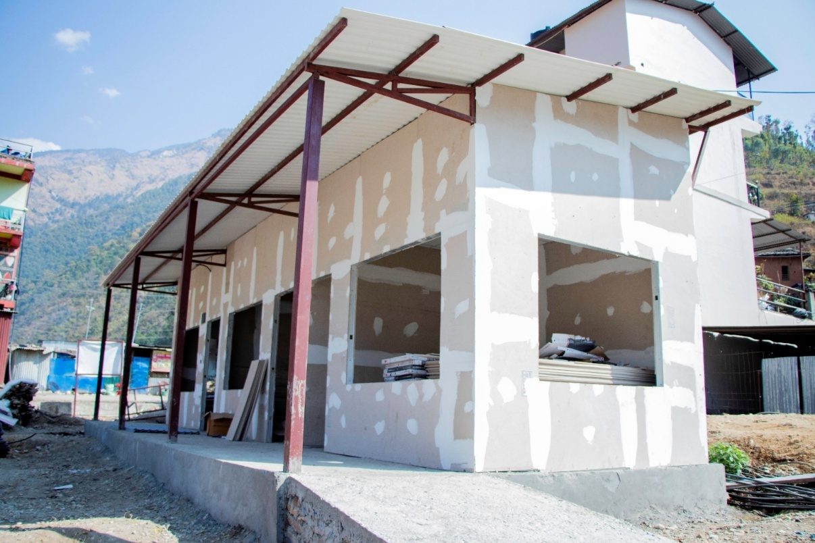
Figure 1: Prefabricated Buildings under Construction for Local Government

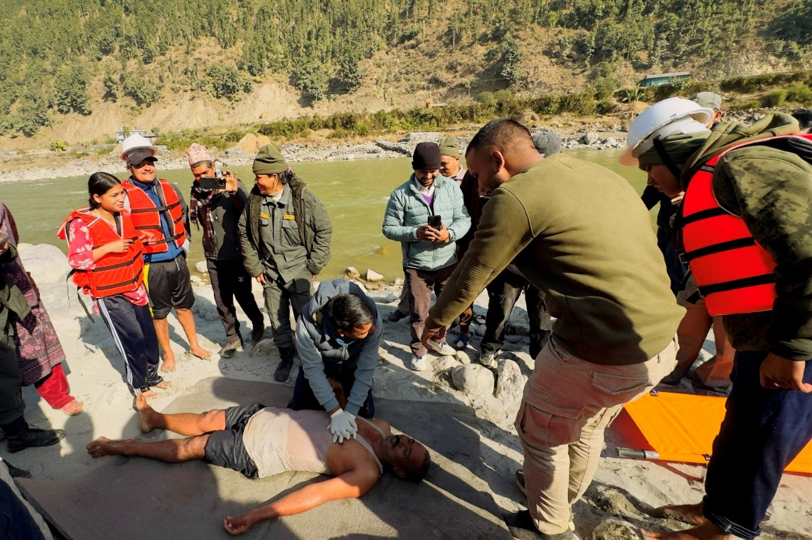
Figure 2: 3-Day Search and Rescue Training
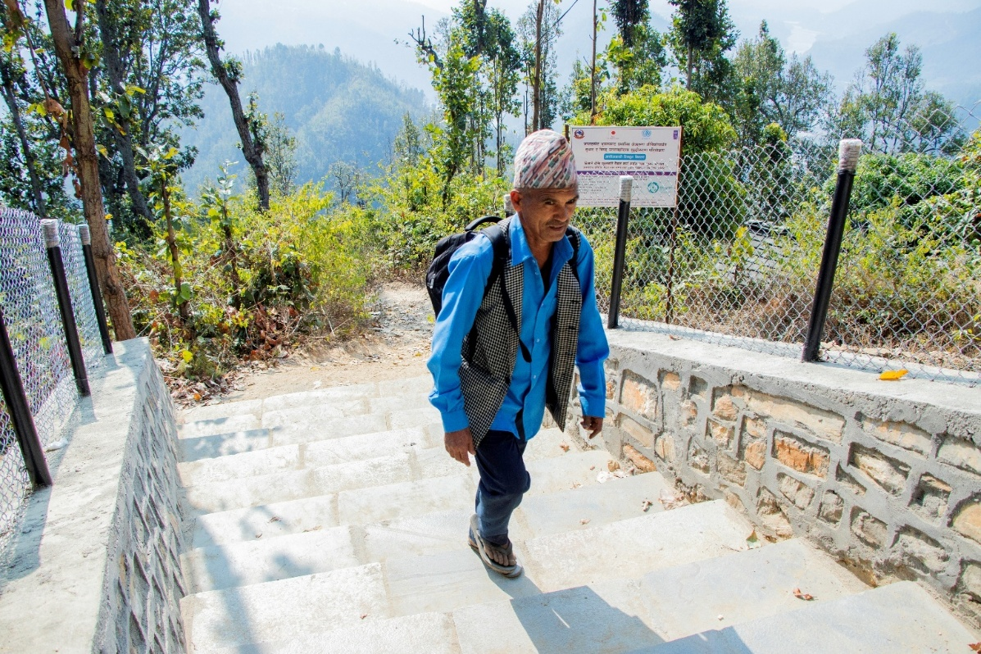
Figure 3: Improved Foot Trails

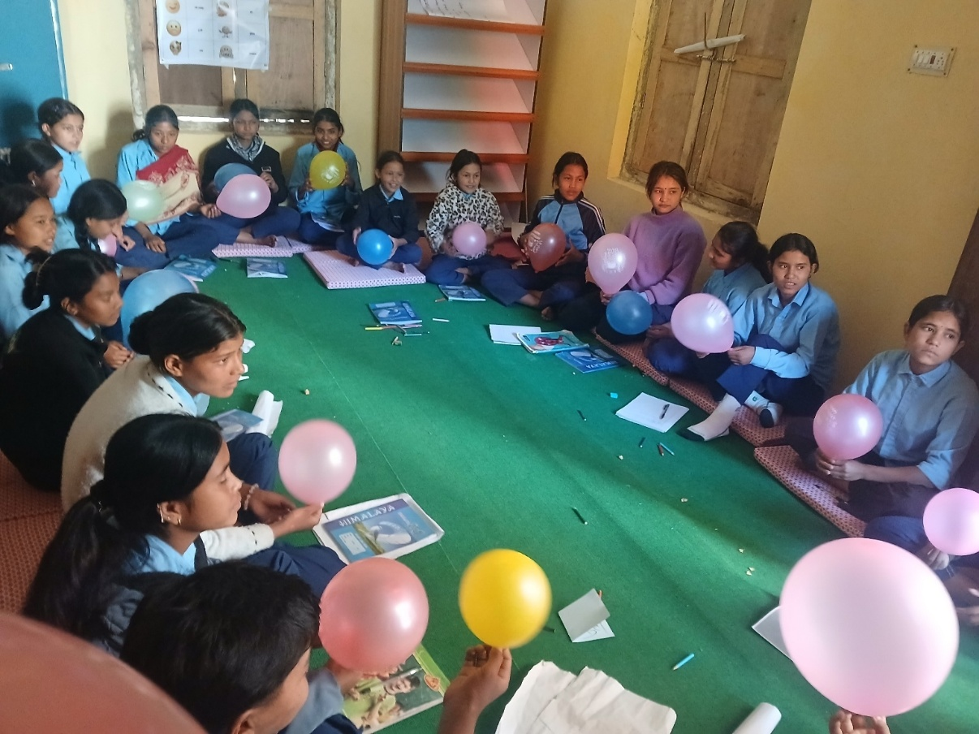
Figure 4: School-Based Psychosocial Group Intervention

