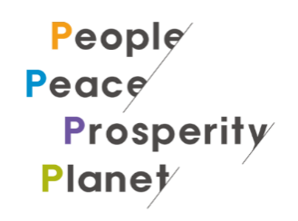
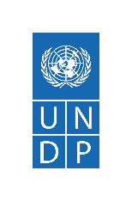
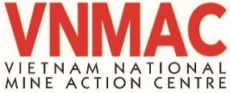
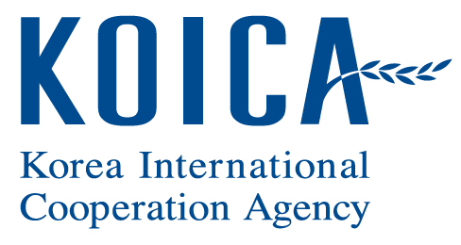

Project Document

Vietnam

Project Title: | Korea – Viet Nam Peace Village Project (KVPVP)
Project Number: | 00098753
Implementing Partner: | UNDP Viet Nam

Start Date:1/1/2022 | End Date:12/31/2026 | LPAC Meeting Date: 01/18/2026

Brief Description
The presence of EO can have a substantial negative impact on human development. Landmines, cluster munitions and other EO are a significant hindrance to countries’ achievements in the simultaneous eradication of extreme poverty and reduction of inequalities and exclusion. This project, which aims to enable inclusive, safe and resilient local development by reducing the impact of EO on local communities in Viet Nam and supporting them to improve livelihoods and health, is structured around two main outcomes and four related outputs. Whereas the first outcome on ‘human security’, and its two associated outputs, relate to mine action and its pillars, the second outcome on sustainable rural development with a focus on livelihoods and health and its two outputs provide solutions for EO victims and their local communities affected by EO.

Contributing Outcome:  Outcome 3: By 2021, participatory and transparent decision-making processes and accountable institutions are strengthened, with policies and implementation mechanisms that are responsive to all people, particularly vulnerable groups, women, youth and children  Indicative Output(s) with gender marker:  Improved human security for communities in target areas (GEN2)  Enhanced sustainable rural development through increased resilience of livelihoods and infrastructure of target communities (GEN2)
  Total resources required | 34,750,000
  Total resources allocated | 0
  UNDP TRAC | 0
  Donor | 25,000,000
  Government | 0
  In-Kind | 9,750,000
  Unfunded | 0
Agreed by (signatures):
Ministry of Defence | United Nations Development Programme (UNDP) | Viet Nam National Mine Action Center (VNMAC)
Print name: | Print name:
Date: | Date:

I. DEVELOPMENT CHALLENGE
The presence of EO can have a substantial negative impact on human development. Landmines, cluster munitions and other EO are a significant hindrance to countries’ achievements in the simultaneous eradication of extreme poverty and reduction of inequalities and exclusion. According to the results of a government-led survey, "Vietnam National Explosive Remnants of War Contamination Surveying and Mapping", from 2010 to 2014, also known as the Landmine Impact Survey, all 63 provinces/cities across the country were potentially contaminated, and provinces located in the central part of Vietnam are among those most affected. The 15 most contaminated provinces according to the Landmine Impact Survey are also among the provinces that have a high ratio of poor and near-poor households, especially the provinces in the Central region.
This project, which aims to enable inclusive, safe and resilient local development by reducing the impact of EO on local communities and supporting them to improve livelihoods and health, is structured around two main outcomes and four related outputs. Whereas the first outcome on ‘human security’, and its two associated outputs, relate to mine action and its pillars, the second outcome on sustainable rural development with a focus on livelihoods and health and its two outputs provide solutions for EO victims and their local communities affected by EO. It offers various options how cleared land can be effectively utilized for sustainable livelihoods and resilient economic and social infrastructure in the context of increasing impacts of climate change and extreme weather events. The suggested intervention will provide best practices which can help improve the mine action sector in Vietnam overall, as well as provide a couple of models how mine action activities can be linked closely with other development solutions.
Selection of Land for Survey and Clearance
Building on the lessons from the Korea-Vietnam Mine Action Project (KVMAP), the project will identify the most appropriate locations for survey and clearance in advance and as per local development plans. This work will be closely aligned with, and based on, local development plans at provincial, district and communal levels including socio-economic development plans, land use plans, rural development plans and others.
Substantial efforts will be put into making sure that survey and clearance efforts contribute to development through strengthening the prioritization system which has been established under KVMAP. The system is based on humanitarian and development priorities as clear justification for selecting sites for survey and subsequent clearance.
Although Vietnam is suffering from widespread contamination with EO. The main priority areas will be identified through a risk assessment, based either on humanitarian or development objectives. Emphasis will be placed on ensuring a consultative process which include as many relevant local agencies and community members as possible, thereby making it an inclusive process by also taking into account gender- and age-diversity. The local planning process will also serve the purpose of providing an update of the provincial-level Landmine Impact Survey. It will thereby build the foundation for a solid Information Management on a provincial level, linked with the national level system based within the Vietnam National Mine Action Center (VNMAC). As result of the above-mentioned process, the provinces can identify the most prioritized land areas for survey and clearance in accordance with Decree 18 and specially the procedure outlined in Circular 195.
Along with this selection process, the project will facilitate inclusive processes with relevant authorities and local communities to 1) re-visit and where required update or expand the provincial SDG Action Plans where they exist, as well as by developing five-year and annual mine action plans; 2) measure achievements; and 3) develop specific, detailed and integrated plans for the duration of the project and, to the extent feasible, combine these with robust M&E framework and resource mobilization plans. These plans again will also closely align with the Socio-Economic Development Plan (national and provincial), the Poverty Reduction Plan, and as relevant the Integrated Rural Development Action Plan.
The main activities under this component include: supporting provinces in development and implementation of mine action strategies and plans as an integrated part of strengthening local institutional capacities and identifying appropriate land areas for survey and clearance.
Survey/Clearance and Information Management
The main activities under this component include: task assignment, of the areas for survey by the specialized units of the army; through survey identify the Confirmed Hazardous Areas for clearance activities; record these findings in the Information Management System for Mine Action (IMSMA) together with other information on EORE and survivor assistance and then use the data (sex, age, and disability disaggregated data (SADDD)) for various decision-making, planning and management purposes; as needed, training on new techniques and technology might also be included in this component. Lastly, close attention will be paid to strengthening institutional capacities at both national and provincial levels for effective management and coordination in the mine action sector.
Relating to survey and clearance, provincial mine action plans should form the basis for all interventions related to Land Release. Using both the Non-Technical Survey and Community-Based Disaster Risk Reduction approaches, the prioritized land will undergo a thorough desk and field assessment to determine Suspected Hazardous Areas, which will later undergo Technical Survey to establish Confirmed Hazardous Areas for clearance.
The bulk of the investment in Land Release and risk identification will go into specific locations which are identified as of high importance for development (as clearly justified in relevant development plans), where firm evidence of contamination has been established through the Non-Technical Survey process, and where subsequent development activities will start within a reasonable timeframe (ideally within one year of land being handed back to community).
The project will continue to utilize innovative development solutions developed during KVMAP, including the software for the e-Quality Management System, as well as continuously promote further innovation through the use of new technology (drones, iPads, camera drones etc.) to reduce risk and for increased efficiency.
Following survey, specialized teams will be tasked with undertaking the clearance of the Confirmed Hazardous Areas; findings will be recorded in IMSMA; again, refresher trainings on standards and procedures for clearance might be undertaken as deemed necessary and especially given the new regulatory framework for Vietnam. The subsequent release of land should give a very high level of confidence that no hazardous objects are left in the ground when it is handed over. All of the proposed activities will be presented in Annual Work Plans for approval by the Joint Project Coordinating Committee (JPCC).
Information management is an integral element of any successful mine action intervention. Improvement of the available information for the EO/mine action sector will support informed policy making and task prioritization for Program 504. Hence, this project will aim to strengthen the system for Information Management in Vietnam through strengthening capacities for the Database Center under VNMAC and provincial database units under the Provincial Military Command (PMC); train staff at different levels and provide technical hardware and assistance to ensure that the Information Management is established and functional to meet the requirements on collecting, storing and providing mine action information by the Circular 195. Then improving effective utilization of the national and provincial information management system as a basis for policy making is also advocated.
Effective leadership and management of the mine action sector: given the recent strengthening of VNMAC’s mandate with the adoption of Decree 18 and Circular 195, as well as the emphasis on provincial planning processes to reduce the impact of EO contamination, some additional effort will also be targeted towards ensuring that national institutions effectively lead and manage mine action functions and responsibilities. Activities in this component will be in support of the national and provincial mine action strategies and plans for 2021-2025 and especially aimed at supporting VNMAC and the target provinces in implementing the strategy. It is expected that the mine action strategies and plans will be developed in the final year of KVMAP and that it will have a clear emphasis on the residual capacity with clearly defined roles and responsibilities vertically and horizontally. This will entail having clear processes in place which ensure that mine action is considered in all relevant policies and development planning – on a national and provincial levels. The project will also support the Ministry of Labour, Invalids and Social Affairs (MOLISA) in terms of Victim Assistance. In addition, the suggested intervention will also relate to the work of other important government stakeholders in the mine action sector, such as the Ministry of Defense, Ministry of Planning and Investment, Ministry of Foreign Affairs, etc.
With support from UNDP Vietnam, the Project will continue to promote the mine action sector and its results on the global arena, as well as advocate for treaty ratifications (APMBT and CCM) and there is a continuous offer to help the Government of Vietnam with any aspects of such ratification process and at any stage of the project.
Increased sustainability and resilience of livelihoods for EO victims and their communities
Vietnam as a whole is particularly vulnerable to climate change and is already impacted by more irregular and intense climate variability and extreme weather events. It ranked as the 6th most climate change affected country, according to Global Climate Risk Index (CRI) 2020. Located in the central parts of Vietnam, the three target provinces not only have widespread EO contamination but are also specifically extremely vulnerable to the risks of floods and storms. This increased exposure of people and economic assets has been the major cause of long-term increases in economic losses from weather- and climate-related disasters.; Every year the country is affected by a range of hydro-meteorological and climatological hazards: droughts and forest fires during January-April; tropical, hail and wind storms; coastal, riverine, and flash floods; heavy rainfall and landslides in June-December; and extreme temperatures (cold and heat waves) throughout the year. This climate exposure and sensitivity in impacting agriculture leading to the consequence of, overall agricultural productivity falling, with the corresponding declines in yields and incomes. This convergence of interrelated challenges is particularly difficult and increases risk for poor, near poor farmers, female farmers, especially those with disabilities and survivors. Given that the majority of EO victims are farmers and engage in agricultural activities for their livelihoods, which are becoming increasingly vulnerable due to climate change and extreme weather events coupled with the dangers of working on the land contaminated with EO. The presence of EO hinders people from cultivating land due to fear of being harmed and in some areas the land has become almost unusable. Therefore, once the lands have been cleared, the project will support EO victims and their communities (here in after can be referred to as ‘farmers’) across the target provinces to expand agriculture activities and implement local initiatives to improve their livelihoods. They will be provided with the skills and knowledge needed to enhance the resiliency and productivity of their agro-ecosystems and increase their capacity to access credit and markets to ensure vital financial sustainability. They will be provided with locally tailored agro-climate advisories and information so that they can reduce risks of changing climate and enhance the resilience of farming systems. The project will also enable local communities to gain access to small-grants to implement nature-based innovative solutions on newly cleared land that will lead to increased sustainability and resilience of livelihoods.
Enhanced resilience of infrastructure and risk-informed development
Vietnam is among the most exposed to natural hazards. Vietnam’s coastal provinces frequently experience typhoons, storm surges, flooding, coastal erosion. While the risks from flooding and storms are already substantial, climate change is expected to intensify these natural hazards. According to the World Bank, around 11.8 million people in Vietnam’s coastal provinces are exposed to the threat of intense flooding and over 35 percent of settlements are located on eroding coastlines. Furthermore, each year, an average of $852 million, or 0.5 percent of national GDP, and 316,000 jobs are at risk from riverine and coastal flooding in the agriculture, aquaculture, tourism, and industry sectors.
To reduce the exposure of poor, near poor and vulnerable people and economic assets from weather- and climate-related disasters, including floods and storms, that have led to increase of loss of life and property and large economic, the project will increase the capacity of local authorities and communities to better understand climate risks and can identify safe locations for inhabitation and agriculture development by producing risk profiles and risks maps. The project will support the costs of constructing low-cost storm- and flood-resilient housing for vulnerable households especially those of Persons with Disabilities (PwDs), including survivors, on the cleared land. The project will also support the costs of constructing storm and flood-resilient commune health stations on the cleared land to ensure that all the communities affected by EO, especially for vulnerable people, PwDs and survivors within the target areas to better gain access to health facilities to enhance the health protection and wellbeing.
Gender mainstreaming in KVPVP
According to Gender and Mine Action Programme (GMAP) of GICHD, “Mainstreaming gender within mine action policies, programmes and operations ensures that the contributions, concerns and needs of all members of affected communities are acknowledged and addressed without bias. It also benefits the community as a whole by ensuring a more coherent, holistic, multi-dimensional response to the different needs of mine-affected women, girls, boys and men. Gender mainstreaming in mine action is not only about equality, but also about quality.”
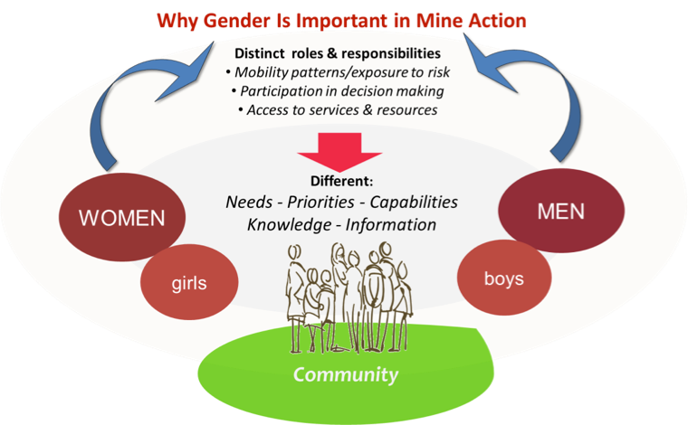
Figure 1 Why Gender Is Important in Mine Action © 2015 Gender and Mine Action Programme (GMAP) - Design by AMBO ADV
As part of the ongoing revision of the regulatory framework for mine action, ongoing and potentially continuing into 2022, UNDP will continue to promote the consideration of gender in all aspect of mine action. With the closer alignment with IMAS and the strong commitment by the national mine action authorities, VNMAC, to adhere to these, the aspect of gender will be more ingrained in the procedures. As the KVPAP will be one of the first large project to be implemented using the new regulations and standards it will be an optimal opportunity to pilot and develop practical guidance for the project itself and the sector as a whole, how to ensure that gender is considered throughout the land release process, not least during the prioritization and planning stages.
Hence, the project will ensure that any policy and knowledge creation would apply gender lenses and angles, recognizing the important role that both women and men can play in MA, with aim to break stereotypes and promote institutional change in VNMAC.
Stronger emphasis on gender will also be considered in engaging responsible parties for the actual implementation of activities. Whereas UNDP has already exemplified and will sustain a strong gender balance in its project team, challenges remain on the Vietnamese side of the Project Management Unit and in actual implementation of especially survey and clearance operations. Although it is acknowledged that VNMAC draws from a cadre of predominately male deminers, but it is evident in other parts of the Vietnamese military, not least in Peacekeeping, that steps have been taken in increasing the amount of women in roles which previously were seen predominantly as male-dominated. Hence, the same effort can be done in mine action. Following are some strategic approaches to ensure gender mainstreaming for KVPVP (i) project management, (ii) field operations and (iii) post-mine action activities, specifically:
(i) Project management:
- Vietnamese project management unit (PMU): KVPVP aims to have at least 30% female representatives in the Vietnamese PMU.
- Roles in project management: Observations from the current KVMAP have shown that VNMAC took initial efforts in engaging their female officers as finance officer and IT officer. However, their roles have somewhat remained 'behind the scene' and not yet been recognized as success factors to the project implementation. For KVPVP, female staff are expected to be more empowered and can take responsibilities in project finance management and information management, which are crucial elements of a mine action project.
- Documenting success stories: Female staff of the Vietnamese PMU should be trained with communications skills in order to be able to write up their good stories on great impacts of KVPVP to the communities and society and enhance their stronger ownership and commitment to the project.
(ii) Field operations:
- Conducting NTS: Female staff should be capacitated to handle NTS tasks, as they are considered to have better access to the local communities as well as can build trust and confidence to the local people, especially senior persons, village women and children.
- On-site operations: Female staff can perform the role of medical officer or logistics support officer on the sites and on a rotation basis.
- Site management unit / Sub-PMU office: Female staff based in the Sub-PMU office on a rotation basis; Field monitoring trips: female participants included in the delegation from Vietnamese PMU for any site check visit. Here the project will also ensure that local female decisionmakers from the PPC and/or lower-level administration take part in field visits. In addition, UNDP can help VNMAC develop a medium-term plan to increase the number of female staff, also in demining operations.
- For both victim assistance and risk education gender considerations are already more evident, and the priority system for VA assistance also considers gender. When it comes to victim assistance, mainstreaming gender ensures providing assistance to all women, girl, boy and men victims, in line with the principle of non-discrimination to other persons with disabilities, be this in relation to healthcare services, psychological and psycho-social support, inclusive education/training and socioeconomic inclusion. For risk education, gender and diversity should be taken into careful consideration for planning public events to make sure selection of time, location and topics that well address the needs of all female, girl, boy and male victims. In addition, experience and work nature has shown that advocacy activities tend to have a more gender-balanced workforce for RE and VA components. These are the important dimensions which need to be systematically analyzed and considered in policymaking and guidelines.
(iii) Post-mine action activities:
- Gender mainstreaming is further elaborated in Outcome 2: Enhanced sustainable rural development through increased resilience of livelihoods and infrastructure of target communities. All activities will employ a gender lens to ensure the needs of women, girls, men and boys, are included. Under output 2.1 agriculture/livelihoods, it is mentioned that female farmers and female -headed households will be prioritized and activities will ensure that they reach and include women, such as engaging female farmers as lead farmers in the Farmer Field School (FFS), women-only FFSs. KVPVP will also engage with women-led organizations like the Vietnam Women’s Union (VWU) as a key stakeholder. These references and others are further elaborated in the post-mine action phase below.
- Under output 2.2, on increasing resilience for people and resilient infrastructure, gender considerations are mainstreamed in the activities. For example, the risk profiling and risk mapping capacity development will ensure that women participate in the trainings. For resilient housing, the intention is to prioritize women-headed households that are poor and near poor. This is also further elaborated in the post-mine action phase.
Furthermore, it is relevant to mention UNDP’s revised Social Environmental Standards (SES), especially the section on ‘Gender Equality and Women’s Empowerment’. UNDP’s revised SES came into effect in Jan 2021 and are included in UNDP’s Programming and Operations Policies and Procedures for Programme and Project Management. The project will have to comply with these standards and how the project will identify and integrate the different needs, constraints, contributions and priorities of women, men, girls and boys.
Mine action and human rights
The vision of the United Nations Mine Action Strategy 2019-2023 has clearly stated that “The vision of the United Nations is a world free from the threat of mines, explosive remnants of war (ERW), including cluster munitions, and improvised explosive devices (IEDs), where individuals and communities live in a safe environment conducive to sustainable peace and development where no one is left behind, where the human rights and the needs of victims are met and where they are fully integrated as equal members of their societies.”
In a global publication of UNDP on Mine Action for Sustainable Development, the relevance of mine action across peace and security, humanitarian, human rights and development pillars have been recognized by the UN General Assembly and Security Council.
In line with that, KVPVP has shown its prominent role in catalyzing human security and sustainable peace by empowering the local communities of the target provinces towards harmonious, safe, resilient and prosperous rural communities through access to cleared land, capacity enhancement and livelihoods development. The specific elaborations on the linkage between mine action and human rights have been integrated and analyzed in various parts of this document.
The Project will also strategically contribute to:
Policy Development and Sector Coordination
The Project will support the VNMAC in fulfilling its central role of sector coordination. This support will include technical advice on how best to design and communicate a process for task prioritization and how to ensure quality management of survey and clearance activities.
To implement Program 504, Vietnam has established a strong coordination mechanism in the Mine Action Partnership Group (MAPG). Through the central position of VNMAC, represented by the Head Deputy of the 504 Executive Committee and Deputy General Director of VNMAC in MAPG’s Executive Committee, the project will further strengthen the policy directions for the EO/mine action sector and the coordination among all stakeholders. As required by MAPG, UNDP will also be able to share experiences from similar coordination mechanisms in the region.
Capacity Building of Local Staff
This five-year project is a continuation of further strengthening and supporting the institutional capacity of VNMAC to fulfil its role as coordination entity for the EO/mine action sector in Vietnam, as well as the MOLISA as the main institution responsible for survivor assistance. Provincial capacities are also strengthened for management and coordination of mine action within their territories as in the Decree 18 and Circular 195. By further strengthening the capacity of these key institutions, the project will significantly improve national and provincial capacities to address the long-term humanitarian and development challenges caused by the threat of EO at different levels. This will be done through provision of technical advice to guide and support relevant staff in all aspects of planning, implementation, quality assurance and financial management needed for the project. In this aspect, continuing implementation of the capacity development action plan which is the result of the capacity development self-assessment conducted by VNMAC with technical support from UNDP is an important part.

Map of project sites
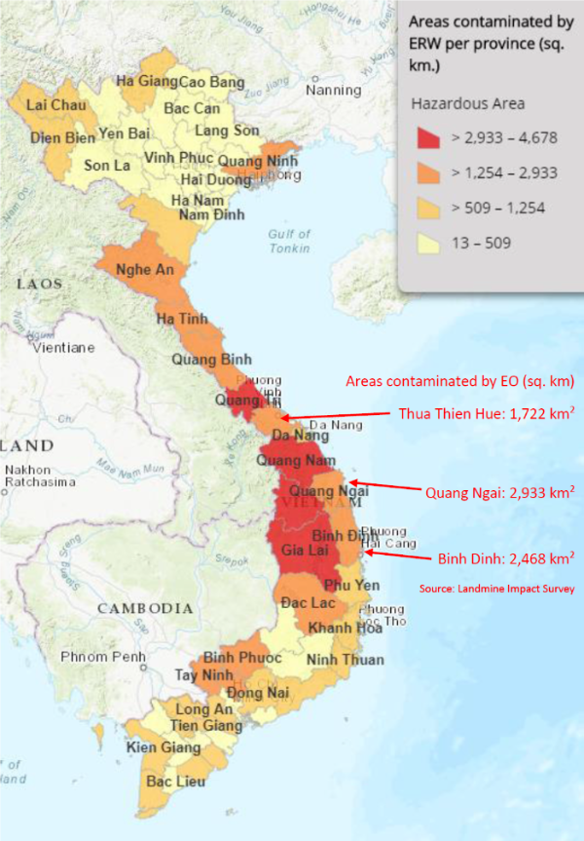

Thua Thien - Hue (Population 1,163,500)
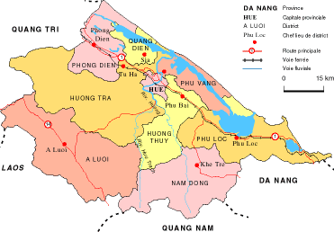

Quang Ngai (Population: 1,231,697 persons)
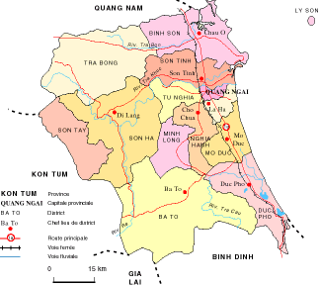

Binh Dinh (Population: 1,534,800 persons)
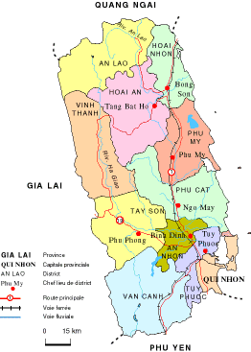
Summary Information of Quang Ngai, Thua Thien Hue, Binh Dinh
Provinces | Population | Contamination level of EO (%) | Number of accidents and victims by EO (2010-2014) | Poverty rate (%) | High priority of the Government in the National rural development  strategy | Flood/ Drought risks
Quang Ngai | 1,231,697 | 57.19% | 45 | 17.22% | Yes | 90%
Binh Dinh | 1,534,800 | 40.96% | 123 | 13.12% | Yes | 90%
Thua Thien Hue | 1,163,500 | 34.08% | 90 | 9.33% | Yes | 90%
Accessibility to the project sites:
- Distance from the capital city:
- Hanoi – Hue: 658 km
- Hanoi – Quang Ngai: 889 km
- Hanoi – Binh Dinh: 1,065 km
- Travel time and mode of transportation:
Route | Mode of transportation | Travel time
Hanoi – Hue | Direct flight | 1 hour 15 minutes
Hanoi – Quang Ngai | Flight (to Quang Nam – Chu Lai airport)  Car (to Quang Ngai) | 1 hour 25 minutes  1 hour (~ 50 km)
Hanoi – Binh Dinh | Direct flight | 1 hour 45 minutes
- Administrative unit:
Thua Thien Hue province
Subdivided into 9 district-level sub-divisions, consisting of 1 provincial city, 2 district-level town and 6 districts: Hue city; Huong Thuy town; Huong Tra town; Phong Dien district; Quang Dien district; Phu Vang district; Phu Loc district; A Luoi district; Nam Dong district; They are further subdivided into 7 commune-level towns (or townlets), 95 communes, and 39 wards.
Quang Ngai province
Subdivided into 13 district-level sub-divisions, consisting of 1 provincial city, 1 district-level town and 11 districts: Quang Ngai city; Duc Pho town; Ba To district; Binh Son district; Ly Son district; Minh Long district; Mo Duc district; Nghia Hanh district; Son Ha district; Son Tay district; Son Tinh district; Tra Bong district; Tu Nghia district. They are further subdivided into 8 commune-level towns (or townlets), 148 communes, and 17 wards.
Binh Dinh province
Subdivided into 10 district-level sub-divisions, consisting of 1 provincial city, 2 district-level towns and 8 districts: Quy Nhon city; An Nhon town; Hoai Nhon town; An Lao district; Hoai An district; Phu Cat district; Phu My district; Tay Son district; Tuy Phuoc district; Van Canh district; Vinh Thanh district. They are further subdivided into 10 commune-level towns (or townlets), 117 communes, and 32 wards.
- Risk factors: accessibility to the program/ project sites could be limited due to: Natural disaster (eg.: storm, flood, landslide); Disease; Border security.

II. STRATEGY

Situation Analysis

1. Needs assessment and solutions
Vietnam has seen tremendous economic progress over the past few decades, which has also resulted in a growing middle class and other healthy signs of a country on a positive development track. It is expected that “[b]y 2035, more than half of Vietnam’s population is projected to join the ranks of the global middle class (11% of the population are classified as such today, consuming USD 15 a day or more; […]).” Vietnam has also recently joined the ranks of countries in the world with high human development. In order to solidify these development gains and ensure further development growth, it will be important to remove obstacles that still constitute a serious human security concern. Risks include those caused by EO contamination and the impact of climate change, as further detailed below.
- Needs assessment
Note: In the following Needs Assessment section linkages to specific elements of the below Problem Tree are identified using the associated reference numbers (e.g. A.1.1) and descriptions, to make it easier for the reader to navigate between the various project documents.
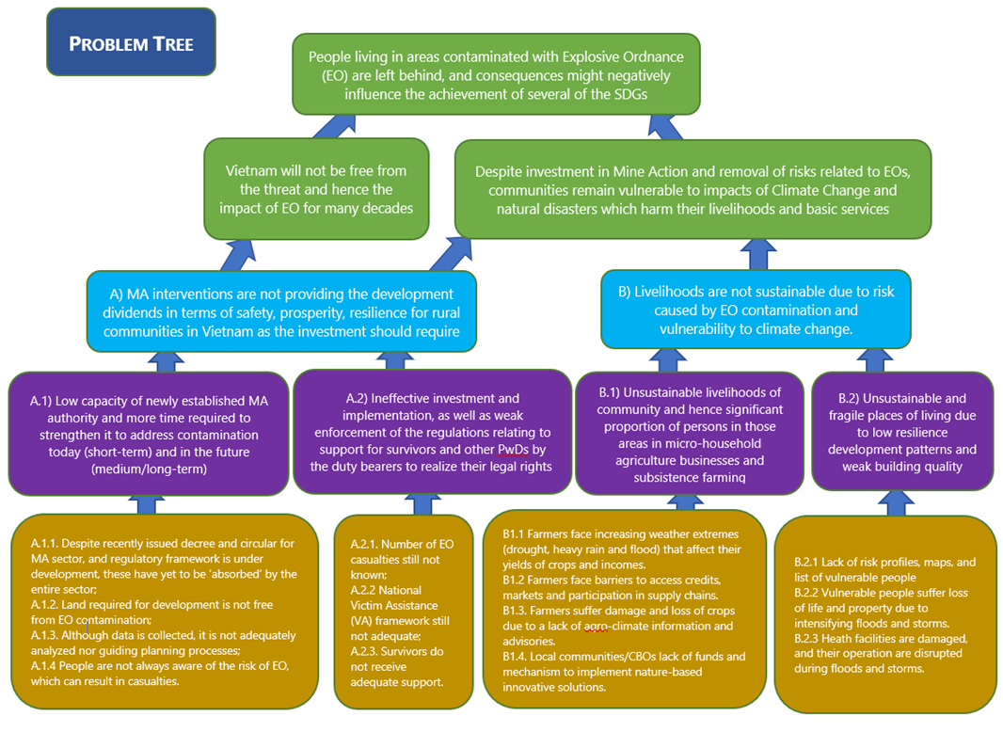
Safety and resilience for rural communities
Development of the national regulatory framework
Associated problems in the Problem Tree:
A.1.1: Despite the recently issued decree and circular for MA sector, and regulatory framework that is under development, these have yet to be ‘absorbed’ by the entire sector.
Vietnam, in cooperation with UNDP, international NGOs and institutions, including the Geneva International Centre for Humanitarian Demining (GICHD), has been conducting a thorough review of the national Technical Regulations for Mine Action (QCVN), as well as procedures for Quality Management (QLCL), Non-Technical Survey, Technical Survey and Clearance. The review has drawn on experience gained in the KVMAP as well as longer term initiatives relating to Quality Management (QM). Other interventions, including those under the UK Government’s Global Mine Action Program 2 (GMAP2), have focused on capacity development in relation to quality and operational compliance within the national program. While the review remains in progress at the time of writing this proposal, it is expected that the new package of regulatory and procedural documentation will be authorized and available for implementation by operating organizations early in 2021. Compared with the previous set of documents, the new system will be more clearly aligned with the IMAS and represents an important step forward in terms of reflecting current best practice as understood within the global mine action sector. Those managers, organizations and individuals who have previously been involved in the KVMAP will benefit from having already been exposed to many of the principles set out in the QLCL procedures, but there will be other changes in approaches and methodologies that will be new for many people.
In any management system the challenges include not only developing a robust and suitable body of policies, processes and procedures, but also in ensuring that those responsible for implementing the system are aware of, and competent to apply, relevant aspects. Achieving comprehensive understanding and implementation are essential to the success of the KVPVP during and after the end of the project.
EO contamination
Associated problems in the Problem Tree:
A.1.2: land required for development is not free from EO
The presence of EO can have a substantial negative impact on human development. Landmines, cluster munitions and other EO are a significant hindrance to countries’ achievements in the simultaneous eradication of extreme poverty and reduction of inequalities and exclusion. According to the results of a government-led survey, "Vietnam National Explosive Remnants of War Contamination Surveying and Mapping", from 2010 to 2014, also known as the Landmine Impact Survey, all 63 provinces/cities across the country were potentially contaminated, and provinces located in the central part of Vietnam are among those most affected. The 15 most contaminated provinces according to the Landmine Impact Survey are also among the provinces that have a high ratio of poor and near-poor households, especially the provinces in the Central region.
The ongoing KVMAP has successfully focused on four out of the five pillars of mine action, namely Survey and Clearance, Victim Assistance, Mine Risk Education and Advocacy. It is estimated that a total of 20,000 ha will have been surveyed and 8,000 ha will have been cleared by the end of the Project, giving back these areas to local communities for socio-economic development. KVMAP successfully used a systematic land release approach of survey to establish Confirmed Hazardous Areas, and then only used expensive clearance assets on a reduced area of land. In KVMAP the cost of ensuring that one square meter of land could be handed back to communities was as low as 5 cents. Hence, it has proven to be a very efficient model worth replicating in other areas, not least as the newly revised technical regulations and procedures might help further improve the mine action process and thereby further reduce the cost.
The three primary target provinces continue to show geographical proportional contamination levels of between 34% and 57%, representing large areas that remain unavailable for safe use and development.
Provinces | Population | EO Contamination level (%)
Quang Ngai | 1,231,697 | 57.19%
Binh Dinh | 1,534,800 | 40.96%
Thua Thien Hue | 1,163,500 | 34.08%
The suggested provinces for this second phase are thereby among the ones with the highest rates of EO contamination. Furthermore, the percentage of poor and near-poor households is 9.3% in Thua Thien Hue, 17,22% in Quang Ngai and 13.12% in Binh Dinh.
Being able to access land safely is a prerequisite for many of the social and economic elements of solution trees and theories of change in mine action. Without free and safe access to land almost any practical activity that relates to livelihood security, provision of housing and infrastructure and wider economic development is impeded or prevented.
Information availability and planning
Associated problems in the Problem Tree:
A.1.3: Although data is collected, it is not adequately analyzed nor guiding planning processes;
A.2.1: The number of EO casualties is still not known
B.2.1: Lack of risk profiles and maps, list of vulnerable people in target areas.
Vietnam faces a range of risks as it seeks to further its upward trajectory of prosperity, and to become more resilient in the face of natural and other crises. Access to, and the effective use of, information is central to any effective risk management process. Information from a range of sources exists in Vietnam, but it is not always easy to access and that information which is available is not always analyzed to best effect to support effective planning.
The Landmine Impact Survey, combined with information collected during the KVMAP, as well as data held by MOLISA and other relevant ministries represent a potentially powerful resource to help planners develop appropriate, well targeted and evidence-based strategies and plans, and for monitors to assess progress and the achievement of hoped for outcomes. To date this potential resource has not been used as widely or transparently as could have been the case. Furthermore, it would also be beneficial if Vietnam can share this data more openly in regional and international forums, as it is a strong indication of efforts already made and can thereby increase the confidence in the sector. Potentially this might also lead to additional funding to address those problems that still remain.
In particular up-to-date risk profiles (addressing not only EO-related risks, but the other risks such as those associated with climate change) are unavailable and details on vulnerable people in target areas are missing. Details of recent casualties from EO accidents in the various provinces is, in most cases, unclear, or statistics are presented in ways that are not entirely helpful to the needs of planners and managers. KVMAP has helped address this issue in two provinces, Quang Binh and Binh Dinh. Quang Tri is a province that falls outside the scope of the KVPVP, but it is another example of a province where there is good data on casualties collected and analyzed by projects supported by international NGOs over many years, but where care needs to be taken in how conclusions are drawn. Publicly available information states that the average number of victims per year in the province is 208, but this figure is based on an average taken over the entire period since the end of the war. Charts from the same Information Management provider show that since 2012 the number of victims has actually varied between 1 and 13 injured and 1 and 2 deaths. While both sets of figures have some mathematical validity, planners need access to base data in order to be able to draw their own conclusions in ways that are most relevant to the problems, need and solutions associated with their projects and programs.
In order to make more general conclusions about EO casualties more data is required beyond the three provinces mentioned above. Hence it will be important to gather data from other provinces among the ones considered most affected by EO. Comprehensive data collection of EO survivors have not taken place in Thua Thien Hue or in Quang Ngai. It should be added that there has not yet been an in-depth analysis of data collected on EO casualties, although this could serve several other purposes in mine action, for example prioritization of survey and clearance of communes with proportionate high number of casualties combined with targeted EORE for residents to prevent further accidents.
Awareness and understanding of risk
Associated problems in the Problem Tree:
A.1.4: People are not always aware of the risk of EO, which can result in casualties
A mine risk knowledge, attitude and practice survey was conducted in Quang Binh and Binh Dinh in 2018. It showed that awareness of EORE and EO among the surveyed population of 1,700 people, of which farmer, pupils and casual workers occupied a vast majority of the respondents, was relatively low with only around 50% of them having good knowledge and 20% exhibiting poor EORE knowledge. They knew very little about EO warning signs, the consequences of EO accidents, EO risk behaviors, and EO features with the proportions of correct knowledge in these areas at 0.8%, 5.7%, 6.2%, and 12.6%, respectively.
Under 20% of surveyed respondents had a proper attitude towards mine risk issues. Even worse, a very small percentage of the general population (roughly 5%) understood the proper response to seeing EO and merely a third exhibited the right attitude when seeing EO warning signs or seeing someone sawing EO. More worrisome, only half of the respondents who were exposed to EO practiced safe behavior whenever they encountered high risk situations, with the rate in Quang Binh (57.3%) being nearly double that in Binh Dinh (32.7%). Nonetheless, the proportions of those practicing appropriate safe behavior when physically seeing EO or entering contaminated area is lower than 30%.
Victim assistance and Persons with Disabilities
Associated problems in the Problem Tree:
A.2.2: National Victim Assistance (VA) framework still not adequate
A.2.3: Survivors do not receive adequate support
Decree 18 stipulates in terms of victim assistance that basic services should be made available for survivors and that it is the responsibility of the government to ensure availability and accessibility of the services. However, the decree does not stipulate specifically how and who should take responsible for this, leaving MOLISA, as national focal point, to develop the technical guidance or SOP victim assistance. Until now, the assistance for survivors has been considered within the related legal regulations on support for PwDs, which include legal documents, guiding decrees and circulars. Whereas this is positive, in line with the Convention on the Rights of Persons with Disabilities (CRPD) and hence should be supported, it unfortunately does not provide a comprehensive level of support to survivors.
According to the Law of Persons with Disabilities and the decree detailing social assistance for the vulnerable populations, including PwDs, only those who have been assessed and where their level of disability are deemed to be either severe and extremely severe are entitled to monthly subsidy and other support from the government. However, many survivors have not been assessed or fall outside these categories. They therefore don’t receive any support from the government scheme for PwDs. Furthermore, quite a few PwDs including survivors remain reluctant to file an application for disability determination, potentially because they don’t see the benefit from it.
The recent mapping of the services for survivors in Quang Binh and Binh Dinh showed that rehabilitation and receiving prosthetics are still the highest priority. However, the rehabilitation services are not always easily available, which creates barriers for survivors to participate fully in social and economic life. In another quick assessment of COVID19’s social and economic impacts on survivors conducted in 2020, 40% out of the 170 participants reported having difficulties in accessing the rehabilitation and prosthetics services in their localities. These challenges, as well as the COVID 19 pandemic, call for new approaches in service delivery.
Sustainability of livelihoods and risk-informed development
Impact of climate change and extreme weather
Associated problem in the Problem Tree:
B.1.1: Farmers face increasing weather extremes (drought, heavy rain and flood) that affects their yields of crops and incomes.
Vietnam is particularly vulnerable to climate change and is already impacted by more irregular and intense climate variability and change. When considering climate change exposure, sensitivity and the capacity to adapt, the country is consistently classified as at ‘very high risk’ or ‘extreme risk’. Every year the country is affected by a range of hydro-meteorological and climatological hazards: droughts and forest fires during January-April; tropical, hail and wind storms; coastal, riverine, and flash floods; heavy rainfall and landslides in June-December; and extreme temperatures (cold and heat waves) throughout the year. Climate exposure and sensitivity will impact agriculture, including loss of arable lands, decreased productivity, and overall loss of livelihoods and incomes. The increased exposure of people and economic assets has been the major cause of long-term increases in economic losses from weather- and climate-related disasters.; Climate change is therefore expected to severely impact agricultural productivity in these regions. Crop productivity will be most impacted by reduced water availability during longer dry seasons, extreme droughts. Extreme drought periods can result in 40 to 70 percent less water available for crops, which especially affects perennial crops. This convergence of interrelated challenges is particularly difficult and increase risk for poor, near poor farmers living on contaminated land, as agriculture remain the predominant form of livelihood for these people in the target provinces. The presence of EO continue to pose a risk for people cultivating the land due to fear of being harmed, and in some areas the land has become almost unusable, or farmers face risk and uncertainty on trying to expand their agriculture activities on previously unused land in order to try to increase their yields.
Therefore, overall agricultural productivity is falling, with the corresponding declines in yields and incomes particularly harmful to those vulnerable small-scale farmers. Crop yields will be negatively impacted by seasonal changes (for example a delayed onset of the rainy season) and more unpredictable precipitation patterns. With the continued growth of climate variability and change, the current strategies of small farmers (<1ha of agricultural land) to cope with climate change and environmental impacts are increasingly ineffective and require transformational adaptation investments to achieve lasting climate resilience.
In the project’s target regions, agricultural policy has been focused on producing higher yields while neglecting the longer-term adaptability of agriculture to climate change. This augments the burden on the government, as development progress is continually affected by climate-driven extreme weather events such as sudden, intense rainfall or drought, as well as by the gradual degradation of soils and water from maladapted cropping systems. Although persons engaged in agricultural activities increasingly apply conventionally modern practices and inputs to agricultural production and water management, these are progressively less and less effective in coping with the growing variability in rainfall and other climate hazards. Cropping systems are less diverse, with a bias towards more climate-vulnerable monocultures, and traditional knowledge of such climate-resilient farming systems as inter-cropping, agroforestry, and integrated crop-animal systems using non-rice crops is undervalued. Poor, near poor and vulnerable farmers, especially female farmers, living on EO contaminated land, i.e. ‘EO victims’, generally lack information and knowledge of how to improve productivity of irrigation, soil and nutrient management, and crop diversification with the aim of enhancing and maintaining climate-resilience of agro-ecosystems.
Although demand exists, most farmers have never received or participated in a training event on climate risk and accessible methodologies for agro-ecosystem vulnerability analysis, farm resource planning and management, resilient agricultural techniques, or water efficiency practices. Furthermore, there is no such training and services that can address also the specific needs of farmers who are PwD, including survivors. This is largely due to the limited technical capacities of agricultural extension agencies to support climate-risk management and resilient agriculture. Current capacity to provide climate-risk informed agricultural information and capacity building in an inclusive manner to climate-vulnerable farmers is limited.
Accessibility to credit and markets
Associated problem in the Problem Tree:
B.1.2: Farmers face barriers to access credits, markets and participation in supply chains
Poor, near poor and vulnerable farmers living on contaminated land, i.e. ‘EO victims’ face many obstacles in accessing credit. Farming households are often constrained to access formal credit because they do not have enough collateral, as well as they cannot borrow on the basis of their income, resulting in a segmented credit marker with informal credit sources that dominant in rural areas because of the limitation of the formal markets or a farmer’s inability to meet conditions set for formal credit. These challenges are also exacerbated for farming households that are headed by a PwD, including survivors, and also female-headed households who face additional difficulties in gaining access to formal credit organizations. Furthermore, an individual farmer household that tries to access credit from the bank has low negotiation power as compared to if farmers come together as a cooperative. In addition, there is a lack of awareness and knowledge of risks of adaptation investments both among farmers and financial intermediaries and a lack of climate risk-informed planning and management of the agricultural systems that can inform the design of appropriate credit instruments. It is also common for poor farmers to source inputs (fertilizers, seeds, seedlings) from local suppliers on credit. Farmers pay back the local suppliers when they harvest the products, either in cash or in harvested products. However, with declining yields due to impacts of climate change, farmers often have difficulty with repaying loans. As mentioned above, the situation can be particularly dire when farmers also have to rely on land which are heavily contaminated with EO. Farmers particularly the poorest and most vulnerable farmers require financial resources from access to credit to diversify towards climate-resilient inputs, technologies, and crops.
For farmers to successfully market their climate-resilient production and continue to adapt to changing climate risks, farmers need stronger market linkages and to participate in value-chain. Farmers often lack the knowledge and the proper inputs/technology and therefore produce products that are of low quality or that do not meet standards such as VietGAP or GlobalGAP. This also results in a lower price received for their products. Furthermore, without following standards, these may have chemical residuals that are not tested/verified, and therefore then they cannot sell their products, or if they do, at a lower price. Analysis of pricing and market trends is generally inaccessible to poor farmers thus hindering their ability to adequately manage climate risk. The access to market by poor and vulnerable farmers is impeded by lack of timely and actionable information on demand, prices, logistics, weather, etc., which can be key to effectively managing the financial impacts of climate shocks. They lack the skills to successfully navigate the relatively complex marketing systems prevailing in towns and cities in the target provinces, as well as nationally and for export. Where information systems exist on-line, poor, near poor, and vulnerable farmers often lack access to this information. In addition, single farmers often are disadvantaged compared to farmer cooperatives as working together in a cooperative has the advantage of economy of scale to reduce costs and increase their negotiation power with larger volume of products. Cooperatives also provide a stronger legal status in Vietnam, compared to single farmers.
To participate in value chain, it is imperative that quality standards are met. At the moment, input suppliers, buyers, processors and certain information and technical assistance providers all participate in value chains in an ad hoc manner. This lack of coordination results in a great deal of uncertainty and contributes to a debilitating sense of risk for farmers. As value chains provide a fundamental incentive to drive and support the adoption of climate-resilient crops and practices, farmers’ participation in these value chains requires access to credit as well as markets. However, the credit worthiness of poor, near poor, and vulnerable farmers, is affected by climate change impacts on their production with climate risks compounding credit risks.
To adapt to evolving climate risks and to enhance the climate resiliency of poor, near poor and vulnerable farmers, currently do not have sufficient means or ability to continuously invest in climate-resilient agricultural technologies and practices and acquisition of inputs essential for climate resilient cropping systems. The incremental costs to poor, near poor and vulnerable farmers of start-up investments in resilient agricultural practices are initially prohibitive.
Lack of localized agro-climate information
Associated problems in the Problem Tree:
B.1.3: Farmers suffer damage and loss of crops due to lack of agro-climate information and advisories.
Although conventional agricultural extension is available to farmers throughout the target provinces, the Government of Vietnam has been unable to provide sufficient, appropriate climate and weather information to help the poor and near poor farmers manage climate risk and adapt to the impacts of climate change. This is largely due to the limited technical capacities of agricultural extension agencies to support climate-risk management and resilient agriculture.
Technical advice on water conservation, seasonal calendar changes or cropping techniques is developed by local authorities and distributed through television and extension services, however, they do not reach all vulnerable groups nor are they detailed enough or actionable. Climate and weather information received through television is too general and not downscaled enough to be useful for decision making at the local level. Information on floods or drought is not linked to actionable advice on how to mitigate or prevent damage to crops. Information transmitted through the loudspeaker system or from GoV staff is perceived as not timely, unpredictable, scattered, with limited integration, difficult to understand or interpret, and wide reaching enough. In addition, most information is developed in a top-down manner without much involvement of farmers or without building on farmer learning and experience, resulting in a mismatch between available information and user requirements.
Across the country, the Government have invested primarily in building capacity and climate information systems at the national level but have done limited work to build the capacity of provincial, district and commune meteorological and agricultural staff to generate and disseminate localized, actionable agro-climatic advisories. Therefore, the need and demand for localized, reliable, timely and integrated climate and agricultural information is very high in the target provinces. The poor, near poor and vulnerable farmers who rely on land which are heavily contaminated with EO, are at risk of the impacts of climate change and extreme weather events, need adequate and timely information to help limit their risks.
Lack of community-based solutions
B.1.4: Local communities/CBOs lack funds and mechanism to implement nature-based innovative solutions.
Poor and vulnerable communities are most at risk to the impacts of climate change because they depend on access to natural resources for their livelihoods and often live in fragile ecosystem. This risk is exacerbated for EO victims on contaminated land. These communities may have traditional knowledge, but with the changing condition (culture, social, economic, climate) the value of traditional knowledge has been devalued. Furthermore, EO victims living on contaminated land have specific challenges and needs that are often not taken into account. As stewards of their land and with their unique understanding of the challenges they face and new livelihood opportunities on newly cleared land would require a strong need to connect and establish partnerships between them and CBOs/NGOs, so they can better document and apply traditional knowledge in combination with scientific knowledges to pressing development challenges and experiment new initiatives. Furthermore, there is a need to replicate and scale up the traditional knowledge and practice beyond a single community. A community-based approach is key for addressing local development challenges that empower communities to act and participate in their own development which will ensure community ownership and impact. There is also currently a lack of funds to fund bottom-up initiatives. Furthermore, there is lack of a suitable mechanism for the overall management of the funds and the implementation projects with all stakeholders.
Loss of life and property
Associated problems in the Problem Tree:
B.2.1: Lack of risk profiles, maps and list of vulnerable people
B.2.2: Vulnerable people suffer loss of life and property due to intensifying floods and storms
B.2.3: Health facilities are damaged, and their operation is disrupted during floods and storms
The absence of rigorous climate risk information places considerable limitations on climate-resilient and risk-informed planning. As land is cleared and to ensure that productive use of the land, decisions are often not underpinned by quality climate risk data. Currently in Vietnam, climate-change projections and associated disaster risk trends are not well understood, integrated or widely disseminated, especially at the sub-national level. When developing plans and maps to safely locate housing and other economic and social infrastructure on newly cleared land, clear information on climate change projections and risks is essential. This information needs to combine available risk assessments, storm surge maps, historical knowledge on disaster and loss, with climate change projections to guide climate-resilient and risk-informed development planning. There is a need to actively engage communities living on contaminated land in all activities of disaster and climate change adaptation risk management, from risk identification and analysis, to action planning, and implementation aiming to reduce vulnerabilities and enhancing their coping and adaptive capacities.
While government programmes are in place to provide safer houses to vulnerable communities, government engineering and construction standards for housing along flood prone regions are not currently consistent throughout all provinces or compliant with requisite standards to safeguard the public from flood and storm impacts. Recent studies have shown that in disaster prone areas, improving housing is often a priority for investment. However, as knowledge of safe housing technologies is generally low, without technical guidance and training, families may inadvertently make investments which further destabilize the structure in the face of storms. Action to promote safer housing and community-based risk sensitive planning within communes for safe siting of the houses is urgently required. In a recent report on “Housing Demands of Poor Households with Difficulties in the 28 Coastal Provinces in Vietnam’ conducted by the Ministry of Construction (MOC) with UNDP’s technical assistance GOV-UNDP-GCF project ‘Improving the resilience of vulnerable coastal communities to climate change related impacts in Vietnam’, found that households in the three provinces have high needs for housing support.
Table. Summary of poor households in need of housing support
Provinces | Total number of households having housing difficulties |  | Total number of households in need of housing support
Provinces | Entire | Coastal | Entire | Coastal
Thừa Thiên Huế | 2.576 | 627 | 2.576 | 627
Quảng Ngãi | 6.120 | 717 | 6.120 | 717
Bình Định | 2.683 | 465 | 2.683 | 465
The housing stock is often constructed with temporary, unstable materials or houses that were built solidly before, but the lifetime has expired or deteriorated, dilapidated and unsafe, and vulnerable to extreme weather events such as floods and storms. Furthermore, there is uncertainty on the safety of the land on which they are built as the land might be contaminated with EO.
Although best practice designs are available and tested through the existing GOV-UNDP-GCF project “Improving the resilience of vulnerable coastal communities to climate change related impacts in Vietnam”, there is a need to scale up the dissemination and implementation of flood and storm-resistant housing technologies, especially for poor families have a higher vulnerability to disaster risk, as they are more likely to live in sub-standard housing. Damage, loss and related recovery costs from floods and storms place a long-term burden on the limited financial resources of already vulnerable people. After the clearing of land and with the increasing climate change risk, action to promote safer housing and community-based risk sensitive planning within communes and for poor and vulnerable people, for safe siting of the houses is urgently required.
The commune health station (CHS) is the health facility at the grassroot level that provide all the basic health care to community members in the area. There is an increase need for accessible health care for the survivors from EO accidents. They might require on-going health care support to manage the after-effects of past accidents. CHS in the target provinces also face the same storm and flood risks and damage. These risks challenge the very key function of the CHSs of providing primary health care for the whole population in the commune and to implement many essential health programs at the community level to prevent and manage communicable and non-communicable diseases, such as HIV/AIDS, Tuberculosis, vaccination, reproductive health and family planning. Disruption of the primary health service delivery due to damage to CHS facilities will also disrupt the operational delivery of services and affect the continuity of business, with disruption to communication and medicine/medical device supply chain, etc. which is detrimental to specific needs for survivors of EO accidents who need regular check-ups. There is lack of knowledge, technology, funds and awareness of climate and storm risks that result in the improper construction of commune health stations, which then affects the delivery of services. Building flood and storm resilient CHSs is needed for vulnerable communities to adapt to and enhance the resilience of health sector at the grassroot level.
- Solutions
Note: In the following Solutions section linkages to specific elements of the Objectives Tree are identified using the associated reference numbers (e.g. 1.1.1) and descriptions, to make it easier for the reader to navigate between the various project documents.
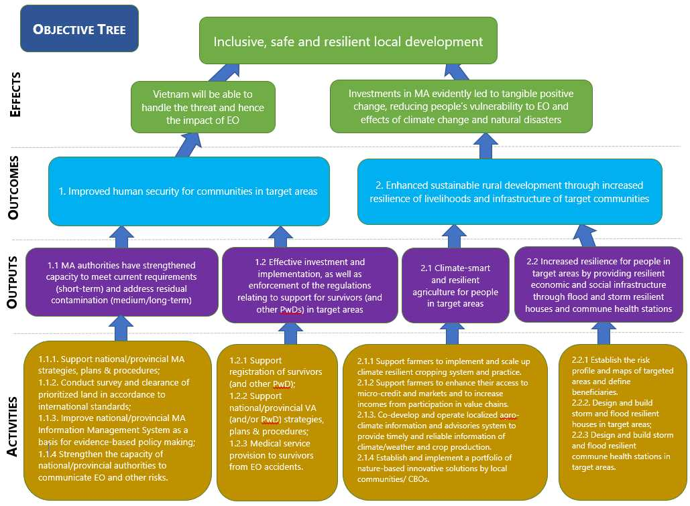
This project aims to demonstrate the key role of mine action in fostering local socio-economic development and building harmonious, safe, resilient and prosperous rural communities in Vietnam. Both KOICA and UNDP have strategies and policies in place to address the issues of poverty, EO and climate change. Overall, the intervention is shaped by the five pillars of the SDGs, namely People, Prosperity, Peace, Partnership and Planet, elements which KOICA has also integrated into its Mission & Vision.
More specifically, KOICA has developed a new approach for its engagement in mine action in Southeast Asia under its broader Implementation Strategy of Peace Village Development Program (PVDP) in the Mekong Cambodia, Laos, Vietnam, Myanmar (CLMV) countries, 2020-2030. The PVDP is closely aligned with the approach advocated by UNDP, and its overall program vision is:
- Unexploded Ordnance (UXO)/Mine-affected Rural Communities Free from the Threat of Mine and UXO with Victims’ Rights Protected; and
- Transformed into the Land of Peace & Prosperity in the Mekong CLMV Countries.
The Strategic Matrix developed for the PVDP Strategy describes three components, Mine Action, Victim Assistance, and Rural Development with two cross-cutting issues of Empowerment and Participation of Women in Rural Community, and Better Resilience to Climate Change and Environment Protection. As part of its strategic approach to implementing the SDGs and in order to support countries in their efforts, UNDP has emphasized three broad development challenges which require different forms of interventions:
1) Eradicating poverty in all its forms and dimensions;
2) Accelerating structural transformations for sustainable development; and
3) Building resilience to crises and shocks.
The Six Signature Solutions is UNDP’s corporate answer to meet these challenges. In short, these are cross-cutting approaches to development in the following areas: poverty reduction, governance; crisis prevention and resilience; environment; clean energy; and women's empowerment and gender equality.
VNMAC, KOICA and UNDP Vietnam have already achieved significant results in their ongoing Trilateral Partnership placing KVMAP at the center of mine action interventions in Vietnam, as well as promoting Vietnam’s experience to a global audience. The linkage between mine action and development and the 2030 Agenda is clear and Vietnam has already started the effort to provide an example of how this can be done. The suggested project will put these lessons learned from KVMAP and other mine action interventions into practice. Although tailored to Vietnam’s unique context as a country rapidly developing despite the legacy of decades of war, the aim will be to present a model for replication in other counties faced with extensive contamination with EO. In addition, the capacity development intervention will be targeted specifically to ensuring a residual capacity whereby Vietnam will be able to handle the sector and EO interventions after the project completion in 2026 with less international support and technical assistance.
The Government of Vietnam has emphasized the Trilateral Partnership between VNMAC, KOICA and UNDP as an important modality for implementing complex mine action interventions. Based on the results of the current KVMAP project, this new project will expand on the implementation methodology and scope putting additional emphasis on the preparatory phase before survey and clearance, as well as on the post-clearance phase when cleared land will be put into use. The experiences from KVMAP will ensure that the link between mine action and development will be even stronger in the suggested second phase, KVPVP.
Vietnam and the Republic of Korea have a lot of commonalities and similarities in their histories and cultures, Mine Action and Rural Development are areas where Vietnam and the Republic of Korea can strengthen partnership. For this project, Vietnam would utilize experiences and expertise from the Republic of Korea where possible. The Trilateral Partnership is unique in its ability to draw on strong expertise in the respective partners: VNMAC which is able to deploy technical teams to the areas contaminated with EO,' and KOICA and UNDP with other strong partnerships within the Government of Vietnam in such areas as:
- governance and participation;
- inclusive growth and support to businesses; and
- climate change and environment.
Hence, the project can draw not only on expertise within the project team itself, but also on a wide range of specialized knowledge within government and the two partner organizations.
Gender considerations will be mainstreamed throughout all project components to ensure that the contributions, concerns and needs of both women and men, girls and boys in affected communities are acknowledged and addressed without bias through ensuring SADDD information is available during processes such as:
- collecting information about locations of EO, affected by disaster risks, proposals for use of cleared land,
- how people would react to potential EO and other threats;
- (about victims, their needs and the level of access to services.
Mine Action Phase: Improved human security for communities
Objectives Tree reference: 1.1.1 Support national/provincial MA strategies, plans and procedures
Given the recent strengthening of VNMAC’s mandate with the adoption of Decree 18 and Circular 195, as well as the emphasis on provincial planning processes to reduce the impact of EO contamination, additional effort will also be targeted towards ensuring that national institutions continue to effectively lead and manage mine action functions and responsibilities. Activities in this component will be in support of the national and provincial mine action strategies and plans for 2021-2025 and especially aimed at supporting VNMAC and the target provinces in implementing the strategy. It is expected that the mine action strategies and plans will be developed in the final year of KVMAP and that it will have a strong emphasis on residual capacity with clearly defined roles and responsibilities vertically and horizontally. This will entail having defined processes in place to ensure that mine action is considered in all relevant policies and development planning – on a national and sub-national level, as well as national teams in place to deal with EO contamination in the future. The Project will support the VNMAC in fulfilling its central role of sector coordination. This support will include technical advice on how best to design and communicate a process for task prioritization and how to ensure quality management of survey and clearance activities. In addition, efforts will be dedicated to showcasing to a global audience Vietnam’s successes in the mine action sector through participation in regional and global forums.
To implement Program 504, Vietnam has established a strong coordination mechanism in the Mine Action Partnership Group (MAPG). Through the central position of VNMAC, represented by the Deputy Head of the 504 Executive Committee and Deputy General Director of VNMAC in MAPG’s Executive Committee, the project will further strengthen the policy directions for the EO/mine action sector and the coordination among all stakeholders. As required by MAPG, UNDP will also be able to share experiences from similar coordination mechanisms in the region.
With support from UNDP Vietnam, the Project will continue to promote the mine action sector and its results on the global arena, as well as advocate for treaty ratifications (APMBT and CCM). There is a standing offer to help the Government of Vietnam with any aspects of such ratification process and at any stage of the project.
Objectives Tree reference: 1.1.2 Conduct survey and clearance of prioritized land in accordance to international standards
Building on the lessons from KVMAP, it will be important to identify the most appropriate locations for survey and clearance in advance and as per local development plans and communities’ interests. To ensure engagement and ownership of the communities and government institutions, UNDP will work with central and provincial government mechanisms and different local stakeholders such as Community Based Organizations (CBOs) and the private sector to ensure that the project’s objectives and interventions are locally owned, gender-responsive, inclusive, risk informed and effective.
Substantial efforts will be put into making sure that survey and clearance efforts contribute to development through strengthening the prioritization system, already established under KVMAP, and reflecting humanitarian and development priorities to justify prioritization of sites for survey and subsequent clearance.
The project will implement a consultative process including as many community members as possible reflecting gender- and age-diversity. UNDP will build on its existing experience and partnerships to ensure that the local planning process will inform provincial level Landmine Impact Surveys, and it will build the foundation for a solid Information Management system on a provincial level, linked with the national level system based within VNMAC. It will not only provide the PPCs with an important set of data supplementing the action plan for strategic planning, it will eventually also become a useful tool for coordination of mine action efforts in the province and nationally. The PPCs will be able to develop prioritized and result-based provincial mine action plans in accordance with the procedure outlined in Circular 195 announced at the end of 2019.
Along with this selection process, the project will facilitate inclusive processes with relevant authorities and local communities to:
1) re-visit and where required update or expand the provincial SDG Action Plans where they exist and five-year and annual mine action plans;
2) measure achievements; and
3) develop specific, detailed and integrated plans for the duration of the project and, to the extent feasible, combine these with robust M&E framework and resource mobilization plans.
These plans again will also closely align with the Socio-Economic Development Strategy, Socio-Economic Development Plan (national and provincial), the Poverty Reduction Plan, and as relevant the Integrated Rural Development Action Plan.
Provincial mine action plans should form the basis for all interventions related to Land Release. Using both the Non-Technical Survey and Community-Based Disaster Risk Reduction approaches, the prioritized land will undergo a thorough desk and field assessment to determine Suspected Hazardous Areas, which will later undergo Technical Survey to establish Confirmed Hazardous Areas for clearance. One gender equality goal the project is on the inclusion of women in the survey and clearance teams, risks instructors, victim assistance teams.
The bulk of the investment in Land Release and risk identification will go into specific locations which are identified as of high importance for development (as clearly justified in relevant development plans), where firm evidence of contamination has been established through the Non-Technical Survey process, and where subsequent development activities will start within a reasonable timeframe (ideally within one year of land being handed back to community).
Following survey, specialized teams will be tasked with undertaking the clearance of the Confirmed Hazardous Areas; findings will be recorded in IMSMA; again, refresher trainings on standards and procedures for clearance will be undertaken as deemed necessary and especially given the new regulatory framework for Vietnam. The subsequent release of land will bring a very high level of confidence that no hazardous objects are left in the ground when it is handed over. All of the proposed activities will be presented in Annual Work Plans for approval by the Joint Project Coordinating Committee (JPCC).
The survey and clearance activities themselves will follow the new Standard Operational Procedures for Non-Technical Survey, Technical Survey and Clearance. These currently exist in draft form but will have been approved before the start of this phase of the project. The new procedures are aligned with the International Mine Action Standards (IMAS). Hence, the build and further improve the procedures tested in KVMAP, which is a good example of how the ongoing project has been able to support policy change and why it will be important to further support Vietnam in this transition to a new way of working in the sector.
The project will continue to utilize innovative development solutions developed during KVMAP, including the software for the e-Quality Management System, as well as continuously promote further innovation through new technology (drones, iPads, camera drones etc.) to reduce risk and for increased efficiency.
Objectives Tree reference: 1.1.3 Improve national/provincial MA information management as a basis for evidence-based policy making
Information management is an integral element of any successful mine action intervention. Improvement of the available information for the EO/mine action sector will support informed policy making and task prioritization for Program 504. This project will strengthen the system for Information Management in Vietnam through strengthening capacities for the Database Center under VNMAC and provincial database units under the PMC, training staff at different levels and providing technical hardware and assistance to ensure that Information Management is established and functional to satisfy the requirements of Circular 195 on collecting, storing and providing mine action information. The project will also advocate improving effective utilization of the national and provincial information management system as a basis for policy making.
Improved risk mapping for provinces will also be critical for upgrading climate- and EO-responsive planning in Vietnam. Project funds will be used to make improved information more accessible to government decision makers at the commune level, but the improved quality data generated will also directly enhance the quality of future climate projections, as well as feeding back into socio-economic development planning processes at the district, provincial, and national level.
Knowledge generation and learning will enhance the capacities of local communities and government agencies with the purpose of enabling them to create their own risk maps beyond the project lifetime through a strong understanding of and ability to effectively identify risk. This will be done by developing integrated risk maps at the sub-national level using a dual approach combining mapping of climate and disaster risk with mapping of EO, which will eventually be combined to provide a comprehensive risk mapping for community members and authorities. It will also require partnerships to ensure the engagement of communities and packaging of information in a way that is appropriate for different audiences as outlined above by facilitating social innovation platforms for engagement, data production, data comparison and prioritization and planning. Community-based risk mapping work will also partner with external experts from non-governmental organisations, mass organisations, and specialized agencies and institutes under the Government.
Objectives Tree reference: 1.1.4 Strengthen the capacity of national/provincial authorities to communicate EO and other risks
The risk education activities will predominately rely on the positive results and lessons learned of KVMAP, not least the outcome of the Knowledge, Attitude and Practice (KAP) surveys (pre- and post-intervention). Furthermore, it aims to support the Government of Vietnam in implementing the EORE Strategy which is being developed as part of KVMAP. The aim will be to further seek synergies/integration into a broader strategic risk education intervention. Such an approach would consider multiple hazards (natural, man-made and EO) with a specific risk reduction modality in mind through teaching predominantly school children how to navigate these dangers.
Objectives Tree reference: 1.2.1 Support registration of survivors (and other PwD)
In a continuation of the past success of establishing databases of PwD including survivors in two provinces, Quang Binh and Binh Dinh, and considering that data on survivors also exist for Quang Tri province, the Project will continue to support PwD data collection using the software developed for MOLISA in KVMAP in the new project provinces, and subject to availability of resources, the project will extend the capability to another three neighboring provinces most contaminated with EO. This can be completed within the first two years of the project and will also utilise the newly developed and KVMAP-supported smartphone application for registry of disability, whereby survivors and PwDs can register their disability and needs.
The database will provide a solid basis to make assumptions about the total number of casualties in Vietnam, as well as the ability to study the most recent cases, from the last five to ten years. More accurate SADDD, including about where accidents have happened, will also be an important factor in terms of national-level priorities for Land Release. If determined that one province or districts within one or a few provinces have seen more accidents during this 10-year period, then VNMAC can direct survey and clearance teams, as well as increase EORE activities, to a particular geographical area as a clear prevention measure. Given that focus on disability in an inclusive manner, the data collected will also provide important statistics for evidence-based policymaking in the wider area of disability in Vietnam.
This component will include training for communal social protection workers on the use of the software (in-person or online training). Instruction of the use of the software will also be digitalized and disseminated to the local workers. In some remote areas, where the digitalized instruction cannot be applied appropriate, in-person training will be utilized. Technical personnel from the software developers and MOLISA’s Department of Social Assistance will provide support when communal workers face any difficulties or challenges.
The software has deliberately been designed with the possibility of PwDs using the option of self-registration (via computer access to Internet or smartphone application), whereby individual users can enter or edit information themselves. The training for communal social protection workers will therefore be combined with an outreach campaign on the use of the software and application for registration of disability via different channels: direct communication such as village meetings, peer outreach or indirect via leaflet, provincial TV or radio spots, and social media.
In addition, at provincial and local levels, social protection communal workers will reach out to survivors and PwDs in their villages to support them with use of the software for registry and to provide case management services to make planning for assistance for survivors and their families easier. The support plan can include referral to health care, prosthetic and rehabilitation, livelihood for income generation and vocation training. The e-learning modules of case management developed with support of KVMAP will be utilized by the communal workers and collaborators so as to ensure their capability to do the case management.
Objectives Tree reference: 1.2.2 Support national/provincial VA (and/or PwD) strategies, plans and procedures
Drawing on experience within the project team gained during the KVMAP and other interventions in Vietnam, and in close collaboration with MOLISA, support will be provided to the national governmental and non-governmental agencies involved in the development, review and updating of strategies relating to PwDs in the project provinces, as well as in their implications at the national level. Strategy development will include facilitation of planning processes and will include extensive stakeholder engagement as well as reflecting the lessons learned from previous projects.
Based on strategic policies and principles, detailed implementation plans will be developed in cooperation with the relevant provincial authorities and representatives. Where necessary, work with individual implementing partners will include support to help develop more detailed procedural documents to ensure the efficiency and quality of practical interventions.
Indicators, in line with those identified in the Project Design Matrix (Annex 4), will be used to monitor activities within the agreed plans, and to identify areas that need further attention or modifications to the adopted methodologies and approaches. Inclusion of more local detail in terms of relevant partners, etc. would help, plus any reference to existing documents, previous interventions that might be relevant and that your team are aware of.
Objectives Tree reference: 1.2.3 Comprehensive service provision to survivors from EO accidents
To address the needs of PwD, including survivors, and based on the lessons learned from KVMAP, the emphasis will be on ensuring that all survivors will receive government social assistance to which they are entitled and that they have requested. This will be part of the policy discussions with the Government of Vietnam to evaluate an adjustment of the current level of disability allowances, considering the improving living standards in Vietnam. The aim is to further strengthen a sustainable system based on a government-led model of cash transfers or insurance for the vulnerable population. This component will be implemented in close collaboration with, and benefit from, synergies established through other and wider initiatives aimed at strengthening social protection and protecting the rights of PwDs in Vietnam. This includes the forthcoming 10-year review of the Law on Persons with Disabilities.
A limited amount of budget will be kept for direct support to survivors and other PwD in specific cases with a strong focus on innovation. The decision for allocating funds will be taken jointly by representatives of the Government of Vietnam, KOICA and UNDP. Special attention will be given for interventions which will have systematic benefits or introduce innovative solutions to existing services.
3D printed prosthetics is, for example, an interesting and new area under development in Vietnam. KVMAP was already able to show how robotic arms using 3D printing technology can make the lives easier for PwDs. During the next phase more emphasis will be placed on connecting the new technology already available in various tech/start-up firms in Vietnam with government-run prosthetic and rehabilitation hospitals serving the three target provinces.
Another area under development is Telehealth services, which could benefit survivors and other PwDs living in more remote area and reduce the costs and inconveniences of travel to the provincial centers for services. This has been identified as frequent obstacle for important regular check-ups. The use of Telehealth can also have the added benefit of making services more sustainable by reducing the ‘distance’ between patient/beneficiary and health expert/service provider. The Government of Vietnam is already introducing Telehealth and UNDP is supporting the Ministry of Health on the inclusion of Ethnic Minorities. Under the next phase of KVMAP, UNDP will identify options for how it could be piloted for better services to PwDs. The telehealth services will be set up at communal health centers, which are then connected with respective district hospitals and provincial hospitals. After a few trainings to ensure the system is working, the survivors can start making appointment with the communal health centers at a convenient time. The center will then support the process of the appointment with the specialist/service provider. The software used for Telehealth will also have a function of reminding the clients/patients to return for check- up and follow up care and support. The pilots will be documented and shared with the Ministry of Health, which is in charge of Telehealth, to advocate for wider usage beyond the end of this project.
Post-mine Action Phase: Enhancing sustainable rural development through increased resilience of livelihoods of target communities
This project will employ an integrated and innovative approach to mine action interventions by providing solutions to target communities affected by EO on how to plan and use cleared land with the intent to promote inclusive and resilient rural development with a focus on enhancing resilient livelihoods and healthcare services that are increasingly at risk by the impacts of climate change and extreme weather events, such as floods and storms. Hence, activities below will be closely linked to the priorities identified in the provincial mine action plans mentioned above, as well as other mine action related priority activities, such as communities selected for EORE.
Objectives Tree reference: 2.1.1 Support farmers to implement and scale up climate resilient cropping systems and practice
As part of a prompt, effective response to climate change and extreme weather events, as per the target laid out in Vietnam’s Sustainable Development Goals, an integrated approach is required to enhance the sustainable rural development of communities living on contaminated land through increased resilience of livelihoods and infrastructure. Building on the ongoing UNDP Vietnam project to support climate smart agriculture, this activity will enable the poor and near poor and vulnerable farmers, including female farmers, who rely on contaminated land for their livelihoods across the target provinces to overcome information, skills, knowledge and financial barriers limiting their abilities to produce climate-resilient crops under conditions of increasing impacts of climate change by empowering them with the skills and capacities, as well as continual access to information, to enable them to choose suitable options to increase the resilience of their farms and income streams.
The project will implement Farmer Field School (FFS) programs to strengthen the resilience and productivity of cropping systems and increase access to information, technical support and other resources and services supporting climate resilient agriculture (CRA). Pilot and scale up climate resilient practices to adapt to climate change including reducing water use, reducing use of seed, pesticides and fertilizer, applying high technology such as information technology remote sensing technology, drones, etc.; applying sustainable farming standards such as SRP, VietGAP, enhancing processing capacity and utilizing by-products. This contributes to the sustainable use natural resources, especially land and water resources, reducing greenhouse gas emissions, protecting the environment, protecting the health of people in the region, improving product quality and food safety to meet the quality standards of the domestic and export markets, while reducing production costs, increasing product value, and increasing farmer incomes.
The Farmer Field School programs will be demand-driven, inclusive, practical and specific per agro-climate zone. Specific attention will be paid to reach women farmers and PwDs for example by setting up women-only or PwD classes, engaging women and PwD lead farmers and trainers, applying flexible time and location of trainings and using visual materials and interactive formats. Hence, specific efforts will be taken to ensure that the FFSs are organized in an inclusive manner and accessible to farmers, especially farmers with disabilities and female farmers and their families, who might be the main breadwinners, to ensure the intervention support their livelihoods. To the extent an added value for entire communities, as part of the definition of ‘victims’ made previously, can be obtained, this will also be considered.
FFS are not actual physical installations but rather flexible arrangements whereby farmers meet at farmers’ fields, a government demonstration site, an input supplier, a market, or wherever the particular curriculum demands. The FFS program will focus on the promotion of CRA packages of crops, practices, and inputs customized by each agro-ecological zone level Climate Innovation Platforms (CIP). At Farmer Field Schools, farmer champions will selected from the different communes in the target provinces and will learn simple methods of analyzing local agro-ecosystem vulnerability using traditional knowledge and scientific information, evaluate and confirm appropriate climate risk mitigation measures, refine and adapt the CRA models for local farm-level application, and learn methods and practices of managing soil, water and crop genetic resources to ensure ongoing, iterative adaptation to continuing climate change. The farmer champion will then bring back the knowledge and skills to her/his commune and will train other farmers.
Objectives Tree reference: 2.1.2 Support farmers to enhance their access to micro-credit and markets and to increase incomes from participation in value chains
To ensure that communities are able to maintain post project climate resiliency of their agro-ecosystems under conditions of evolving climate variability, the project will build the capacities of households to access credit for investments in climate-resilient agricultural technologies and practices, and acquisition of essential climate-resilient inputs for crop production. At the same time, the project will work with lenders to streamline protocols and procedures, as well as to develop and apply appropriate instruments for lending to poor, near-poor, and vulnerable smallholders, for their adaptation investments. Specific efforts will be taken to ensure that the appropriate instruments for lending to PwDs, including survivors, and women. A number of successful projects have aimed to enhance technology transfer in agricultural production through improving access to credit based on so-called group business plans. Cooperatives and farmer interest groups have been proven to be valuable vehicles to access credit from the two main existing state credit institutions which are the Vietnam Bank for Social Policies (VBSP) and the Vietnam Bank for Agricultural Development and Rural Development. The business plans are simple, developed consultatively, and continuously updated to guide the group members’ agricultural investment.
For farmers to successfully market their climate-resilient production and continue to adapt to changing climate risks, this activity will facilitate value-chain and market linkages through innovative, multi-stakeholder CIPs. The CIPs will bring together representatives of the key stakeholders in specific value chains: growers; mass organizations like the Vietnam Women’s Union (VWU) and Farmers’ Unions, as well as cooperatives and other associations; input providers; buyers; lending institutions; GoV and NGO technical assistance organizations; key climate, market and agricultural information providers; and others, as relevant. These multi-stakeholder platforms will enable relevant value chain stakeholders to collaboratively discuss the challenges of climate change and its impact on agricultural productivity in their locality and to discuss and promote innovative and inclusive solutions towards resilient agricultural systems. Each CIP will develop a strategy for the climate-resilient production and commercialization of at least one particular value-chain; stakeholders, will commit to collaborating in the implementation of the strategy they develop. The platform will identify, develop, and promote straightforward and integrated strategies for developing climate-resilient and inclusive value chains, including equitable market access and credit. It will be a platform to engage other programs and projects and therefore facilitate coordination and synergies, information exchange and scaling of good practice from the KOICA-financed project, bring together partners who would otherwise have limited opportunities for exchange and collaboration. As markets are accessed and revenues increase from sales, interest in Climate Innovation Platform participation is expected to be sustained.
Objectives Tree reference: 2.1.3 Co-develop and operate localized agro-climate information and advisories system to provide timely and reliable information of climate/weather and crop production
To enable climate-risk informed agricultural planning, this project will also enhance the capacities of extension staff and the farmers in generation and use of agro-climate advisories. Increasing the quality and accessibility of climate information will enable farmers to use a key climate risk management tool to enhance the resilience of farming systems in the target provinces. With systematic reception and interpretation of climate and weather information, they will be able to plan for and manage the impacts of increased climate variability. As climate change increasingly challenges traditional local knowledge of key farming cycles (by, for example, raising the unpredictability of optimal planting dates) or increases the likelihood of unseasonable rain or droughts, farmers are increasingly in need of access to actionable weather and climate information that can help them cope with these changes.
Meeting a high demand for more localized and actionable agro-climate information so farmers – and agricultural planners – can better identify climate risks and potential impacts, plan their crop calendars and take timely measures to avoid damage and loss from extreme weather events, this project will improve the current GoV forecasting and advisory systems towards a more farmer needs-driven agro-climate information service. This activity will develop and disseminate climate information in the form of agricultural advisories tailored to local agricultural systems and socio-economic conditions. This will be done by replicating Participatory Scenario Planning, a proven multi-stakeholder and inclusive approach for enabling access to seasonal climate forecasts, understanding and interpretation of the forecasts and associated uncertainty into locally relevant information that is useful in decision making and planning for climate resilient agriculture and climate resilience. Official and scientific weather, climate and agricultural planning information will be combined with farmer knowledge and experience to jointly develop user-friendly and farmer-relevant advisories per season and per cropping system.
Linked to the development of the Climate Innovation Platforms, the project will assemble a technical group in charge of the co-development of seasonal and ten-to-fifteen-day agro-climate advisories. This technical group will be led by the district Department of Agriculture and Rural Development (DARD) and be comprised of provincial hydro-meteorological services staff, district agricultural staff, mass organizations such as Vietnam Women’s Union and representatives of the Farmer Field School lead farmers. The DARD will be trained and technically supported by an external research organization or NGO experienced in developing agro-climate advisories through Participatory Scenario Planning processes. Sub-groups will be formed as required to produce tailored advisories for different cropping systems within the sub-project.
These groups will meet and discuss agricultural and climate information, trends and patterns at pre-season, post-season and 10-day/15-day periods. The platforms will use data and information provided by the network of weather stations, farmer champions, and other sources to develop and package easily accessible agro-climate advisories.
Advisories produced by multi-stakeholder platforms will be disseminated through traditional local administrative systems via written notifications, loudspeakers, TV and radio; through farmer champions from each platform disseminating to neighboring farmers in their commune/village; and through a partnership with a private sector operator to communicate via SMS and mobile phone applications. To enhance replication, the project will ensure that local government officials are also trained in the system and will encourage information sharing by the government in other districts to promote potential replication through government systems.
Objectives Tree reference: 2.1.4 Establish and implement a portfolio of nature-based innovative solutions by local communities/CBOs.
As poor and vulnerable communities, especially those living on contaminated land, are most at risk to the impacts of climate change because they depend on access to natural resources for their livelihoods they also have unique understanding of the challenges they face, this activity will provide small grants for community-based nature-based innovative solutions. Through this activity there will be a stronger linkage between cleared land and subsequent development interventions that meet their needs and increased their livelihood opportunities on newly cleared land. To overcome the challenge of lack of mechanism and funds for such initiatives for these small grants will fund community-based approach that is key for addressing local development challenges that empower communities, especially women and PwDs, to act and participate in their own development which will ensure community ownership and impact. A mechanism will be set up to establish partnerships between farmer and CBOs/NGOs, mass organization such as the Vietnam Women’s Union, and local authorities to develop, select and implement nature-based solutions on cleared land that will enhance the community’s resilience. UNDP will build on the model of the GEF Small Grants Programme which has been operational since 1992 that provides grants directly to local communities.
Enhancing resilience of economic and social infrastructure of target communities
Objectives Tree reference: 2.2.1 Establish the risk profile and maps of targeted areas and define beneficiaries
As part of its response to the local plans and as a specific support to those areas prioritized for Land Release and Community-Based Disaster Risk Reduction interventions, the project will provide a number of interventions in the areas of resilience strengthening and community development.
Building upon the Green Climate Fund-UNDP-GOV project “Improving the resilience of vulnerable coastal communities to climate change-related impacts in Vietnam,” this project will apply Community-Based Disaster Risk Assessment (CBDRA) to assess climate change and disaster related risks in the target areas. The issue of EO is a known burden on the psychology, economy, and society of contaminated areas. At the same time, awareness on the long-term negative consequences of climate risks and projected climate scenarios is lacking among community members and decision makers. Government officials, NGOs practitioners, experts, and the community will participate in training and gain skills on conducting risk profiling and mapping of their local area to ensure that new resilient housing and commune health stations will be built in low risk areas. Specific effort will be made to ensure high participation of women and PwDs in the training. The risk profiles and maps that will be produced will provide additional analysis on the disaster risks that will support the identification of prioritization of land to be cleared in the development of the Provincial Mine Action Plans (see Objectives Tree reference: 1.1.2). Climate risk informed selection of safe locations for house and commune health station construction is critical for stability and resilience.
Objectives Tree reference: 2.2.2. Design and build storm and flood resilient houses in target areas;
Building on UNDP’s extensive experience in supporting climate risks-stricken areas in several provinces in central region of Vietnam, the Project will utilize data and experience from UNDP’s past support to identify areas/communities affected by both EO and frequent natural disasters. The Project will provide comprehensive support to these communities such as risk assessment and clearance of land, then contribute the funds to build flood/storm resilient housing. As shelter accounts for the highest amount of monetary losses in climate-related disasters, resilient houses are central to the adaptive capacity of most vulnerable households, especially poor, near-poor, female-headed households. Housing is often the single largest asset owned by individuals and families, as well as the location where other family-owned assets (tools, furniture, stored food, etc.) are concentrated, and where many activities fundamental to livelihoods and education occur.
The project will scale up interventions that have already been tested to increase the resilience of vulnerable communities. Project funds will cover the costs of constructing low-cost storm- and flood-resilient housing for vulnerable households based on lessons learned from previous housing programme designs and the successful design implemented by the joint Green Climate Fund-UNDP-GOV project "Improving the resilience of vulnerable coastal communities to climate change-related impacts in Vietnam’’. Female-headed households and poor and near-poor vulnerable households will be prioritized. The methods of siting and designs of houses will include the resilient features (see figure 1): (a) an elevated and strong foundations; (b) solid frame and walls; (c) a mezzanine to shelter people and their belongings during floods; (d) reinforced windows, doors, escape door and strengthened roof with proper bracings and fittings. There are also improvements applied to drainage, siting and raising plinths, and improved monitoring of the construction process to ensure that the finished product is one that reflects all of the resilience features of the approved design.
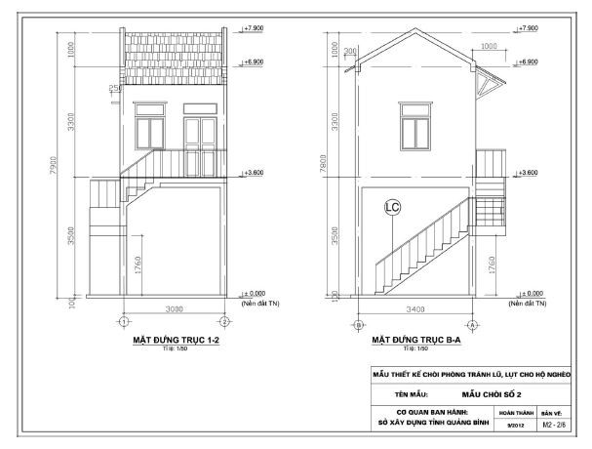
Figure 2 Flood- and storm-resilient house design, already tested and proven successful through the joint Green Climate Fund-UNDP-GOV project "Improving the resilience of vulnerable coastal communities to climate change-related impacts in Vietnam.” More than 3,200 resilient houses have been built since 2017.
In addition to the construction of these houses with resilient features, small additions to the design could be made in order to meet the accessibility needs of the intended family (i.e. addition of a small ramp). This activity is also linked to community-based approaches for risk assessment (see activity 2.2.1) to inform safe siting for the new constructions. For example, construction of flood and storm-resilient houses will not be built on high-risk sites.
The project will use gender sensitive planning and implementation to ensure the highest gains are made for gender equity. The project will provide direct benefits to women as project beneficiaries, especially within communes where the building of houses will occur and are the most vulnerable to climate shocks and variability. In many communes, women often bear the brunt of extreme weather events and disrupted livelihoods. Furthermore, the project will also enhance the awareness to women exposed to climate change risks and provide support on how to mitigate risks to their business thereby protecting their livelihoods and enhancing their adaptive capacities so they are not left behind.
Objectives Tree reference: 2.2.3 Design and build storm and flood resilient commune health stations in target areas
This activity will design and build resilient storm and flood commune health stations. These buildings will be designed based on the current Vietnamese construction standards of the health facilities at the grassroot level but will be influenced by the resilient features and construction practices deployed in the resilient housing. To do so, consultation with Ministry of Heath, provincial departments of health, MOC in applying building standards based on the risk of extreme weather events. The project will develop the appropriate design and construction for the resilient storm and flood commune health stations that not only meet all the Vietnamese required standards for primary health care service provision, but also mitigate the climate change impacts as well as adapt to extreme weather events such as storm and flood situations in the region, while ensuring that the heath stations can provide the grassroots level health services to victims of the effect of EO, and for women, and fulfil key responsibilities and duties and ensure continuity of provision of health services.
Accessing the stable energy supply is fundamental requirement for health facilities to provide uninterrupted and qualified health services. Given the problem of utilizing fossil fuel-based energy supply and the risks of energy blackouts caused by disaster situations such as floods and storms, sustainable and clean energy solutions for resilient commune health stations, such as rooftop solar energy system will be explored. With access to reliable and stable energy, the risk of disruption to primary health service provision will be lowered, thus reducing risk to the heath of patients at risk, especially in emergency situations. Furthermore, with stable energy provision, refrigeration of important medicines and vaccines will be at less risk of being spoiled. To complement the resilient CHSs, the project will work with the provincial department of health to enhance their business continuity and operational plans to ensure continuity of services to the commune, during extreme weather events, especially during the flood and storm season. The project will coordinate with the Ministry of Health, PPCs and provincial department of health to enhance operation of flood and storm-resilient CHS, based on Vietnamese National Standards and National Criteria of Commune Health facilities. Storm and flood resilient commune health stations with improved operational capacity will enhance the health protection and wellbeing of many people in the community, especially survivors of EO accidents.
In addition, along with the Government commitment and programme on digitalization of the health sector, the grassroots telemedicine function room will be set up using the software “Doctor for everyone” which is supported by UNDP in collaboration with Ministry of Health to connect healthcare workers at community level with both local residents and healthcare workers at the higher level. The grassroots telemedicine program will contribute to capacity building for healthcare workers at the lowest level and the better and more sustainable provision of and easier access to health services. COVID-19 has doubled risks to not only the quality and continuation of health services but also the health of people in rural areas. Fridges and vaccine transportation boxes will be provided together with stable electric to ensure the essential health service provision and precaution measures during the floods, storms in the context of COVID-19 pandemic. Clean water systems will be set up to ensure one of the essentially required precaution measures when providing healthcare services, especially during the floods and storms in the COVID-19 context.

2. Lessons learned from past programs/projects
2-1. Performance of KVMAP:
As the first large mine action project jointly implemented by government agencies i.e. VNMAC and MOLISA, and with new partners KOICA and UNDP, KVMAP achievements, challenges and lessons learnt have established a strong foundation for KVPVP. Following the Theory of Change, the key components implemented under the framework of KVMAP include:
- Survey and Clearance
- Information Management
- Mine Risk Education (now called EORE)
- Victim Assistance
- Policy Development and Sector Coordination
Overall KVMAP performance by main component is presented below.
Survey and Clearance
Under this component, non-technical survey, technical survey and clearance activities are implemented subsequently. Non-technical survey is the first and important part of the Land Release process where the suspected contaminated areas have been studied with desk review of bombing data and then interviews with individuals living in or in close vicinity to the contaminated areas. VNMAC completed most of non-technical survey in 2018 in preparation for the subsequent technical survey and clearance operations. Following the results of non-technical survey, up to 21 survey teams and 64 clearance teams mobilized by the Ministry of Defense were deployed for field survey and clearance operations. By end of December 2020, more than 16,880 ha have been surveyed and more than 9,000 ha of Conformed Hazardous Areas have been cleared. The results are presented in the bellow maps which serve as evidence-based documentation of survey and clearance results.
In an effort to reinforce the quality management of survey and clearance operations in the field, a Quality Management Software has been developed and training was conducted in late June 2019 for 150 staff in the field. Then, the quality management software was improved and handed over to VNMAC on September 2020. It is expected that VNMAC can apply this software in their survey and clearance operation later on, not only for KVMAP but also for projects in other provinces.
Another effort to improve quality management of survey and clearance operation is the dispatch of an International Quality Management Advisor to the field to support VNMAC in their operation. With more than 120 individual field visits to survey and clearance sites, the advisor was able to provide advice to survey and clearance teams in particular and VNMAC in general with special attention given to core safety, quality and liability related issues. These have been reinforced in meetings and other forms of communication throughout the year such as quarterly reporting and technical letters to VNMAC leadership.
Survey and clearance results by 2021
Quang Binh Province | Binh Dinh Province
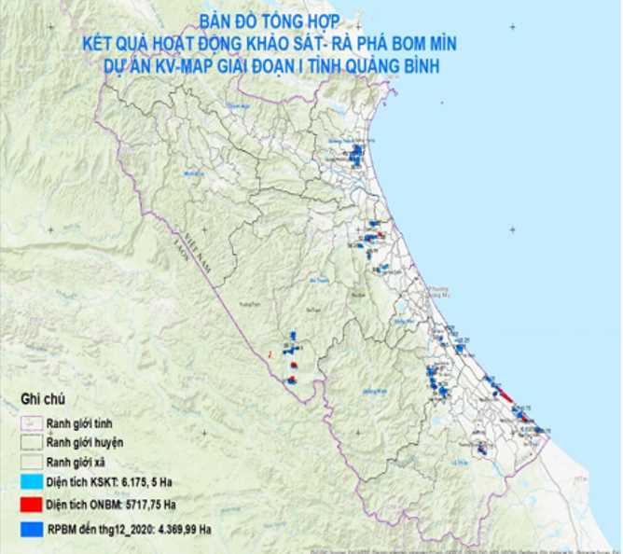 | 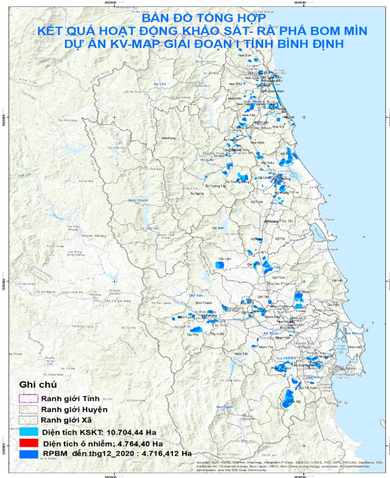
-Turquoise color - Total technical survey area: 6,175.5 ha  -Red color - Total CHAs: 5,717.75 ha  -Navy color – Total clearance area: 4,389.99 ha | -Turquoise color - Total technical survey area: 10,704.44 ha  -Red color - Total CHAs: 4767.43 ha  -Navy color – Total clearance area: 4767.43 ha
Information Management
Information Management is an integral part of any successful mine action project. In the KVMAP, it stays at the center and connects all other components together. The component ensures the necessary information for decision-making in the project and secures document and record management systems to be in place. Survey and clearance result reports are continued to be checked and entered into IMSMA by the Database Center in VNMAC in Hanoi. So far, more than 16,880 ha surveyed, and over 9,000 ha cleared have been uploaded into ArcGIS and IMSMA, equivalent to 100 percent of the survey and clearance results.
In addition, after nearly two years of piloting the KVMAP Information Management regulations, and in implementation of the Decree 18 and Circular 195, VNMAC has been revising the regulations for their application nationwide. The draft revised Information Management regulations have been presented in two consultation workshops in Binh Dinh and Quang Binh with participation of PMC representatives who are responsible for collecting and management of mine action databases in their respective provinces. VNMAC will finalize the revised regulations and submit them for approval early 2021.
Lastly, a KVMAP page has been developed, managed by VNMAC and updated with information about project activities to provide information for public audience and improve image of the project. A registry software has also developed and managed by MOLISA/DSA to collect information on PwDs and UXO survivors. Based on this software, a database of more than 75,000 PwDs including more than 4,700 UXO survivors has been established and analyzed to management purposes and making evidence-based decision on supporting UXO survivors.
Explosive Ordnance Risk Education
Starting with the baseline KAP survey to provide evidence-based information on awareness status, needs and appropriate approaches on EORE to target population, various EORE programs have been developed including integration of EORE knowledge in primary and secondary school curriculum, gameshows and competition for school kids, public awareness campaigns on the occasion of the International Mine Action Day (April 4), EORE activities in communities, EORE raising awareness through broadcasting on local television and radio/communal loudspeakers system, public posters on EORE in schools and communities, etc. Various trainings on EORE have been conducted for hundreds of local staff including school managers and teachers, district and communal military commands, red cross, youth union, women’s union, etc. to build their capacity on management and implementation of EORE activities. In close collaboration with provincial departments including PMC, Department of Education and Training, Red Cross, Provincial Television, etc., nearly 300 EORE events have been organized to benefit more than 600,000 school children and local people on raising their awareness on mine risk. It should be noted that almost half of them are women and girls. In the last year of implementation, the project also conducts an end-line KAP survey to document the impact of EORE interventions and supports to the development of a national guideline on EORE.
Victim Assistance
Following the development and implementation of the software for registry and information management, the database of UXO survivors and PwDs in the two provinces has been established to serve as the basis for various intervention. The software has then been upgraded by creating applications on smart phones both on Android and IoS, which increase accessibility for PwDs and UXO survivors to registry of their disabilities, thus increasing their access to the government’s support policies. Subsequent trainings for local social workers at provincial, district and communal levels have been conducted with participation of more than 1,000 persons to improve their knowledge and skills on social work and in supporting the UXO survivors.
Based on information from the database and taking into consideration of the negative impact of the COVID-19 pandemic on various vulnerable groups including people with disabilities and UXO survivors, a rapid assessment of social, economic impacts of COVID-19 on PwDs and UXO survivors was launched in April 2020 and in response to their needs, emergency packages were delivered to around 6,000 UXO survivors and poor PwDs and children with disabilities in Quang Binh and Binh Dinh.
The database of UXO survivors, need assessment results and mapping services showed that health care and prosthetic devices and rehabilitation was top priority for the UXO survivors. With the support from Quang Binh and Binh Dinh DOLISAs, 1,034 UXO survivors received health care screening and 176 of them have been diagnosed and prescribed for prosthetic devices.
In responding to the COVID-19 and other emerging diseases, e-learning modules of case management for UXO survivors and PwDs have been developed so as to increase knowledge and skills in case management for communal social workers and collaborators with an aim to provide better support for the vulnerable populations, including PwDs and UXO survivors.
In the last year of project implementation, based on the results of case management activities of UXO survivors to identify their needs, direct interventions for assisting livelihood of hundreds of UXO survivors and their families will be conducted. The intervention is expected to be a model for application in other provinces in the following KVPVP project.
Policy Development and Sector Coordination
The following KVMAP activities could have the potential to transform the mine action sector following the issuance of Decree 18 and Circular 195:
- Survey procedures: the project is building on previous efforts in developing a procedure for technical survey. By using this guidance for technical survey in two key provinces, the project is has been promoting this as best practice for future mine action interventions throughout Vietnam. VNMAC is currently in the process of developing or revising legal documents on survey and clearance procedures/standards and quality management, and it is evident that the survey procedure is an updated version based on KVMAP experience and global best practice.
- Quality Management System: a few years ago a system had been developed for Program 504, i.e. government-led mine action projects. However, it had not been used in practice. By applying and testing the Quality Management System, the project helped promote Quality Assurance/Quality Control according to the International Organization for Standardization (ISO) and in line with the IMAS. With new Circular 195, there are some adjustments in Quality Management forms and these templates are well reflected in the revised version of the Quality Management System. Again, KVMAP has contributed to the lesson learnt considered in this revision.
- After piloting the Information Management regulations for KVMAP, VNMAC is revising the regulations for nationwide application as required by the Decree 18 and the Circular 195 on the establishment and management of a mine action information database.
- KVMAP experience in EORE contributed to development of a roadmap for development of the national EORE strategy. A workshop is planned in March 2021 to further elaborate the strategy.
- KVMAP activities are also integrated into other projects implemented by UNDP and in lights of donor coordination. For example, the coastal resilience project funded by Green Climate Fund and implemented by UNDP in Quang Binh to build resilient houses for the most vulnerable households in response to the flooding situation and COVID-19. During the visit in 2019, Korean Ambassador and a Vice Chair of the Quang Binh province, it was discussed that Korea really would like to see some of the cleared land used for eco-tourism projects that benefit the local people through promoting tourism and for more and more Koreans to visit and understand more about Vietnamese country and people. In Binh Dinh, lessons learnt from the three on-going projects in coral reef conservation, promoting value chains for climate smart agriculture product (groundnut) and medicinal plants for Ba Na indigenous people can be applied to support the UXO survivors or in the coming KVPVP project.
As part of promoting mine action in Vietnam, and particularly this project, it is planned to present key results from these efforts, as well as other opportunities identified during the implementation of the project, in several upcoming international fora related to mine action.
Close coordination with other relevant stakeholders, such as Mines Advisory Group, Norwegian People’s Aid, Quang Tri Mine Action Center, Catholic Relief Services, International Center and Golden West, has taken place throughout 2020. This has included overall coordination, such as with Mines Advisory Group which also has survey and clearance operations in Quang Binh province, and more issue-specific, for example with Catholic Relief Services on EORE and with Norwegian People’s Aid on Information Management and new Technical Survey procedures. KVMAP has also collaborated with Quang Tri Mine Action Center in trainings on Information Management, thereby further strengthened such local capacities for the benefit of the entire mine action sector in Vietnam. Collaboration with other mine action operators have also helped create synergies and multiplier effects between various interventions. Regular technical coordination has also taken place during the KVMAP inception phase, and later within the framework of the Landmine Working Group.
UNDP has been in contact with and established working relationships with both the APMBT and CCM Implementation Support Unit to support Vietnam’s participation in relevant international conferences. Moreover, frequent interaction with UNDP mine action programs in Lao PDR and Cambodia, as well as UNDP mine action projects outside the region, has been useful in terms of promoting best practice for the VNMAC-KOICA-UNDP mine action project in Vietnam.
Achievements - Cross-Cutting Issues
As the KVMAP emphasizes an effective, accountable, transparent set-up in support of the SDG 16 and safe human settlements in support of the SDG 11, contributing to the SEDP 2016-2020 and 2017-2020 One UN Strategic Plan, one of the concerns of the project is gender mainstreaming in project implementation at different stages.
Participation of women in project activities is a requirement, where possible. For survey and clearance component, no women participate in the operations as the national military forces are almost exclusively composed of men. In other components, efforts have been made with other civil agencies and organisations to ensure better participation of women during this process. Local partners, including PMCs and the Red Cross, were requested to take into account the gender balance for the EORE trainings and events to make sure that more women need to participate where possible. As a result, women accounted for more than 50% percent participants in trainings for community EORE; The trained women became leading communicators for EORE for the villagers, playing major roles in raising awareness of EORE for villagers via their broadcast on communal loudspeakers. The EORE events reached a fair balance between women and girls compared men and boys, with 50% women and girls out of 362,792 reached people. In the trainings for updated legal regulations and polices of supporting the vulnerable populations affected by COVID 19, including PwDs and UXO survivors affected and community- based rehabilitation, there were more female social workers taking part in the trainings, i.e. more than 60 percent.
2-2. Further lessons learned from KVMAP and other projects:
Regarding mine action, there are many lessons that can be drawn from the more than four decades of effort to reduce the risk to the local population. However, the most recent/on-going collaboration between VNMAC, KOICA and UNDP provide some very recent and quite detailed lesson learned which can benefit the entire sector. The aim of the KVMAP project was to align it closely with the Socio-Economic Development Plan (SEDP) 2016-2020, and to provide direct support to the National Mine Action Program for 2010 – 2025, known as the Program 504. Whereas it is possible to see these linkages on an overall level, a challenge remains in making any direct and tangible correlation between the very broad aspirations outlined in these national documents and the very concrete results from the project intervention.
More specific and important lessons learned and recommendations from the on-going Trilateral Partnership between the Government of Vietnam, KOICA and UNDP were already captured in the Mid-Term Review conducted at the end of 2019. A few highlights which point towards a future stage for the sector in Vietnam, and hence important for this project to consider, include the recommendations to: 1) ensure a well-established mechanism or process between provincial authorities and VNMAC whereby priorities and criteria to identify these are agreed and made public; 2) strengthen the linkage between mine action and development is strengthened; 3) ensure strong sector coordination; and finally 4) make progress on the international conventions related to mine action.
In addition, and related to project management, continued close cooperation of the Joint Project Management Unit (JPMU) and JPCC, where needed, from both sides through timely discussion, and sharing information and suggestions to appropriate actions to solve pressing issues is essential. The project management structure is therefore in place and has proven to be an important mechanism for creating results. The fact that this mechanism works very well due to KVMAP experience is worth highlighting.
Because KVMAP spans a large area with some locations not being easily accessible due to mountains, steep slopes and remote border areas, the survey and clearance operations can encounter difficulties, especially when it rains. Adding to this is the distance from Hanoi to the target provinces, which is why it is suggested in this phase to establish the functions of Peace Village Coordinators in each province. This will support the oversight, as well as the coordination with local authorities and between the province and Hanoi.
For the mine risk education (MRE – now globally referred to as EORE) component under the KVMAP, it is proved that it requires multi-sectoral coordination. VNMAC has played coordinating role to ensure EORE delivered appropriately and targeted at the risk populations. The implementing partners in the provinces with their strengthens under technical assistance from VNMAC and UNDP, their capacity was built to implement the interventions. In addition, the project has worked closely with other operators so as to maximize the available resources, such as communication and training materials and also to ensure the same key messages delivered to the target populations.
In the area of victim assistance, MOLISA has played the lead role in coordinating and making relevant policies, the direct interventions to support the EO survivors should be implemented by DOLISA and relevant partners at local level. The delay during KVMAP in implementation of the direct support for EO survivors is partly attributed by the project management structure, when MOLISA is a responsible party and UNDP can only sign agreement with them. Meanwhile, almost all the work is done by the provinces, DOLISA, which it has been more difficult to sign an agreement with. KVPVP therefore suggests a new management structure to rectify this in the future. This is further justified by KVMAP already supporting MOLISA in establishing the national structure which was required for the Victim Assistance component, not least the software for registration and information management of PwD including UXO survivors. MOLISA has made commitments to expand the software throughout the country. In addition, case management regulations and other related policies and guideline developed with support of KVMAP also contribute to more effective implementation of Victim Assistance going forward. At the end of KVMAP (December 2021) several additional innovations will also have been tested and can be brought to scale during KVPVP.
The on-going KVMAP has shown that participating regional and international forums and joint efforts to share a few success stories with others has been a catalyst for domestic self-reflection and improvement. At the first international conference on Vietnam “Overcoming War Legacies, Endeavour for Peace and Sustainable Development” in UNHQs in March 2019, Vietnam was highly appreciated of its effort and countries expressed wishes to cooperate and learn from Vietnam. The aspiration to contribute to the UN peacekeeping mission, as well as the Women, Peace and Security agenda, has been well acknowledged by the UN and thus can help to raise demining standard at home. For this reason, the Project will continue to support efforts to either ratify or showcase Vietnam’s adherence to international treaties, active participation in relevant global events, especially as these relate to the Mine Action sector.
For building resilient housing, this project will draw on the rich lessons learned and good practices from the existing Coastal Resilience Project, funded by the Green Climate Fund. Through this project UNDP has supported the construction of over 3,200 flood and storm resilient to date. The designs for these houses had already undergone a rigorous and lengthy development and appraisal process by the Vietnam Institute of Building and Science Technology (IBST), MOC at the national level and approved by the Provincial Departments of Construction. These houses have proven highly successful during the recent floods and storms and have saved lives and livelihoods of people in the flood and storm affected provinces in Central Region of Vietnam. The resilient housing designs applied by UNDP have been highly appreciated by individual households, local authorities and the Government of Vietnam. This project will benefit from this tested approach already applied by UNDP in the framework of the GCF project. Furthermore, for the construction of resilient commune health stations, the resilient features, designs and good construction practices will benefit from the existing approach deployed for resilient homes with the necessary modifications.
In regard to the overall funding requested for KVPVP, it is based on the experience and achieved results from KVMAP and other UNDP projects. Due to the unique characteristics of a typical mine action project, especially with regard to survey and clearance activities and field operations, large amount of resources are required for mine action activities. However, various factors have been carefully weighted for planning and budgeting for KVPVP based on accomplishments from the current KVMAP. While all funding are spent only for mine action in KVMAP, allocation for KVPVP is to ensure a cost harmonized estimate for both Outcome 1 “Improved human security for communities in target areas” with a focus on mine action and Outcome 2 “Enhanced sustainable rural development through increased resilience of livelihoods and infrastructure of target communities” aiming at ensuring post-mine action activities to form a strong linkage between mine action, livelihood improvement and sustainable development. Furthermore, the budgets allocated to rural development activities under output 2.1 and output 2.2 have been calculated based on similar unit costs in on-going UNDP projects on resilient housing and climate-resilient agricultural livelihoods. For the commune health stations, the cost calculation is based on Ministry of Health Decision # 4667/QĐ-BYT dated 07/11/2014 regulating the criteria for the commune health stations (CHS) toward the year 2020 With this experience, we are confident in the estimates in the budget.

Theory of Change
The correlation between the various activities, outputs and outcomes described in the section above can also be illustrated in the below Theory of Change, which in addition refers to the SDGs the project will help influence.
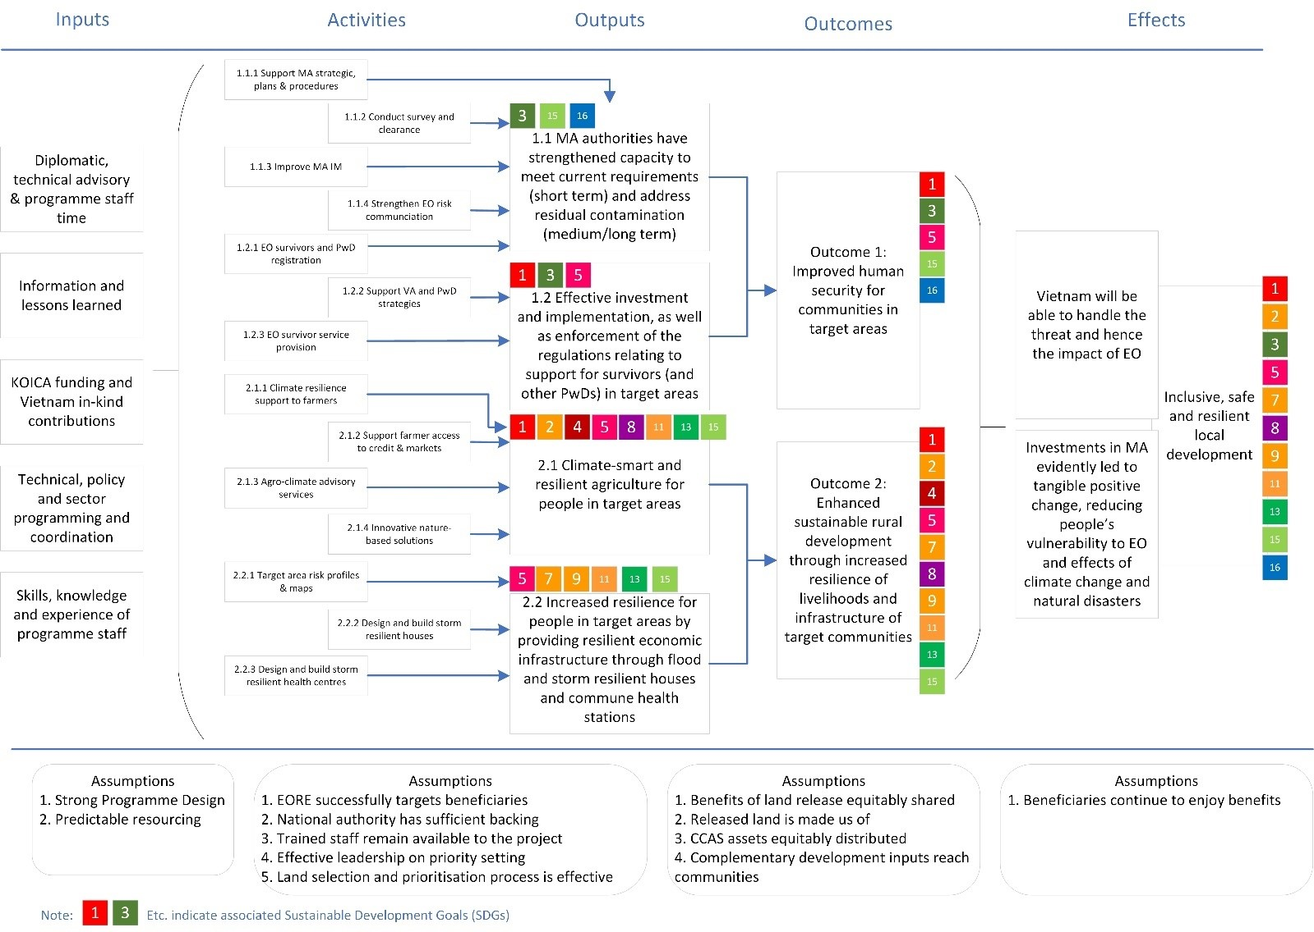

III. RESULTS AND PARTNERSHIPS

Expected Results
The Project, which is aligned with the Sustainable Development Goals (SDGs), particularly SDG 16 and SDG 11, as well as SDG 2, and has two outcomes and related four Outputs:
- Improved human security for communities in target areas;
  - MA authorities have strengthened capacity to meet current requirements (short-term) and address residual contamination (medium/long-term);
  - Effective investment and implementation, as well as enforcement of the regulations relating to support for survivors (and other Persons with Disabilities (PwDs)) in target areas;
- Enhanced sustainable rural development through increased resilience of livelihoods and infrastructure of target communities;
  - Climate-smart and resilient agriculture for people in target areas;
  - Increased resilience for people in target areas by providing resilient economic and social infrastructure through flood and storm resilient houses and commune health stations.

Resources Required to Achieve the Expected Results
· 2022-2026/USD 25M (total)
· Contribution from KOICA: USD 25M (out of total budget)
· Confirmed co-financing from other donors: USD 9.75M
- Government of Vietnam’s in-kind contribution: USD 8M
- UNDP in-kind contribution: USD 1.75M

Partnerships
As the co-chair of the Landmine Working Group, UNDP has strong cooperation with other actors in the mine action sector, as well as development partners supporting these.

Partner country analysis
- Policy and strategies – enabling environment
The Project will support to address issues related to relevant National Resolutions, Government Strategies and Action Plans on mine action and new rural development program (NTP-NRD) and telehealth program etc:
- Prime Minister Decision 504/QĐ-TTg dated 21 Apr 2010 on Mine Action from 2010 - 2025, in which the following is direction for 2016-2025
- Continue to carry out bomb and mine clearance for socio-economic development tasks and to ensure safety for people, reaching the target of about 800,000 ha by 2025.
- Continue to raise awareness about the situation and consequences of landmines / UXOs remnant in Vietnam in order to mobilize support from foreign governments non-governmental organizations, international organizations and individuals for the implementation of the Program.
- Continue to implement programs of risk education on mine / UXO accidents.
- Continue to carry out projects to support victims and support resettlement for people in areas contaminated with EO in heavily polluted provinces.
- National Assembly Resolution No 25/2021/QH15 dated 28 July 2021 on National Target Programme on New Rural Development (NTP-NRD) for the 2021-2025 period, with the specific targets till 2025 as follows:
- At least 80% of communes meeting new rural standards, at least 10% of the communes in particular will meet the model new rural standards, no more communes below 15 criteria; maintains the construction of advanced new rural areas and model new rural areas for communes, districts and provinces that have been recognized as meeting new rural standards; the average income of rural residents increases at least 1.5 times compared to 2020.
- At least 50% of districts, towns and provincial cities meeting new rural standards, completing the new rural construction task, of which at least 20% of qualified districts are recognized as advanced new rural districts, model new rural districts.
- At least 15 provinces and cities recognized by the Prime Minister as having completed the new rural construction tasks
- At least 60% of villages belonging to communes with special conditions in border areas, mountainous areas, coastal flatlands and islands will be recognized as having met new rural standards according to the criteria for new rural set by the provincial.
- The Decision No. 942/QD-TTg of Prime Minister dated 15 June 2021 approving the Strategies for Development of E-government targeting to 2025, with specifying for the health sector as below:
- Each resident has an individual health record.
- Each commune health station (CHS) implements management activities in the digital environment.
- Each medical examination and treatment facility deploys telehealth/telemedicine for consultation, examination and treatment based on actual needs.
- Every hospital and medical center deploy electronic medical records, non-cash drug payments, and electronic prescriptions.
- Drug, medical equipment, medical examination and treatment prices are publicized transparently.

Risks and Assumptions
Please see attached Risk Register and Risk Management Analysis

Stakeholder Engagement

4. Stakeholder analysis
4-1. Beneficiaries
Based on the above analysis, the Project will support the following groups of beneficiaries in the three provinces. Direct beneficiaries will be the population in these target provinces and more specifically individuals (women, girls, boys and men) whose lives and limbs are protected because they physically use/will use cleared and reduced land post-clearance for a productive and/or frequent and/or sustainable activity, as well as other household member benefiting from this; people receiving and those trained on providing EORE messages; all survivors from accidents with EO receiving assistance and poor households, especially female-headed poor households. Indirect beneficiaries will be those who may benefit from cleared land as they are members of the same community as direct beneficiaries without using land themselves; persons who learn from persons reached by EORE messages; persons living in same household as direct beneficiary of assistance due to accidents with EO; and to the extent models and approaches based on lessons learned from these interventions can be replicated in other parts of Vietnam, then many more Vietnamese citizens will indirectly benefit from the project.
See also attached Beneficiary Analysis
4-2. Recipient organization
VNMAC, as the national mine action center, will play a central role in the design and implementation of the proposed project. VNMAC was established in 2014 through decision 319 to support National Steering Committee 504 (now NSC 701). For the first few years and in practice, the activities of VNMAC covered predominantly those under Program 504. With recently issued Decree 18 and especially Circular 195, the center has received more sector wide responsibilities. Still, realizing its full role as a national mine action center as understood internationally is a gradual process which is linked to working with international organizations to develop necessary capacities.
Importantly, it should be highlighted that VNMAC is leading a process of revising its entire regulatory framework for the sector, including the beforementioned technical regulations (QCVN), national standards (TCVN), as well as procedures for Quality Management (QM) and survey & clearance (all in draft as of time of writing – December 2020). In addition, VNMAC is leading a process of developing a strategy for EORE. These will complement the recent issuance of Decree 18 and Circular 195, and although the technical regulatory framework is still under development, it is clear that the process VNMAC is leading will align it much closer with IMAS. Lastly, it should also be mentioned that UNDP helped facilitate VNMAC’s capacity development self-assessment, which openly has made clear the areas where support is still required. This builds a strong foundation for the collaboration with VNMAC in making the KVPVP a success.
VNMAC has a Director General, who is a member of the JPCC, and three Deputy Director Generals, with whom KVPVP will engage with more frequently for project implementation issues, including in the JPMU. Each of the deputies cover various aspects of VNMAC’s work, such as planning and strategies, survey and clearance in including Quality Management, and information management, EORE and VA. They are supported by the Planning and Coordination Department, External Relations Department, Technical Department, and Finance Department. In addition, VNMAC has a Training Centre, Survey and Clearance Centre, and Information Management Database Centre.
Given VNMAC new mandate and the updated regulatory framework, there is not only a readiness for this suggested intervention, but also a momentum to help shape the future of how Vietnam deals with the contamination with EO throughout the country. As mentioned in previous sections of this document, there will be a clear emphasis throughout this project phase on the residual capacity.
PPCs (Provincial People's Committees) are the executive arms at provincial level of the target provinces, and are responsible for implementing policy and overall management at the provincial level. The PPCs are in charge of the province's departments. With recently issued Degree 18 and especially Circular 195, the PPCs have also received more responsibilities in management of mine action in their respective provinces.
The PPCs will also be able to assign a lead department at provincial level for the respective components, outputs and activities. The PPC will help ensure good implementation of advisory services and capacity building based on the priority areas of the province, directing the relevant agencies in overall annual planning and regular sharing of information to use funds for programs to be effective. Moreover, they will provide timely guidance and support to ensure good coordination technical activities and help address problems during implementation.
PPCs will help create all favourable conditions in accordance with Vietnam Law for KVPVP in the province, including and as needed provision of the required human and financial resources, so that activities can be implemented. They will also be responsible for mobilizing additional resources (which could be in-kind, or labour days or direct budget integrated from the programmes at central or provincial level in the province) as a contribution for KVPVP implementation. PPCs facilitate the access by KOICA, UNDP and other needed experts and its associate partners to the program areas in province to conduct research and studies and to provide technical and capacity building support in accordance with the Law of Vietnam. In addition, PPCs will assign relevant departments and agencies of the province to coordinate with KOICA and UNDP to conduct surveys and studies for development of activities and report results of program activities for relevant agencies and donors.
4-3. Other stakeholders in recipient country
- KOICA has become an important donor for mine action in Vietnam as well as for the Southeast Asia countries such as Lao and Cambodia. KOICA Vietnam has already funded the KVMAP project in the two provinces of Quang Binh and Binh Dinh and strongly supported UNDP and VNMAC in project implementation. Besides playing a key role on the overall management of the project, though its seat in the JPCC and active engagement with the JPMU, KOICA can help facilitate identifying relevant and appropriate opportunities for knowledge exchange with Korean experience in mine action, not least how residual contamination is being addressed, as well as integration of victim assistance into wider disability framework. Moreover, KOICA can support South-South cooperation, focusing particularly on mine action management experience, building resilience of communities and Vietnam’s regional neighbours in Southeast Asia.
- Ministry of National Defense plays an important role at the line ministry overseeing key institutions, including VNMAC, National Steering Committee 701 and the Engineering Command.
- National Steering Committee 701 (Standing Office of the National Steering Committee on the Settlement of Post-war Unexploded Ordnance and Toxic Chemical Consequences) oversee the entire sector on behalf of the Government of Viet Nam.
- Engineering Command and MOD units play a key role in the implementation of the survey and clearance component, as their teams will be tasked with these activities under overall supervision of VNMAC. In addition, they will be play an important role in ensuring that the revised regulatory framework will be implemented correctly, bringing the entire land release process in close alignment with best practice and the International Mine Action Standards (IMAS).
- MOLISA has worked with victim assistance and mine risk education programs at the provincial level, with sustained INGO support over a decade. Another MOLISA initiative was the creation of the Vietnam Bomb and Mine Action Centre (VBMAC) in 2008 to provide a civilian oversight body on mine action work to facilitate international partner and INGO partnerships. At the time responsibilities appeared to cover both regulatory functions and operational capacities. However, there was sporadic and limited funding support to work at the provincial level through VBMAC, with most donor resources channelled through INGOs. MOLISA will engage in supporting the provinces to implement the victim assistance activities via their coordination and management roles. Any required guidance for piloting any initiative will be supported by MOLISA before it is up streamed to the policy level.
- DOLISA (Department of Labor, Invalids and Social Affairs) will be instrumental in the implementation of the Victim Assistance component in the three provinces.
- DARDs (Department of Agriculture and Rural Development) are responsible in leading , managing and coordinating with relevant organizations for implementing output 2.1: i) Support farmers to implement and scale up climate resilient crop system and practice; ii) Support farmers to enhance their access to micro-credit and markets, post-harvest and to increase incomes from participation in value chains; iii) Co-develop and operate localized agro-climate advisories for farmers; iv) Establish and implement a portfolio of nature-based innovative solutions by local communities/ CBOs.
- Ministry of Health is in charge of Health Sector and provides policy guidance to provinces on health-related matters.
- Other partners:
  - International Non-governmental Organisations/mine action operators: can contribute through close coordination with UNDP, for example via the Landmine Working Group (LWG) which UNDP co-chairs, to provide technical support to government partners such as development of legal documents, planning, training, etc.
  - National Partners/Civil Society (i.e. Farmer Union, Women Union, Youth Union, Veteran Union, Viet Nam Red Cross; etc.) and Private sector partners and companies. Civil society often has a nationwide network, can directly interact with communities and can easily reach the target groups, especially for risk education, engaging women and provision of livelihood support. Private companies can provide more advanced technology and solutions to support the project target groups.
  - International Partners/embassies and other development partners: can highlight issues around mine action and community resilience building, and potentially linkages or exchange of experiences can help improve respective intervention. In addition, they can also potentially consider providing further support to these sectors in their development programs for scaling up/wider application.
4-4. Development partner analysis
The Government of Vietnam – UNDP partnership officially started in 1978, when there was an extremely limited foreign presence in the country. Since then, UNDP has stood side-by-side with Vietnam as it began its development trajectory from a poor nation devastated by war to a lower middle-income country championing poverty reduction and leading in growth. UNDP has been working closely with the Government of Vietnam and other partners to expand the choices for people and ensure that everyone has equal access to opportunities to realize their full potential.
UNDP’s contributions on issues related to Climate Change and environment, Leave No One Behind agenda and governance have been well received by national partners. During 2018-2019 only, UNDP’s introduction of new concepts and recommendations on inclusive IR4.0, inclusive innovation, anticipatory and adaptive and agile governance, addressing fragmentation and commercialization of the state, enhancing productivity and competitiveness of Vietnamese firms, etc. have been well received and resonated by the policy makers. The recommendations for example on attracting quality FDI and enhancing the linkages between FDI and domestic firms were reflected in the Party’s Resolution on FDI and UNDP advice influenced the formulation of Vietnam’s IR4.0 strategy. UNDP’s support and advice to national priorities and development agenda setting was recognized and appreciated by the GOV/Ministry of Foreign Affairs-UN Review meeting in October 2019.
Key contributions in the area of poverty eradication and greater socio-economic equity:
- As an input into the design of the national Socio Economic Development Strategy (SEDS) 2020-2030 and Socio Economic Development Plan (SEDP) 2021-2025, UNDP co-led the preparation of two key position papers on behalf of the UN and development partners which were well-received by the Minister of Planning and Investment as well as the national drafting team. These papers focused on: (i) SDGs and Sustainable Development - Climate Change, Circular Economy and Natural Resource and Environment; and (ii) Institutional Reform and Governance. UNDP also provided technical support to SEDS’s specific working group on circular economy and the consultations on the master plan for socio-economic development of Ethnic Minority areas government.
- UNDP introduction of the Multidimensional Poverty (MDP) measurements and approach, MDP analysis and monitoring has contributed to improvements in Vietnam’s policies and programs on poverty reduction, social assistance that address both the chronic poverty and emerging deprivations in non-income dimensions. Following the government’s adoption of MDP tools, the UNDP-supported 2016 nation-wide exercise of applying MDP measurements for identifying the poor households has changed the number of eligible households for support by National Poverty Reduction policies and programmes for 2016-2020: 2.1% of Vietnam’s households (1.97 million people) that are not income poor but suffer from non-income deprivations are now identified as ‘multidimensional poor’ and eligible for GOVN support under the poverty reduction policies and programs and social assistance schemes. The application of MDP in Vietnam was assessed as among the best practices in Asia Pacific region.
- UNDP’s support to the design and implementation of the National Targeted Programmes on New Rural Development and Sustainable Poverty Reduction (NTP-NRD and NTP-SPR) 2016-2020 with the focus on the Ethnic Minority/Ethnic Minority areas, in particular the promotion of local community strengths and local initiatives for economic empowerment of EM women business groups have contributed to the country’s efforts in addressing the chronic poverty and the unfinished MDG agenda, new challenges in achieving SDG1. At the same time the support also has provided substantial inputs to the formulation of the next generation of NTPs for poverty reduction with new innovative elements and comprehensive approach in providing favorable and equal conditions for all.
- UNDP-supported review of social assistance policies and development of the Master Plan for Social Assistance Reform and Development (MPSARD) in the period 2017-2025, vision to 2030 have introduced the life-cycle, rights based approach and universal floor coverage for the application in designing and implementing social assistance policies, and contributed to the increases of coverage and benefit levels for some groups, and key directions for reforming the Social Assistance/Social Protection (SA/SP) system of LMIC Vietnam toward more inclusive and sustainable development.
The above UNDP country program support has contributed to Vietnam’s remarkable achievements in sustainable poverty reduction, addressing the disparities by ethnicity, gender and locality, and promoting inclusive growth.
Key contribution in the area of low-carbon, resilient and environmentally sustainable development include:
- UNDP’s technical support in modelling greenhouse gas (GHG) mitigation options and adaptation measures helped Vietnam to define national GHG targets, enabled adoption and submission of its intended nationally determined contribution (NDC) to the United Nations Framework Convention on Climate Change (UNFCCC), prepared biannual update reports, raised ambition and set priorities in its second Nationally Determined Contribution to be submitted to the UNFCCC in mid-2020. Assessing the impacts and co-benefits of climate actions helped Vietnam to define optimal options to reduce GHG emission, adapt to changing climate, while enhancing sustainable economic growth.
- The Climate Change Bottleneck Analysis led by UNDP on behalf of the UN on energy transition, industry transition, infrastructure cities, resilience and adaptation, nature-based solutions and climate finance and carbon financing, was provided to government in preparation for the UNSG’s Climate Summit in September 2019, was the first of its kind and recognized as global best practice. The analysis identifies key barriers and provides options of solutions to accelerate climate actions to achieve Vietnam’s climate targets.
- UNDP supported the formulation of key legal frameworks, including inclusion of circular economy into the Law on Environmental Protection and energy efficiency in the draft Law on Construction.
- UNDP’s technical support to the government resulted in adoption of at least five policy instruments to enable the systematic integration of biodiversity concerns in development planning. UNDP supported the formulation and implementation of 31 community-based forest management plans to ensure sustainable development of forests, to reduce GHGs emissions from deforestation and forest degradation, and improve livelihoods and incomes for 447,826 forest-dependent ethnic minority people (51% are women) through supporting GOVN in adoption of a comprehensive National REDD+ Programme (NRAP) to enrich natural forest and biodiversity, establishment of a National Steering Committee to oversight NRAP implementation. These efforts contributed to improvement of forest area coverage from 40.7% of total land area in 2013 to 41.2% in 2016 (CPD Indicator 3.6.2).
- UNDP is leading technical support to the scaling up the climate and disaster resilient housing, with the blending of finance from the Government of Vietnam (the Government resilient housing program #48) and Green Climate Fund. By 31 March 2020, the support to building resilience of the coastal vulnerable communities, resulted in complete construction of 2,400 new low-cost and storm-resilient houses and repair of 5,403 houses for the poor, near poor, and women headed households, benefiting more than 35,000 people, 60% of them are women in 8 coastal provinces of Thanh Hoa, Quang Binh, Thua Thien Hue, Quang Nam, Quang Ngai, Phu Yen, Binh Dinh and Khanh Hoa.
- UNDP support to enhancement of local community’s resilience is also made through the scaling up actions by the CBDRM. By 31 December 2019, 252 CBDRM trainings provided in 100 communes in 7 provinces helped enhance knowledge and skills of more than 32,083 local people and local authorities of which more than 48% were women. UNDP’s tsunami and disaster risk management awareness campaign resulted in improved understanding and response skills of 6,250 students and local people, 3,000 of them are female in 5 cities and provinces Ha Noi, Thua Thien Hue, Ninh Thuan, Quang Nam and Ho Chi Minh City in 2018 and 2019.
- Law bans deforestation: To reduce emission from deforestation and forest degradation and to protect ecosystems, UNDP’s support for the forest law and forestry sector led to improved livelihoods and incomes for 447,826 forest-dependent ethnic minority people (51% are women) through supporting GOVN in adoption of a comprehensive National REDD+ Programme (NRAP) to enrich natural forest and biodiversity, establishment of a National Steering Committee to oversight NRAP implementation, and implementation of 31 community-based forest management plan. These efforts contributed to improvement of forest area coverage from 40.7% of total land area in 2013 to 41.2% in 2016/2017; and UNDP’s technical support and bottom-up approach to implement REDD+ led to an effective implementation of community-based forest management plans, reducing risks of deforestation and forest degradation and improving livelihoods and incomes for 338,283 forest-dependent people, 51% of them are women. On average, each household directly involved in forest protection has been able to increase their income by about US$ 20 per ha per year as performance-based payments. Many other households got access to revolving loans which enable them to increase their investment of about US$ 400-500 per year for agriculture activities.
Key contribution in the area of increased voice and institutional accountability include:
- UNDP continued to contribute to strengthening accountable institutions through the Vietnam Provincial Governance and Public Administration Performance Index (PAPI) which collects citizen feedback about performance of 63 provincial governments. Every year, the PAPI report captures the views and experiences of more than 14,000 citizens. The findings are widely disseminated, including with local governments to identify areas of weaknesses and realistic approaches to improving their performance. Since the start of this citizen feedback channel in 2009, almost all 63 provinces have developed action plans and directives/resolutions to request local government agencies to improve their performance in response to citizen feedback. Previous PAPI findings have been cited by the Prime Minister and his Deputies in dialogues with more than 20 provincial governments. In addition, PAPI results were presented and discussed in 21 provincial diagnostic workshops. Finally, PAPI findings and methodology integrated into the high-level training for senior Party and government leaders in the pool of 2021-2025 Government executives.
- UNDP worked closely with the Government Inspectorate and the Vietnam Chamber of Commerce and Industry (VCCI) on the implementation of the revised Anti-Corruption Law which included for the first time and thanks to UNDP’s advocacy a new chapter on corruption in the private sector. UNDP helped develop secondary legislation (Decree 59), manuals and trainings on developing codes of conduct and internal control mechanisms. In addition, 11 large business associations have pledged to work with the VCCI and UNDP to strengthen business integrity in their respective sector. Businesses can now play a stronger role in improving their own performance in building business integrity, which in turn will result in pushing public institutions to becoming more transparent and accountable to the public.
UNDP’s country level and global expertise will therefore provide an effective platform for the implementation of the new phase of the mine action programme.
South-South and Triangular Cooperation (SSC/TrC)

Korean experience and expertise
As KVPVP is developed as a major project under the framework of the flagship program ‘The Peace Village’ of the Korean government, the project will be utilizing every possibility to further engage Korean experts and Korean institutions as a valuable resource of expertise for the project execution. UNDP will source experts through various mechanisms with specific knowledge of Korean experience addressing the threat of EO, Trilateral Partnership involving Korean technical know-how and knowledge, as well as specific Korean practice in institutional capacity development. UNDP Vietnam will therefore, together with UNDP’s GPN/ExpRes ONE roster, launch a specific call in Korea for experts to the roster. It is expected that KOICA will play an important role in facilitating such a call among Korean experts. Initially, it is suggested to focus on mine action expertise, including on EORE/behavioral change and support to PwD and UXO survivors. However, the plan is to later also source experts for other profiles in the roster, including on rural development and recovery. As the GPN/ExpRes ONE roster is global, experts can be engaged for Vietnam, Southeast Asia, and in fact for the entire world if sources and selected by other UNDP country offices. Besides being a mechanism to source specific Korean expertise to KVPVP, it can therefore also lead to a bigger involvement of Korean experts in other parts of UNDP’s work globally.
To ensure good practices from Korea are identified and utilized in Vietnam, the project will also engage the UNDP Seoul Policy Centre. The center was established in 2011, with the objective of brokering new partnerships between the Republic of Korea and the developing world through UNDP networks in various areas such as governance, rural development, anti-corruption, etc. It thereby supports knowledge exchange on key development challenges based on Korea’s experiences.
UNDP will also leverage existing cooperation partnerships with Korean organizations. For example, UNDP has an existing MOU with a Korean Organization in which the areas of cooperation initially support to construction of resilient houses and also include socio-economic and development needs at the local level, including rural development and livelihood supports.
In addition, UNDP will utilize the global system for deploying UN Volunteers (UNV) to establish three positions as Peace Village Coordinators for Korean junior professionals in each of the target provinces. The role of the Peace Village Coordinator will be to provide support and assistance, together with one national assistant and interpreter, to the local authorities/PPC. This function will thereby play a critical role in ensuring the close engagement and capacity strengthening, as well as management and coordination of the project at the provincial level. The Peace Village team will be fielded within the offices of the provincial authorities to be able to closely assist them with planning and implementation of project activities. The Peace Village Coordinators will help ensure coordination at the provincial level, coordination between provinces, as well as linking with the national/policy level, and importantly act as liaison officers for the triangular exchange between Korea, UNDP and Vietnam.
Hence, the Peace Village Coordinators will also help identify opportunities for study visits between the Republic of Korea and Vietnam. The study visits will have to be well-planned with clear objectives of how lessons learned and new gained experiences will be replicated within Vietnam. Topics could include mine action in Korea and how it has dealt with the remaining EO threats (‘residual contamination’) and victim assistance, but it might also study areas of planning and prioritization (the pre-mine action stage) or rural development and climate change adaptation (the post-mine action stage). Considering the engagement of the Republic of Korea in various countries affected by EO, it is also expected that Korean mine action experts can play a facilitating role in exchange of experiences from similar contexts, and also help sharing Vietnamese expertise in mine action with other countries as part of triangular cooperation between the Republic of Korea, Vietnam and other countries affected by EO. This will be done in support of the beforementioned KOICA Implementation Strategy of PVDP in the Mekong CLMV countries, promoting mutual learning through sharing of best practices among these countries, as well as between them and Korea. The emphasis will particularly be on Information Management and use of IMSMA for proper and evidence-based planning; Quality Management; and most importantly capacity development of national authorities, thereby strengthening other ‘pillars’ of the KOICA Strategy.
In addition, during the start-up the project there will be a KMCO as part of the project management team. The KMCO has already been selected and is expected to start working in February 2021. Hence, by the time the new project starts, January 2022, the KMCO will already be very experienced in UNDP processes and UNDP’s approach to mine action and community-based sustainable rural development. It is therefore foreseen that the KMCO will play a pivotal role during the first critical period of the new project, ensuring that the Korean knowledge and expertise become an integral part of the project implementation. Moreover, the KMCO will be an important focal point for the Peace Village Coordinators in terms of training and deployment to provinces, and the KMCO will continue to act as a support for them during the first year of the project.
Knowledge
The current KVMAP project has already contributed to various important processes and knowledge products, including the new national standards for mine action in Viet Nam (about to be approved). In addition, the methodology for capacity assessment was presented as a case study in the newly published UNDP Handbook for Capacity Development in Mine Action.
Similarly, it is expected that KVPVP will generate important knowledge on the practical implementation of the new national standards, which are aligned with the International Mine Action Standards (IMAS). Important lessons can also be drawn from this unique project design in terms of linking mine action closer with development outcomes and obtaining the SDGs.

Sustainability and Scaling Up
As mentioned previously, the capacity development intervention will be targeted specifically to ensuring a residual capacity whereby Vietnam will be able to handle the sector and EO interventions after the project completion in 2026 with less international support and technical assistance.

IV. PROJECT MANAGEMENT

Cost Efficiency and Effectiveness

Delivery option analysis
Procurement at UNDP
In order to fulfil its mandate and achieve its vision of empowered lives and resilient nations, UNDP must procure a significant volume of goods and services. As a public organization entrusted with donor funds and committed to supporting developing economies, UNDP works to improve access to quality assured supplies in a cost effective and reliable way. We do this by abiding the following principles:
· Best Value for Money, which consists of the selection of the offer that best meets the end-users’ needs and that presents the best return on investment. Best Value for Money is the result of several factors, including quality, experience, the vendor’s reputation, life-cycle costs and benefits, and parameters that measure how well the good or service allows the organization to meet its social, environmental or other strategic objectives.
· Fairness, Integrity and Transparency, which ensures that competitive processes are fair, open, and rules-based. All potential vendors should be treated equally, and the process should feature clear evaluation criteria, unambiguous solicitation instructions, realistic requirements, and rules and procedures that are easy to understand.
· Effective International Competition, understood as giving all potential vendors timely and adequate information on UNDP requirements, as well as equal opportunity to participate in procurement actions, and restricting them only when it is absolutely necessary to achieve UNDP development goals; and
· In the best interest of UNDP, which means that any business transactions must conform to the mandates and principles of UNDP and the United Nations.
UNDP has to strictly observe its financial rules and regulations. While this may sometimes lengthen the procurement process, UNDP delegates a significant amount of authority to its Country Offices, has introduced more flexible methods for low-value/low-risk purchasing, and approves purchase orders electronically, all of which save time and money for the organization and its vendors.

Project Management
Project Management:
Project Director: Appointed by SC 701
Deputy Project Directors: VNMAC Vice DG, PPCs Vice Chairs
Project Support - Joint Project Management Unit:
The JPMU will be in charge of the project management and staffed/part timed from the national side with VNMAC and UNDP staff. The JPMU will serve as a management entity.
UNDP Staff:
- Head of Unit (Governance & Participation Unit) 30%;
- Programme Analyst 70%;
- Project Manager/Manager Land Release, Multiple Risks Education & Survivor Assistance;
- Manager on Livelihoods & Resilient Housing;
- 2 Project Assistants
- Interpreter
- Driver (contributed by UNDP)
Part-timed staff from VNMAC:
- Staff from relevant division such as survey and clearance, risk education and victim assistance
Project Sub-Project Management Unit:
- Head of SPMU assigned by VNMAC
- Staff part timed from PPCs
- Local Coordinator
In order to act as an integrator between various levels of the project, UNDP will arrange a project office in Hanoi and sub-offices in each of the provinces.
Rather than setting up a separate and autonomous implementation capacity, the project will aim to strengthen oversight, planning and implementation capacity within existing structures, providing technical assistance and expertise to those structures as required. These sub-PMUs will therefore be staffed with local officials and the minimum required hired staff to fulfil the vital functions of the office. Each Sub-PMU will report to a Vice Chair of the Province who is Vice Project Director.
Depending on local staff the PPC will be able to second/allocate (maybe only portion of time) to the project, to this function might be added a few support/administrative staff. The role of the local Coordinator and her/his team is to act as a support role to the PPC and its related ministry provincial departments in ensuring implementation of project, as well as act as overall focal point for the project within the province and hence keeping the PPC regularly updated about the implementation of the project and all its components.

UNDP Technical Support to VNMAC, MOLISA & PPCs
National/Hanoi-based
• UNDP Chief Technical Advisor: responsible for technical strategy and advice on all project components (with a focus on overall governance of mine action and survey and clearance); support to sector-level coordination; coordination with other initiatives (60 months);
• KOICA Multilateral Cooperation Officer (KMCO) on Mine Action: responsible for research and communication (external/internal); main focal point between KOICA and Korean involved agencies and focal point for the Peace Village Coordinators (14 months);
Work will be undertaken at either at the offices of national partners or the UNDP Country Office, with frequent travel to the target provinces.
• UNDP strategic policy and technical advice will be reinforced with specific technical expertise in Information Management (IM) and Quality Management (QM). The IM expertise will be aimed at capacity building of implementing partners on result-oriented planning and information management/IMSMA, whereas the QM expertise will be addressing issues of capacity building of partners in Quality Management of mine action activities and reporting. It is though foreseen that this will not be long-term advisor positions but instead be implemented as consultancies and/or in partnership with the Geneva International Centre for Humanitarian Demining (GICHD) and/or in partnership with one of the demining operators active in Vietnam.
Sub-national/Province-based
• International Technical Focal Points (3 persons x 54 months - one per province) working in close collaboration with national Provincial Project Coordinators (3 persons x 60 months), and all supported by national Project Assistants cum Interpreters (3 persons x 60 months); responsible for support and assistance to the local authorities/PPC, as well as coordination within and among provinces, as well as linkage to national level and Korean experience;

V. RESULTS FRAMEWORK
Name of the Project | Korea – Vietnam Peace Village Project
Goal | The local communities of the target provinces are empowered towards harmonious, safe, resilient and prosperous rural communities through access to cleared land, capacity enhancement and livelihoods development.
Objectives | 1. To survey and clear land for the socio-economic development of local communities.  2. To support socio-economic development for local communities living on and around newly cleared land.  3. To strengthen the resilience of local communities, especially UXO survivors, to mines, disasters and other risks.
SDG | The Project, which is aligned with the Sustainable Development Goals (SDGs), particularly the SDG 11 and SDG 16  11. Make cities inclusive, safe, resilient and sustainable  16. Promote just, peaceful and inclusive societies
Objective 1 | To survey and clear land for the socio-economic development of local communities.
Objective 3 | To strengthen the resilience of local communities, especially UXO survivors, to mines, disasters and other risks.
UNDP Vietnam's 2022-2026 CPD | Outcome 3 – By 2026, people in Viet Nam, especially those at risk of being left behind, will benefit from and contribute to a more just, safe and inclusive society based on improved governance, more responsive institutions, strengthened rule of law and the protection of and respect for human rights, gender equality and freedom from all forms of violence and discrimination in line with Viet Nam’s international commitments  Output 3.3: Gender-responsive, risk-informed and anticipatory capacities supported to improve human security, respond to future crises and sustain peace
KOICA's Public Administration Programme | Outcome 1: Protecting human rights and strengthening access to justice for the marginalized and vulnerable  Output 3. Strengthen the right to development by improving human rights, security, and access to the rule of law for the marginalized
Outcome 1 | Improved human security for communities in target areas | Base Line | Annual Goal Year 1 | Annual Goal Year 2 | Annual Goal Year3 | Annual Goal Year 4 | Annual Goal Year 5 | Project Target | Means of Verification | Source of Information | Frequency of data collection | Frequency of reporting
Indicator 1.1 | % of the population who feel safe walking around their residence in the area (SDG 16.1.4)'. | TBD | 5% increase comparing to the baseline | 10% increase comparing to the baseline | 15% increase comparing to the baseline | 20% increase comparing to the baseline | 25% increase comparing to the baseline | Up to 75% increase comparing to the baseline | - Final project report | - Official documents/reports of the related authorities and stakeholders  - Data record in IMSMA | Annual | Annual
Indicator 1.2 | % local people's awareness or willingness to apply skills and knowledge trained | TBD | 5% increase comparing to the baseline | 10% increase comparing to the baseline | 15% increase comparing to the baseline | 20% increase comparing to the baseline | 25% increase comparing to the baseline | Up to 75% increase comparing to the baseline | - Final project report | - KAP survey report  - Surveys to participating trainees | Annual | Annual
Output 1.1 | Mine Action (MA) authorities have strengthened capacity to meet current requirements (short-term) and address residual contamination (medium/long-term) | Base Line | Annual Goal Year 1 | Annual Goal Year 2 | Annual Goal Year3 | Annual Goal Year 4 | Annual Goal Year 5 | Project Target | Means of Verification | Source of Information | Frequency of data collection | Frequency of reporting
Indicator 1.1.1 | # ha of prioritized land surveyed and cleared (with 10% of farmland created and expanded) | 11,578 ha surveyed in Binh Dinh (KVMAP) and Hue (NPA)  3,000 ha cleared in Binh Dinh (KVMAP) | additional 3,000 ha  surveyed  500 ha cleared | additional 4,500 ha  surveyed  1,500 ha cleared | additional 4,500 ha  surveyed  1,500 ha cleared | additional 3,000 ha  surveyed  1,500 ha cleared | additional 1,000 ha cleared | Up to  15,000 surveyed  6,000 cleared  from KVPVP support | Prioritization list, survey reports, CHAs reports, clearance reports | - Official documents/reports of the related authorities and stakeholders  - Data record in IMSMA | Quarterly | Biannual
Indicator 1.1.2 | # of people reached through the information and educational campaigns on EORE and other risks (# of people who received capacity building training in disaster response) | About 80,000 local people and school kids provided with information on EORE from KVMAP activities in Binh Dinh. However, information on other risks is still limited | 60,000 | 80,000 | 70,000 | 40,000 | 50,000 | 300,000 | - Event reports  - Disaggregated data on people benefited from risk education | - Participation list | Quarterly | Biannual
Output 1.2 | Effective investment and implementation, as well as enforcement of the regulations relating to support for survivors (and other PwDs) in target areas | Base Line | Annual Goal Year 1 | Annual Goal Year 2 | Annual Goal Year3 | Annual Goal Year 4 | Annual Goal Year 5 | Project Target | Means of Verification | Source of Information | Frequency of data collection | Frequency of reporting
Indicator 1.2.1 | % of survivors registered in the victims digital platform (# of e-government users - the survivors using the digital platform) | More than 30,000 PwDs including 1,250 UXO survivors in Binh Dinh registered in the digital platform. | 5% increase comparing to the baseline | 10% increase comparing to the baseline | 15% increase comparing to the baseline | 20% increase comparing to the baseline | 25% increase comparing to the baseline | Up to 75% | Reports and case study of survivors and indirect victim assistance | - Official documents/reports of the related authorities/stakeholders | Quarterly | Biannual
Objective 2 | To support socio-economic development for local communities living on and around newly cleared land.
Objective 3 | To strengthen the resilience of local communities, especially UXO survivors, to mines, disasters, and other risks.
UNDP Vietnam's 2022-2026 CPD | Outcome 2 – People in Viet Nam, especially those at risk of being left behind, benefit from and contribute to a safer and cleaner environment resulting from Viet Nam’s effective mitigation and adaptation to climate change; disaster risk reduction and resilience building; promotion of circular economy; provision of clean and renewable energy; and sustainable management of natural resources  Output 2.1: Innovative and resilience-building solutions introduced to reduce risks from disasters and climate change and health impacts for vulnerable people
KOICA's Rural Development Programme | Outcome 1.3 Enhancing the marketability of agricultural products  Outcome 2. Inclusive and sustainable rural development
KOICA's Urban Development Programme | Outcome 1: By 2030, an increase in the number of cities and settlements in which integrated policies and plans aimed at integrated and efficient resource utilization, climate change mitigation and adaptation, and disaster resilience are reflected and applied; Significantly reduce the number of deaths and victims from natural disasters, including water-related disasters, while protecting the poor and vulnerable, and reduce economic losses  Outcome 2.1: By 2030, establish adequate, safe and economically adequate levels of access to housing and basic services for all and improve urban poor housing  Outcome 2.2: Expanding safe, inclusive and accessible public and green spaces for women, children, the elderly and people with disabilities
Outcome 2 | Enhanced sustainable rural development through increased resilience of livelihoods and infrastructure of target communities | Base Line | Annual Goal Year 1 | Annual Goal Year 2 | Annual Goal Year3 | Annual Goal Year 4 | Annual Goal Year 5 | Project Target | Means of Verification | Source of Information | Frequency of data collection | Frequency of reporting
Indicator 2.1 | # of people with increased income from crops (average income of small-scale producers by sex and indigenous status) | TBD | - | 1,500 | 2,500 | 3,500 | 3,000 | 10,500 | Surveys; training records; M&E mission; records by CSOs | Final project report; Independent Project Evaluation Reports | Quarterly | Biannual
Output 2.1 | Climate-smart and resilient agriculture for people in target areas | Base Line | Annual Goal Year 1 | Annual Goal Year 2 | Annual Goal Year3 | Annual Goal Year 4 | Annual Goal Year 5 | Project Target | Means of Verification | Source of Information | Frequency of data collection | Frequency of reporting
Indicator 2.1.1 | # farmers provided with climate smart agriculture knowledge, skills, and inputs for cultivation (# of farmers who benefit from capacity building projects) | TBD | 500 | 1,000 | 2,500 | 3,500 | 3,000 | 10,500 | Training records; surveys | Project Reports and case studies of households and communes receiving support; Disaggregated data on beneficiaries ;Provincial level data;  DARD statistics | Quarterly | Biannual
Indicator 2.1.2 | # of local government staffs trained on CRA, FFS, agro-climate advisories and its application in planning and decision-making | TBD | 10% of provincial Government staff (DARD, Agriculture extension centre, etc) | 30% of provincial Government staff (DARD, Agriculture extension centre, DONRE, etc) | 40% of provincial Government staff (DARD, Agriculture extension centre, DONRE, etc) | 50% of provincial Government staff (DARD, Agriculture extension centre, DONRE, etc) | 60% of provincial Government staff (DONRE and DARD) | 60% of provincial Government staff (DONRE and DARD) | - Record of training  - Information on  coverage from extension agencies;  - Mid-term and final evaluation | Project Reports and case studies of households and communes receiving support; Disaggregated data on beneficiaries | Quarterly | Biannual
Output 2.2 | Increased resilience for people in target areas by providing resilient economic and social infrastructure through flood and storm resilient houses and commune health stations | Base Line | Annual Goal Year 1 | Annual Goal Year 2 | Annual Goal Year3 | Annual Goal Year 4 | Annual Goal Year 5 | Project Target | Means of Verification | Source of Information | Frequency of data collection | Frequency of reporting
Indicator 2.2.1 | # of resilient houses built (# of household with enhanced/improved housing conditions) | TBD | 0 | 50 | 100 | 150 | 100 | 400 | KOBO/SeeTel monitoring system ((app-based documentation of construction of houses at specific stages); | Project Reports; Reports and case studies of households and communes receiving support | Quarterly | Biannual
Indicator 2.2.2 | # of commune health stations built and in use | TBD | 0 | 5 | 15 | 20 | 10 | 50 | KOBO/SeeTel monitoring system ((app-based documentation of construction of commune health stages at specific stages); | Acceptance and handover list;  Project Reports; Reports and case studies of communes receiving support | Quarterly | Biannual
Note 1 | Sex-, age- and disability-disaggregated data (SADDD) using Washington Group Short Set of Questions (WGSS) on Disability
Note 2 | Some annual goals are not cumulative. See indicator
Note 3 | Goals will be adjusted according to the results of the Baseline.
Note 4 | Frequency of data collection for outcome indicators will be carried out annually. Data collection for output indicators will be carried out, as appropriate, on a quarterly, biannual or annual basis.

VI. MONITORING AND EVALUATION
In accordance with UNDP’s programming policies and procedures, the project will be monitored through the following monitoring and evaluation plans:
Monitoring Plan
Monitoring Activity | Purpose | Frequency | Expected Action | Partners (if joint) | Cost(if any)
Track results progress | Progress data against the results indicators in the RRF will be collected and analysed to assess the progress of the project in achieving the agreed outputs. | Quarterly, or in the frequency required for each indicator | Slower than expected progress will be addressed by project management. | VNMAC and PPCs
Monitor and Manage Risk | Identify specific risks that may threaten achievement of intended results. Identify and monitor risk management actions using a risk log. This includes monitoring measures and plans that may have been required as per UNDP’s Social and Environmental Standards. Audits will be conducted in accordance with UNDP’s audit policy to manage financial risk. | Quarterly | Risks are identified by project management and actions are taken to manage risk. The risk log is actively maintained to keep track of identified risks and actions taken. | VNMAC and PPCs
Learn | Knowledge, good practices and lessons will be captured regularly, as well as actively sourced from other projects and partners and integrated back into the project. | Annually | Relevant lessons are captured by the project team and used to inform management decisions. | VNMAC and PPCs
Annual Project Quality Assurance | The quality of the project will be assessed against UNDP’s quality standards to identify project strengths and weaknesses and to inform management decision making to improve the project. | Annually | Areas of strength and weakness will be reviewed by project management and used to inform decisions to improve project performance. | VNMAC and PPCs
Review and Make Course Corrections | Internal review of data and evidence from all monitoring actions to inform decision making. | Annually | Performance data, risks, lessons and quality will be discussed by the project board and used to make course corrections. | VNMAC and PPCs
Project Report | Brief quarterly progress reports including a short version of stocktaking section. Annual progress reports will be presented to the JPCC and key stakeholders, consisting of progress data showing the results achieved against pre-defined annual targets at the output level, the annual project quality rating summary, an updated risk long with mitigation measures, and any evaluation or review reports prepared over the period. | Quarterly, annually, and at the end of the project (final report) | Relevant lessons are captured by the project team and used to inform management decisions. | VNMAC and PPCs
Project Review (Project Board) | The project’s governance mechanism (i.e., JPCC, the KVPVP project board) will hold regular project reviews to assess the performance of the project and review the Multi-Year Work Plan to ensure realistic budgeting over the life of the project. In the project’s final year, the JPCC shall hold an end-of project review to capture lessons learned and discuss opportunities for scaling up and to socialize project results and lessons learned with relevant audiences. | Biannually | Any quality concerns or slower than expected progress should be discussed by the JPCC and management actions agreed to address the issues identified. | VNMAC and PPCs
Evaluation
Evaluation Title | Partners (if joint) | Related Strategic Plan Output | UNDAF/CPD Outcome | Planned Completion Date | Key Evaluation Stakeholders | Cost | Source of Funding
Mid-Term Review | VNMAC and PPCs |  | 3 | [object Object] | Government, KOICA/UNDP | 30000 | Project budget
Final Evaluation | VNMAC and PPCs |  | 3 | [object Object] | Government, KOICA/UNDP | 30000 | Project budget

VII. MULTI-YEAR WORK PLAN – incomplete, so please see attached workplan instead
Expected Outputs | Planned Activities | Planned Budget by Year |  |  |  |  | Responsible Party | Planned Budget
Expected Outputs | Planned Activities | 1 | 2 | 3 | 4 | 5 | Responsible Party | Funding Source | Budget Description | Amount
Improved human security for communities in target areas | Mine Action (MA) authorities have strengthened capacity to meet current requirements (short-term) and address residual contamination (medium/long-term) |  |  |  |  |  | VNMAC
Improved human security for communities in target areas | Effective investment and implementation, as well as enforcement of the regulations relating to support for survivors (and other PwDs) in target areas |  |  |  |  |  | MOLISA, People's Committees of Binh Dinh, Thua Thien Hue, Quang Ngai
 | Subtotal
Increased resilience for people in target areas by providing flood and storm resilient houses and commune health stations |  |  |  |  |  |  | People's Committees of Binh Dinh, Thua Thien Hue, Quang Ngai
 | Subtotal
Total

VIII. GOVERNANCE AND MANAGEMENT ARRANGEMENTS

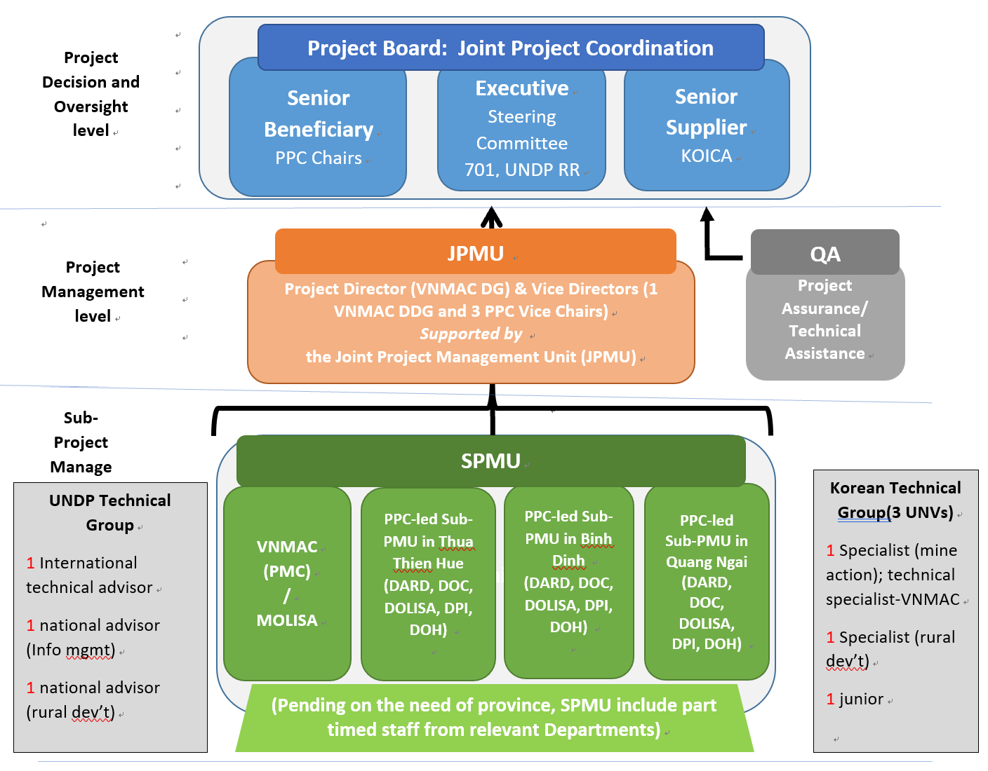
The Joint Project Coordination Committee, co-chaired by the Vice-Minister of MoD and Chair of Steering Committee 701, KOICA Country Director and the UNDP Resident Representative, Chairs of Provincial People’s Committees, is the highest decision-making level.

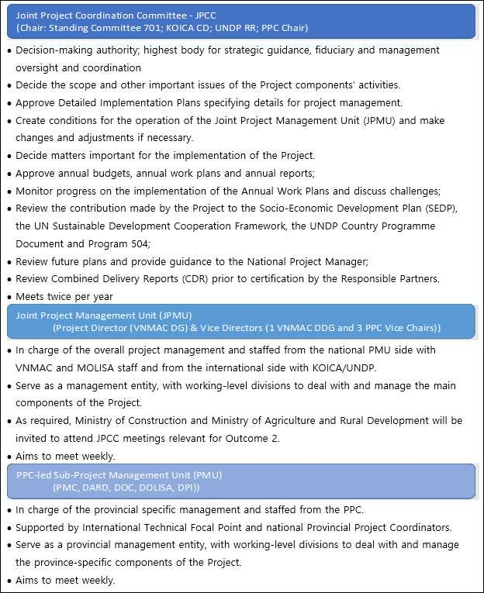
Project Assurance: Quality assurance will be properly ensured both for the use of the Project resources and quality assurance for implementation of Project’s activities. The Project Quality Assurance Team will be responsible for coordination with all relevant stakeholders and quality assurance of the project implementation.

IX. LEGAL CONTEXT
This project document shall be the instrument referred to as such in Article 1 of the Standard Basic Assistance Agreement between the Government of (country) and UNDP, signed on (date). All references in the SBAA to “Executing Agency” shall be deemed to refer to “Implementing Partner.”
This project will be implemented by UNDP Viet Nam(“Implementing Partner”) in accordance with its financial regulations, rules, practices and procedures only to the extent that they do not contravene the principles of the Financial Regulations and Rules of UNDP. Where the financial governance of an Implementing Partner does not provide the required guidance to ensure best value for money, fairness, integrity, transparency, and effective international competition, the financial governance of UNDP shall apply.

X. RISK MANAGEMENT

See attached Risk Management Analysis

XI. Project Board TOR

Overall Responsibilities
The Project Board (JPCC) is ultimately responsible for making sure that the project remains on course to deliver the desired results. It is responsible for making by consensus management decisions for the project*:
- at designated decision points during the implementation of the project (see specific responsibilities bellow);
- when guidance is required by the Project Manager; and,
- when project tolerances (normally in terms of time and budget) have been exceeded.
The Project Board reviews and approves the annual work plans (AWP) and authorizes any major deviation from these plans. It ensures that the required resources are available, arbitrates on any conflicts within the project and negotiates a solution to any problems between the project and external bodies. In addition, it approves the appointment and responsibilities of the Project Manager. It may also decide to delegate its Project Assurance responsibilities to a staff of UNDP and/or the Implementing Partner.

Composition and organization
The Board contains three roles:
- The Executive is ultimately responsible for the project. He/she has to ensure that the project remains focused on achieving its objectives and is cost-effective. The Head of the Implementing Partner (or his/her nominee) and the UNDP Resident Representative (or his/her nominee) will co-chair the group.
- The Senior Suppliers represent the interests of the parties providing funding and/or technical expertise to the project. Their primary function within the Board is to provide guidance regarding the technical feasibility of the project. They are accountable for the quality of the resources (funding or technical assistance) provided by the suppliers. Therefore, they must have the authority to commit or acquire the resources required.
- The Senior Beneficiaries represent the interests of those who will ultimately benefit from the project. They monitor the accomplishments and outputs of the project against the agreed requirements.
*[Potential members of the Project Board are normally reviewed and recommended for approval during the LPAC meeting. It is recommended that the Project Board composition does not contain more participants than absolutely necessary to carry out the above mentioned 3 functions. In some cases, the Executive and Senior Beneficiary functions can be combined].

Specific Responsibilities

When Project Is Initiated
- Provide general, high-level, strategic oversight to the project activities including financial oversight.
- Agree on the Project Manager responsibilities, as well as the responsibilities of the other members of the Project team.
- Delegate any Project Assurance function as appropriate.
- Review and appraise detailed Project Plans and AWP, including the risk log and the monitoring and communication plan.

During Project Implementation
- Provide project and policy implementation oversight.
- Provide overall guidance and direction to the project, ensuring it remains within specified constraints.
- Approve annual work plans and budgets; and based on the approved annual work plans (AWP) authorize any major deviation from the approved work plans and budgets.
- Conduct meetings at least twice a year to review Project Progress Reports and provide direction and recommendations to ensure agreed deliverables are produced satisfactorily according to plans.
- Approve changes and amendments to the existing project document.
- Monitor progressive achievement of project objectives and provide guidance on long term sustainability of the project’s achievements.
- Provide high-level quality assurance for project results and input and advice to on-going risk analysis.
- Undertake mobilization of funding for the project and consider funding for emerging issues.
- Invite representatives of other project beneficiaries to inform on their specific activities and needs.
- Provide overall guidance and direction to the project.
- Address project issues as raised by the Project Manager.
- Provide guidance and agree on possible management actions to address specific risks.
- Agree on Project Manager’s tolerances within the AWP.
- Conduct regular meetings to review the Project Quarterly Progress Report and provide direction and recommendations to ensure that the agreed deliverables are produced satisfactorily according to plans.
- Review Combined Delivery Reports (CDR) prior to certification by the Implementing Partner.
- Appraise the Project Annual Review Report, make recommendations for the next AWP, and inform the Outcome Board about the results of the review.
- Provide ad-hoc direction and advice for exception situations when project manager’s tolerances are exceeded.
- Assess and decide on project changes through revisions.
- Consider recommendations form the JPMU

When Project Is Being Closed
- Review and approve the Final Project Review Report, including lessons learned.
- Commission project evaluation when required.
- Assure that all Project deliverables have been produced satisfactorily.
- Review and approve the Final Project Review Report, including Lessons-learned.

Meetings
The Project Board meets:
- On a semi-annual basis to review and approve the regular project reports.
- At any other time a meeting is requested by one of its members, the Project Manager or the Project Assurance because guidance is required, tolerances have been exceeded, or a particular issue or risk requires the intervention of the Project Board.

Project Assurance

Responsibilities
Project Assurance is the responsibility of each Project Board member. [However, the role can be delegated by the Project Board. When this happens, the Project Assurance person supports the Project Board by carrying out objective and independent project oversight and monitoring functions. The Project Assurance function has to be independent of the Project Manager; therefore the Project Board cannot delegate any of its assurance responsibilities to the Project Manager. A UNDP Programme Officer typically holds the Project Assurance role given UNDP’s ultimate fiduciary responsibility for the project.]
The following list includes the key elements that need to be checked for assurance purposes throughout the project.
- Maintenance of thorough liaison throughout the project between the members of the Project Board.
- Beneficiary needs and expectations are being met or managed
- Risks are being controlled
- Adherence to the Project Justification (Business Case)
- Projects fit with the overall Country Programme
- The right people are being involved
- An acceptable solution is being developed
- The project remains viable
- The scope of the project is not “creeping upwards” unnoticed
- Internal and external communications are working
- Applicable UNDP rules and regulations are being observed
- Any legislative constraints are being observed
- Adherence to monitoring and reporting requirements and standards

During the implementation of the project
- Ensure that funds are made available to the project.
- Ensure that project outputs definitions and activity definition including description and quality criteria have been properly recorded in the Atlas Project Management module to facilitate monitoring and reporting.
- Ensure that risks and issues are properly managed, and that the logs in Atlas are regularly updated.
- Ensure that critical project information is monitored and updated in Atlas, using the Activity Quality log in particular.
- Ensure that Project Quarterly Progress Reports are prepared and submitted on time, and according to standards in terms of format and content quality.
- Ensure that CDRs and FACE are prepared and submitted to the Project Board and Outcome Board.
- Perform oversight activities, such as periodic monitoring visits and “spot checks”.
- Ensure that the Project Data Quality Dashboard remains “green”

When the project is being closed
- Ensure that the project is operationally closed in Atlas.
- Ensure that all financial transactions are in Atlas based on final accounting of expenditures.
- Ensure that project accounts are closed, and status set in Atlas accordingly.

Note on Project Tolerance
No project ever goes 100% according to the initial plan. Even with a good plan, some things will go a little slower than planned or cost a little more; other things will go faster or cost a little less. Although the Project Board agrees on a plan with the Project Manager at the beginning of the year, it does not want the Project Manager to be constantly running back to it, saying “I have spent a small amount more than we had planned this week” or “I am a day late this week”. On the other hand, the Project Board does not want progress to deviate wildly from the plan without being told and being able to react.
So where is the dividing line between deviations that are permissible without Project Board intervention and deviations that require the intervention of the Project Board? The dividing line is called tolerance. Tolerance is a permissible deviation from the project plan that does not require bringing the deviation to the attention of the Project Board.
The tolerances for the project are normally reviewed and recommended for approval during the LPAC meeting. Subsequently, the Project Board may want to agree with the Project Manager on a tolerance for each deliverable once the AWP has been produced.
When it appears that the tolerance granted by the Project Board to the Project Manager for the project as a whole or a particular deliverable has been exceeded or is likely to be exceeded, the Project Board needs to convene and agree on the measures to be taken.
Separate tolerance figures should be given for:
- time (to deliver outputs/activities)
- cost (of project/activities)
- scope (of project)
Tolerance figures need not be the same for over and under cost and time. A tolerance of, say + 5% to - 20% may be more realistic than +/- 10%. In addition, it may be more realistic to quote tolerances as “real” figures rather than percentages – for example, ten days or a defined amount of money. The setting of these tolerances is done as part of the work planning (AWP).
Example:
The PM will need to refer to the Project Board as soon as it will appear that
- total budget requirements are more than 10% higher than planned
- delivery is more than 15% bellow targets
- any new workshop/travel/activity costing more than $1,000 is required
- the estimated cost of any of the project activities is increased by more than $5,000
- the implementation of any of the project activities is delayed by more than 3 months

Project Board Members – to be added
Member Role | Full Name | Title, Organization | Contacts

Risk Matrix

See attached Risk Register

https://www.undp.org/content/undp/en/home/librarypage/poverty-reduction/mine-action-for-sustainable-development.html
The five mine action pillars are: Land Release (i.e. Clearance); Explosive Risk Education; Victim Assistance; Advocacy; and Stockpile Destruction. The last pillar is not yet part of the work being done by at least international organizations working on mine action in Vietnam.
https://www.vn.undp.org/content/vietnam/en/home/projects/kvmap-korea-viet-nam-mine-action-project.html
Government Decree on management implementation of mine action; No. 18/2019/NĐ-CP; 1 February 2019 and Circular Regulating details of the number of articles and methods on implementation of the Government Decree No. 18/2019/NĐ-CP dated 1 February 2019 on implementation and management of mine action; No: 195/2019/TT-BQP (Circular 195); Hanoi, 27 December 2019; Chapter II, Article 5.
In the following the term ‘survivor’ will be used specifically for persons who survived accidents with EO, whereas EO ‘victims’ will be used in line with the definition in the International Mine Action Standards (IMAS): “persons either individually or collectively who have suffered physical, emotional and psychological injury, economic loss or substantial impairment of their fundamental rights through acts or omissions related to the use of mines or the presence of [Explosive Remnants of War (ERW)]. Victims include directly impacted individuals, their families, and communities affected by landmines and ERW.” Hence, ‘victims’ include survivors, as well as families of those killed by EO. It includes entire communities whose lives and livelihoods are impacted by the presence of EO. As part of this intervention specific emphasis will be on those within these communities who are considered poor, near poor and vulnerable. International Mine Action Standards (IMAS) 4:10: Glossary of mine action terms, definitions and abbreviations; https://www.mineactionstandards.org/fileadmin/MAS/documents/standards/Glossary_of_mine_action_terms_and_abbreviations_Ed.2_Am.10.pdf; the term ‘Explosive Ordnance’ consists of at least the following items relevant for Vietnam: Mines, Cluster Munitions, Unexploded Ordnance, Abandoned Ordnance; For more definitions on beneficiaries, see recent Standardising Beneficiary Definitions in Humanitarian Mine Action; 2nd Version [SBD 2.0]; https://commons.lib.jmu.edu/cisr-globalcwd/1481/;
For the Project Management structure and the JPCC, see below
For a definition of Information Management in Mine Action, please see Geneva International Centre for Humanitarian Demining (GICHD) https://www.gichd.org/
The Anti-Personnel Mine Ban Treaty (APMBT) and The Convention on Cluster Munitions (CCM).
https://germanwatch.org/sites/germanwatch.org/files/20-2-01e%20Global%20Climate%20Risk%20Index%202020_10.pdf
Institute of Meteorology, Hydrology and Climate Change (IMHEN) and UNDP (February 2015). Vietnam Special Report on Managing the Risks of Extreme Events and Disasters to Advance Climate Change Adaptation. Summary for Policymakers.
According to MONRE, 2016 was particularly severe, with an acute El Niño-induced drought and saline intrusion affecting a third of the country, followed by a sequence of typhoons, tropical depressions and heavy rainfall events causing flooding in the North and South-Central Coast and Central Highlands regions. In 2016 alone, more than 2.2 million people were affected, 230 people lost their lives, and an estimated US$1.7 billion of damage and loss occurred, or approximately 0.83 percent of the country’s Gross Domestic Product. In 2017, Vietnam was affected by a number of tropical storms, floods (riverine and flash), heavy rainfall, landslides, and a heatwave, resulting in more than five million people affected, 400 deaths and 650 people injured, 558,000 houses damaged, flooded or destroyed and 350,000ha of crops affected. Typhoon Damrey in November 2017 caused the most damage, with 4.3 million people in 15 provinces in Central Vietnam estimated as being affected, 123 people who lost their lives, and 305,254 houses damaged, flooded or destroyed.
Classification by the Centre for Research on the Epidemiology of Disasters’ Emergency Events Database, http://www.emdat.be/classification
Rentschler, J, de Vries Robbé, S, Braese, J, Huy Nguyen, D, van Ledden, M, and Pozueta Mayo, B. 2020. Resilient Shores: Vietnam’s Coastal Development Between Opportunity and Disaster Risk. Washington, DC: The World Bank
Ibid.
http://www.gmap.ch/gender-diversity-matter/
https://www.mineaction.org/sites/default/files/documents/un_mine_action_strategy_2019-2023_-_final_for_online_0.pdf
https://www.undp.org/content/undp/en/home/librarypage/poverty-reduction/mine-action-for-sustainable-development.html
Vietnam Contamination Report officially released on 4 Apr 2018
Ibid
Decision 1052 / QD-LDTBXH 2019 announces the results of reviewing poor households in 2018: https://luatvietnam.vn/chinh-sach/quyet-dinh-1052-qd-ldtbxh-2019-cong-bo-ket-qua-ra-soat-ho-ngheo-nam-2018-175726-d1.html
http://nongthonmoi.gov.vn/Pages/danh-sach-cong-thong-tin-dien-tu-trang-mang-chuong-trinh-nong-thon-moi-cua-18-tinh.aspx
http://eng.climaterisk.org.vn
https://thuathienhue.gov.vn/en-us/Home/Detail/tid/Administrative-units/newsid/1BAF9DCE-8529-4D76-A99A-A999010D6792/cid/AEBA5AE7-F4B9-4D9B-A507-DE8802BF1D14 https://en.wikipedia.org/wiki/Th%E1%BB%ABa_Thi%C3%AAn-Hu%E1%BA%BF_Province)
https://vi.wikipedia.org/wiki/Qu%E1%BA%A3ng_Ng%C3%A3i https://dangcongsan.vn/tien-toi-dai-hoi-dang-bo-cac-cap-va-dai-hoi-xiii-cua-dang/tin-hoat-dong/quang-ngai-co-11-huyen-1-thanh-pho-va-1-thi-xa-548116.html
https://vi.wikipedia.org/wiki/B%C3%ACnh_%C4%90%E1%BB%8Bnh https://www.binhdinh.gov.vn/inetcloud/portal/main/page/intro/donvihanhchinh.ivt?intl=vi
OECD: Multi-dimensional Review of Vietnam - Towards an Integrated, Transparent and Sustainable Economy; 20 February 2020; p. 18; accessible via this link https://www.oecd-ilibrary.org/sites/367b585c-en/index.html?itemId=/content/publication/367b585c-en
UNDP: 2020 Human Development Report (HDR); http://hdr.undp.org/en/2020-report
National Technical Regulation on non-technical, technical survey and clearance in mine action (QCVN)
In the sector it is considered that a cost around USD 1 per m² is a good benchmark of an efficient clearance project.
https://luatvietnam.vn/chinh-sach/quyet-dinh-1052-qd-ldtbxh-2019-cong-bo-ket-qua-ra-soat-ho-ngheo-nam-2018-175726-d1.html (MOLISA’s poverty and near poverty household survey in 2019)
First-ever official database on persons with disabilities and unexploded ordnance survivors in Quang Binh and Binh Dinh provinces launched; https://www.vn.undp.org/content/vietnam/en/home/presscenter/pressreleases/PwDdatabase.html
www.qtmac.vn casualty information.
The World Risk Index ranks Vietnam as 18th most at-risk in the world, under the category of ‘very high risk’, see: Alliance Development Works, United Nations University Institute for Environment and Human Security (2016). World Risk Report 2016. Focus: Logistics and Infrastructure. www.WorldRiskReport.org. The Climate Change Vulnerability Index ranks Vietnam 13th, under the category of ‘extreme risk’, see: Maplecroft (2011). Climate Change Risk Atlas 2011. maplecroft.com/about/news/ccvi.html.
Classification by the Centre for Research on the Epidemiology of Disasters’ Emergency Events Database, http://www.emdat.be/classification
Institute of Meteorology, Hydrology and Climate Change (IMHEN) and UNDP (February 2015). Vietnam Special Report on Managing the Risks of Extreme Events and Disasters to Advance Climate Change Adaptation. Summary for Policymakers.
According to MONRE, 2016 was particularly severe, with an acute El Niño-induced drought and saline intrusion affecting a third of the country, followed by a sequence of typhoons, tropical depressions and heavy rainfall events causing flooding in the North and South-Central Coast and Central Highlands regions. In 2016 alone, more than 2.2 million people were affected, 230 people lost their lives, and an estimated US$1.7 billion of damage and loss occurred, or approximately 0.83 percent of the country’s Gross Domestic Product. In 2017, Vietnam was affected by a number of tropical storms, floods (riverine and flash), heavy rainfall, landslides, and a heatwave, resulting in more than five million people affected, 400 deaths and 650 people injured, 558,000 houses damaged, flooded or destroyed and 350,000ha of crops affected. Typhoon Damrey in November 2017 caused the most damage, with 4.3 million people in 15 provinces in Central Vietnam estimated as being affected, 123 people who lost their lives, and 305,254 houses damaged, flooded or destroyed.
Housing Demands of Poor Households with Difficulties in the 28 Coastal Provinces in Vietnam. Ministry of Construction. 2019.
https://www.undp.org/content/undp/en/home/six-signature-solutions.html
Mid-term Evaluation Report of the KVMAP 2019
The system will be based on the model from Quang Tri Mine Action Center (QTMAC). See for example http://www.qtmac.vn/en-us/Home/Weekly-Plan
Circular 195; Chapter II, Article 5.
For the Project Management structure and the JPCC, see below
https://www.mineactionstandards.org/
For a definition of Information Management in Mine Action, please see Geneva International Centre for Humanitarian Demining (GICHD) https://www.gichd.org/
https://www.greenclimate.fund/project/fp125
https://www.greenclimate.fund/project/fp013
Mid-term Evaluation Report of the KVMAP 2019
For more about VNMAC, please see http://vnmac.gov.vn/en/index.html
Prime Minister’s Decisions 1614 and 59. https://drive.google.com/open?id=19Pybm36p1DbXmbJ-mBL4NbQY4rVeeqkO and https://drive.google.com/open?id=1Q51GSbIBc-m3hGcabSwzTpbCunYtuJTI
Data calculated from the 2016 Vietnam Household Living Standard Survey (VHLSS).
Measurement and Uses of Multidimensional Poverty in Asia Pacific Countries 2019. https://www.undp.org/content/dam/undp/library/km-qap/UNDP-RBAP-Multidemensional-Poverty-Index-Measurement-Asia-Pacific-2020.pdf
Master Plan for Social Assistance Reform and Development (MPSARD) in the period 2017-2025, vision to 2030. https://drive.google.com/open?id=1UwzMw5QOLDEDCXGDAIsVvn4NgnotRk7x
UN-REDD Project Annual Review Reports.
National Reducing Emission from Deforestation and Forest Degradation (REDD+) Programme (NRAP). April 2017. https://www.youtube.com/watch?v=QmcVXg6U_Iw; http://www.unredd.net/documents/un-redd-partner-countries-181/national-redd-strategies-1025/16264-viet-nam-national-redd-action-program-2nd-12.html?path=un-redd-partner-countries-181/national-redd-strategies-1025
Decision by Minister of Agriculture and Rural Development Announcing National Forest Status in 2016. May 2017. http://bit.ly/2Bzt88l
Annual Reviews of the “Improving the Resilience of Vulnerable Coastal Communities to Climate Change Related Impacts in Vietnam” Project.
UNREDD 2018 Annual Review and Final Evaluation Report.
https://www.undp.org/content/undp/en/home/crisis-response/deployment-mechanism.html
http://www.undp.org/content/seoul_policy_center/en/home.html
At the moment, it is anticipated that the KMCO will be engaged for a two-year period, i.e. until February 2023. Should KOICA and UNDP agree to recruit another KMCO beyond this period, the function will continue, although it is expected that after the first year of deployment the Peace Village Coordinators will be working more independently.
This staff will be dispatched by KOICA under a separate budget, this position is therefore not included in the present project’s budget. The KMCO is planned to take up the position in early 2021, and hence it is estimated that only 14 months will remain of the KMCO position by the time the KVPVP starts early 2022.

